Christen Clark

Steps made to make bamazonDB and screen shots.

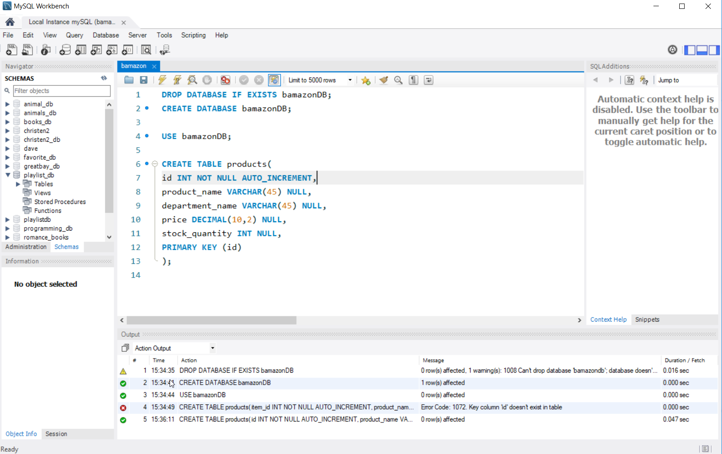

Action line 5 says created table.

Database with 11 bamazon things listed. This was made in excel.

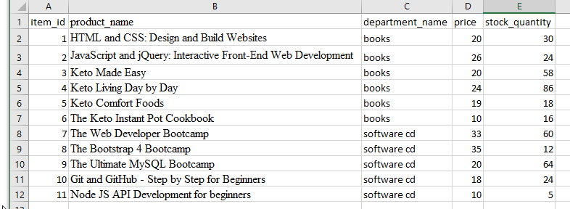

Inserted 11 items

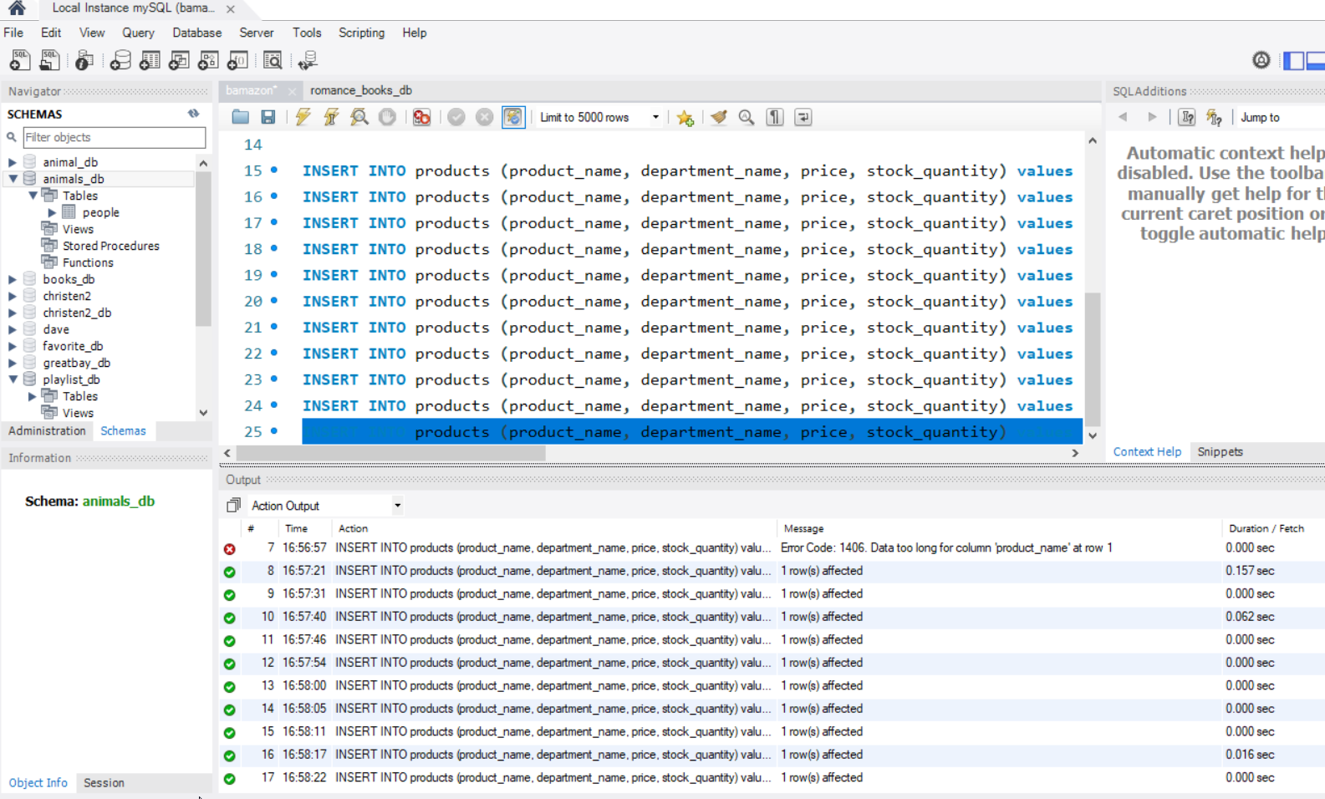

Note line 7 text was too long so I shortened length of title of book.

Made database on mySQL workbench

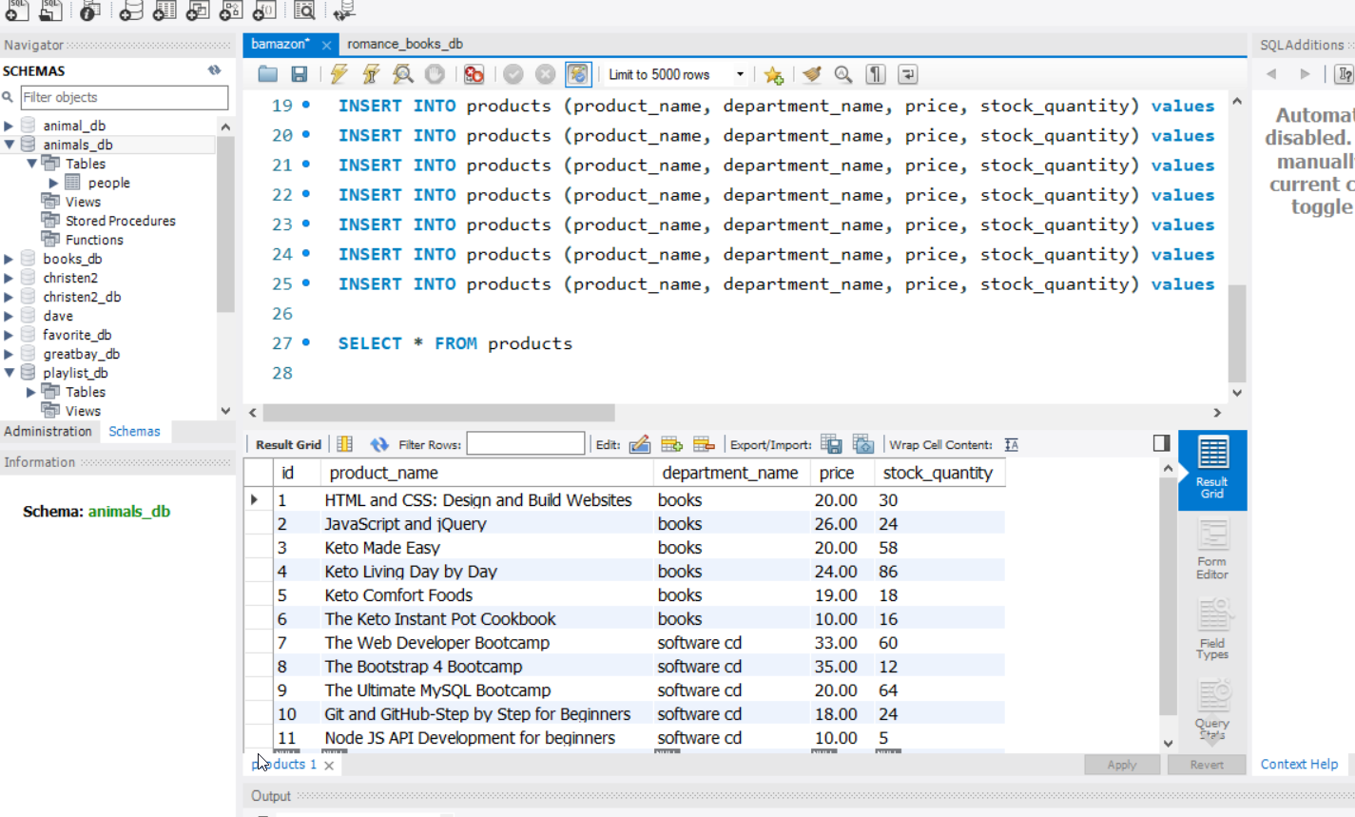

Print out of id, product_name and price.

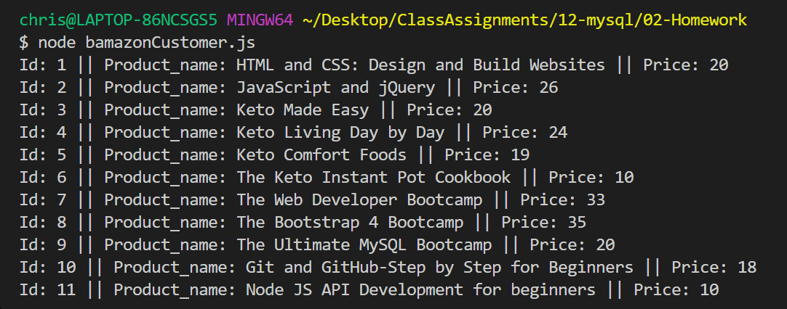

Do you want to review products? Yes List of products

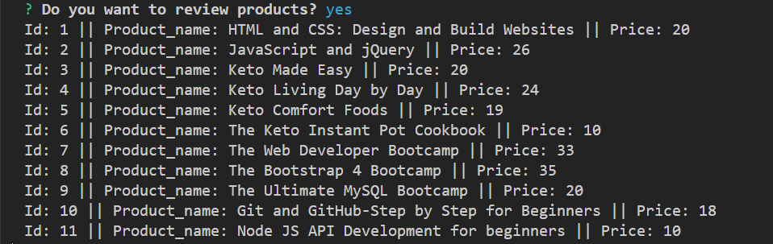

Enter the product Id you would like to buy? (id number)

How many would you like to buy? (customer quantity)



Customer selected id 3 ( list product name, price and quantity)

Product has been ordered, Your total cost is id 3 which is $20 * 6 quantity



If you want to exit program pick exit as second choice from Do you want to review products question

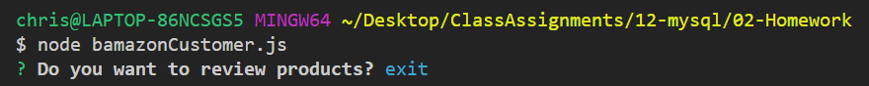

If customer wants more product than in stock it will tell customer that there is insufficient quantity.

