OPTIONS.applyFilters = true; % perform filtering via MatPIV methods (you may want to customize which filter method you use ... our camera provide good enough image quality, so did not require all filter methods)
OPTIONS.thold_snr = 1.6; % threshold for use with snr-filtering
OPTIONS.thold_peak = 0.5; % peak to peak filtering
OPTIONS.thold_local = 3; % threshold for std. use with local filtering
OPTIONS.thold_local_num = 5; % number of vectors to apply the local filtering upon
OPTIONS.thold_local_stat = 'median'; % use type filtering in localfilt. suggest 'median'
OPTIONS.thold_global = 3; % threshold for use with globalfiltering (choose 3 or 'loop' ... loop is causing extreme memory usage/errors with v1.7)
OPTIONS.Nglobal = 2; % iterations for use with globalfiltering (I dont think is working with v1.7)

After matpiv()
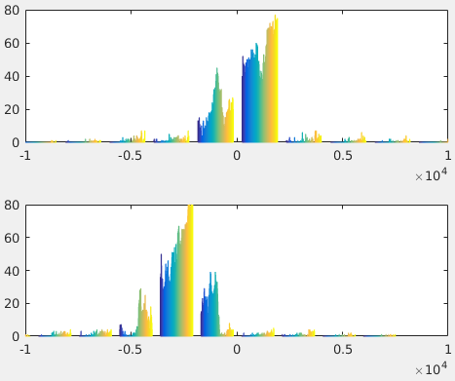

After SNR filter: 1100 of 16129 vectors were removed
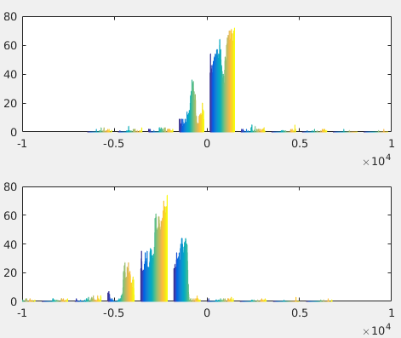

After PEAK filter: 556 of 16129 vectors were removed
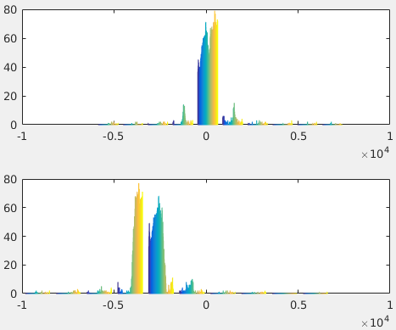

After GLOBAL-loop-1: 192 of 16129 vectors were removed
After GLOBAL-loop-2: 187 of 16129 vectors were removed
After GLOBAL-loop-3: 141 of 16129 vectors were removed
After GLOBAL-loop-4: 79 of 16129 vectors were removed
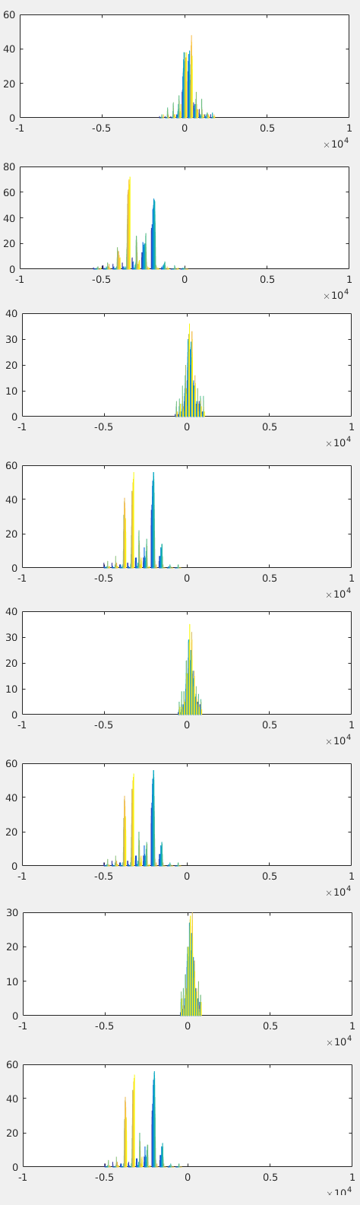

After LOCAL filtering: 482 of 16129 vectors were removed
