**Appetizers**

Skate wing *olive tomato fennel parsley*

Sweet breads

*cabbage celery root apple*

*leek*

Duck *artichoke carrot ginger orange frisée*

Pasta *beet ricotta lemon fava bean pancetta peach*

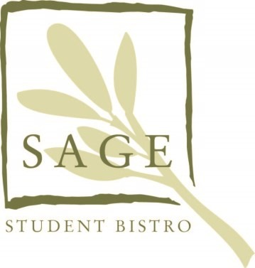

**Entrée**

Tile Fish *shrimp lobster arborio zucchini pearl onion*

Chicken *shallot turnip*

*sweet potato swiss chard rosemary*

Beef *oxtail mushroom beans radish*

*kale green onion broth*

Pork

*pineapple*

*avocado onion polenta tomatillo bok-choy*