**BISTRO CASUAL DINING MENU SPRING 2016**

**ENTREES:**

**Sunshine Chicken 7.50**

**Orange-Ginger Glazed Chicken Breast, Jasmine Rice, Snap Peas**

**Lamb Borghini 7.25**

**Lamb & Wild Mushroom Ragu over Bucatini Pasta, Pecorino-Romano Cheese, Garlic**

**Bread**

**Santa Fe Salmon 8.50**

**Cast Iron Salmon Fillet, Ancho Chili BBQ Sauce, Grilled Fresh Asparagus & Peruvian**

**Potatoes**

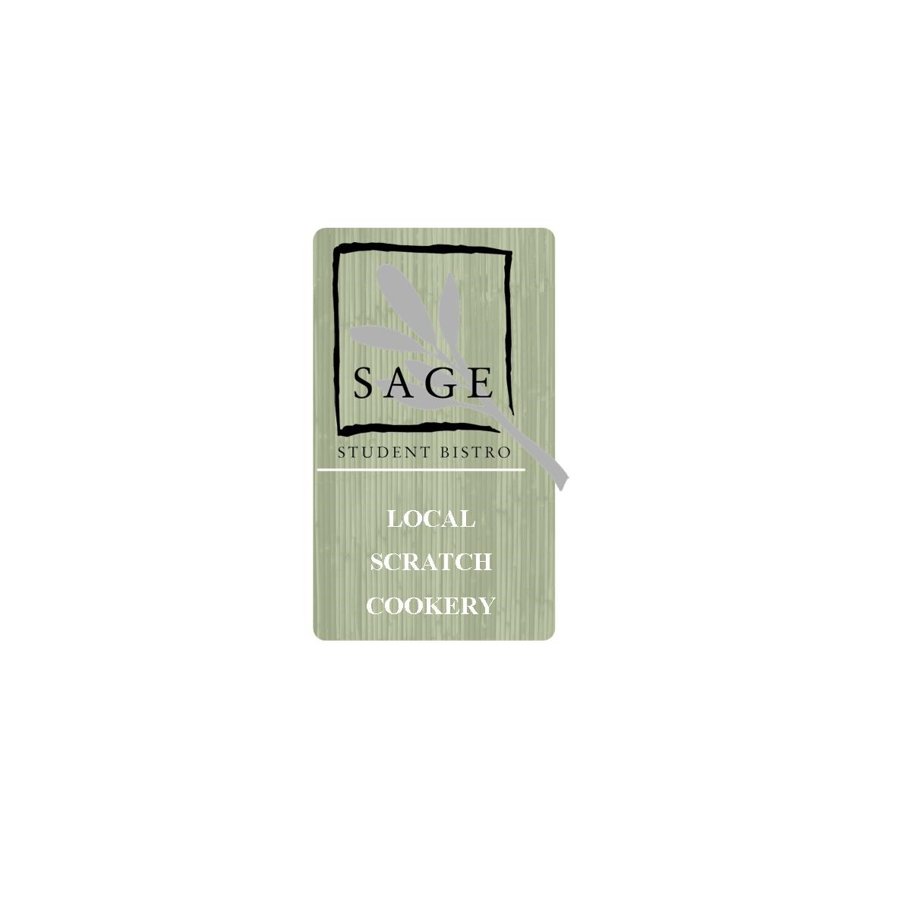

Please inform your server if you have any special dietary concerns.

Consuming raw or undercooked animal protein may put you at risk for certain illnesses.

**SANDWICHES: (served with fresh fruit or fries)**

**Blackstone Reuben 6.75**

**House Corned Beef, Sauerkraut, 1000 Island & Swiss Cheese on Grilled Marble Rye**

**Cubano 5.75**

**Roast Pork Loin, Ham, Swiss, Pickles, Spanish Onion & Yellow Mustard on Cuban Bread**

**Bistro Burger 5.95**

**Fresh Ground Chuck Burger, Cheddar Cheese, Brioche Bun,**

**lettuce, tomato, house pickles, red onion, *add cherry w ood smoked bacon .75***

**SALADS:**

**“It’s Greek To Me” 6.50**

**Feta Cheese, Kalamata Olives, Cucumbers, Tomatoes, Garbanzos, Red Onion, Roasted**

**Peppers, Artichoke Hearts, Mixed Greens, Grilled Pita, Balsamic Vinaigrette**

***add grilled chicken breast 2.25 add salmon fillet 3.95***

**Bistro Side Salad 2.50**

**Mixed greens with tomato, cucumber, carrot, olives, red onion**

***(Balsamic Vinaigrette or Buttermilk Ranch Dressing)***