Matthew Seto

16 Jan 2018

Lab 1 – Geoprocessing and Python

**Lab Purpose:**

The purpose of this lab is to familiarize with the programmatic process concept. Using ArcMAP’s model builder, a simple ‘program’ is built to perform basic GIS tasks, then that model is exported to a Python script. This is to reinforce the concept that underneath the ArcMAP GUI, all actions can be scripted. This lab also serves as an introduction to source control through GitHub.

**Lab Results:**

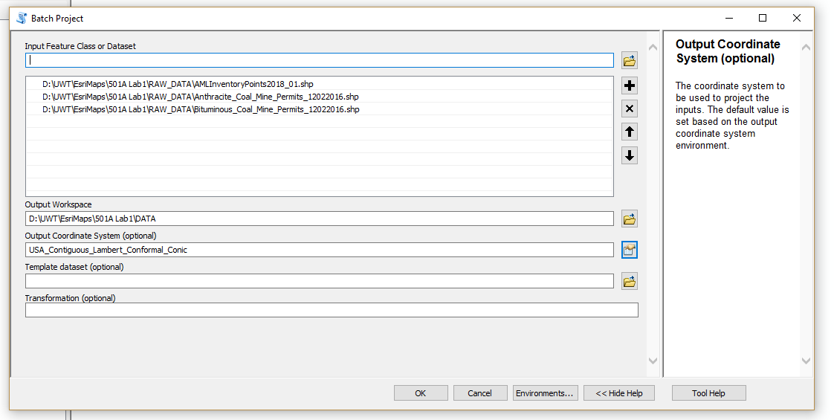

2.

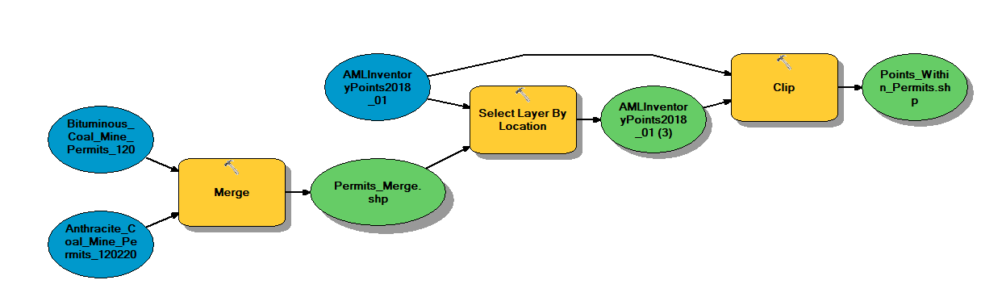

1. Setom_Lab1.py
2. 555