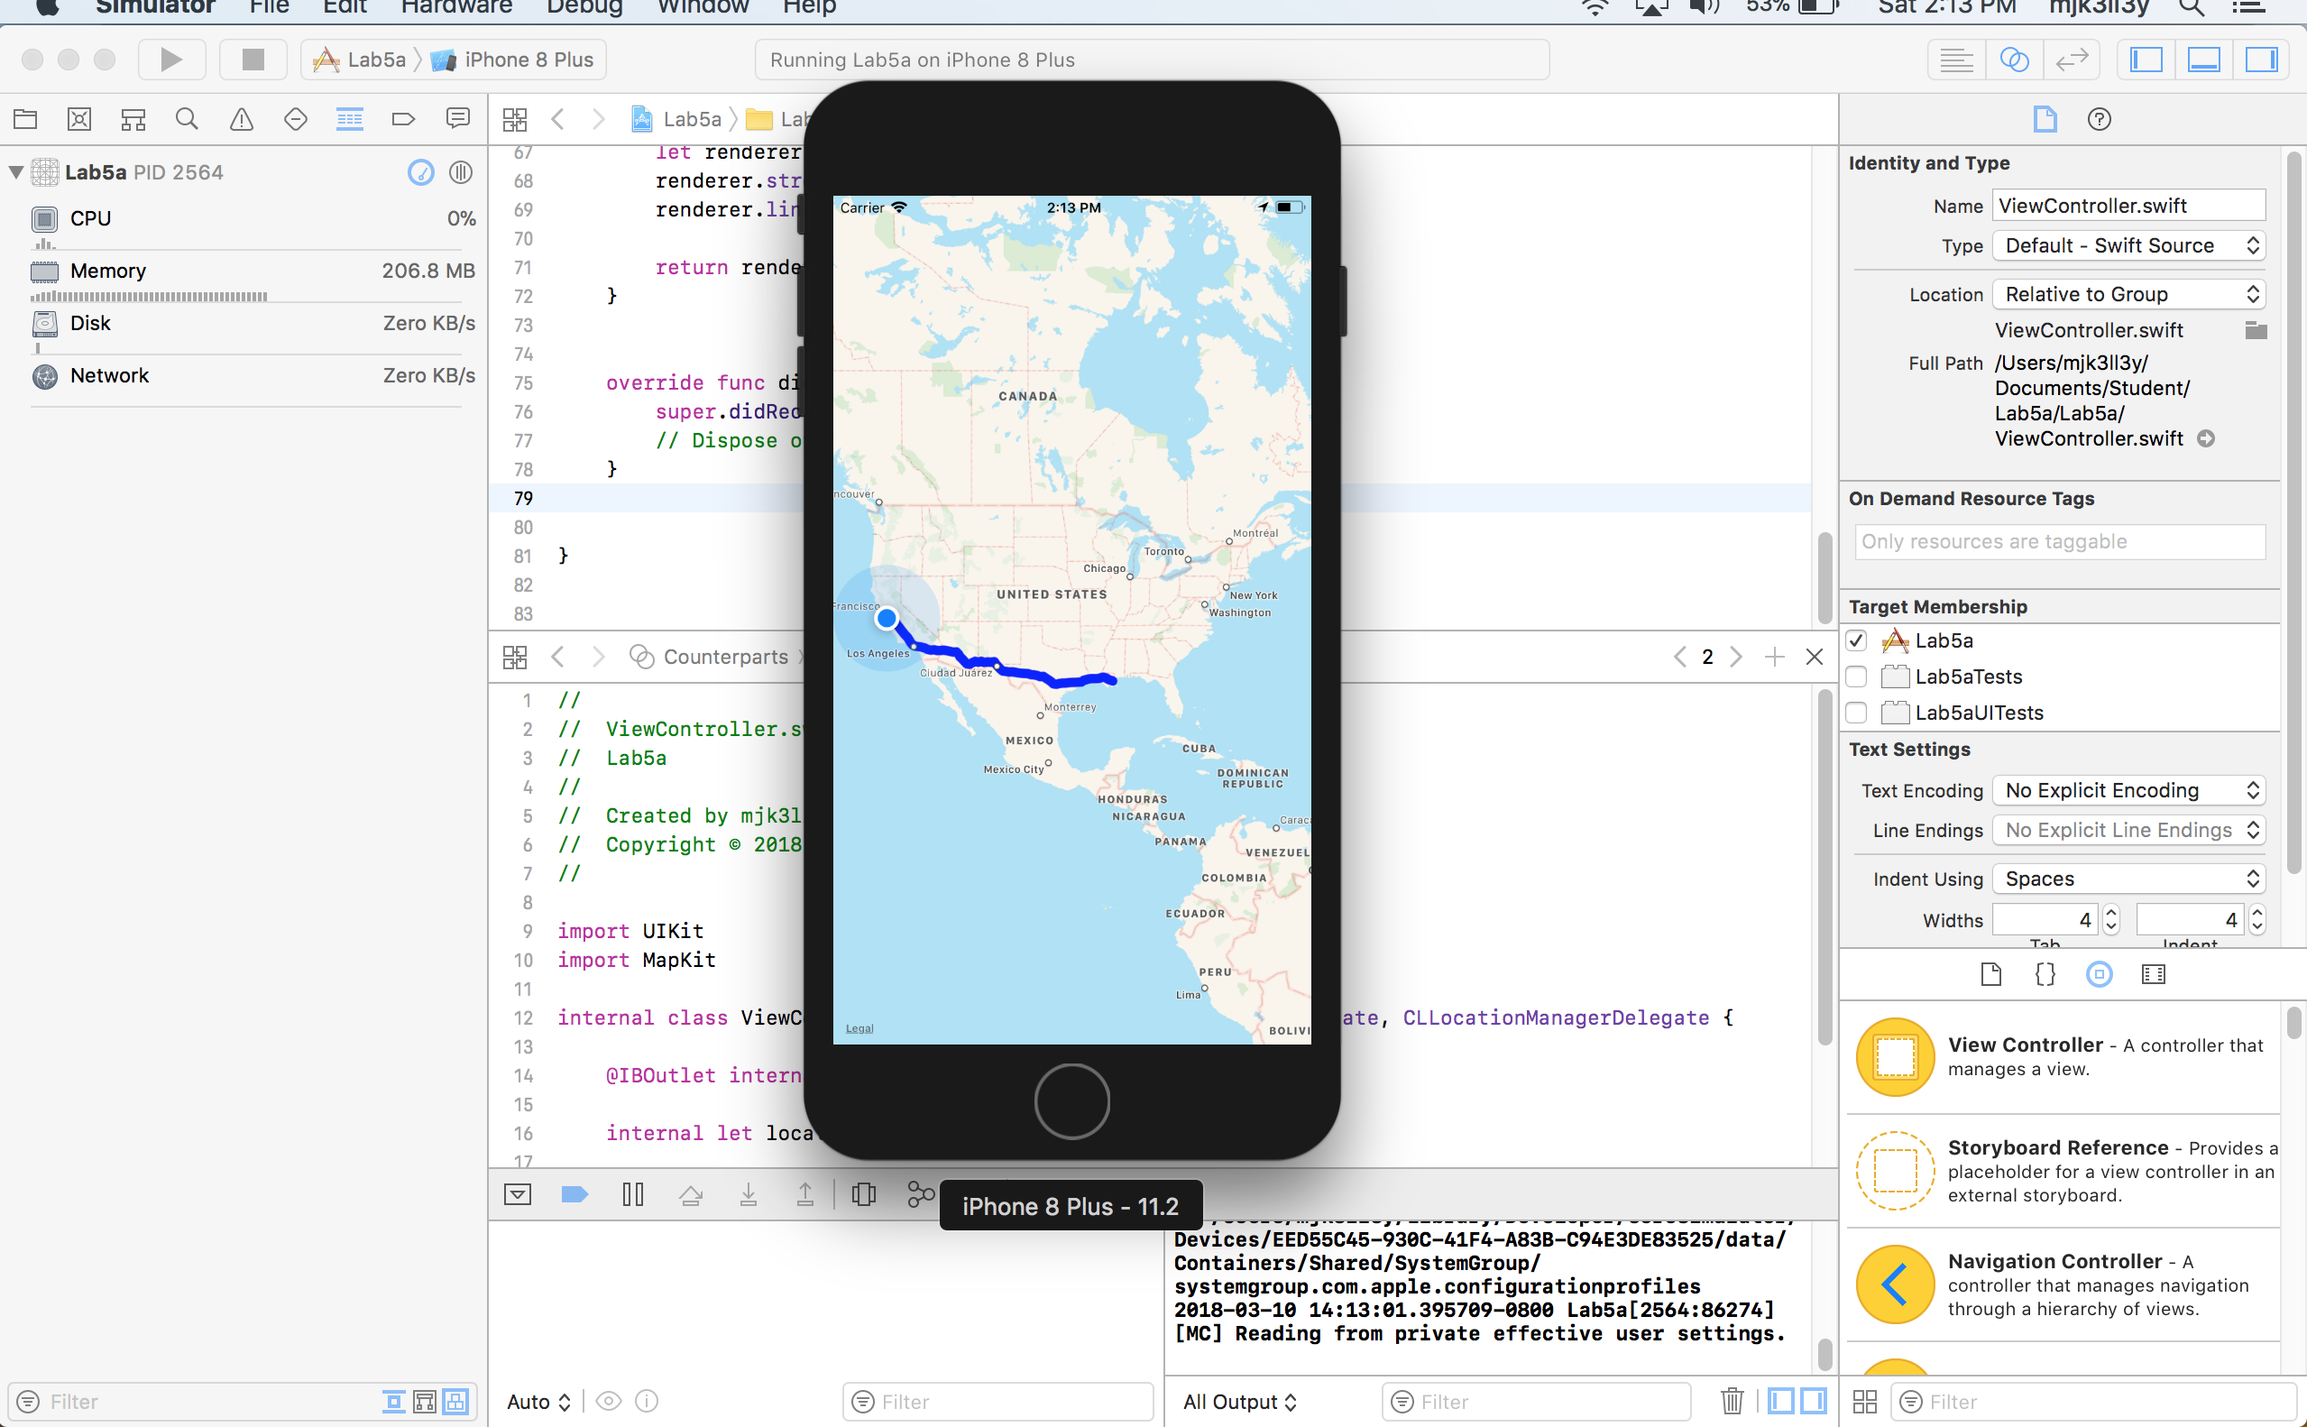

//

// ViewController.swift

// Lab5a

//

// Created by mjk3ll3y on 3/10/18.

// Copyright © 2018 Kulm. All rights reserved.

//

import UIKit

import MapKit

class ViewController: UIViewController, MKMapViewDelegate, CLLocationManagerDelegate {

@IBOutlet var mapKitView: MKMapView!

let locationManager = CLLocationManager()

override func viewDidLoad() {

super.viewDidLoad()

mapKitView.delegate = self

mapKitView.showsUserLocation = true

mapKitView.showsScale = true

mapKitView.showsCompass = true

mapKitView.showsPointsOfInterest = true

locationManager.requestAlwaysAuthorization()

locationManager.requestWhenInUseAuthorization()

if CLLocationManager.locationServicesEnabled() {

locationManager.delegate = self

locationManager.desiredAccuracy = kCLLocationAccuracyBest

locationManager.startUpdatingLocation()

}

let sourceCoordinates = locationManager.location?.coordinate

let destCoordinates = CLLocationCoordinate2DMake(29.9511, -90.0715)

let sourcePlacemark = MKPlacemark(coordinate: sourceCoordinates!)

let destPlacemark = MKPlacemark(coordinate: destCoordinates)

let sourceItem = MKMapItem(placemark: sourcePlacemark)

let destItem = MKMapItem(placemark: destPlacemark)

let directionRequest = MKDirectionsRequest()

directionRequest.source = sourceItem

directionRequest.destination = destItem

directionRequest.transportType = .automobile

let directions = MKDirections(request: directionRequest)

directions.calculate(completionHandler: {

response, error in

guard let response = response else {

if error != nil {

print("Oops, Something went wrong.")

}

return

}

let route = response.routes[0]

self.mapKitView.add(route.polyline, level: .aboveRoads)

})

}

func mapView(_ mapView: MKMapView, rendererFor overlay: MKOverlay) -> MKOverlayRenderer {

let renderer = MKPolylineRenderer(overlay: overlay)

renderer.strokeColor = UIColor.blue

renderer.lineWidth = 5.0

return renderer

}

override func didReceiveMemoryWarning() {

super.didReceiveMemoryWarning()

// Dispose of any resources that can be recreated.

}

}