UI Systems4

Preface
Look at you…reading the Preface! I’m impressed by your dedication! Hello, and welcome to the sixth edition of Learning Web Design.
It’s hard to believe that I wrote the first edition of this book 25 years ago. To say things have changed since then would be a vast understatement. Web design and development have gotten so much better! We have more and better tools at our disposal for layout, performance, interactivity, and efficiency than we did then. In fact, the development landscape has improved significantly even since the publication of the fifth edition in 2018. The inevitable byproduct of that evolution, however, is that it has become more complicated, and there is a lot more to learn.
If that feels overwhelming, don’t worry. Some say my superpower is taking big, gnarly, complicated concepts and making them clear and understandable. This book assumes you are starting from square one, with little or no experience with code. It begins with an explanation of how the web works, and progresses gradually, with exercises and quizzes in each chapter so you can apply and measure what you’ve learned along the way. By the end of the book, you will have a solid foundation in HTML, CSS, JavaScript, and image production that will serve you well as you learn and practice more on your own. Although I start as simply as possible, I’ll also introduce you to advanced features along the way, so you’ll have a good overview of the possibilities when you’re ready to explore them.
Like the previous ones, this edition addresses the specific needs and concerns of beginners of all backgrounds, including seasoned graphic designers, programmers looking to expand their skills, and anyone else wanting to learn how to make websites. Whether you are reading this book on your own or using it as a companion to a web design course, I hope that it gives you a good head start, and that you have fun in the process.

What’s New in This Edition
Thankfully, web technologies have settled down a bit in recent years, and responsive web design and features that were experimental in HTML5 are now the default ways of doing things. That said, there are still plenty of changes in this sixth edition. Here’s an overview.

More Thorough JavaScript Instruction
I’m most excited about the expanded JavaScript section, written by my friend and fellow web old-timer Aaron Gustafson. In addition to being a JavaScript expert, Aaron is a strong advocate for progressive enhancement and accessibility, and he’s been writing about the web for decades—including his own book, Adaptive Web Design: Crafting Rich Experiences with Progressive Enhancement (aaron-gustafson.com). He also wrote the JavaScript chapters in one of my early books, Web Design in a Nutshell (published in 2001), so Aaron and I have been collaborating on this sort of thing for a while!
Aaron will lead you through lessons and exercises that will give you a good feel for what it’s like to add interactivity to a web page with JavaScript. You will learn the ins and outs of variables, conditionals, loops, and arrays and how to use them to manipulate web content and its presentation. His chapters are a good first step on your JavaScript journey (should you choose to take it!).

Updates Everywhere!
All other chapters have been updated to reflect the latest standards and practices.
The majority of the changes are in the CSS chapters, where the specs are always evolving. There is a new chapter, Chapter 14, Selectors, where you’ll get a chance to try out newer ways to target page elements for styling. Flexbox and Grid Layout now each have their own chapters. Chapter 19, Responsive Web Design, has been expanded with information about design systems and container queries. Finally, Chapter 20, Transitions, Transforms, and Animation, includes details on cutting-edge CSS syntax options such as variables, nesting, and layers.
In addition, the image production chapters have had a major overhaul to reflect the requirements of responsive layouts and to keep up with the available image editing and design tools.

Online Articles
To make room for all the new material, some content from the previous edition has been moved to online articles, available at learningwebdesign.com/articles/. You’ll find information on responsive image markup, background images, border images, the command line, CSS Shapes, Git and GitHub, and more. There are references to specific articles throughout the book.

URL Shortening
Because it isn’t possible to include everything there is to know about web development in one book, I provide plenty of references to online resources for further learning. Unfortunately, some of those URLs can be really long. In this edition, I have employed O’Reilly’s URL shortener to make the most unwieldy URLs easier to type in your browser. For example, instead of typing:
developer.mozilla.org/Apps/Fundamentals/Audio_and_video_delivery/Adding_captions_and_subtitles_to_HTML5_video
you can simply type:
oreil.ly/IsL_9
Better, right? Appendix D, Shortened URL Reference, lists the full URL for every shortened version in the book.

How This Book Is Organized
The book is divided into five parts, each dealing with an important aspect of web development:
Part I, Getting Started
Part I lays a foundation for everything that follows in the book. I start off with some important general information about the web design environment, including the various roles you might play, the technologies you might learn, and the tools that are available to you. You’ll get your feet wet right away with HTML and CSS and learn how the web and web pages generally work. I’ll also introduce you to some Big Concepts that will get you thinking in the same way that modern web designers think about their craft.
Part II, HTML for Structure
The chapters in Part II cover the nitty-gritty of the elements and attributes available to give content semantic structure. We’ll cover the markup for text, links, images, tables, forms, and embedded media.
Part III, CSS for Presentation
In the course of Part III, you’ll progress from learning the basics of Cascading Style Sheets for changing the presentation of text, to creating multicolumn layouts and even adding time-based animation and interactivity to the page. This part of the book provides an introduction to responsive web design as well as techniques that are part of the modern developer’s workflow.
Part IV, JavaScript for Behavior
Aaron Gustafson starts Part IV with a rundown of JavaScript syntax, so that you can tell a variable from a function. In Chapter 24, Working with the DOM and Events, you’ll use JavaScript with the DOM to add a theme toggle button to a page. He’ll also give you the big picture on how JavaScript is used in modern development, including introductions to libraries and frameworks.
Part V, Web Images
Part V introduces the various image file formats that are appropriate for the web, provides strategies for choosing them as part of a responsive workflow, and describes how to optimize them to make the file sizes as small as possible. It also includes a chapter on SVG graphics, which offer great advantages for responsive layouts and interactivity.
Part VI, Appendices
Part VI holds reference material such as answers to the quiz questions at the end of each chapter, lists of HTML global attributes and CSS selectors, and the list of expanded URLs in the book.

Typographical Conventions
Italic
Used to indicate filenames and directory names, as well as for emphasis
Colored italic
Used to indicate URLs and email addresses
Colored roman
Used for special terms that are being defined
Constant width
Used to indicate code examples and keyboard commands
Colored constant width
Used for emphasis in code examples
Constant width italic
Used to indicate placeholders for attribute and style sheet property values
→
Indicates that a line of code was broken in the text but should remain together on one line in use

Acknowledgments
Once again, many smart and lovely people had my back on this edition.
First, I want to thank Aaron Gustafson for agreeing to come on board as the author of the chapters in Part IV and for his patience and grace throughout the process. I’m confident the new chapters will give readers an excellent first experience with writing code.
I want to say a special thanks to my tech reviewers, Brad Frost, Jens Oliver Meiert, and Marija Zaric, whose expertise and attention to detail made this a much better book. Thank you for sprinkling nice comments in there as well.
A second thank you goes to Brad Frost for not only finding a way to fit writing a Foreword into his bonkers schedule, but really knocking it out of the park. Brad is an inspiration professionally, but also as a model for how to live life.
I want to thank my terrific team of folks at O’Reilly Media: Jeff Bleiel (developmental editor), Jonathon Owen (production editor), Rachel Head (copyeditor), Sonia Saruba (proofreader), Potomac Indexing, LLC (indexer), Kristen Brown (production support), and Catherine Dullea (figure review). Special thanks go to InDesign and book production expert Ron Bilodeau, for getting me back up to speed with InDesign and for being a real joy to work with.
Warm thanks also go to Edie Freedman for hiring me as a book designer at O’Reilly 33 years ago and setting my whole life on a new trajectory that most unexpectedly resulted in me becoming the author of 14 books. You are a mentor and a great friend.
Finally, no acknowledgments would be complete without profound appreciation for the love and support of my dearest ones, Jeff and Arlo.
I dedicate this edition to the memory of Pableaux Johnson, my larger-than-life friend, gone too soon.

About the Author
Jennifer Robbins began designing for the web in 1993 as the graphic designer for Global Network Navigator, the first commercial website. In addition to this book, she has written multiple editions of Web Design in a Nutshell and HTML5 Pocket Reference, published by O’Reilly. She is a founder and organizer of the Artifact Conference, which addressed issues related to mobile web design. Jennifer has spoken at many conferences and has taught beginning web design at Johnson and Wales University in Providence, Rhode Island. When not on the clock, Jennifer enjoys making things, sewing, travel, cooking, and road trips to visit friends all around the country.

O’Reilly Online Learning
For more than 40 years, O’Reilly Media has provided technology and business training, knowledge, and insight to help companies succeed.
Our unique network of experts and innovators share their knowledge and expertise through books, articles, and our online learning platform. O’Reilly’s online learning platform gives you on-demand access to live training courses, in-depth learning paths, interactive coding environments, and a vast collection of text and video from O’Reilly and 200+ other publishers. For more information, visit oreilly.com.

How to Contact Us
Please address comments and questions concerning this book to the publisher:
O’Reilly Media, Inc.
1005 Gravenstein Highway North
Sebastopol, CA 95472
800-889-8969 (in the United States or Canada)
707-827-7019 (international or local)
707-829-0104 (fax)
support@oreilly.com
oreilly.com/about/contact.html
We have a web page for this book, where we list errata, examples, and any additional information. You can access this page at oreil.ly/learningWebDesign_6e.
For more news and information about our books and courses, see our website at oreilly.com.
Find us on LinkedIn: linkedin.com/company/oreilly-media
Watch us on YouTube: youtube.com/oreillymedia

Comparison of UI systems in Unity

Comparison of UI systems in Unity
UI Toolkit is intended to become the recommended UI system for you to develop UI in your projects. However, in its current release, UI Toolkit does not have some features that uGUI (Unity UI) and IMGUI (Immediate Mode GUI) support. uGUI and IMGUI are more appropriate for certain use cases, and are required to support legacy projects.
This page provides a high-level feature comparison of UI Toolkit, uGUI, and IMGUI, and their respective approaches to UI design.

General consideration
The following table lists the recommended and alternative system for runtime and Editor:
Unity 6 | Recommendation | Alternative
Runtime | uGUI (Unity UI) | UI Toolkit
Editor | UI Toolkit | IMGUI

Roles and skill sets
Your team’s skill set and comfort level with different technologies is also an important consideration.
The following table lists the recommended system for different roles:
Roles | UI Toolkit | uGUI (Unity UI) | IMGUI | Skill sets
Programmer | Yes | Yes | Yes | Programmers can use any game development tool or API.
Technical Artist | Partial | Yes | No | Technical artists who are familiar with Unity’s GameObject-based tools and workflows are likely to be comfortable working with GameObjects, Components, and the Scene view.  They might not be comfortable with UI Toolkit’s web-like approach or IMGUI’s pure C# approach.
UI Designer | Yes | Partial | No | UI designers who are familiar with UI creation tools are likely to be comfortable with UI Toolkit’s document-based approach and can use the UI Builder to visually edit their UI.  If they are not familiar with GameObject-based workflows, they might require help from programmers or level designers.

Innovation and development
UI Toolkit is in active development and releases new features frequently. uGUI and IMGUI are established and production-proven UI systems that are updated infrequently.
uGUI and IMGUI might be better choices if you need features that are not yet available in UI Toolkit, or you need to support or reuse older UI content.

Runtime
UI Toolkit is an alternative to uGUI (Unity UI) if you create a screen overlay UI that runs on a wide variety of screen resolutions. Consider UI Toolkit to do the following:
- Produce work with a significant amount of user interfaces
- Require familiar authoring workflows for artists and designers
- Seek textureless UI rendering capabilities
uGUI is the recommended solution for the following:
- UI positioned and lit in a 3D world
- VFX with custom shaders

- and materials
- Easy referencing from MonoBehaviours

Use Cases
The following table lists the recommended system for major runtime use cases:
Unity 6 | Recommendation
Multi-resolution menus and HUD in intensive UI projects | UI Toolkit
World space UI and VR | uGUI
UI that requires customized shaders and materials | uGUI

In details
The following table lists the recommended system for detailed runtime features:
Unity 6 | UI Toolkit | uGUI
WYSIWYG  authoring | Yes | Yes
Nesting reusable components | Yes | Yes
Global style management | Yes | No
Layout and Styling Debugger | Yes | Yes
Scene  integration | Yes | Yes
Rich text tags | Yes | Yes*
Scalable text | Yes | Yes*
Font fallbacks | Yes | Yes*
Adaptive layout | Yes | Yes
Input system support | Yes | Yes
Serialized events | No | Yes
Visual Scripting support | No | Yes
Compatible with Rendering pipelines | Yes | Yes
Screen-space (2D) rendering | Yes | Yes
World-space (3D) rendering | No | Yes
Custom materials and shaders | No | Yes
Sprites  / Sprite atlas  support | Yes | Yes
Dynamic texture atlas | Yes | No
Textureless elements | Yes | No
UI anti-aliasing | Yes | No
Rectangle clipping | Yes | Yes
Mask clipping | No | Yes
Nested masking | Yes | Yes
UI transition animations | Yes | No
Integration with Animation Clips  and Timeline | No | Yes
*Requires the TextMesh Pro package

Editor
UI Toolkit is recommended if you create complex editor tools. UI Toolkit is also recommended for the following reasons:
- Better reusability and decoupling
- Visual tools for authoring UI
- Better scalability for code maintenance and performance
IMGUI is an alternative to UI Toolkit for the following:
- Unrestricted access to editor extensible capabilities
- Light API to quickly render UI on screen

Use Cases
The following table lists the recommended system for major Editor use cases:
Unity 6 | Recommendation
Complex editor tool | UI Toolkit
Property drawers | UI Toolkit
Collaboration with designers | UI Toolkit

In details
The following table lists the recommended system for detailed Editor features:
Unity 6 | UI Toolkit | IMGUI
WYSIWYG authoring | Yes | No
Nesting reusable components | Yes | No
Global style management | Yes | Yes
Layout and Styling Debugger | Yes | No
Rich text tags | Yes | Yes
Scalable text | Yes | No
Font fallbacks | Yes | Yes
Adaptive layout | Yes | Yes
Default Inspectors | Yes | Yes
Inspector: Edit custom object types | Yes | Yes
Inspector: Edit custom property types | Yes | Yes
Inspector: Mixed values (multi-editing) support | Yes | Yes
Array and list-view control | Yes | Yes
Data binding: Serialized properties | Yes | Yes

Additional resources
- Migrate from uGUI to UI Toolkit
- Migrate from IMGUI to UI Toolkit

UI Toolkit

UI Toolkit
UI Toolkit is a collection of features, resources, and tools for developing user interface (UI).
Topic | Description
Introduction to UI Toolkit | Learn about UI Toolkit, its features, roles, and responsibilities in the development process.
Get started with UI Toolkit | Follow a simple workflow to get started with UI Toolkit.
UI Builder | Use a visual authoring tool to create and edit UI Toolkit assets such as UXML and USS files.
Structure UI | Structure your UI with either UXML or C#.
Style UI | Style your UI with USS.
Control behavior with events | Map user interactions to elements, such as input, touch and pointer interactions, drag-and-drop operations, and other event types. This system includes a dispatcher, a handler, a synthesizer, and a library of event types.
UI Renderer | Use a rendering system built directly on top of Unity’s graphics device layer.
Data binding | Link properties to the controls that modify their values.
Support for Editor UI | A set of components to create Editor UI.
Support for runtime UI | A set of components to create runtime UI.
Work with text | Learn how to work with text in UI Toolkit, including fonts, styles, and text elements.
Test UI | Learn how to test and debug your UI.
UI Toolkit examples | A collection of UI Toolkit examples to help you learn how to use it.
Migration guides | Guides to help you migrate from uGUI or IMGUI to UI Toolkit.

Additional resources
- 📚 Documentation: Comparison of UI systems in Unity
- 📺 Video: Unity Input System in Unity 6 (4/7): Input System and UI toolkit
- 📖 E-Book: Create scalable and performant UI with UI Toolkit in Unity 6
- ⚙️ Sample project: Dragon Crashers - UI Toolkit Sample project
- ⚙️ Sample project: QuizU - A UI toolkit sample

Did you find this page useful? Please give it a rating:

Report a problem on this page

Introduction to UI Toolkit

Introduction to UI Toolkit
You can use UI Toolkit to develop custom UI and extensions for the Unity Editor, and runtime UI for games and applications.

Web-inspired design
UI Toolkit is designed for optimal performance and adaptability across platforms and it is inspired by standard web technologies. If you have experience developing web pages or applications, the core concepts of UI Toolkit might be familiar to you. With UI Toolkit, you can separate the structure, style, and behavior of your UI, similar to how you might with HTML, CSS, and JavaScript.
UI Toolkit uses the following assets, similar to web development:
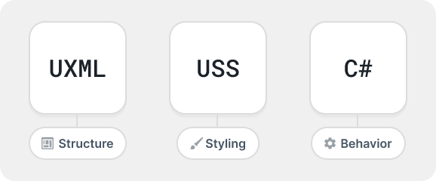Relationship between UI assets and C# code

UXML
UXML is a markup language inspired by HTML and XML that defines UI structure and reusable templates. While you can build UI in C#, using UXML is recommended.

USS
USS are style sheets that apply visual styles and layout rules to UI. Similar to CSS, USS supports a subset of standard CSS properties. While you can define styles in C#, using USS is recommended.

Retained mode architecture
UI Toolkit operates in a retained mode architecture, which means the UI builds a hierarchical structure and maintains it in memory. The framework handles rendering and updates to the UI based on the state of that tree. Here’s what retained mode means in detail:

Declarative structure
UI components are defined and managed as objects or nodes within a visual tree

. Visual tree is an object graph made of lightweight nodes that holds all the elements in a window or panel. It defines every UI built with UI Toolkit. You declare the UI structure once, UI Toolkit takes care of rendering and updates based on the changes to the tree.
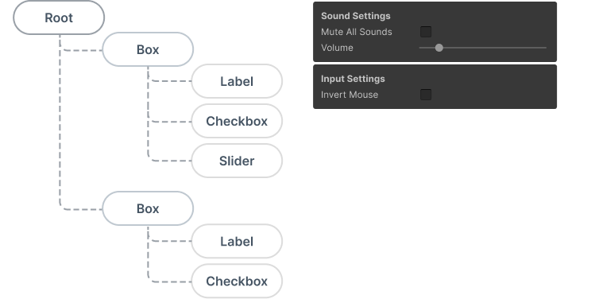Visual tree example

State persistence
The UI elements in retained mode persist in memory after creation. You can modify their properties, and UI Toolkit reflects changes in the next rendering cycle. For example, if you have a button, you don’t need to redraw it manually. Updating its properties, such as position or appearance, is enough. The system handles the rest.

Event handling
Events such as clicks, drags, or key presses are routed automatically to the appropriate visual elements

in the tree. You attach handlers to UI elements, UI Toolkit propagates events appropriately.

Data binding
UI Toolkit supports a data binding system that allows you to link properties of UI elements to data sources. This means that when the data changes, the UI updates automatically, and vice versa. This is similar to how frameworks like React or Angular handle data binding in web development.
Data binding example

Layout engine
UI Toolkit uses a layout engine based on the CSS Flexbox model. This lets you to define how UI elements are positioned and sized within their parent containers. The layout engine automatically calculates the size and position of elements based on their properties, making it easier to create responsive designs.
Use flex properties for efficient space distribution, easy reordering, and absolute positioning of elements. The layout engine also supports alignment, justification, wrapping, and much more.
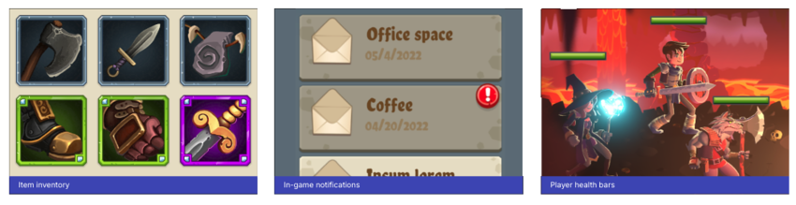Flexbox layout examples

Library of UI controls
UI Toolkit provides a rich library of standard UI controls that you can use to build your interfaces, such as buttons, toggles, and list and tree views. You can use them as is, customize them, or create your own controls.
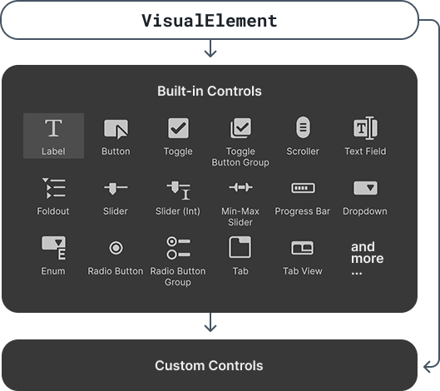Standard UI controls

Text and fonts
UI Toolkit supports a text system that allows you to work with fonts, styles, and text elements. You can use system fonts or import custom fonts, and apply styles such as bold, italic, or underline. The text system is designed to work seamlessly with the layout engine, ensuring that text flows correctly within your UI.
Text and fonts example

Support for Editor and runtime UI
UI Toolkit lets you create a UI that works seamlessly in both Editor and runtime UI. The same UI elements, styling, and layout system apply across both scenarios, reducing duplication and ensuring consistency. Whether you’re building in-game menus, heads-up displays (HUDs), or custom Editor tools, UI Toolkit provides the capability to adapt your UI for different contexts.
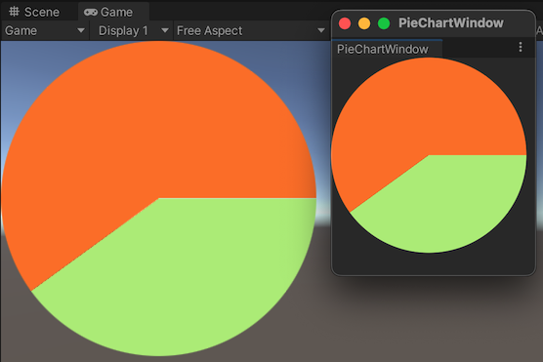A pie chart appears in both the scene and an Editor window.

UI tools and resources
UI Toolkit provides a set of tools and resources to help you design, develop, and debug your UI.

UI Debugger
UI Debugger is a diagnostic tool that resembles a web browser’s debugging view. Use it to explore a hierarchy of elements and get information about their underlying UXML structure and USS styles.
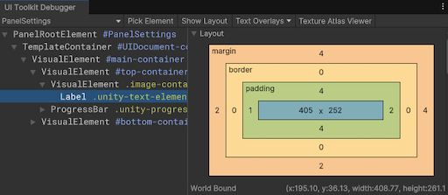UI Debugger example

UI Builder
UI Builder is a visual authoring tool that lets you create and edit UXML and USS files. You can design your UI visually, drag and drop elements, and customize styles without writing code.
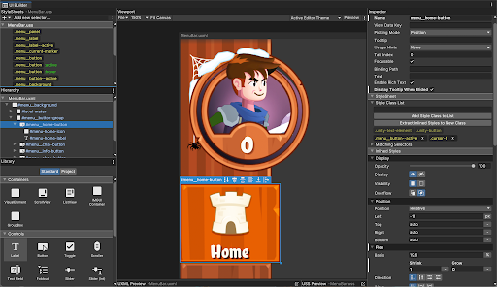UI Builder example

UI samples
A library of code samples for UI controls that you can view in the Editor under Window > UI Toolkit > Samples.
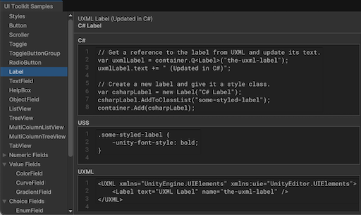UI Toolkit samples

Roles and responsibilities
In a studio, UI Toolkit can be used across different disciplines, with each role contributing to specific parts of the process.

UX/UI Designers
UX/UI designers are responsible for the overall look and feel of the UI. They create wireframes, mockups, and prototypes to define the user experience.
Designers use UI Builder to visually design the UI and create UXML and USS files for structure and styling.

Developers
Developers implement the behavior of the UI and integrate it with game or editor logic. They work closely with designers to ensure that the UI meets the design specifications and functions correctly.
Developers use C# to create custom functionality, handle user interactions, and bind data. They also use UI Toolkit’s API to interact with the UI controls created by designers and to develop custom UI controls that designers can use and customize in their designs.

Technical Artists
Technical artists often act as a bridge between designers and developers. They ensure that the visual assets are optimized for performance and integrate well with the UI.
Technical artists assist in creating USS styles and troubleshooting issues that arise during development.

QA/Testing
QA/testers test the UI to ensure it functions correctly and meets design specifications.
Testers use the UI Debugger to inspect the UI hierarchy and verify interactions.

Additional resources
- Get started with UI Toolkit
- UI Toolkit examples

Get started with UI Toolkit

Get started with UI Toolkit
Want to create your first UI with UI Toolkit? Use this basic UI Toolkit workflow example to get started.
Note: For demonstration purposes, this guide describes how to add UI controls for the Editor UI. However, the instructions on adding UI controls to a UI Document also apply to runtime UI. For more information, refer to Get started with runtime UI.
If you perform a specific task often, you can use UI Toolkit to create a dedicated UI for it. For example, you can create a custom Editor window. The example demonstrates how to create a custom Editor window and add UI controls into your custom Editor window with UI Builder, UXML, and C# script.
You can find the completed files that this example creates in this GitHub repository.

Create a custom Editor window
Create a custom Editor window with two labels.
- Create a project in Unity Editor with any template.
- In the Project window, right-click in the Assets folder, and then select Create > UI Toolkit > Editor Window.
- In UI Toolkit Editor Window Creator, enter SimpleCustomEditor in the C# box.
- Keep the UXML checkbox selected and clear the USS checkbox.
- Select Confirm.
- To open the Editor window, select Window > UI Toolkit > SimpleCustomEditor.
You can find the source files for it in the Assets/Editor folder.

Add UI controls to the window
You can add UI controls to your window in the following ways:
- Use the UI Builder to visually add the UI controls
- Use an XML-like text file (UXML) to add the UI controls
- Use C# script to add the UI controls
You can use any of these methods individually, or combine. The following examples create three sets of labels, buttons, and toggles with a combination of these methods.

Use UI Builder to add UI controls
To visually add UI controls to your window, use UI Builder. The following steps add a button and a toggle into your custom Editor window in addition to the default label.
- In the Editor folder, double-click SimpleCustomEditor.uxml to open the UI Builder.
- In the UI Builder, drag Button and Toggle from Library > Controls into the Hierarchy or the window preview in the Viewport.
- In the Hierarchy window, select Label.
- In the Inspector

- window, change the default text to These controls were created in UI Builder in the Text field.
- In the Hierarchy window, select Button.
- In the Inspector window, enter This is button1 in the Text field.
- Enter button1 in the Name field.
- In the Hierarchy window, select Toggle.
- In the Inspector window, enter Number? in the Label field.
- Enter toggle1 in the Name field.
- Save and close the UI Builder window.
- Close your custom Editor window if you haven’t done so.
- In the Project window, select SimpleCustomEditor.cs and make sure the Visual Tree Asset is set to SimpleCustomEditor (Visual Tree Asset) in the Inspector window.
- Select Window > UI Toolkit > SimpleCustomEditor to re-open your custom Editor window to see the button and the toggle you just added.
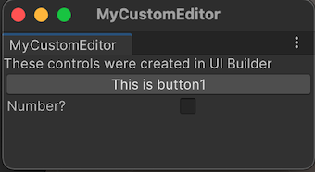Custom Editor Window with one set UI Controls

Use UXML to add UI controls
If you prefer to define your UI in a text file, you can edit the UXML to add the UI controls. The following steps add another set of label, button, and toggle into your window.
- In the Editor folder, select Assets > Create > UI Toolkit > UI Document to create a UXML file called SimpleCustomEditor_UXML.uxml.
- Select the arrow on SimpleCustomEditor_UXML.uxml in the Project window.
- Double-click inlineStyle to open SimpleCustomEditor_UXML.uxml in a text editor.
- Replace the contents of SimpleCustomEditor_uxml.uxml with the following:
<ui:UXML xmlns:ui="UnityEngine.UIElements" xmlns:uie="UnityEditor.UIElements" xsi="http://www.w3.org/2001/XMLSchema-instance" engine="UnityEngine.UIElements" editor="UnityEditor.UIElements" noNamespaceSchemaLocation="../../UIElementsSchema/UIElements.xsd" editor-extension-mode="False">
<ui:Label text="These controls were created with UXML." />
<ui:Button text="This is button2" name="button2"/>
<ui:Toggle label="Number?" name="toggle2"/>
</ui:UXML>

- Open SimpleCustomEditor.cs.
- Import the UXML file you created manually by adding the following to the CreateGUI method:
// Import UXML created manually.
var visualTree = AssetDatabase.LoadAssetAtPath<VisualTreeAsset>("Assets/Editor/SimpleCustomEditor_uxml.uxml");
VisualElement labelFromUXML = visualTree.Instantiate();
root.Add(labelFromUXML);

- Save your changes.
- Select Window > UI Toolkit > SimpleCustomEditor. This opens your custom Editor window with three labels, two buttons, and two toggles.
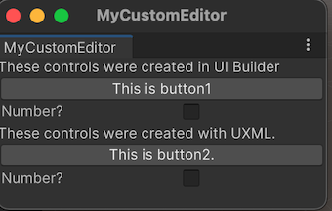Custom Editor Window with two sets UI Controls

Use C# script to add UI controls
If you prefer coding, you can add UI Controls to your window with a C# script. The following steps add another set of label, button, and toggle into your window.
- Open SimpleCustomEditor.cs.
- Unity uses UnityEngine.UIElements for basic UI controls like label, button, and toggle. To work with UI controls, you must add the following declaration if it’s not already present.
using UnityEngine.UIElements;

- Change the text of the existing label from "Hello World! From C#" to "These controls were created using C# code.".
- The EditorWindow class has a property called rootVisualElement. To add the UI controls to your window, first instantiate the element class with some attributes, and then use the Add methods of the rootVisualElement.
Your finished CreateGUI() method looks like the following:
public void CreateGUI()
{
// Each editor window contains a root VisualElement object
VisualElement root = rootVisualElement;

// VisualElements objects can contain other VisualElements following a tree hierarchy.
Label label = new Label("These controls were created using C# code.");
root.Add(label);

Button button = new Button();
button.name = "button3";
button.text = "This is button3.";
root.Add(button);

Toggle toggle = new Toggle();
toggle.name = "toggle3";
toggle.label = "Number?";
root.Add(toggle);

// Instantiate UXML created automatically which is set as the default VisualTreeAsset.
root.Add(m_VisualTreeAsset.Instantiate());

// Import UXML created manually.
var visualTree = AssetDatabase.LoadAssetAtPath<VisualTreeAsset>("Assets/Editor/SimpleCustomEditor_uxml.uxml");
VisualElement labelFromUXML = visualTree.Instantiate();
root.Add(labelFromUXML);
}

- Select Window > UI Toolkit > SimpleCustomEditor to open your custom Editor window to see three labels, three buttons, and three toggles.
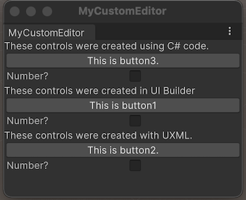Custom Editor Window with three Controls

Define the behavior of your UI controls
You can set up event handlers for your UI controls so that when you click the button, and select or clear the toggle, your UI controls perform some tasks.
In this example, set up event handlers that:
- When a button is clicked, the Editor Console displays a message.
- When a toggle is selected, the Console shows how many times the buttons have been clicked.
Your finished SimpleCustomEditor.cs looks like the following:
using UnityEditor;
using UnityEngine;
using UnityEngine.UIElements;

public class SimpleCustomEditor : EditorWindow
{
[SerializeField]
private VisualTreeAsset m_VisualTreeAsset = default;

[MenuItem("Window/UI Toolkit/SimpleCustomEditor")]
public static void ShowExample()
{
SimpleCustomEditor wnd = GetWindow<SimpleCustomEditor>();
wnd.titleContent = new GUIContent("SimpleCustomEditor");
}

private int m_ClickCount = 0;

private const string m_ButtonPrefix = "button";

public void CreateGUI()
{
// Each editor window contains a root VisualElement object
VisualElement root = rootVisualElement;

// VisualElements objects can contain other VisualElement following a tree hierarchy.
Label label = new Label("These controls were created using C# code.");
root.Add(label);

Button button = new Button();
button.name = "button3";
button.text = "This is button3.";
root.Add(button);

Toggle toggle = new Toggle();
toggle.name = "toggle3";
toggle.label = "Number?";
root.Add(toggle);

// Instantiate UXML created automatically which is set as the default VisualTreeAsset.
root.Add(m_VisualTreeAsset.Instantiate());

// Import UXML created manually.
var visualTree = AssetDatabase.LoadAssetAtPath<VisualTreeAsset>("Assets/Editor/SimpleCustomEditor_uxml.uxml");
VisualElement labelFromUXML = visualTree.Instantiate();
root.Add(labelFromUXML);

//Call the event handler
SetupButtonHandler();
}

//Functions as the event handlers for your button click and number counts
private void SetupButtonHandler()
{
VisualElement root = rootVisualElement;

var buttons = root.Query<Button>();
buttons.ForEach(RegisterHandler);
}

private void RegisterHandler(Button button)
{
button.RegisterCallback<ClickEvent>(PrintClickMessage);
}

private void PrintClickMessage(ClickEvent evt)
{
VisualElement root = rootVisualElement;

++m_ClickCount;

//Because of the names we gave the buttons and toggles, we can use the
//button name to find the toggle name.
Button button = evt.currentTarget as Button;
string buttonNumber = button.name.Substring(m_ButtonPrefix.Length);
string toggleName = "toggle" + buttonNumber;
Toggle toggle = root.Q<Toggle>(toggleName);

Debug.Log("Button was clicked!" +
(toggle.value ? " Count: " + m_ClickCount : ""));
}
}

Test the example
- From the menu, select Window > UI Toolkit > SimpleCustomEditor.

Additional resources
- UXML
- Visual Tree

- Label
- Button
- Toggle

- Create a custom Editor window

UI Builder

UI Builder
UI Builder lets you visually create and edit UI assets, such as UI Documents (.uxml), and StyleSheets (.uss), that you use with UI Toolkit.
You can also install the following optional packages that offer additional functionality in UI Builder:
- The com.unity.vectorgraphics package allows you to assign a VectorImage as a background style on an element.
- The com.unity.2d.sprite package allows you to assign a 2D Sprite

- asset (or sub-asset) as a background style on an element. With the 2D Sprite package installed, you can also open the 2D Sprite Editor directly from the Inspector

- pane.
Topic | Description
UI Builder interface overview | Understand the UI Builder interface.
Get started with UI Builder | Understand the workflow to create UI in UI Builder by an example.
Work with elements | Learn how to structure UI controls in your project.
Use UXML instances as templates | Learn how to use existing UXML Documents as templates inside your UXML Documents in UI Builder.
Style UI with UI Builder | Learn how to create and manage USS styles, how to use USS selectors and variables, and how to position elements and set background images.
Assign USS variables in UI Builder | Learn how to assign and remove a USS variable in UI Builder.
Test UI | Debug your styles and test inside the UI Builder.

Additional resources
- Get started with UI Toolkit
- Get started with runtime UI
- Structure UI with UXML
- Style UI with USS

Tab 7

