Guide for Gaining Access to Army Skillport and Completing your Computing Environment Section of ATCTS

Contents

To gain access to Army Skillport do these 4 things 1

To complete an item for the Computing Environment section of ATCTS do these 4 things 2

# To gain access to Army Skillport do these 4 things

1. Verify if you have an existing account
   1. <https://usarmy.skillport.com/skillportfe/custom/login/usarmy/login.action>
   2. Tip: Use your AKO username not your mail.mil username
   3. Tip: Use Chrome or Firefox to access Army Skillport
2. If you have an account and can log in jump to the section for completing a computing environment If not proceed to step 3.
3. Fill out the Skillport account request form
   1. 
   2. Fill out the full form above including updating with your local Government POC, Command, and Location. If you are on KX01 or KX03 leave this as in the example.
   3. The Gov Lead must Sign the form and must email the form to [ciog-6.netcomiawip.inbox@mail.mil](mailto:ciog-6.netcomiawip.inbox@mail.mil). Ask them to CC you on it as it goes out so you can track
   4. If you don’t get an email for access to you mail.mil within 4-5 working days reach out to your GOV lead again
   5. NOTE: Do not submit this form with the button in the form it must be emailed by the government lead for contractor accounts.
   6. NOTE: If you don’t know your AKO username log in and check it before you submit the form. If you don’t have an AKO username then use first.last but the risk of account setup issues is higher
   7. NOTE: Per Adam, your ATCTS portal must show you on orders for IAT or IAM to be granted a new account.
4. Log into your account and download the app
   1. <https://usarmy.skillport.com/skillportfe/custom/login/usarmy/login.action>
   2. Download the app following this guide
   3. NOTE: Site name is usarmy
   4. NOTE: App is great for the books and videos but NETCOM specific courses are not usable

# To complete an item for the Computing Environment section of ATCTS do these 4 things

1. Verify if you already have an applicable Computing Environment training or certification.
   1. Log into ATCTS (<https://atc.us.army.mil/iastar/profile/index.php>) from IE (CAC needed)
   2. Look at the “Computing Environment Certifications/Training” section
      1. 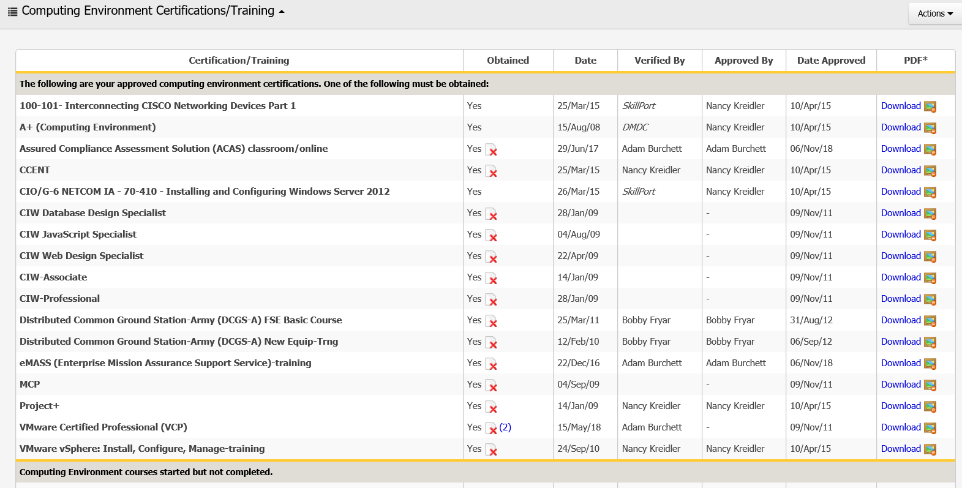
   3. Is there an item in the list that is still valid for the type of admin that you hold? In short if you hold admin for a specific technology you must have something in this section for that technology. Most commands require that you have at least 1 but not all. Other commands are stricter. For example; eMASS, HBSS, and ACAS you must have the exact training even if you hold another training that would otherwise qualify your account request may be denied if it is not in your ATCTS profile
      1. BAD Example: You don’t see anything in the list. You must get an item in the approved section of the “Computing Environment Certifications/Training” section. Skip to the next section
      2. BAD Example: If you have admin rights to a Microsoft Windows Server 2016 and only to a 2016 Server while you hold the 70-410 training then you must upgrade to the current 2016 training. Skip to the next section
      3. PARTIAL Example: If you have admin rights to a Microsoft Windows Server 2016 and to a 2012R2 server while you hold the 70-410 training then you must MAY need update to the current 2016 training. Skip to the next section
      4. GOOD Example: If you have admin rights to a CISCO switch and you have the CCENT or the 100-101 course. Mission complete. Check Skillport for continuing education opportunities to keep your CompTIA or (ISC)2 baseline certification up to date.
      5. GOOD Example: If you have admin rights to a RedHat Server and you have the RHCSA course. Mission complete. Check Skillport for continuing education opportunities to keep your CompTIA or (ISC)2 baseline certification up to date.
      6. BEST Example: If you have admin rights to a RedHat Server and you have the RHCSA course, AND If you have admin rights to a 2012R2 Server and you have the 2012R2 course, AND if you have admin to the VMware ESXi/VCSA and have the VCP course. Mission complete. Check Skillport for continuing education opportunities to keep your CompTIA or (ISC)2 baseline certification up to date.
2. Choose a training course in Army SkillPort applicable to the type of admin you have.
   1. First and foremost always approve any training plan you have with your manager to ensure you are charging training time to the appropriate charge codes and are meeting management intent for training.
   2. Log into Army Skillport (<https://usarmy.skillport.com/skillportfe/custom/login/usarmy/login.action>) from Chrome or FireFox
   3. Choose Browse the library
      1. 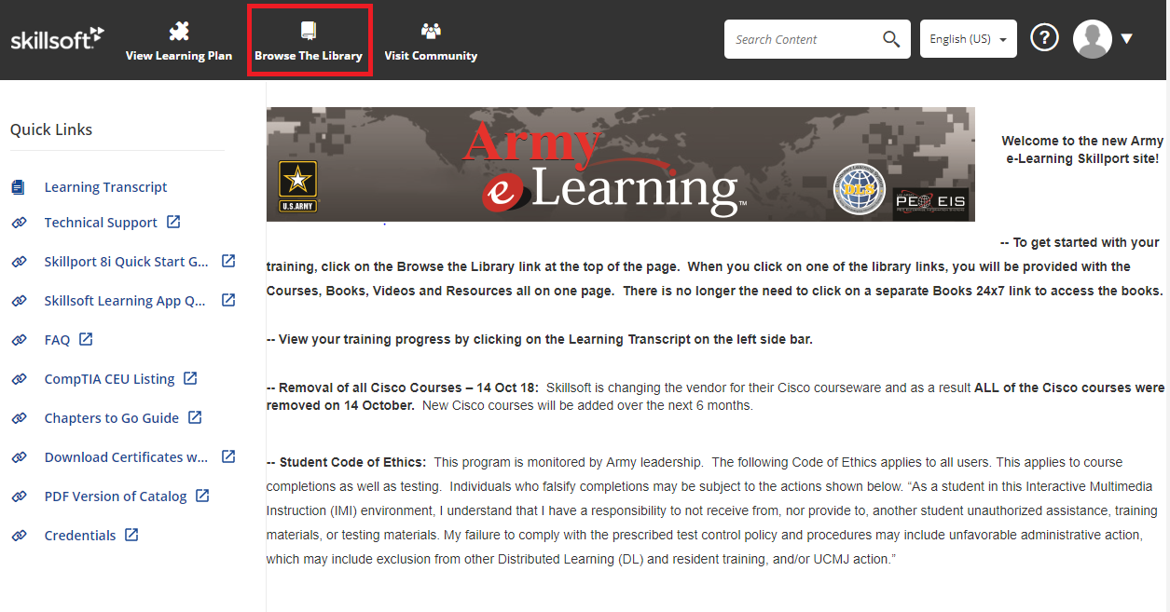
   4. Choose the “Computing Environment Training” Section
      1. 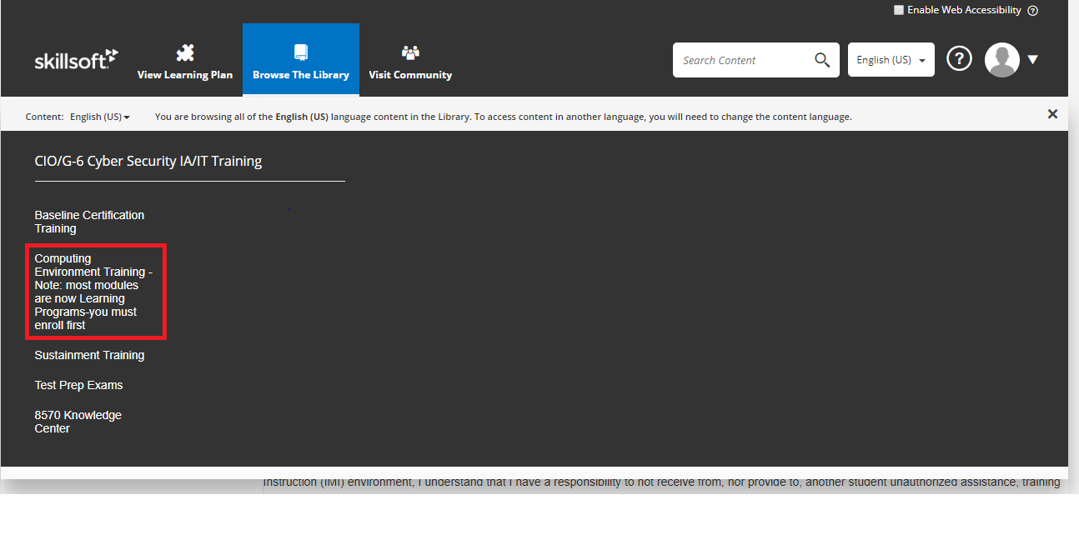
   5. Choose a vendor category on the side menu
      1. 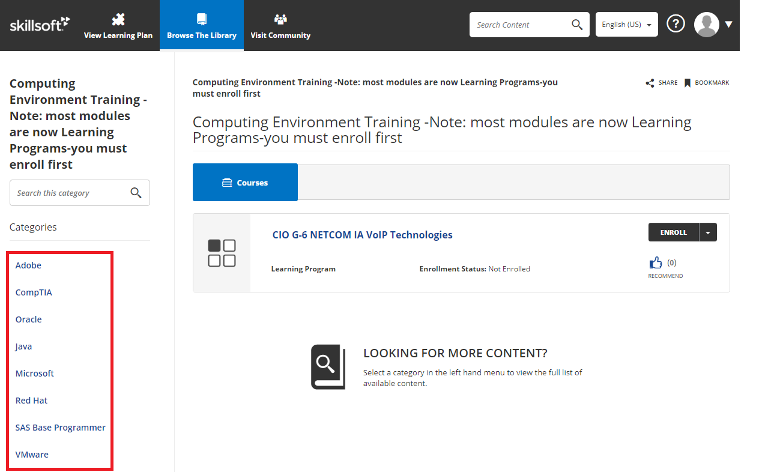
   6. Choose a Technology Category (Microsoft example)
      1. 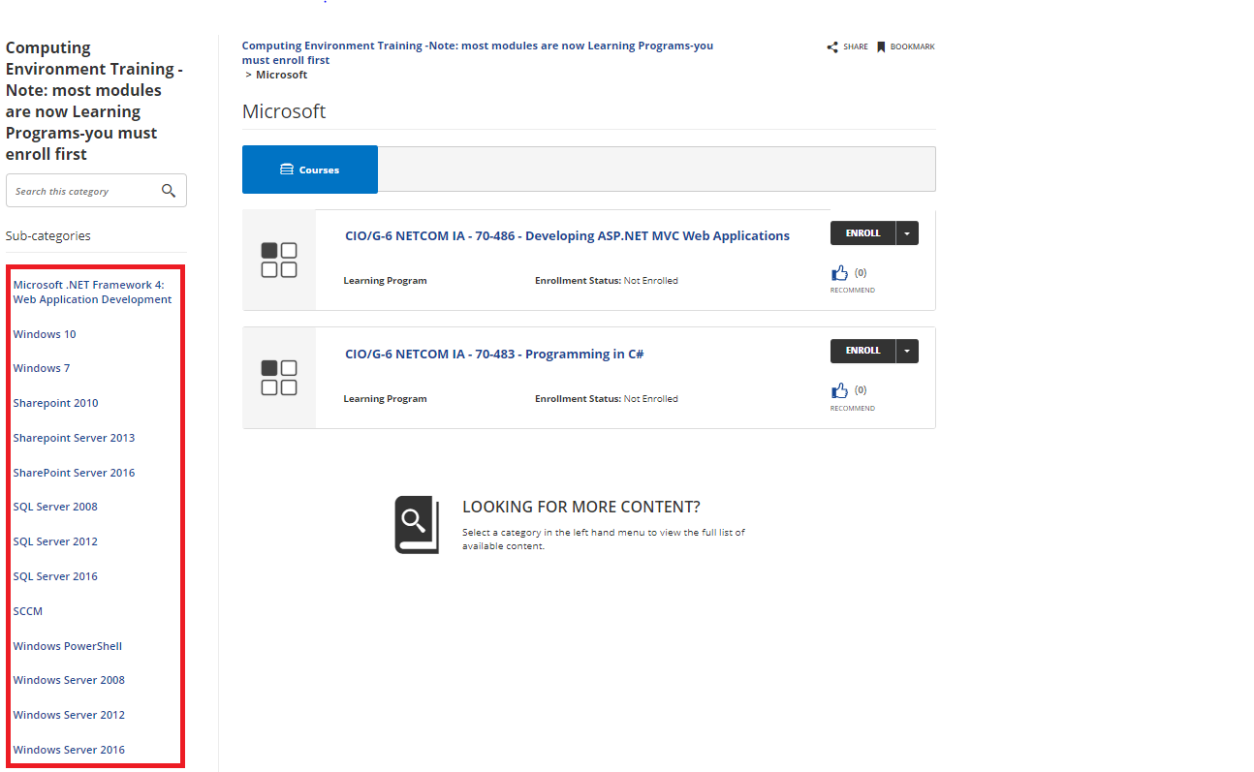
   7. Enroll in a course (Microsoft Windows 10 Example)
      1. 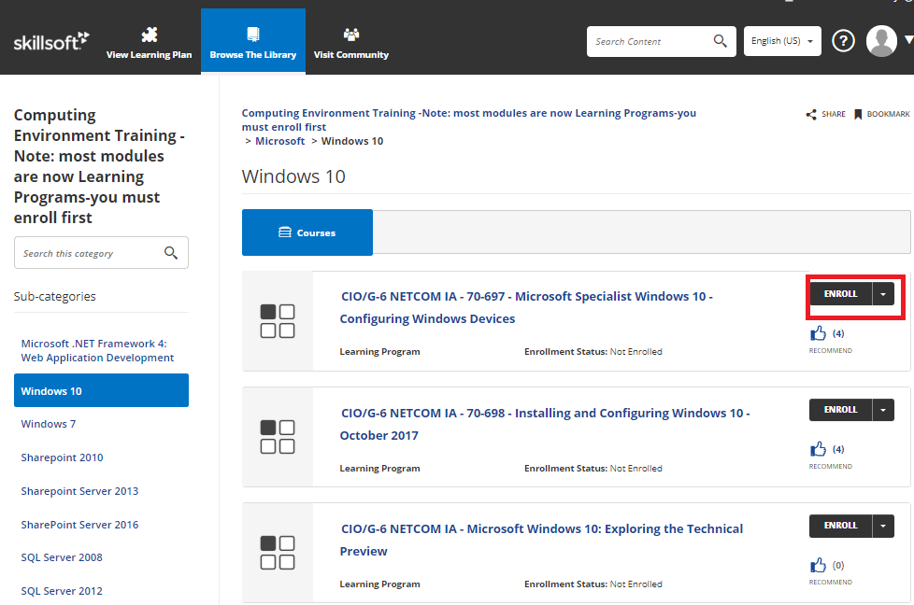
3. Complete the full course including all sub modules then check your training transcript
   * 1. 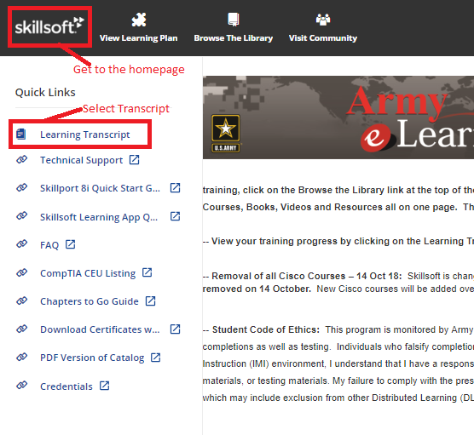
   1. Download your course completion certificate
      1. 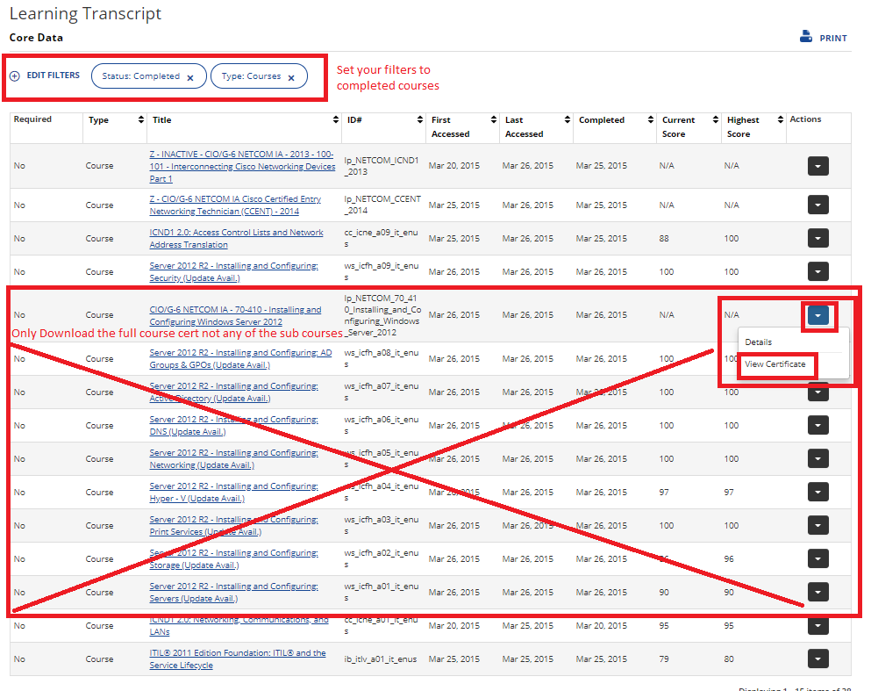
4. Email your certification to your contracts training manager or PM and upload it to ATCTS once it has been added and verified by skillport