

[@clarkfennell](http://www.twitter.com/clarkfennell)

[@clarkfennell](http://ww.instagram.com/clarkfennell)



07709 019 664

clarkfennell@mac.com





[clarkfennell.github.io](https://clarkfennell.github.io/)

[linkedin.com/in/clark-fennell-5b308672](http://www.linkedin.com/in/clark-fennell-5b308672)

Clark Fennell

Developer

Education

* Codecademy.com ([www.codecademy.com](http://www.codecademy.com))

*Full Stack Developer Course* **2018**

* LinkedIn Learning ([www.lynda.com](http://www.lynda.com/))

*JavaScript Essential Training* **2019**

*CSS: Advanced Layouts with Grid* **2019**

*PHP 7 New Features* **2019**

*GIT Essential Training* **2019**

*HTML Essential Training* **2019**

*CSS Essential Training* **2019**

* Brentwood Grammar School

*A levels* **2005 -2007**

*Physics*

*ICT*

*Computer Science*

*Graphic Design*

*GCSE* **2000 – 2005**

*Biology English Literature*

*Chemistry English Language*

*Physics R.E.*

*Maths French*

*ICT Graphics*

Experience

* Hydra Creative ([www.hydracreative.com](http://www.hydracreative.com))

*Web Developer* **2018 – Present**

* Shaping Success North ([www.et-foundation.co.uk](http://www.et-foundation.co.uk/))

*ICT Administration Officer (Freelance)* **2017 – 2018**

* Bear Jokes Clothing

*Owner/Designer/Marketing Manager* **2009 – 2012**

* Footstools Direct ([www.footstoolsdirect.com](http://www.footstoolsdirect.com))

*ICT Specialist (Freelance)* **2017 – 2018**

* Cheaney Shoes ([www.cheaney.co.uk)](http://www.cheaney.co.uk/)

*Store Manager* **2016 – 2017**

* BCBG MAXAZRIA ([www.bcbg.com](http://www.bcbg.com/))

*Concessions Manager*  **2016**

* Fred Perry ([www.fredperry.com](http://www.fredperry.com/))

*Merchandiser* **2014 – 2016**

*Store Manager* **2012 - 2014**

* Choice Design ([www.choicestore.co.uk](http://www.choicestore.co.uk/))

*Supervisor* **2009 – 2012**

* Bosco ([www.bosco.co.uk](http://www.bosco.co.uk))

*Floor Manager* **2012**

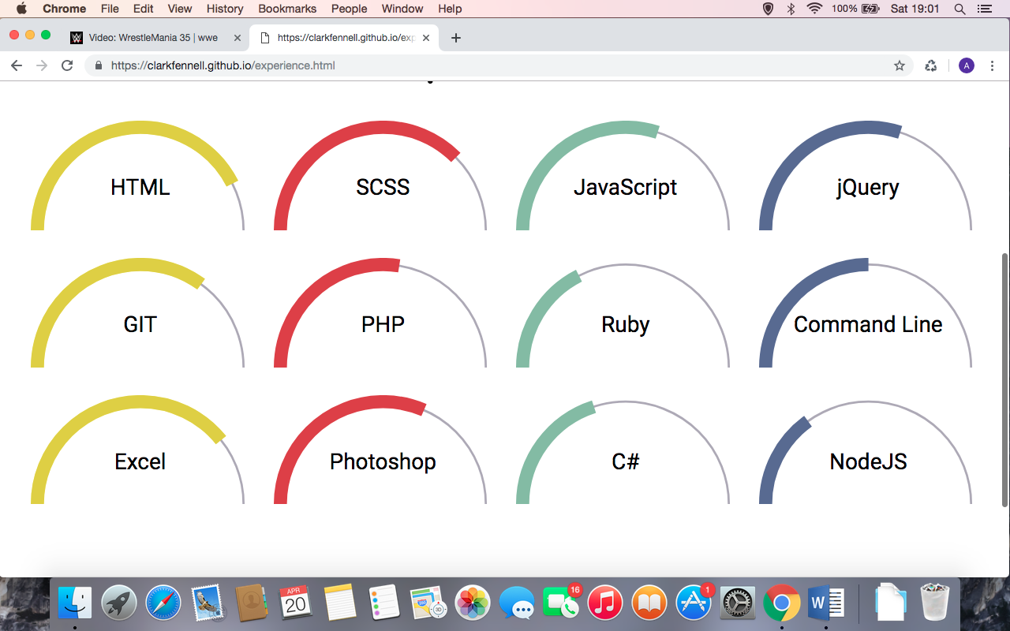Knowledge