PE05: Programming Exercise
Clustering Methods and PCA
- In this programming exercise, you will analyze a dataset using the k-means clustering algorithm.
- Dataset: mtcars.csv is provided with this assignment. This original mtcars dataset holds specifications for different car models.
- Tools: Jupyter notebook.
- A very basic Jupyter notebook file is provided but you will have to fill it all in
Step 0: Install and load Python libraries.
- Import all the relevant Python libraries required to conduct K-Means clustering
Step 1: Load the dataset and Explore the data.
- Load the mtcars.csv dataset into a dataframe df.
- Drop all columns except ['car_model' ,'mpg', 'hp']
- Study the dataset by using the usual Python/pandas functions for a dataset.
  - Describe what you see based on the functions used.
  - Note that one of the columns contains characters (non-numeric) data.
- Create a new dataframe called cars to hold numeric data only:
  - You want to drop the non-numeric column to prepare the data for K-means.
  - Confirm cars contains numeric values only.
Step 2: Use k-means algorithm to find clusters in the data.
- First normalize the cars dataset to ensure attributes with large values do not skew the results.
  - confirm the normalization by showing the 10 top instances in the notebook.
- Next, run the k-means for k=3, k=10, and k=20, store the models in km3, km10, and km20 respectively.
  - Set the random seed to 42.
  - For each of the three models, print
    - The predictions (y_pred) for data
    - The cluster centers.
- Use a scatter plot to visualize the clusters based on mpg and hp in the dataset.
  - For each of the three models (k=3, k=10, and k=20)
    - Show a different scatter plot including the centroids found above.
- Which of k=3, k=10, and k-20 provide the best clusters for this given pair of features? Explain.
Step 3: Repeat steps 1 to 3 but with all the features and plot the new clusters (step 2.3) and their centers. You do not need to print or show any other information. Use this new data and clusters in the following steps.
Step 4: Finding the optimal k for k-means:
- In the textbook, there is a discussion of the elbow method which makes it possible to pick an optimal value for k. an alternate method is to perform a grid search as demonstrated in the follow code snippet:
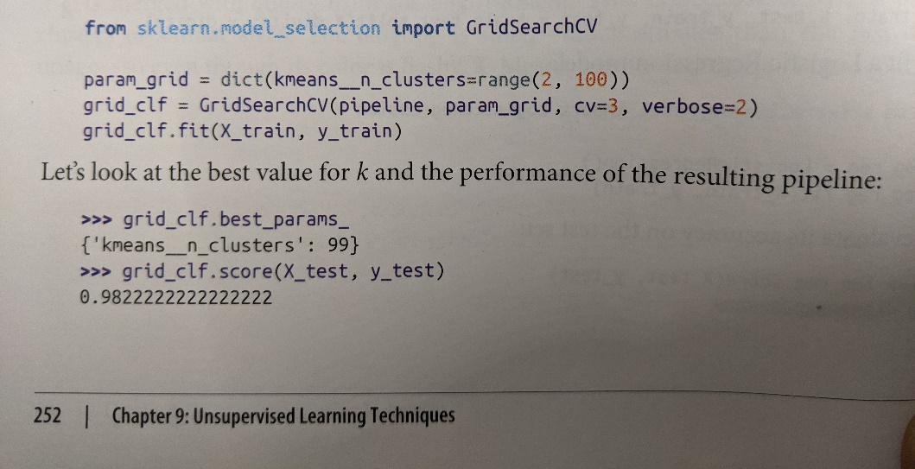

- Perform a grid search to produce k-means models for k=1 to k=20
  - What is the optimal value for k (kmeans_n_cluster)?
  - What is the model score for the optimal k?

Step 5: Dimensionality Reduction – Principal Component Analysis:
- After determining the number of clusters in the cars dataframe, we are now going to determine the optimal number of features (dimensions) that describes the variance in the dataset using Principal component Analysis (PCA).
  - Refer to the section in the textbook Chapter 8 titled Choosing the Right Number of Dimensions

- Assuming we are selecting an explained variance of 95%, derive the minimum number of dimensions required to preserve 95%of the dataset variance. Hint: use the code example in the textbook.
  - What is the dimension d?
  - The dataset started with 11 dimensions, is d a significant dimensionality reduction?
  - What are the benefits of this dimensionality reduction?
  - What are possible disadvantages of dimensionality reduction?
- Using the additional code snippet in the textbook (same section), derive the X_reduced dataframe.
  - Print it in your notebook.
- Plot the Explained Variance vs Dimensions curve (see figure 8.8 in chapter 8)
  - Label the plot with “Dimensions” and “Explained Variance”.
  - Visualize the 0.95 point corresponding to the calculated reduced dimension d.

- Save all your answers, relevant function outputs and plots in a single notebook.
- Submit the notebook file to your instructor.

