PE01: Programming Exercise

In this programming exercise, we cover the machine learning process by using Google's Teachable Machine.
The teachable Machine is a great tool that gives use access to an online image classifier using either pictures or live video, a sound classifier, and a body pose classifier.

1) Go to https://teachablemachine.withgoogle.com/ and read about the Teachable Machine. Read the tutorials and do aa bit of research to find out how people are applying the tool.

2) What are the three simple steps involved in training a model on the teachable Machine webpage? (3 points)

3) Watch the video describing the three steps. Summarize what you have learned in the videos. (6 points)

4) You are now going to train your own model.
- Select New Project in the top left corner menu.
- Select Image Project.
- Using what you have learned from reading the previous webpage and watching the video, train your own image classifier using at least two different classes.
- Keep it simple for now. make it interesting.
- For example, you could train images or video captures of people with masks and without masks to see if the trained model can classify new pictures or videos correctly.

- Describe in detail what you decided to classify. What practical problem would this classifier solve or address? How many classes your model will classify? (10 points)

5) Once you are done training the model, test it with live video or uploaded pictures. How well does did the model perform? (1 point).

6) How many samples did you gather for each class? How distinct were those images? Comment on what could be changed to make the model perform better. (5 points)

7) Select Export model and choose the TensorFlow tab to download the python code using TensorFlow Keras.
Download it to your computer ("click on download my model"). You will provide this python script along with answers to the questions above.

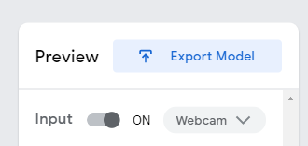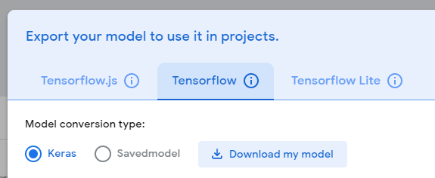

8) Note that you can run the python script to do inference on test images. You just need to make sure that the path and file name for your images is correct in the script. Replace <IMAGE_PATH> with the test image path in your system. See image = Image.open('test_photo.jpg')
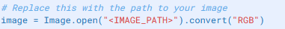

9) Go back to the images you gathered for the training and test them against the model. Note that you can collect new images from each class using the Teaching Machine tool without training them, then download them to your computer.

10) Submit two sample images from each class along with your .h5 Keras model, the python script, and a PDF containing answers to the questions above. Also, submit a screen shot of your trainable machine screen with sample results. Something like the below screenshot, if applicable. (5 points).

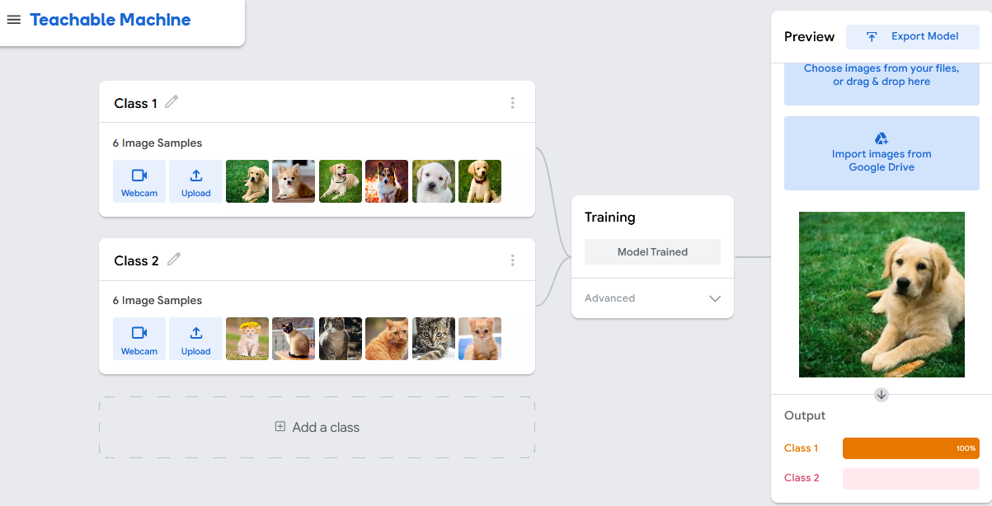

Optional: Go one step further: modify the python script so that it classifies images from a live webcam video. Hint: use the OpenCV or other computer vision packages

