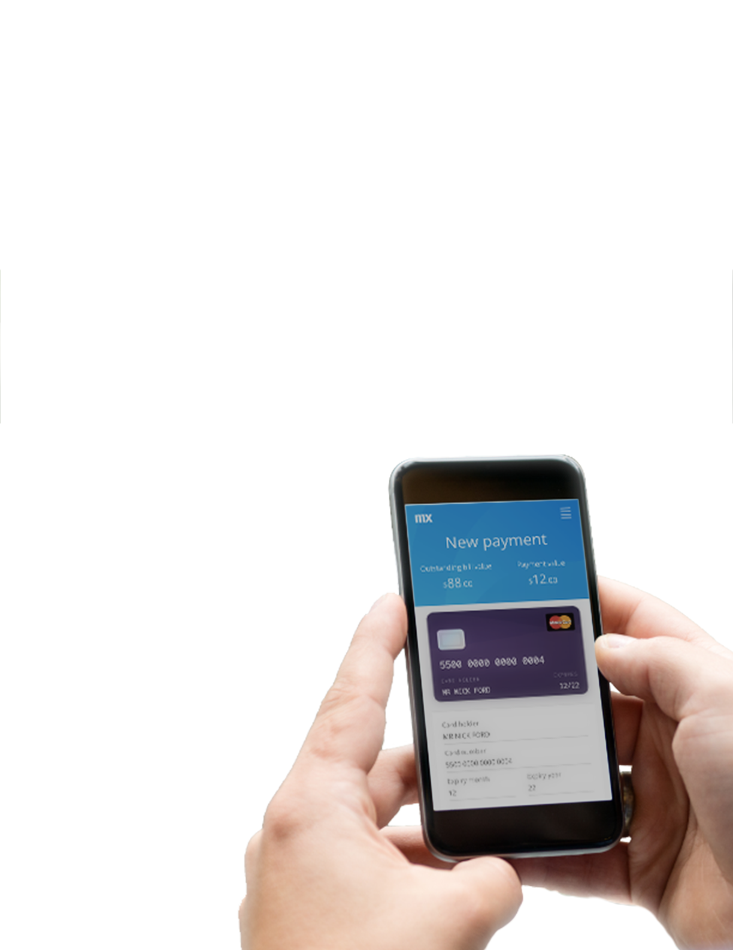

Mendix Classroom Exercise

## Building Apps with the Web Modeler

**Introduction and Getting Familiar with Mendix**

1. Introduction to Mendix low-code application development platform
2. Sign up for free to start building:
   1. Visit www.mendix.com and click the green ‘Start for free’ button in top right corner
   2. A sign-up form will generate; use your university email address and school name as the company name
   3. Create your password considering these rules: 8+ characters, upper and lowercase, number and symbol required
3. Follow the account confirmation link sent to your email which will bring you to sprintr.home.mendix.com
   1. This page is the Collaboration Portal where you can see community updates and view a quick list of your apps
4. To move into the Web Modeler, which is the development environment you will use to build your app:
   1. Click the green ‘Create App’ button in the top right
   2. From the Starter Apps tab, select the Event App
   3. Click the green ‘Use this app’ button
   4. You will be prompted to name your app, so choose something unique with your Name in it and click ‘Create App’
   5. It could take a few moments for the app environment to provision. While you wait, let’s discuss why you might want to create an event app – say you belong to a student club and you’ve been approved to host a week-long speaker series featuring alumni and prominent industry speakers. You need to create an app to organize the event and you need a working prototype by tomorrow to show your advisors.
5. When your app is ready, you will be brought to the Collaboration Page for your app, which is where is you can add team members to work on your app with you and post to your discussion board
6. Click the blue ‘Edit App’ button in the top right corner
   1. It could take a few moments for the app environment to provision
7. Now that your app has loaded, let’s take a quick tour of the features you will use:
   1. Along the upper left-hand side, you will see four icons:
      1. The first is the Pages editor where you can see there are already three pre-built pages to work with
      2. The second is the Domain Model editor which brings you to the domain model, or the data structure, of your app, using Unified Modeling Language (UML). Think of this as an Excel file of data. Within the Entity titled ‘ProgramItem’, there are several attributes like FullName, Email, and Description. Think of these as the different columns of data from your Excel file.
      3. The third icon is the Microflows editor. Microflows are the business logic of your app using Business Process Modeling Notation.
      4. Last, the fourth icon is the Navigation editor. The navigation of your app determines the order of pages and sections and how they flow together.
   2. Along the right-hand side of your screen, you’ll see three columns each titled Toolbox, Properties and Buzz. You will be using the first two to build the app today.
      1. The Toolbox is comprised of building blocks and widgets
      2. Properties is where you determine things like the text, spacing and layout
      3. The buzz section is the live discussion thread that is useful when you are working in a group

**Adding data to the Domain Model**

1. Let’s add two new attributes to the domain model. Since this is an event app, you want to have data around the dates and addresses of the various events.
   1. Select the Domain Model editor icon, which is the second icon in the menu on the upper left-hand side
   2. Select the ProgramItem entity so that is it highlighted in an orange border
   3. Click the blue ‘New Attribute’ button underneath the entity
   4. In the Create New Attribute window that opens, name the attribute Date
   5. In the Type field, select ‘Date and Time’ from the drop-down menu
   6. Click ‘Create’ and you’ll see that the Date attribute has been added to your domain model
   7. Again, click the blue ‘New Attribute’ button underneath the entity
   8. In the Create New Attribute window that opens, name the attribute Address
   9. In the Type field, ‘String’ will already be selected
   10. Click ‘Create’ and you’ll see that the Address attribute has been added to your domain model

**Creating Pages and UI**

1. In the top left corner, click the Pages icon and select the ‘Program’ page from the list
2. Let’s add a map and an information card to this page of events. Think of ‘Program’ as another word for ‘Event’. First, you’ll create space for the map and info card to be added.
   1. Click into the white space just above the list of Programs so that the area is highlighted in orange and it says ‘Layout Grid’ along the top border
   2. On the right-hand side of the screen, under Properties, under Expand, you will see an ‘Add Row’ option with up and down arrows
   3. Click the ‘Add Row’ up arrow once to create a new row of space above your Program list
   4. Highlight the new row so that the orange border appears around it and you will see on the right under Properties, under Row Layout, there are layout options for Desktop, Tablet and Phone
   5. Under Desktop, choose the second option on the list which shows the side-by-side layout, choose the same side-by-side layout under Tablet, and under Phone, keep the first vertical layout as the selection
   6. Developing on Mendix allows you to create apps that automatically adapt to all devices and responsive design consideration are built into the platform
3. Now that you’ve created the two new columns for the map and info card to be added, let’s configure them to our data source
   1. Select the first column so the orange border appears around it
   2. On the right-hand side of your screen, select Toolbox, then Widgets, then Data Containers
   3. Click on the Data View widget and drag it over to your first column and drop it into the column with your mouse, the column should now say ‘Data View’ along the orange border
   4. Do the same action for the second column below: select the second column so the orange border appears, go to the right-hand side of your screen and select Toolbox, then Widgets, then Data Containers, and drag and drop the Data View widget you’re your mouse onto the second column
   5. When you select the first column, it will prompt you to select the data source. On the right-hand side under Properties, under Data Source, change the source from ‘Context’ to ‘List Widget’
   6. In the field directly below List Widget, it will prompt you to select the widget, so choose ‘List View with entity ProgramItem’ from the drop-down
   7. Do the same for the second column. When you click on the second column, you will be prompted to select the data source. On the right-hand side under Properties, under Data Source, change the source from ‘Context’ to ‘List Widget’. In the field directly below List Widget, it will prompt you to select the widget, so choose ‘List View with entity ProgramItem’ from the drop-down
4. You are now ready to add the actual map and information card
   1. Select the first column and on the right-hand of the screen go to Properties, then Building Blocks, then click into the Search bar and type the word ‘map’
   2. A number of Map options will come up, scroll down to the Widgets section and under Display, select the first option titled ‘Google Maps’ and drag and drop that map onto the first column
   3. Select the second column and on the right-hand of the screen go to Properties, then Building Blocks, then click into the search bar at type the words ‘card user’
   4. Select the info card that comes up titled ‘Card User’ and drag and drop that card onto the second column
5. Let’s click into the map and resolve the red error message:
   1. When you select the map, go to the right-hand side under Properties, under General, and click into the text field titled ‘Default Center Address’
   2. Type into the name of your city and state (e.g, Denver, CO) into the Default Center Address field
   3. Under Properties, there is a section underneath ‘General’ titled ‘Context’, expand that section
   4. Click into the text field under ‘Address’ where it says ‘Select an Attribute’
   5. From the ‘Select Attribute’ window, choose ‘Address’ from the list and click ‘Select’
   6. Your map will now reflect the address you chose as the default
6. Let’s configure the info card to reflect our data model:
   1. Select the text field for ‘Title’ so that only the word ‘Title’ has the orange border
   2. Under Properties, under General, in the content box, delete the word Title
   3. In the bottom right of the content box, select the ‘Add Attribute’ button
   4. From the Select Attribute pop-up, click on ‘Full Name’ and hit Select
   5. Next, Select the text field for ‘Details’ so that only the word ‘Details’ has the orange border
   6. Under Properties, under General, in the content box, delete the word Details
   7. In the bottom right of the content box, select the ‘Add Attribute’ button
   8. From the Select Attribute pop-up, click on ‘Email’ and hit Select
   9. Next, select the text field with the string of numbers and simply hit delete on your keyboard or using the delete button in the bottom right of your screen, getting rid of that text line entirely
7. Since you created the map and info card to appear at the top of the page when one of the programs is selected from the list, you want to make that list stays static and it doesn’t bring us to another page unnecessarily:
   1. Click into the list so that the entire list is highlighted in orange and it says ‘List View’ along the top
   2. Over on the right under Properties, under Event, you’ll see that the On-click action has ‘Page’ selected
   3. Change the on-click action to the ‘Nothing’ icon. Now your list is static.

**Using microflows to create business logic**

1. There is one more item to configure on the info card you created, and that’s the blue ‘Details’ button:
   1. Select the blue ‘Details’ button on the info card so that it is highlighted in orange
   2. On the right under Properties, under Events, the on-click action is set to ‘Nothing’
   3. You could change the on-click action to the ‘Page’ icon and select the page it moves to, but let’s use this opportunity to create a simple Microflow
   4. Change the on-click action to the ‘Microflow’ icon and in the field below, click in where it says ‘Select Microflow’
   5. Click the ‘New Microflow’ button at the top left of the pop-up window
   6. Name your new microflow ‘ShowPage’, with no spaces between words
   7. You’ll be brought to the Microflow editor where you’ll see the ‘ProgramItem’ entity has already been called and there is already a start point and end point flow ready to be configured
   8. On the right under Properties, under Client Activities, select the icon titled ‘Show Page’
   9. Drag and drop the ‘Show Page’ activity directly between the green start point and the red end point
   10. Select the ‘Show Page’ icon from your microflow so that it is highlighted in orange
   11. On the right under Properties, under Data Source, under Page, you want to click into the field to select the page that button will bring you to
   12. From the Select Page pop-up window, choose ‘ProgramDetail (MyFirstModule) from the list
   13. Below the Page field is a field titled ‘Object to Pass’, click into the field and select ‘ProgramItem’ from the drop-down
   14. Now your ‘Details’ button has been configured to advance to the ProgramDetail page when selected

**Deploy and Interact on Mobile**

1. You are now ready to publish and deploy the app you’ve built:
   1. In the top-right corner of the screen, select the green ‘Publish’ button
   2. It may take a few moments for the app environment to be established, but you will see a message that your app is running and the option to view your app in various formats
   3. Select the ‘View on mobile device’ button in the bottom right of the Publish window
   4. This will generate a QR code which you can use to access the app on your mobile phone by opening your phone’s camera, hovering over the QR code, and following the link that generates to view your app
   5. Viewing the app on your mobile phone, click the hamburger menu in the top left and navigate to the ‘Program Page’. Here you’ll see the map and info card you configured.
   6. Click the ‘Details’ button on the info card. Using the microflow you configured, the button will bring you to the ‘ProgramDetail’ page
   7. Continue to explore the app on your mobile phone

Congrats! You’ve built and deployed your first app on Mendix in no time at all. Please continue to build out this app or any other apps using Mendix. Visit learn.mendix.com to access free training materials and certifications.

Note: this tutorial was published in May 2018 for the Mendix Web Modeler BETA. For updated tutorial and resources, please visit [www.mendix.com/university-program](http://www.mendix.com/university-program).