failurefull <- read_csv("train.csv")

## Rows: 26570 Columns: 26  
## ── Column specification ────────────────────────────────────────────────────────  
## Delimiter: ","  
## chr (4): product_code, attribute_0, attribute_1, failure  
## dbl (22): id, loading, attribute_2, attribute_3, measurement_0, measurement_...  
##   
## ℹ Use `spec()` to retrieve the full column specification for this data.  
## ℹ Specify the column types or set `show_col_types = FALSE` to quiet this message.

**structure and summary**

str(failurefull)

## spc_tbl_ [26,570 × 26] (S3: spec_tbl_df/tbl_df/tbl/data.frame)  
## $ id : num [1:26570] 0 1 2 3 4 5 6 7 8 9 ...  
## $ product_code : chr [1:26570] "A" "A" "A" "A" ...  
## $ loading : num [1:26570] 80.1 84.9 82.4 101.1 188.1 ...  
## $ attribute_0 : chr [1:26570] "material_7" "material_7" "material_7" "material_7" ...  
## $ attribute_1 : chr [1:26570] "material_8" "material_8" "material_8" "material_8" ...  
## $ attribute_2 : num [1:26570] 9 9 9 9 9 9 9 9 9 9 ...  
## $ attribute_3 : num [1:26570] 5 5 5 5 5 5 5 5 5 5 ...  
## $ measurement_0 : num [1:26570] 7 14 12 13 9 11 12 4 9 10 ...  
## $ measurement_1 : num [1:26570] 8 3 1 2 2 4 2 8 6 4 ...  
## $ measurement_2 : num [1:26570] 4 3 5 6 8 0 4 8 5 7 ...  
## $ measurement_3 : num [1:26570] 18 18.2 18.1 17.3 19.3 ...  
## $ measurement_4 : num [1:26570] 12.5 11.5 11.7 11.2 12.9 ...  
## $ measurement_5 : num [1:26570] 15.7 17.7 16.7 18.6 17 ...  
## $ measurement_6 : num [1:26570] 19.3 17.9 18.2 18.3 15.7 ...  
## $ measurement_7 : num [1:26570] 11.7 12.7 12.7 12.6 11.3 ...  
## $ measurement_8 : num [1:26570] 20.2 17.9 18.3 19.1 18.1 ...  
## $ measurement_9 : num [1:26570] 10.7 12.4 12.7 12.5 10.3 ...  
## $ measurement_10: num [1:26570] 15.9 17.9 15.6 16.3 17.1 ...  
## $ measurement_11: num [1:26570] 17.6 17.9 NA 18.4 19.9 ...  
## $ measurement_12: num [1:26570] 15.2 11.8 13.8 10 12.4 ...  
## $ measurement_13: num [1:26570] 15 14.7 16.7 15.2 16.2 ...  
## $ measurement_14: num [1:26570] NA 15.4 18.6 15.6 12.8 ...  
## $ measurement_15: num [1:26570] 13 14.4 14.1 16.2 13.2 ...  
## $ measurement_16: num [1:26570] 14.7 15.6 17.9 17.2 16.4 ...  
## $ measurement_17: num [1:26570] 764 682 663 826 580 ...  
## $ failure : chr [1:26570] "No" "No" "No" "No" ...  
## - attr(*, "spec")=  
## .. cols(  
## .. id = col_double(),  
## .. product_code = col_character(),  
## .. loading = col_double(),  
## .. attribute_0 = col_character(),  
## .. attribute_1 = col_character(),  
## .. attribute_2 = col_double(),  
## .. attribute_3 = col_double(),  
## .. measurement_0 = col_double(),  
## .. measurement_1 = col_double(),  
## .. measurement_2 = col_double(),  
## .. measurement_3 = col_double(),  
## .. measurement_4 = col_double(),  
## .. measurement_5 = col_double(),  
## .. measurement_6 = col_double(),  
## .. measurement_7 = col_double(),  
## .. measurement_8 = col_double(),  
## .. measurement_9 = col_double(),  
## .. measurement_10 = col_double(),  
## .. measurement_11 = col_double(),  
## .. measurement_12 = col_double(),  
## .. measurement_13 = col_double(),  
## .. measurement_14 = col_double(),  
## .. measurement_15 = col_double(),  
## .. measurement_16 = col_double(),  
## .. measurement_17 = col_double(),  
## .. failure = col_character()  
## .. )  
## - attr(*, "problems")=<externalptr>

summary(failurefull)

## id product_code loading attribute_0   
## Min. : 0 Length:26570 Min. : 33.16 Length:26570   
## 1st Qu.: 6642 Class :character 1st Qu.: 99.99 Class :character   
## Median :13284 Mode :character Median :122.39 Mode :character   
## Mean :13284 Mean :127.83   
## 3rd Qu.:19927 3rd Qu.:149.15   
## Max. :26569 Max. :385.86   
## NA's :250   
## attribute_1 attribute_2 attribute_3 measurement_0   
## Length:26570 Min. :5.000 Min. :5.00 Min. : 0.000   
## Class :character 1st Qu.:6.000 1st Qu.:6.00 1st Qu.: 4.000   
## Mode :character Median :6.000 Median :8.00 Median : 7.000   
## Mean :6.754 Mean :7.24 Mean : 7.416   
## 3rd Qu.:8.000 3rd Qu.:8.00 3rd Qu.:10.000   
## Max. :9.000 Max. :9.00 Max. :29.000   
##   
## measurement_1 measurement_2 measurement_3 measurement_4   
## Min. : 0.000 Min. : 0.000 Min. :13.97 Min. : 8.008   
## 1st Qu.: 5.000 1st Qu.: 4.000 1st Qu.:17.12 1st Qu.:11.051   
## Median : 8.000 Median : 6.000 Median :17.79 Median :11.733   
## Mean : 8.233 Mean : 6.257 Mean :17.79 Mean :11.732   
## 3rd Qu.:11.000 3rd Qu.: 8.000 3rd Qu.:18.47 3rd Qu.:12.410   
## Max. :29.000 Max. :24.000 Max. :21.50 Max. :16.484   
## NA's :381 NA's :538   
## measurement_5 measurement_6 measurement_7 measurement_8   
## Min. :12.07 Min. :12.71 Min. : 7.968 Min. :15.22   
## 1st Qu.:16.44 1st Qu.:16.84 1st Qu.:11.045 1st Qu.:18.34   
## Median :17.13 Median :17.52 Median :11.712 Median :19.02   
## Mean :17.13 Mean :17.51 Mean :11.717 Mean :19.02   
## 3rd Qu.:17.80 3rd Qu.:18.18 3rd Qu.:12.391 3rd Qu.:19.71   
## Max. :21.43 Max. :21.54 Max. :15.419 Max. :23.81   
## NA's :676 NA's :796 NA's :937 NA's :1048   
## measurement_9 measurement_10 measurement_11 measurement_12   
## Min. : 7.537 Min. : 9.323 Min. :12.46 Min. : 5.167   
## 1st Qu.:10.757 1st Qu.:15.209 1st Qu.:18.17 1st Qu.:10.703   
## Median :11.430 Median :16.127 Median :19.21 Median :11.717   
## Mean :11.431 Mean :16.118 Mean :19.17 Mean :11.703   
## 3rd Qu.:12.102 3rd Qu.:17.025 3rd Qu.:20.21 3rd Qu.:12.709   
## Max. :15.412 Max. :22.479 Max. :25.64 Max. :17.663   
## NA's :1227 NA's :1300 NA's :1468 NA's :1601   
## measurement_13 measurement_14 measurement_15 measurement_16   
## Min. :10.89 Min. : 9.14 Min. : 9.104 Min. : 9.701   
## 1st Qu.:14.89 1st Qu.:15.06 1st Qu.:13.957 1st Qu.:15.268   
## Median :15.63 Median :16.04 Median :14.969 Median :16.436   
## Mean :15.65 Mean :16.05 Mean :14.996 Mean :16.461   
## 3rd Qu.:16.37 3rd Qu.:17.08 3rd Qu.:16.018 3rd Qu.:17.628   
## Max. :22.71 Max. :22.30 Max. :21.626 Max. :24.094   
## NA's :1774 NA's :1874 NA's :2009 NA's :2110   
## measurement_17 failure   
## Min. : 196.8 Length:26570   
## 1st Qu.: 619.0 Class :character   
## Median : 701.0 Mode :character   
## Mean : 701.3   
## 3rd Qu.: 784.1   
## Max. :1312.8   
## NA's :2284

**Remove ID colum**

failurefull = failurefull %>% select( -id)

## Factor Conversion and reclassification

#I'm going to convert attributes 2 & 3 to factors as well even though they are numeric because I assume all of the attributes are indicative of the material type given the labels on attributes 0 & 1 (i.e. "material_8")   
  
failurefull = failurefull %>% mutate_if(is.character,as_factor)%>%   
 mutate(attribute_2 = as_factor(attribute_2))%>%  
 mutate(attribute_3 = as_factor(attribute_3))%>%  
 mutate(failure = fct_recode(failure, "No" = "0", "Yes" = "1"))

## Warning: Unknown levels in `f`: 0, 1

#Let's explore the values of == 0 for measurements 0, 1, & 2 which shows no missingness.   
  
failurefull %>% filter(measurement_0 == 0)  
  
#538 rows where measurement_0 == 0   
  
failurefull %>% filter(measurement_1 == 0)  
  
#378 rows where measurement_1 == 0   
  
failurefull %>% filter(measurement_2 == 0)  
  
# 418 rows where measurement_2 == 0  
  
#given every other measurement has misssingness and these seem like NA's rather than true zeroes. Let's convert.

## Convert zeroes to NA

failurefull = failurefull %>% mutate(measurement_0 = na_if(measurement_0, "0"))%>%  
 mutate(measurement_1 = na_if(measurement_1, "0"))%>%  
 mutate(measurement_2 = na_if(measurement_2, "0"))

skim(failurefull)

Data summary

|  |  |
| --- | --- |
| Name | failurefull |
| Number of rows | 26570 |
| Number of columns | 25 |
| _______________________ |  |
| Column type frequency: |  |
| factor | 6 |
| numeric | 19 |
| ________________________ |  |
| Group variables | None |

**Variable type: factor**

| skim_variable | n_missing | complete_rate | ordered | n_unique | top_counts |
| --- | --- | --- | --- | --- | --- |
| product_code | 0 | 1 | FALSE | 5 | C: 5765, E: 5343, B: 5250, D: 5112 |
| attribute_0 | 0 | 1 | FALSE | 2 | mat: 21320, mat: 5250 |
| attribute_1 | 0 | 1 | FALSE | 3 | mat: 10865, mat: 10362, mat: 5343 |
| attribute_2 | 0 | 1 | FALSE | 4 | 6: 10455, 5: 5765, 8: 5250, 9: 5100 |
| attribute_3 | 0 | 1 | FALSE | 4 | 8: 11015, 9: 5343, 6: 5112, 5: 5100 |
| failure | 0 | 1 | FALSE | 2 | No: 20921, Yes: 5649 |

**Variable type: numeric**

| skim_variable | n_missing | complete_rate | mean | sd | p0 | p25 | p50 | p75 | p100 | hist |
| --- | --- | --- | --- | --- | --- | --- | --- | --- | --- | --- |
| loading | 250 | 0.99 | 127.83 | 39.03 | 33.16 | 99.99 | 122.39 | 149.15 | 385.86 | ▃▇▂▁▁ |
| measurement_0 | 538 | 0.98 | 7.57 | 4.02 | 1.00 | 5.00 | 7.00 | 10.00 | 29.00 | ▇▇▂▁▁ |
| measurement_1 | 378 | 0.99 | 8.35 | 4.11 | 1.00 | 5.00 | 8.00 | 11.00 | 29.00 | ▆▇▂▁▁ |
| measurement_2 | 418 | 0.98 | 6.36 | 3.24 | 1.00 | 4.00 | 6.00 | 8.00 | 24.00 | ▇▇▂▁▁ |
| measurement_3 | 381 | 0.99 | 17.79 | 1.00 | 13.97 | 17.12 | 17.79 | 18.47 | 21.50 | ▁▃▇▃▁ |
| measurement_4 | 538 | 0.98 | 11.73 | 1.00 | 8.01 | 11.05 | 11.73 | 12.41 | 16.48 | ▁▅▇▁▁ |
| measurement_5 | 676 | 0.97 | 17.13 | 1.00 | 12.07 | 16.44 | 17.13 | 17.80 | 21.42 | ▁▁▇▃▁ |
| measurement_6 | 796 | 0.97 | 17.51 | 1.00 | 12.71 | 16.84 | 17.52 | 18.18 | 21.54 | ▁▂▇▅▁ |
| measurement_7 | 937 | 0.96 | 11.72 | 1.00 | 7.97 | 11.04 | 11.71 | 12.39 | 15.42 | ▁▃▇▃▁ |
| measurement_8 | 1048 | 0.96 | 19.02 | 1.01 | 15.22 | 18.34 | 19.02 | 19.71 | 23.81 | ▁▅▇▂▁ |
| measurement_9 | 1227 | 0.95 | 11.43 | 1.00 | 7.54 | 10.76 | 11.43 | 12.10 | 15.41 | ▁▃▇▃▁ |
| measurement_10 | 1300 | 0.95 | 16.12 | 1.41 | 9.32 | 15.21 | 16.13 | 17.02 | 22.48 | ▁▂▇▂▁ |
| measurement_11 | 1468 | 0.94 | 19.17 | 1.52 | 12.46 | 18.17 | 19.21 | 20.21 | 25.64 | ▁▂▇▃▁ |
| measurement_12 | 1601 | 0.94 | 11.70 | 1.49 | 5.17 | 10.70 | 11.72 | 12.71 | 17.66 | ▁▂▇▃▁ |
| measurement_13 | 1774 | 0.93 | 15.65 | 1.16 | 10.89 | 14.89 | 15.63 | 16.37 | 22.71 | ▁▇▇▁▁ |
| measurement_14 | 1874 | 0.93 | 16.05 | 1.49 | 9.14 | 15.06 | 16.04 | 17.08 | 22.30 | ▁▂▇▃▁ |
| measurement_15 | 2009 | 0.92 | 15.00 | 1.55 | 9.10 | 13.96 | 14.97 | 16.02 | 21.63 | ▁▃▇▂▁ |
| measurement_16 | 2110 | 0.92 | 16.46 | 1.71 | 9.70 | 15.27 | 16.44 | 17.63 | 24.09 | ▁▃▇▂▁ |
| measurement_17 | 2284 | 0.91 | 701.27 | 123.30 | 196.79 | 618.96 | 701.02 | 784.09 | 1312.79 | ▁▅▇▁▁ |

#These complete_rates for measurements 0, 1, & 2 seem more plausible given the 90 - 98.5% complete_rate of the other measurements. I wonder if these values will be more predictive of failure than before converting to NA?

**Visualizing Missingness**

gg_miss_var(failurefull, show_pct = TRUE)

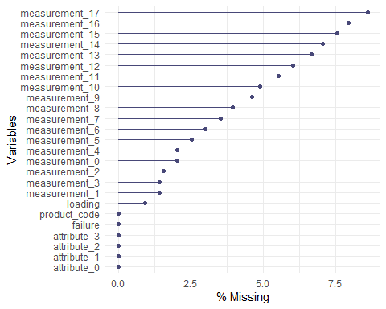

#measurements 11 through 17 have > 5% missingnes but all variables are 90%+ complete and so column-deletion is probably too aggressive here.

gg_miss_case(failurefull)

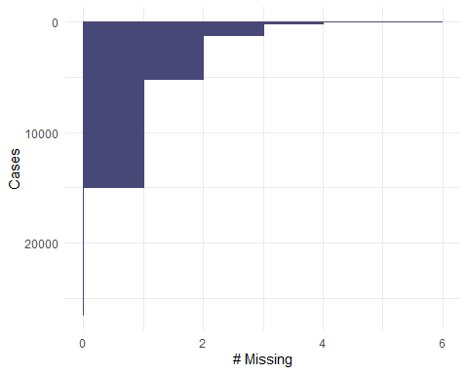

#nearly 15,000 observations have 1 missing value. Over 5,000 observations have 2 missing values.

gg_miss_fct(x = failurefull, fct = failure)

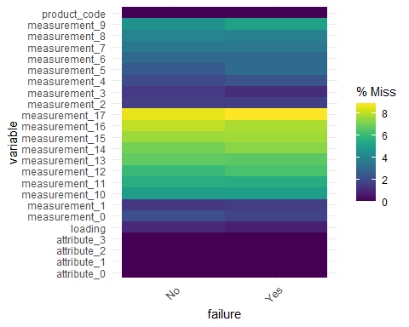

#there doesn't appear to be a dramatic difference in missingness of any values for products that failed. We aren't missing critical data.

vis_miss(failurefull)

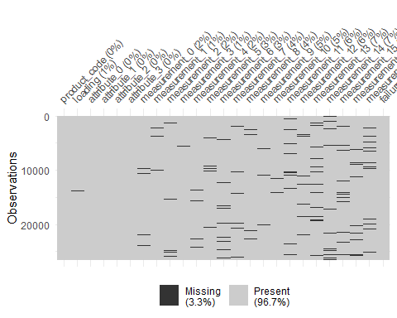

#The missingness appears to be random with no discernible patterns. Row-wise deletion would eliminate a significant amount of data. Similarly, column-wise deletion would completely eliminate variables that are 90%+ complete. For these reasons, I am going to pursue imputation to handle missingness. However, I am going to use row-wise deletion for missingness of the loading variable because it is a key measurement of the product's usefulness.

failurefull = failurefull %>% drop_na(loading)  
  
#row-wise deletion for the loading variable before proceeding with imputation.

**Imputation**

imp_vals = mice(failurefull, m=3, method='pmm', printFlag=FALSE)

## Warning: Number of logged events: 539

#m is the number of imputations, 3 is used here rather than 5 due to dataset size.   
#pmm is "predictive mean matching" = imputation method for numeric data  
#printFlag reduces amount of output

summary(imp_vals)

failurefull_complete = complete(imp_vals)  
  
vim_plot = aggr(failurefull_complete, numbers = TRUE, prop = c(TRUE, FALSE),cex.axis=.7)

## Warning in plot.aggr(res, ...): not enough horizontal space to display  
## frequencies

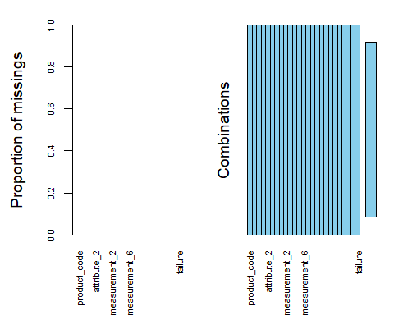

#data is complete, no missingness.

**Exploratory Analysis**

str(failurefull$failure)

## Factor w/ 2 levels "No","Yes": 1 1 1 1 1 1 2 2 1 1 ...

summary(failurefull$failure)

## No Yes   
## 20715 5605

ggplot(failurefull, aes(x = failure)) + geom_bar()

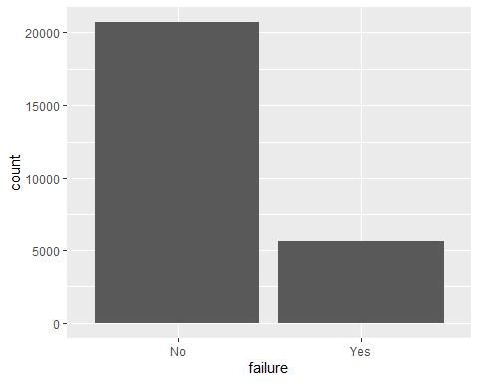

#There are 5649 failures out of 26570 observations

p1 = ggplot(failurefull_complete, aes(x= product_code, fill = failure)) + geom_bar(position = "fill")  
p2 = ggplot(failurefull_complete, aes(x = loading, y = failure))+ geom_boxplot()  
p3 = ggplot(failurefull_complete, aes(x = measurement_0, y = failure))+ geom_boxplot()  
p4 = ggplot(failurefull_complete, aes(x = measurement_1, y = failure))+ geom_boxplot()  
grid.arrange(p1, p2, p3, p4, ncol = 2)

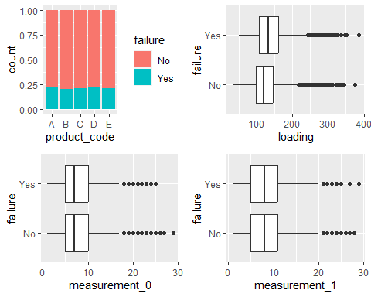

# The response variable is failure.   
#loading is predictive of failure   
#product code is predictive of failure   
#There is no discernible predictive effect of measurements 0 & 1 on failure.

#Above, we can see that the proportion of product failures are clustered around 20% for all product codes. Let's look at the interaction between product code and loading on failure.   
  
ggplot(failurefull_complete, aes(x = loading, y= product_code, color = failure))+ geom_point(alpha = 0.3,position = "jitter")

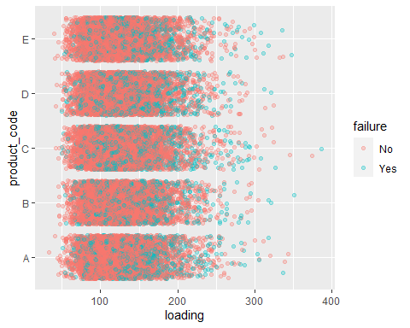

#clearly there is increased product failure at higher loading values. However, it's hard to tell much else.

p5 = ggplot(failurefull_complete, aes(x = attribute_2, fill = failure))+ geom_bar(position = "fill")  
p6 = ggplot(failurefull_complete, aes(x = attribute_3, fill = failure))+ geom_bar(position = "fill")  
p7 = ggplot(failurefull_complete, aes( x = attribute_0, fill = failure)) + geom_bar(position = "fill")  
p8 = ggplot(failurefull_complete, aes( x = attribute_1, fill = failure)) + geom_bar(position = "fill")  
  
grid.arrange(p5, p6, p7, p8, ncol = 2)

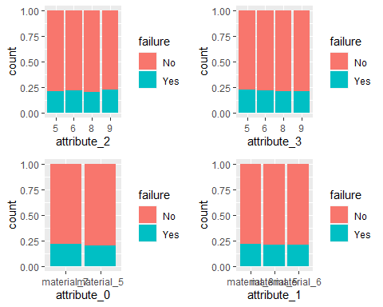

#Attributes 0, 2 & 3 appear to be predictors of failure.

#let's look at the interaction between loading amount across the various attributes. It appears that the various attributes strongly influence the loading value.  
  
p25 = ggplot(failurefull_complete, aes(x = loading, y= attribute_0, color = failure))+ geom_point(alpha = 0.3,position = "jitter")  
p26 = ggplot(failurefull_complete, aes(x = loading, y= attribute_1, color = failure))+ geom_point(alpha = 0.3,position = "jitter")  
p27 = ggplot(failurefull_complete, aes(x = loading, y= attribute_2, color = failure))+ geom_point(alpha = 0.3,position = "jitter")   
p28 = ggplot(failurefull_complete, aes(x = loading, y= attribute_3, color = failure))+ geom_point(alpha = 0.3,position = "jitter")  
  
grid.arrange(p25, p26, p27, p28, ncol = 2)

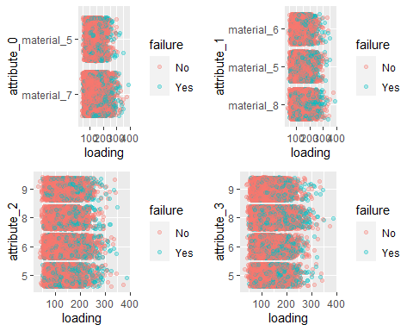

# This wasn't as useful as I had hoped!

p9 = ggplot(failurefull_complete, aes(x = measurement_2, y = failure))+ geom_boxplot()  
p10 = ggplot(failurefull_complete, aes(x = measurement_3, y = failure))+ geom_boxplot()  
p11 = ggplot(failurefull_complete, aes(x = measurement_4, y = failure))+ geom_boxplot()  
p12 = ggplot(failurefull_complete, aes(x = measurement_5, y = failure))+ geom_boxplot()  
grid.arrange(p9, p10, p11, p12, ncol = 2)

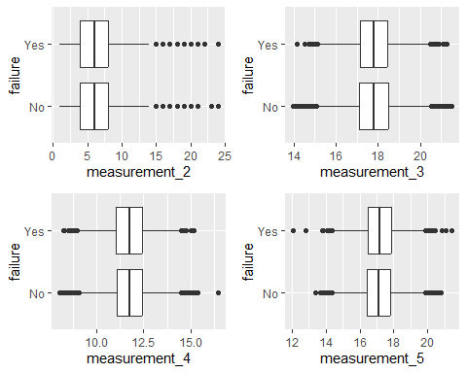

#No discernible predictive value of these measurements on failure.

p13 = ggplot(failurefull_complete, aes(x = measurement_6, y = failure))+ geom_boxplot()  
p14 = ggplot(failurefull_complete, aes(x = measurement_7, y = failure))+ geom_boxplot()  
p15 = ggplot(failurefull_complete, aes(x = measurement_8, y = failure))+ geom_boxplot()  
p16 = ggplot(failurefull_complete, aes(x = measurement_9, y = failure))+ geom_boxplot()  
grid.arrange(p13, p14, p15, p16, ncol = 2)

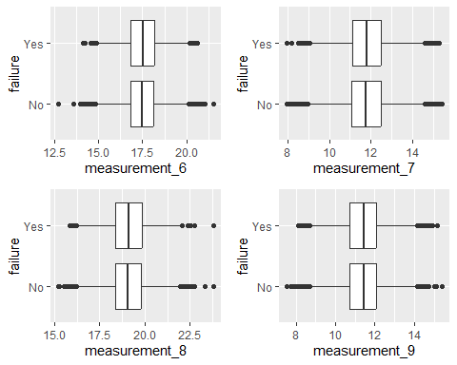

#No discernible predictive value of these measurements on failure.

p17 = ggplot(failurefull_complete, aes(x = measurement_10, y = failure))+ geom_boxplot()  
p18 = ggplot(failurefull_complete, aes(x = measurement_11, y = failure))+ geom_boxplot()  
p19 = ggplot(failurefull_complete, aes(x = measurement_12, y = failure))+ geom_boxplot()  
p20 = ggplot(failurefull_complete, aes(x = measurement_13, y = failure))+ geom_boxplot()  
grid.arrange(p17, p18, p19, p20, ncol=2)

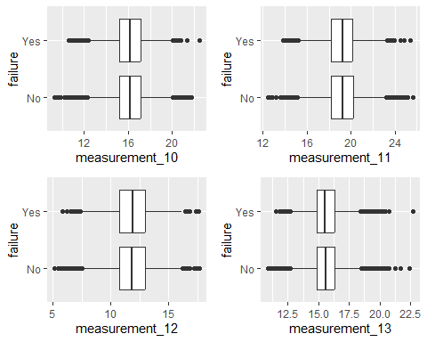

#No discernible predictive value of these measurements on failure.

p21 = ggplot(failurefull_complete, aes(x = measurement_14, y = failure))+ geom_boxplot()  
p22 = ggplot(failurefull_complete, aes(x = measurement_15, y = failure))+ geom_boxplot()  
p23 = ggplot(failurefull_complete, aes(x = measurement_16, y = failure))+ geom_boxplot()  
p24 = ggplot(failurefull_complete, aes(x = measurement_17, y = failure))+ geom_boxplot()  
grid.arrange(p21, p22, p23, p24, ncol=2)

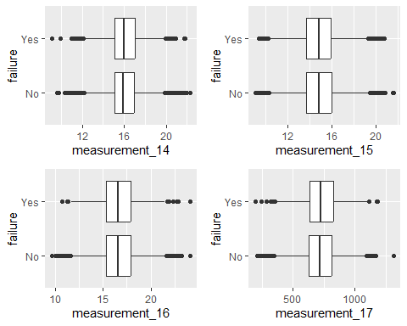

# There is a slight difference in the mean values of measurement_17 for products that failed vs. products that did not fail.

**Loading appears to be the strongest predictor of failure. Attributes 0, 2 & 3 appear to be weak predictors of failure. Measurements 5, 8 and 17 are the only measurement that exhibit a slight discernible difference in mean values for product failure.**