**SPACEWALK - COTO (CENTOS 6/6.5)**

Links:

http://dfwlpiki.dfwlp.org/index.php/Installing_Spacewalk_on_CentOS_6

OFICIAL:

<https://fedorahosted.org/spacewalk/wiki>

BACKUP:

<https://fedorahosted.org/spacewalk/wiki/SpacewalkBackup>

HTTP:

<https://spacewalk/rhn/systems/SystemList.do>

-----------

User: spaceadm

**P**ass: AdmiN--2013

-------------------

**KickStart Menu COTO:**

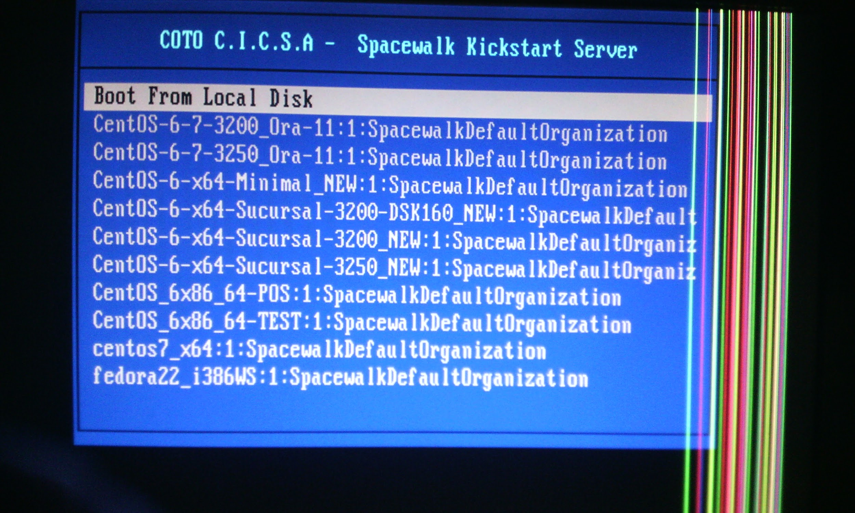

-------------------------------------------------------------------------------

Script para la instalación de paquetes en el cliente:

Creamos a un repo local:

cat > /etc/yum.repos.d/localrepo.repo << EOF

[localrepo]

name=Unixmen Repository

baseurl=http://spacewalk/pub/localrepo

gpgcheck=0

enabled=1

EOF

--------

Eliminado los repos de Centos:

mv /etc/yum.repos.d/CentOS-* /tmp

yum clean all

Instalamos el wget:

yum install wget -y

Instalamos el wget /curl (si no lo tenemos instalado)

yum install wget /curl -y

No bajamos el tar para la instalación del cliente Spacewalk:

curl -O<http://spacewalk/pub/spacewalk.tar> && tar xvf spacewalk.tar && cd spacewalk

vi INSTALL:

cp space-client.repo /etc/yum.repos.d

mv /etc/yum.repos.d/CentOS* /tmp/

yum install http://spacewalk/pub/rhn-org-trusted-ssl-cert-1.0-2.noarch.rpm -y

yum -y install rhn-client-tools rhn-check rhn-setup rhnsd m2crypto yum-rhn-plugin rhncfg-actions osad

rhnreg_ks --serverUrl=http://spacewalk/XMLRPC --activationkey=1-2-centos-6.7-x86_64-base

rhn-actions-control --enable-all

/etc/init.d/osad start

rm -rf /etc/yum.repos.d/CentOS-* /etc/yum.repos.d/epel*

yum clean all

-----

Listar Repos:

yum repolist

------

UPDATE SYSTEN:

yum -y update

rm -rf /etc/yum.repos.d/CentOS-* /etc/yum.repos.d/epel*

------------------------------

ERROR DEPENDENCIES:

TIPS:

Se pueden instalar antes o después del error:

rpm -Uvh python-hwdata-1.7.3-1.el6.noarch.rpm && rpm -Uvh jabberpy-0.5-0.21.el6.noarch.rpm && rpm -Uvh m2crypto-0.20.2-9.el6.x86_64.rpm && rpm -Uvh python-gudev-147.1-4.el6_0.1.x86_64.rpm

------

Install pgpkey (Channel):

rpm --import gpgkey

Check:

rpm -qa | grep c105b9de

------

yum -y update

rm -rf /etc/yum.repos.d/CentOS-* /etc/yum.repos.d/epel*

-------------------------------------------------------------------

**From public repo:(proxy)**

rpm -Uvh http://yum.spacewalkproject.org/2.6-client/RHEL/6/x86_64/spacewalk-client-repo-2.6-0.el6.noarch.rpm

-----

rpm -Uvh http://dl.fedoraproject.org/pub/epel/epel-release-latest-6.noarch.rpm

yum install rhn-client-tools rhn-check rhn-setup rhnsd m2crypto yum-rhn-plugin

**Error Dependencies?:**

wget <http://spacewalk/pub/spacewalk.tar> && tar xvf spacewalk.tar && cd spacewalk

cp space-client.repo /etc/yum.repos.d

rpm -Uvh python-hwdata-1.7.3-1.el6.noarch.rpm && rpm -Uvh jabberpy-0.5-0.21.el6.noarch.rpm && rpm -Uvh m2crypto-0.20.2-9.el6.x86_64.rpm && rpm -Uvh python-gudev-147.1-4.el6_0.1.x86_64.rpm

yum install rhn-client-tools rhn-check rhn-setup rhnsd m2crypto yum-rhn-plugin

rhnreg_ks --serverUrl=http://spacewalk/XMLRPC --activationkey=1-2-centos-6.7-x86_64-base --force

--------------------------

wget <http://spacewalk/pub/spacewalk-paquetes/pyOpenSSL-0.10-2.el6.x86_64.rpm>

O

wget http://spacewalk/pub/spacewalk-paquetes.tar

yum remove rhnlib -y

rpm -ivh spacewalk-client-repo-1.7-5.el6.noarch.rpm

yum install rhn-client-tools rhn-check rhn-setup rhnsd m2crypto yum-rhn-plugin pyOpenSSL*

rhnreg_ks --serverUrl=http://spacewalk/XMLRPC --activationkey=1-2-centos-6.7-x86_64-base --force

---------------------------------------------------------------------

**Re agregar un equipo al Spacewalk:(CentOs 6.7)**

curl -O <http://spacewalk/pub/spacewalk.tar> && tar xvf spacewalk.tar && cd spacewalk

cp space-client.repo /etc/yum.repos.d

yum clean all

yum install http://spacewalk/pub/rhn-org-trusted-ssl-cert-1.0-2.noarch.rpm -y

rpm --import gpgkey

rhnreg_ks

rhnreg_ks --serverUrl=http://spacewalk/XMLRPC --activationkey=1-2-centos-6.7-x86_64-base --force

**rm -rf /etc/yum.repos.d/CentOS-* /etc/yum.repos.d/epel\***

-----------

**Re agregar un equipo al Spacewalk:(CentOs 7)**

rhnreg_ks --serverUrl=http://spacewalk/XMLRPC --activationkey=1-2-centos7-x86_64 --force

yum -y update

mv CentOS-* /tmp/ && yum clean all && yum repolist

------------------

**Re agregar un equipo al Spacewalk:(CentOs 6.8)**

rhnreg_ks --serverUrl=http://spacewalk/XMLRPC --activationkey=1-2-centos-6.8-x86_64-base --force

yum -y update

mv CentOS-* /tmp/ && yum clean all && yum repolist

------------------------------------------

**ImportError: cannot import name idn_pune_to_unicode:**

vi /usr/lib/python2.6/site-packages/rhn/connections.py

Cambiar esto :

def idn_puny_to_unicode(hostname):

Por:

def idn_pune_to_unicode(hostname):

Cambiar:

#def idn_ascii_to_puny(hostname):

Por:

def idn_ascii_to_pune(hostname):

--------------------------------------------------------------------

**ImportError: cannot import name SSL:**

File "/usr/lib/python2.6/site-packages/rhn/connections.py", line 14, in <module>

from rhn import SSL

ImportError: cannot import name SSL

FIX:

Deberian estar todos estos files:

/usr/lib/python2.6/site-packages/rhn

UserDictCase.py

SSL.py

SmartIO.py

rhnLockfile.py

nonblocking.py

__init__.py

connections.py

UserDictCase.pyo

UserDictCase.pyc

transports.pyo

transports.pyc

transports.py

SSL.pyo

SSL.pyc

SmartIO.pyo

SmartIO.pyc

rpclib.pyc

rpclib.py

rhnLockfile.pyo

rhnLockfile.pyc

nonblocking.pyo

nonblocking.pyc

__init__.pyo

__init__.pyc

connections.pyo

connections.pyc

rpclib.pyo

-------------

**Instalar :**

yum install gcc gcc-c++ libffi-devel openssl-devel

----

**Update Python Version.**

cd /usr/local/src/

wget https://www.python.org/ftp/python/2.7.9/Python-2.7.9.tgz

tar xvfz Python-2.7.9.tgz

cd Python-2.7.9

ls -lrt

./configure

make

make install

python --version

yum install python-pip

pip install cryptography

TEST:

rhnreg_ks

-------------------------------------------------------------

**TIPS:**

**Sync Repo:**

spacewalk-repo-sync --channel centos-6-x86_64-updates --type yum --sync-kickstart

spacewalk-repo-sync --channel spacewalk-client-2.2-el6-x86_64-centos

spacewalk-repo-sync --channel epel-6-x86_64-centos --type yum --sync-kickstart

spacewalk-repo-sync --channel epel_rhel6_x86_64 --type yum --sync-kickstart

spacewalk-repo-sync --channel securityfirst_rhel6_x86_64

--------------------------------------

**Add new repo:**

/usr/bin/spacewalk-common-channels -v -u admin -p pass -a i386,x86_64 -k unlimited 'centos5*' 'spacewalk-nightly-client*'

------------------------------

**List Repos:**

spacewalk-repo-sync --list

------------------------------

**Add package manually:**

**Primero crear el Channel por la web.**

cp /usr/share/rhn/RHN-ORG-TRUSTED-SSL-CERT /var/www/html/pub/RHN-ORG-TRUSTED-SSL-CERT

/usr/bin/rhnpush --channel=centos7-x86_64 --server=http://localhost/APP --dir="/repositorio/centos7_x64/Packages" -u spaceadm -p AdmiN--2013 -v --tolerant

-----

/usr/bin/rhnpush --channel=local_rh_4.8_x86_64 --server=http://localhost/APP --dir="/repositorio/rh4.8-X86/RedHat/RPMS" -u spaceadm -p AdmiN--2013 -v --tolerant

-----------------------------

**Local repo from CD:**

mount -o loop,ro /media/USB_stick/V33411-01.iso /mnt

vi /etc/fstab

/media/USB_stick/V33411-01.iso /mnt iso9660 loop,ro 0 0

-------

mkdir -p /var/www/html/pub/OL63

ln -s /mnt/Packages/* OL63 /var/www/html/pub/OL63

chown apache.apache -R /var/www/html/pub/OL63

cd /var/www/html/pub/OL63

rpm -i httpd-2.2.15-29.0.1.el6_4.x86_64.rpm libxml2-2.7.6-14.0.1.el6.x86_64.rpm libxml2-python-2.7.6-8.el6_3.4.i686.rpm deltarpm-3.5-0.5.20090913git.el6.x86_64.rpm createrepo-0.9.9-18.0.1.el6.noarch.rpm createrepo-0.9.9-18.0.1.el6.noarch.rpm

/etc/init.d/httpd start

cd /etc/yum.repos.d/

cat > /etc/yum.repos.d/OL63.repo << EOF

[OL63]

name=Oracle Linux 6.3 x86_64

baseurl=file:///var/www/html/pub/OL63

gpgkey=file:///etc/pki/rpm-gpg/RPM-GPG-KEY

gpgcheck=0

enabled=1

EOF

cd /var/www/html/pub/OL63/

createrepo -v /var/www/html/pub/OL63

yum clean all

yum update

----------------------------------

En los Clientes:

cat > /etc/yum.repos.d/OL63.repo << EOF

[OL63]

name=Oracle Linux 6.3 x86_64

baseurl=http://10.250.88.30/pub/OL63

gpgkey=file:///etc/pki/rpm-gpg/RPM-GPG-KEY

gpgcheck=0

enabled=1

EOF

----------------------------------------------------------------------------

**SPACEWALK - COTO (Fedora 22)**

wget [http://spacewalk/pub/spacewalkFd22.tar](https://spacewalk/pub/spacewalkFd22.tar) && tar xvf spacewalkFd22.tar

useradd mockbuild && groupadd mockbuild

dnf -y install rhn-client-tools rhn-check rhn-setup rhnsd m2crypto dnf-plugin-spacewalk

dnf install http://spacewalk/pub/rhn-org-trusted-ssl-cert-1.0-2.noarch.rpm -y

cp -p /usr/lib/python2.7/site-packages/rhn/connections.py /usr/lib/python2.7/site-packages/rhn/

rhnreg_ks --serverUrl=http://spacewalk/XMLRPC --activationkey=1-fedora-22-i386-key --force

-----------------------------------------------------------------------------

# **Unregister a Host from RHN Spacewalk**

In the client run:

rm -f /etc/sysconfig/rhn/systemid

--------------------------------------------------

**Hubicacion Kickstart Scripts:**

/repositorio/ks/centos

extras

script-desktop.sh

script-minimal-i386.sh

script-3250.sh.20140113

script-oraclelinux.sh

script-pos.sh

script-minimal-centos7.sh

script-3200.sh-06112014

script-interactive.sh

script-3250.sh.20150514

spacewalk.tar

spacewalk

script-minimal.sh

script-3250.sh

Script-3200.sh

-----------------------------------------------------

**Hubicacion Extra:**

/repositorio/centos6_x64/extras/

-----------------------------------------------------

**Restart services:**

/usr/sbin/spacewalk-service restart

---------------------------------------

**Kickstart Folder: cobler**

/var/satellite/rhn/kickstart/1/

--------------------------------------------

**Cobbler sync:**

cobbler sync

------------------------------------

**Agregar nuevo KickStart Profile**

cd /var/satellite/rhn/kickstart/1/

1) Descargar ISO

2) Monto la ISO

3) Creo una carpeta y copio los archivos locales

4) Crear el Channel (WEB)

5) Crear el repositorio (defino al url del repo)(WEB)

6-a) Corro el sync:

spacewalk-repo-sync --channel centos-6.8-x86_64-updates

6-b)Crear el repositorio (defino al url del repo) (SHELL)

/usr/bin/rhnpush --channel=centos7-x86_64 --server=<http://localhost/APP> --dir="/Path-Iso/centos7_x64/Packages" -u spaceadm -p AdmiN--2013 -v --tolerant

7) Creo el kickstart.

Spacewalk:

System --> KickStart --> Distribution (Nuevo Distribution)

Distribution Label*: Nombre Dist.

Tree Path*: /var/satellite/rhn/kickstart/1/Path_ISO

**Base Channel*: (DEBE Crearse antes...)**

Installer Generation*: Distro

Kernel Options: ------

Post Kernel Options: -------

System --> KickStart --> Profile (Nuevo Profile)

System --> KickStart --> Profile → Script

echo "#########################"

echo " Llamo a script-3250.sh"

echo "#########################"

echo "Voy a Montar Repositorio"

mkdir /mnt/temp

mount -o nolock 128.2.101.107:/repositorio/ks/centos /mnt/temp

cd /mnt/temp

echo "Voy A Correr el Script"

bash script-3250.sh_new

echo "#########################"

-----------------------------------

**Estructura de Archivos:**

Filesystem Size Used Avail Use% Mounted on

/dev/mapper/rootvg-root

1.5G 734M 638M 54% /

tmpfs 1.9G 0 1.9G 0% /dev/shm

/dev/sda1 380M 146M 214M 41% /boot

/dev/mapper/rootvg-home

477M 2.3M 449M 1% /home

/dev/mapper/rootvg-tecnol

190M 1.6M 179M 1% /tecnol

/dev/mapper/rootvg-usr

5.7G 2.2G 3.2G 41% /usr

/dev/mapper/rootvg-var

6.0G 3.9G 1.9G 68% /var

/dev/mapper/rootvg-audit

283M 30M 239M 11% /var/log/audit

satellite/repositorio

25G 11G 15G 44% /repositorio

satellite 173G 141G 33G 82% /satellite

satellite/pgsql 18G 13G 6.0G 67% /var/lib/pgsql

satellite/tftpboot 400M 199M 202M 50% /var/lib/tftpboot

128.2.101.107:/repositorio/ks/centos

25G 11G 15G 44% /mnt/temp

----

**Script Option:**

Ubicacion del Script:

/repositorio/ks/centos/Nombre_del Script.sh

<https://drive.google.com/drive/folders/0B-4WnfGOZgJBcjJpcmlkZEMtcW8>

Ubicacion de los archivos "Extras":

/repositorio/centos6_x64/extras/files/reemplaza_Nombre_archivo.sh_new

/repositorio/centos6_x64/extras/files/migra_suc.sh_new

<https://drive.google.com/drive/folders/0B-4WnfGOZgJBM1AxQzdXd1U5TjQ>

-----------------------------------------------------------------