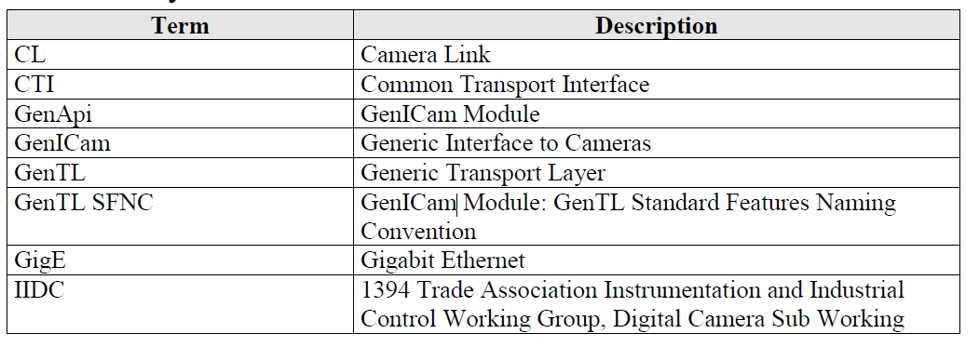

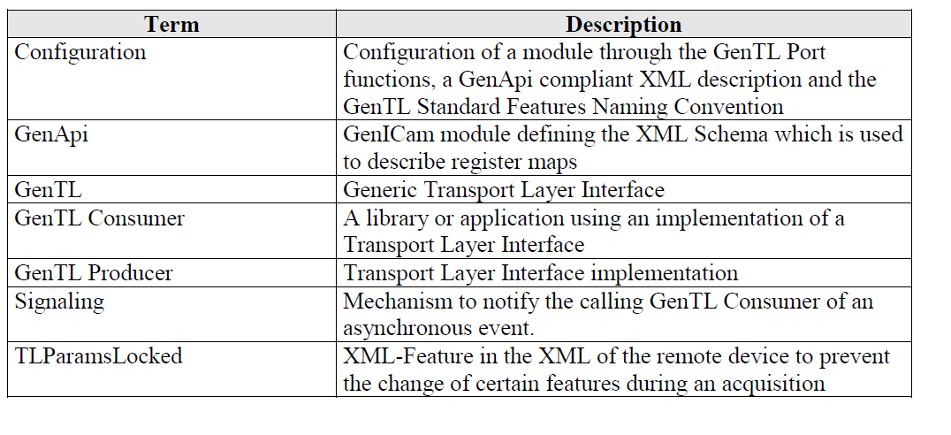

A **GenTL Producer** is a software driver implementing the GenTL Interface to enable an

application or a software library to access and configure hardware in a generic way and to

stream image data from a device.

A **GenTL Consumer** is any software which can use one or multiple GenTL Producers via the

defined GenTL Interface. This can be for example an application or a software library.

If a GenTL Consumer requests a Device that has been instantiated from within the same

process beforehand and has not been closed, the Interface returns an error. If the instance was

created in another process space and the GenTL Producer explicitly wants to grant access to

the Device this access should be restricted to read only.

A buffer acts as the destination for the data from the acquisition engine. To allow the acquisition engine to stream data into a buffer it has to be placed into the Input

Buffer Pool by calling the DSQueueBuffer function with the BUFFER_HANDLE retrieved

through announce functions.

The acquisition engine is the core of the GenTL data stream. Its task is the transportation

itself, which mainly consists of the buffer management.

As stated before, the goal for the acquisition engine is to abstract the underlying data transfer

mechanism so that it can be used, if not for all, then for most technologies on the market. The

target is to acquire data coming from an input stream into memory buffers provided by the

GenTL Consumer or made accessible to the GenTL Consumer. The internal design is up to

the individual implementation, but there are a few directives it has to follow.