Practical no 1

Practical Manual: Simple SOAP Temperature Converter Web Service in NetBeans
Aim:
To build, deploy, and consume a SOAP-based Web Service using Java (JAX-WS) in NetBeans IDE to convert temperature from Fahrenheit to Celsius and vice versa.

1. System Requirements & Setup
- IDE: NetBeans IDE (8.2 / 12+)
- Java Development Kit: JDK 8 or higher
- Application Server: GlassFish Server or Apache Tomcat (with JAX-WS support)
2. Project File Structure

TemperatureApp/
├── Source Packages/
│ └── practical1/
│ └── temperature.java (SOAP Web Service)
└── Web Pages/
├── input.jsp (User Input Form)
└── output.jsp (Web Service Result Page)

3. Step-by-Step Implementation

Step 1: Create a Java Web Application
- Open NetBeans IDE and navigate to File → New Project.
- Select Java Web → Web Application, then click Next.
- Name the project TemperatureApp and click Next.
- Select your GlassFish / Tomcat Server and click Finish.

Step 2: Create the Web Service (temperature.java)
- Right-click the project name in NetBeans, select New → Web Service.
- Configure the web service details:
  - Web Service Name: temperature
  - Package: practical1
- Click Finish.
- Open temperature.java and write the following code
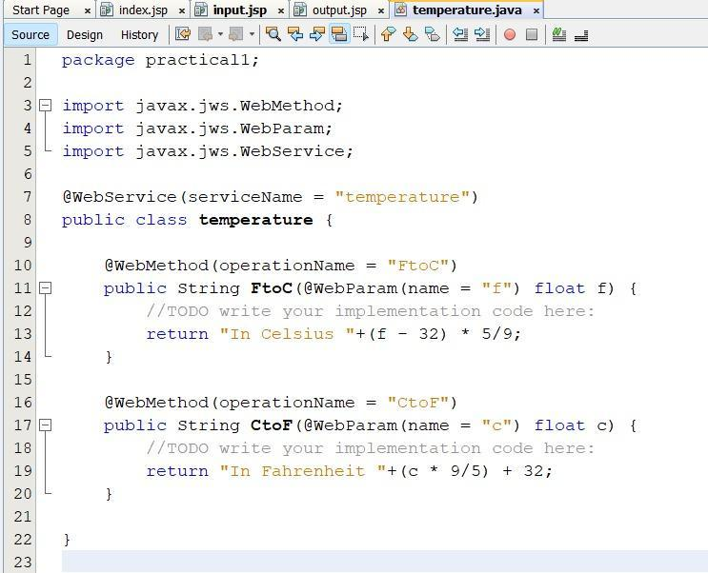

Step 3: Deploy Service & Generate Client Stubs
- Right-click the project TemperatureApp and click Clean and Build.
- Right-click the project and click Deploy.
- Right-click the project node and go to New → Web Service Client.
- Choose Project as the WSDL source and select temperature.
- Name the package temp and click Finish. (NetBeans will generate the invocation stubs automatically).

Step 4: Create the Input Form Page (input.jsp)
- Expand Web Pages, right-click, and choose New → JSP...
- Name the file input.jsp.
- Write the following form code:

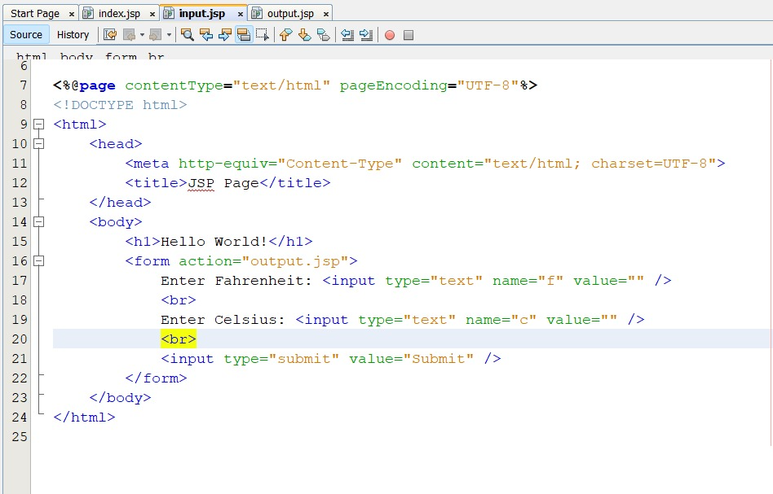

Step 5: Create the Output Result Page (output.jsp)
- In Web Pages, create another JSP file named output.jsp.
- Add the code below to call both SOAP operations (CtoF and FtoC):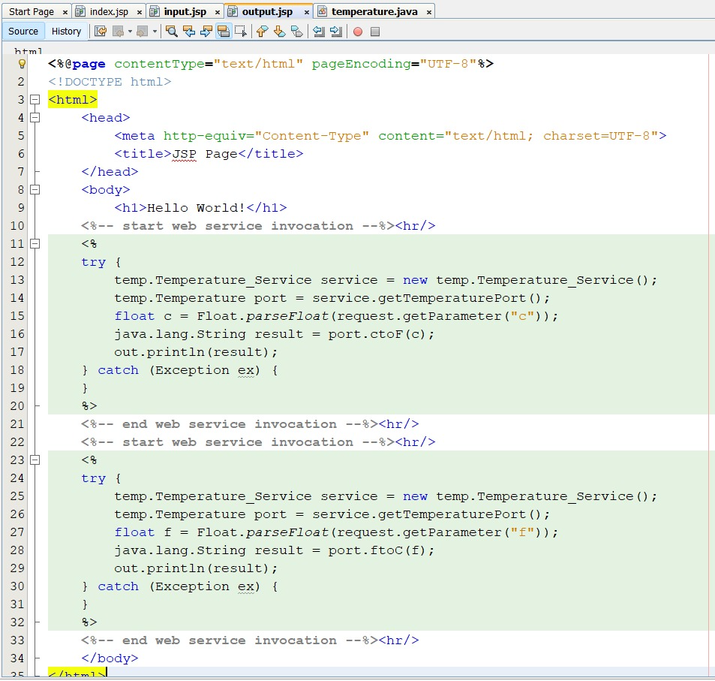

4. Execution & Output Screen Verification

1. Input Interface (input.jsp)
Run input.jsp by right-clicking it and selecting Run File.
- Heading: Hello World!
- Inputs: Enter Fahrenheit and Celsius values (e.g., 55).
- Button: Click Submit.

2. Output Interface (output.jsp)
Upon submission, output.jsp processes the input using the SOAP Web Service and outputs:
