Step 1: Create an Auth0 account
Go to:
Auth0 Dashboard (https://auth0.com/)
Create an account and create a Tenant if Auth0 asks you to.

Step 2: Create an Auth0 application
In Auth0:
Applications → Applications → Create Application
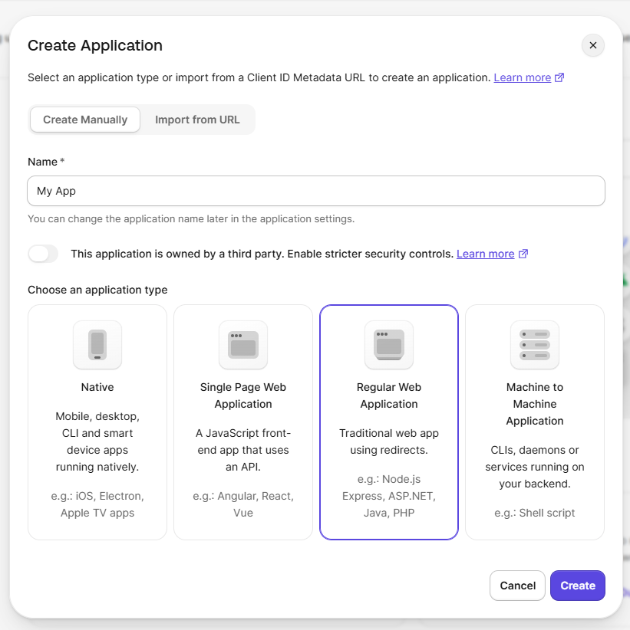

Choose:
Name:
My App
Application Type:
Regular Web Application

Click Create.

You will see:
Domain
Client ID
Client Secret
Keep these values. Do not put the Client Secret inside a JSP page or JavaScript.
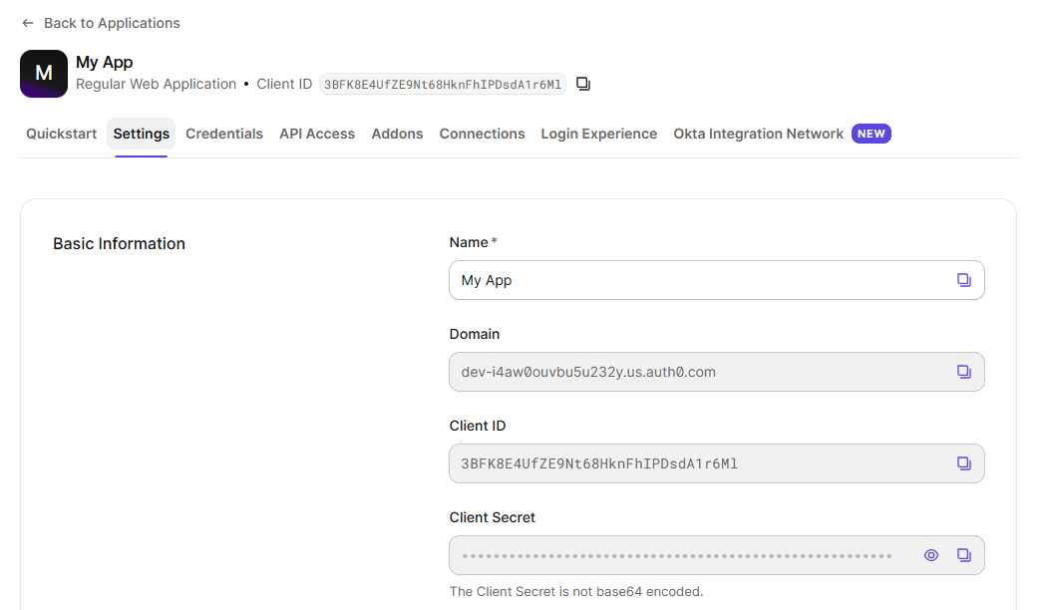

Step 3: Configure Google login
In Auth0 go to:
Authentication → Social → Google
Enable the Google connection.
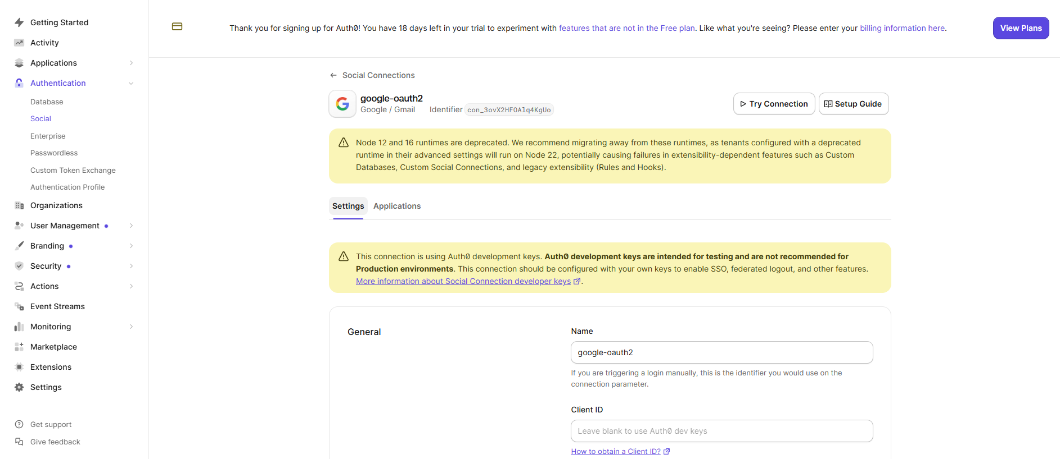
Click ‘Try Connection’
Enter Google account details
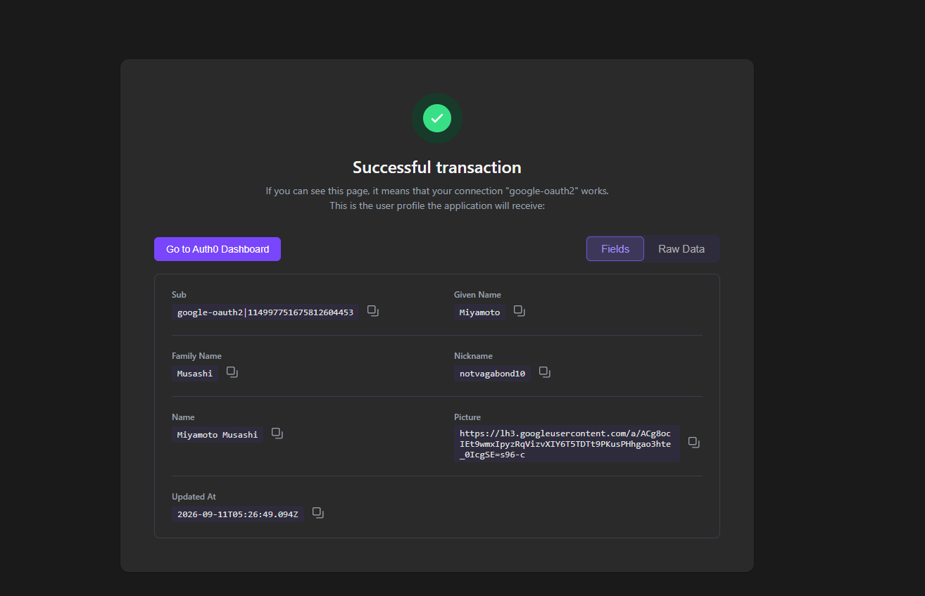

Step 4: Open your NetBeans project
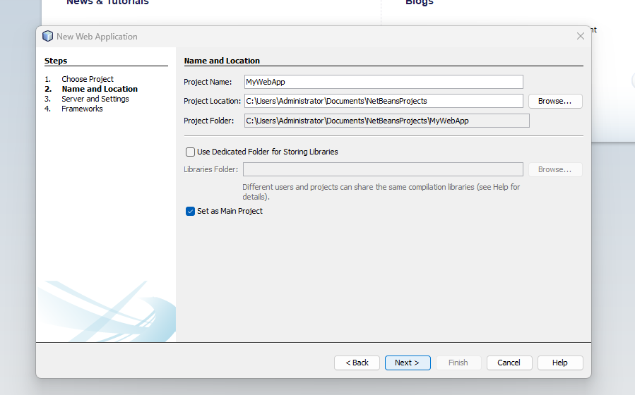

Step 5: Configure Auth0 callback URL
Go back to your Auth0 application.
Under Settings, find:
Allowed Callback URLs
Enter:
http://localhost:8080/MyWebApp/callback

Also configure:
Allowed Logout URLs
http://localhost:8080/MyWebApp/
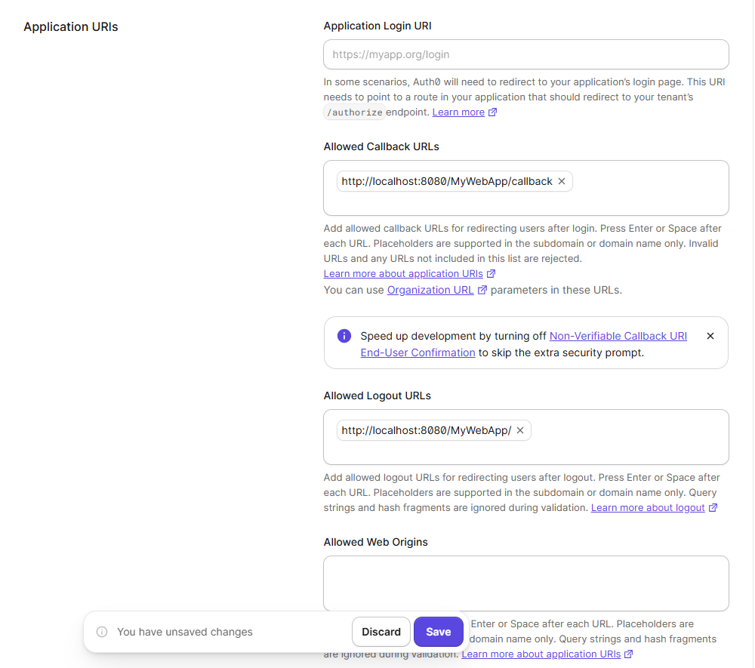

The callback URL is important: Auth0 requires the redirect URI used by your application to be registered in the application's settings.
Click Save Changes.

Step 6: Create login.jsp
In NetBeans:
Web Pages → New → JSP

Name it:
login.jsp

Put this in it:
<!DOCTYPE html>
<html>
<head>
<title>Login</title>
</head>
<body>
<h2>My Application</h2>

<a href="${pageContext.request.contextPath}/login">
Login with Google
</a>
</body>
</html>

That's all you need on the login page.
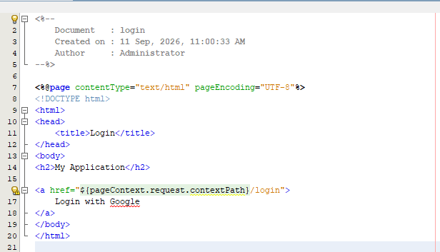

Step 7: Create LoginServlet
In NetBeans:
Source Packages → New → Servlet
Name:
LoginServlet
Package:
com.myapp
Map it to:
/login

The code should be:
package com.myapp;

import java.io.IOException;
import java.net.URLEncoder;
import javax.servlet.ServletException;
import javax.servlet.annotation.WebServlet;
import javax.servlet.http.HttpServlet;
import javax.servlet.http.HttpServletRequest;
import javax.servlet.http.HttpServletResponse;

@WebServlet("/login")
public class LoginServlet extends HttpServlet {

@Override
protected void doGet(HttpServletRequest request,
HttpServletResponse response)
throws ServletException, IOException {

String domain = "YOUR DOMAIN VALUE ";
String clientId = "YOUR CLIENT VALUE";

String callback =
"YOUR CALLBACK URL";

String url =
"https://" + domain +
"/authorize" +
"?response_type=code" +
"&client_id=" + clientId +
"&redirect_uri=" +
URLEncoder.encode(callback, "UTF-8") +
"&scope=" +
URLEncoder.encode(
"openid profile email", "UTF-8") + "&connection=google-oauth2";

response.sendRedirect(url);
}
}
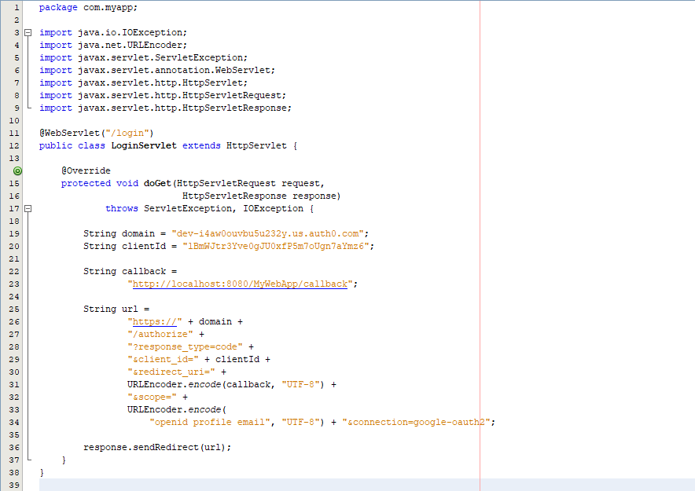

Step 8: Make it directly open Google (Already added in above code) Go to next step
If you want the user to go directly to Google rather than seeing the Auth0 login page, add:
&connection=google-oauth2

So this part:
"&scope=" +
URLEncoder.encode("openid profile email", "UTF-8");

becomes:
"&scope=" +
URLEncoder.encode("openid profile email", "UTF-8") +
"&connection=google-oauth2";

Auth0 documents google-oauth2 as the connection name for explicitly selecting Google during the authorization request.

Step 9: Create CallbackServlet
Create another Servlet:
CallbackServlet
URL:
/callback

This will be the code:
package com.myapp;

import java.io.IOException;
import javax.servlet.ServletException;
import javax.servlet.annotation.WebServlet;
import javax.servlet.http.HttpServlet;
import javax.servlet.http.HttpServletRequest;
import javax.servlet.http.HttpServletResponse;
import javax.servlet.http.HttpSession;

@WebServlet("/callback")
public class CallbackServlet extends HttpServlet {

@Override
protected void doGet(HttpServletRequest request,
HttpServletResponse response)
throws ServletException, IOException {

String code = request.getParameter("code");

if (code == null) {
response.sendError(
HttpServletResponse.SC_UNAUTHORIZED,
"Login failed"
);
return;
}

/*
* Here we will exchange the authorization code
* with Auth0 for the user's tokens.
*/

HttpSession session = request.getSession();

session.setAttribute("loggedIn", true);

response.sendRedirect(
request.getContextPath() + "/home.jsp"
);
}
}
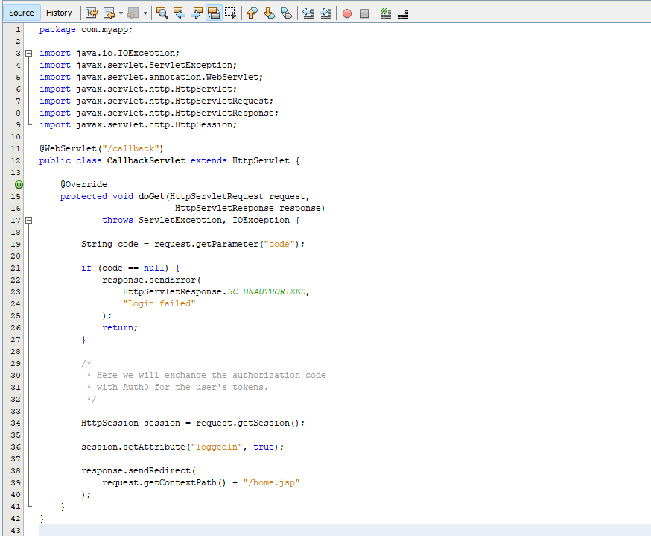

Step 10: Create home.jsp
Create:
home.jsp
Use this code:
<%
Boolean loggedIn =
(Boolean) session.getAttribute("loggedIn");

if (!Boolean.TRUE.equals(loggedIn)) {
response.sendRedirect("login.jsp");
return;
}
%>
<!DOCTYPE html>
<html>
<head>
<title>Home</title>
</head>
<body>
<h2>Welcome!</h2>
<p>You are logged in.</p>
<a href="logout">Logout</a>
</body>
</html>
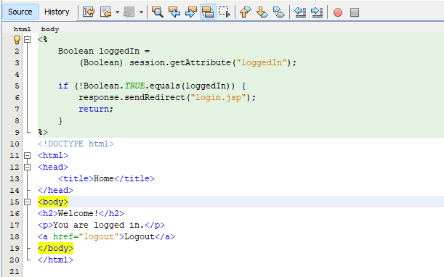

Step 11: Test it
Run your NetBeans project.
Open:
http://localhost:8080/MyWebApp/login.jsp
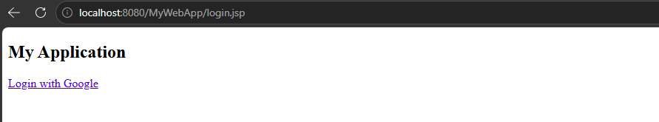
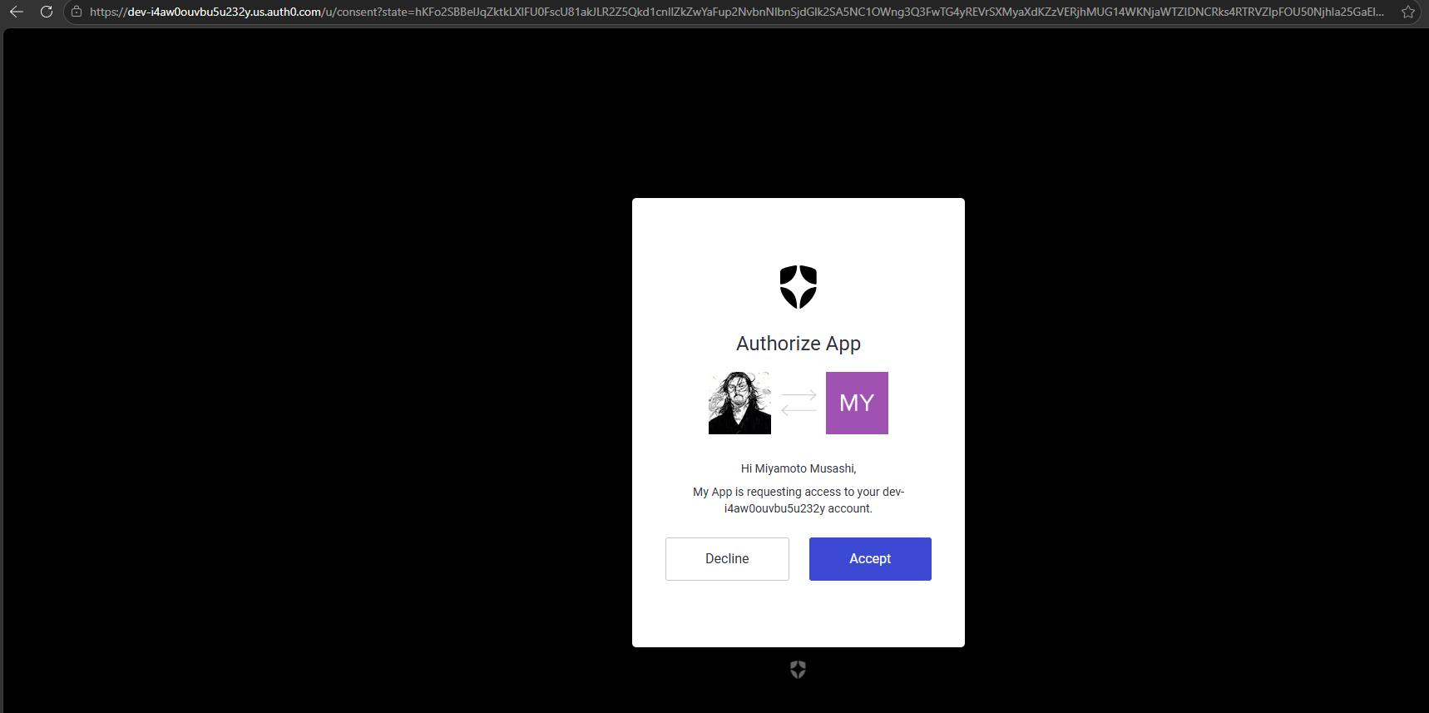
Sign in with Google account
Accept request
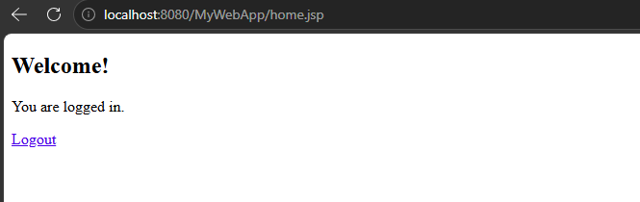
Practical successful

