PRE-AUDIT CAMPAING FOR REE (view for the drafter)

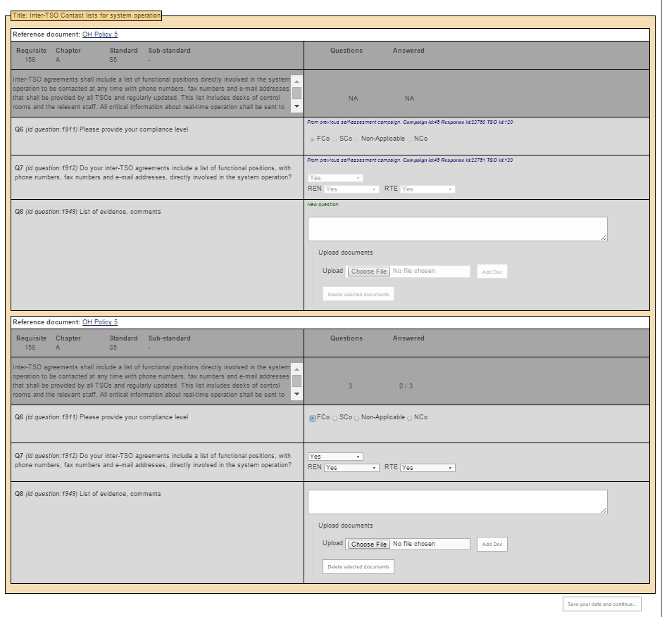

PRE-AUDIT CAMPAING FOR REE (view for the Approver)

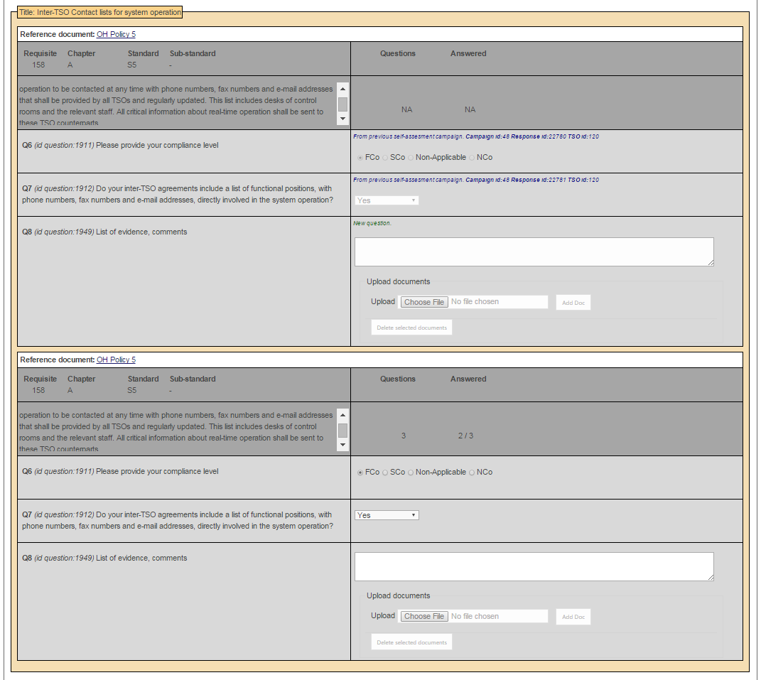

Missing the neighbours, it should show the information that the drafter inserted

Missing the neighbours, it should show the information that the drafter inserted

AUDIT PHASE (VIEW OF THE APPROVED ANSWERS OF REE BY THE AUDIT TEAM MEMBER OF SERBIA-EMS)

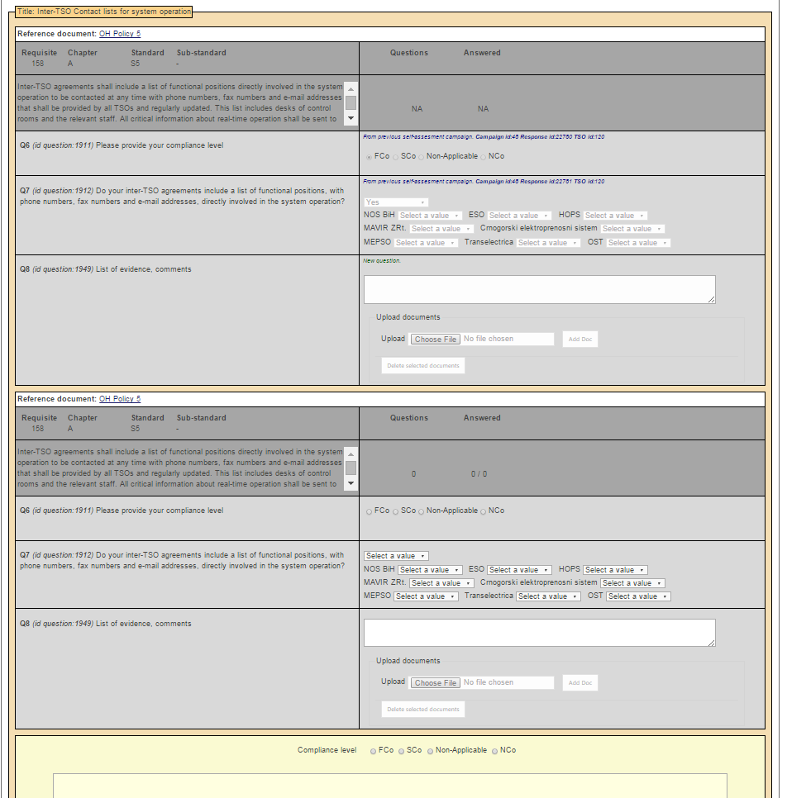

It should show the neighbours and answers of REE not EMS.

It should look as in the first picture of this document