BUDGETLive

Description:

BUDGETLive is a budget web application that allows users to personalize a budget with customary categories. This web app does not hold bank account or credit card information. This is a basic budget calculator that represents information visually with graphs. It is self-managed and safe to use. A user has a total amount for a monthly time frame. The user then divides the total amount into categories. Categories have budgets of their own and are a fraction of the total budget for the month. The user adds transactions into the web application by first choosing what category the transaction belongs to. Transactions made during the month are seen on a line graph. A pie chart shows the divisions of the total budget, each slice represents a category. When a slice of the pie chart is clicked on, a bar graph shows the spent amount versus the amount remained in the category. A user may see their “Info” by clicking on “info” on the menu bar. The info shows basic information including a “Link Code”. If the user wishes another user to join the budget, the new user may easily become a member by filling out basic credentials including the link code in the link up page. A user may now see the transactions made by the other joint user when logged in. A user may view their “Annual Budget” as well. When this option is clicked on the menu bar, the user may view bar graphs showing spent amount vs remaining amount for each month of the year. Monthly graphs only appear on the page if a transaction has been made during that particular month.

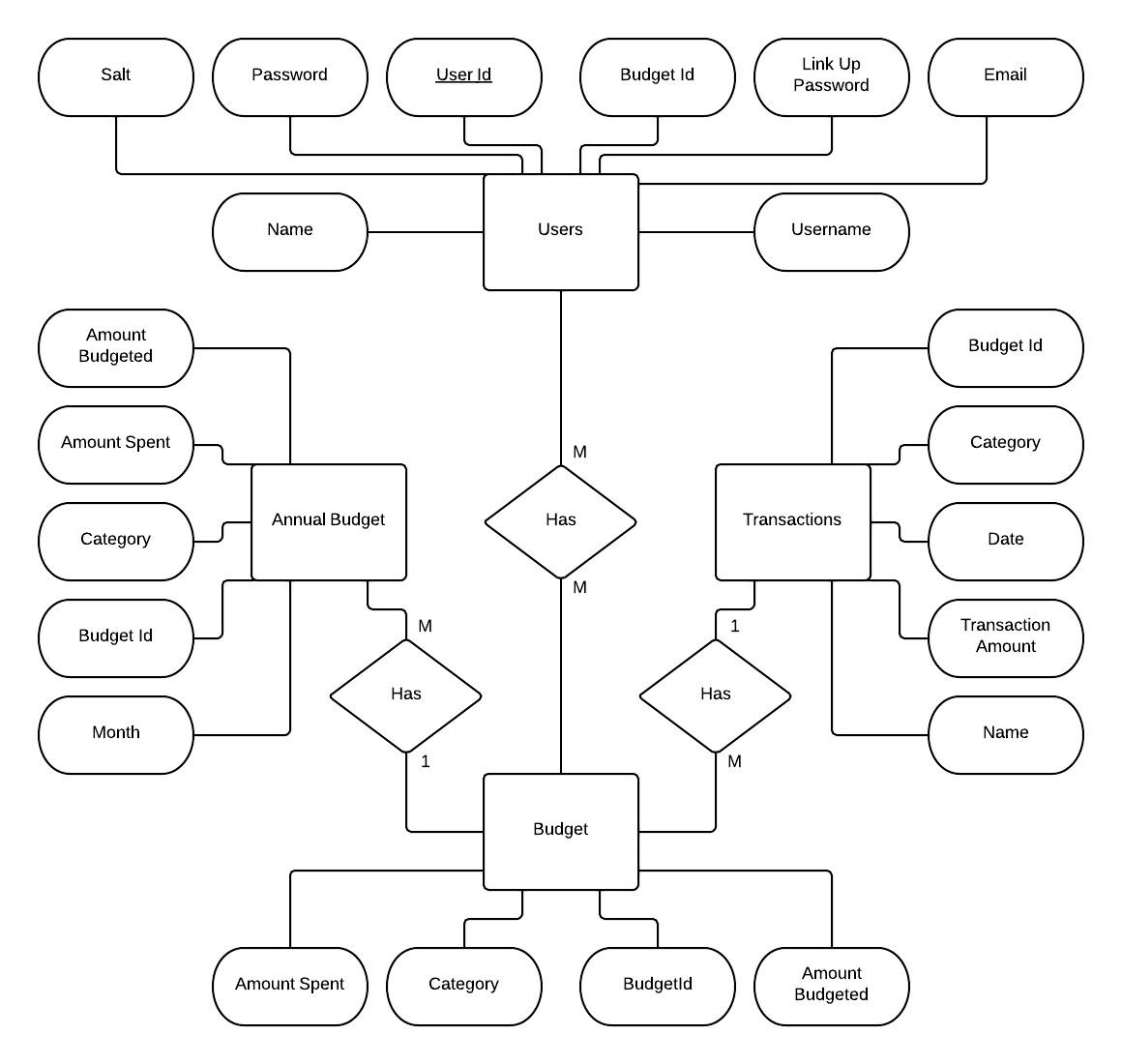Database Schema:

Contributions:

Team:  
 We came up with the idea while discussing other possible ideas. Cameron was really the one that finalized the idea. We decided on how the user should experience the web application before it was implemented.

Iris Martinez:

I worked on the entire front end. I designed the logo, layout, chose the colors, set up the process of how a budget should be created, and added information that came from the database to go into graphs. Each graph showed different information and it was my job to make sure all the data was shown correctly and everything remained organized. My part was all about making the user experience simple, easy, and attractive to use.

Cameron Lasky:

I worked on the entire back end. I designed the database and made sure everything worked well together. I set up a MVC pattern for our code and implemented the models and controls. I did server and client side validation for inputs, and made sure routing directed users to the main page to log in (so that they can’t access an account via url). I also set up the passwords and salts. My part was all about linking the different parts of our project together to make it all work.

Future Work:

One big step we hope to make into the future is to create a complimentary phone application that shows the same information as the web app, but designed to easily enter transactions into a budget. Things we plan to add is a page of records that shows detailed records of each transaction made during the year. A feature we hope to add in the future is the ability to take pictures of receipts and have receipt information automatically added to the budget. We, one day, would like to make accounts more personalized by adding profiles giving the user the ability to update personal information.