Download cando2.zip from: http://farnsworth.chem.temple.edu/scratch

Double click on it and drag the “cando2” directory into your “\Program files” directory.

Click “Start” and Right-click on “My Computer” and select “Properties”.

Click the “Advanced” tab and at the bottom click “Environment Variables”.

Go to the “System variables” list and find the variable “Path” and click on it and then click “Edit”.

Move the cursor to the end of the “Variable value” and add: “C:\Program files\cando2\bin;”.

If there wasn’t a semicolon at the end of the line when you started then use:
“;C:\Program files\cando2\bin;”

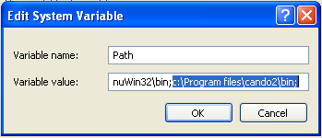

Now click “OK” and “OK” again and “OK” again to close the dialog boxes.

Now start a command shell by clicking “Start->All Programs->Accessories->Command Prompt”

Type: cd “\Program files\cando2\Resources\examples\helixMimic” <return>

To see what is in the directory type: dir <return>

To find a bis-peptide that can mimic an alpha-helical peptide type:

cando search3.csc <return>

A lot of output will be generated along with a file called “_hits.oml” that contains the results.

To view the results type:

candoView _hits.oml <return>

The bis-peptide is in cyan/blue/white/red and the p53 helix that is being matched is in magenta.

Drag the slider at the bottom to view all of the results.

Click on the “Info” tab to view the score and the sequence of each hit.

The sequence is described in “cando-script” format so that it can be copied and pasted into a cando-script to generate a structure or for further scoring/manipulation with cando.

You can use any editor to edit cando-script files like “search3.csc”. Editors like “vi” or “emacs” are recommended because they can help you keep track of the brackets that are integral to cando-script.

