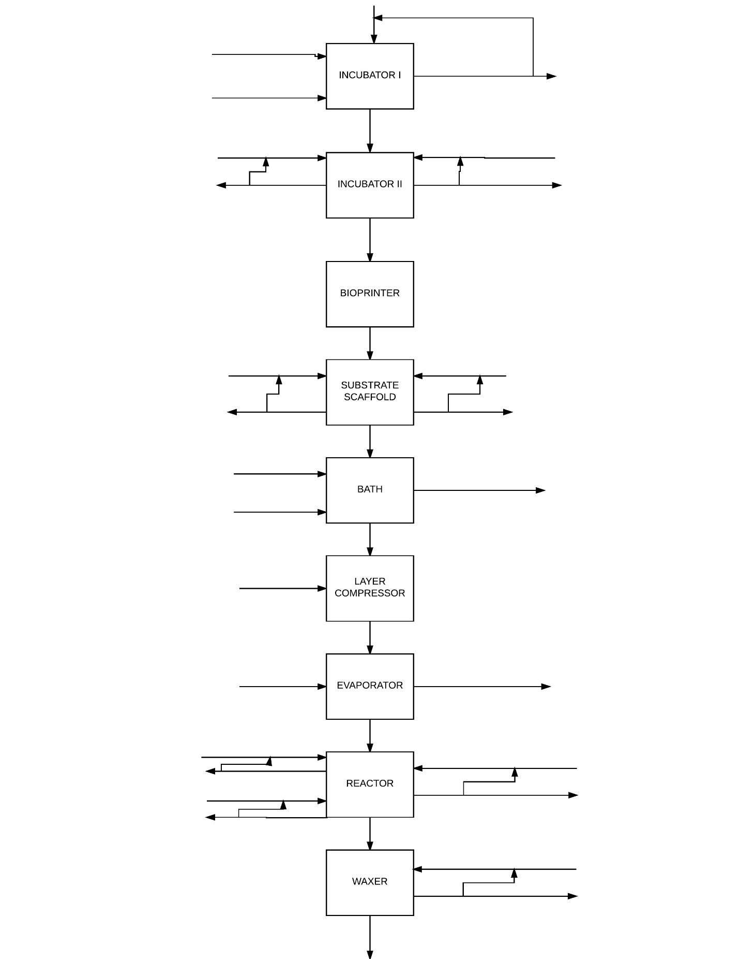

44

43

42

41

40

39

38

37

34

36

35

33

32

31

30

29

28

27

26

25

24

23

22

21

20

19

18

17

16

15

14

13

12

11

10

9

8

7

6

5

4

3

2

1

1. Base pairs of DNA coding for specific type (pattern) of collagen desired [75,000 sets of the code]
2. Epithelial cells [25,000 cells]
3. Fresh restriction enzymes [25,000 enzymes]
4. Recycled restriction enzymes [25,000 enzymes]
5. Purge restriction enzymes [25,000 enzymes]
6. Engineered cells [25,000 cells]
7. Fresh nutrients (oxygen, agarose, antibiotics, water) [1.7 microL]
8. Recycled nutrients (oxygen sugars, antibiotics, water) [0.3 microL]
9. Purge nutrients (oxygen, sugars, antibiotics, water) [0.2 microL]
10. Fresh additives (growth factors, minerals, fiber, fatty acids, amino acids) [0.7 microL]
11. Recycled additives (growth factors, minerals, fiber, fatty acids, amino acids) [0.3 microL]
12. Purge additives (growth factors, minerals, fiber, fatty acids, amino acids) [0.2 microL]
13. Multiplied engineered cells [5,000,000 cells]
14. Multiplied engineered cells [5,000,000 cells == 270,270 cells/hour]
15. Fresh nutrients (oxygen, sugars, antibiotics, water) [32 L]
16. Recycled nutrients (oxygen, sugars, antibiotics, water) [3 L]
17. Purge nutrients (oxygen, sugars, antibiotics, water) [2 L]
18. Fresh additives (growth factors, minerals, fiber, fatty acids, amino acids) [12 L]
19. Recycled additives (growth factors, minerals, fiber, fatty acids, amino acids) [3 L]
20. Purge additives (growth factors, minerals, fiber, fatty acids, amino acids) [2 L]
21. Single layer of collagen (3 feet x 6 feet x 1 inch) [100,000,000,000,000 cells]
22. Cold water [85 L]
23. Soap [2 L]
24. Dirty water [87 L]
25. Single layer of collagen (3 ft x 6 ft x 1 inch)
26. Desired number of layers of collagen (assume 19 layers) (3 ft x 6 ft x 1.6 ft)
27. Plurality of layers of collagen (20 layers) (3 ft x 6 ft x 1.67 ft)
28. Dry, hot air [2074732 L == 12350 L / hour]
29. Saturated, hot air [2074732 L == 12350 L / hour]
30. Dried leather (3 ft x 6 ft x 0.007 ft)
31. Fresh chromium (III) sulfate [4 L]
32. Recycled chromium (III) sulfate [1 L]
33. Purge chromium (III) sulfate [1 L]
34. Fresh additives (coloring, odor) [ 3.5 L]
35. Recycled additives (coloring, odor) [0.5 L]
36. Purge additives (coloring, odor) [0.5 L]
37. Fresh preservatives (calcium propionate, sodium nitrate, sodium nitrite, sulfites) [3.5 L]
38. Recycled preservatives (calcium propionate, sodium nitrate, sodium nitrite, sulfites) [0.5 L]
39. Purge preservatives (calcium propionate, sodium nitrate, sodium nitrite, sulfites) [0.5 L]
40. Tanned hide (3 ft x 6 ft x 0.007 ft)
41. Fresh wax [1.8 L]
42. Recycled wax [0.20 L]
43. Purge wax [0.05 L]
44. Finished product – leather (3 ft x 6 ft x 0.0105 ft)

Description of Process at Each Step:

* Incubator I: sets of DNA, epithelial cells, and restriction enzymes are placed in the incubator for 12 hours to allow the restriction enzymes to cut the DNA of the epithelial cells and the sets of DNA to be inserted into the cells. Due to the sticky ends of the cut DNA and DNA to be inserted, the cells are engineered to produce the type of collagen desired for the leather of the final product.
* Incubator II: The cells are given nutrients and additives and allowed to multiply.
* Bioprinter: The cells are packed into “cartridges” in the bioprinter. The bioprinter is programmed to “print” the cells onto the substrate scaffold into the desired structure.
* Substrate Scaffold: The substrate scaffold gives the cells the nutrients and additives needed to continue to multiply and fill out the scaffold while creating the collagen desired. A layer of collagen is produced.
* Bath: The layer of collagen is cleaned of any residue left from the substrate scaffold, additives, and nutrients.
* Layer compressor: Anywhere from 1 to 49 more layers of collagen are added onto the first layer and allowed to sit. The wet collagen coagulates into one large layer.
* Evaporator: The wet collagen is put through the evaporator to take out all of the water and create a much thinner layer of collagen.
* Reactor: The collagen is tanned in the reactor with chromium (III) sulfate like a traditional hide would be. Color and odor additives, as well as preservatives, are added here as well to attain the desired appearance of the leather.
* Waxer: A thin wax coat is added to the leather to protect it. This is the final product.

Estimated Times:

* Incubator I: 12 hours
* Incubator II: 1 week
* Bioprinter: 18.5 hours
* Substrate scaffold: 25 days
* Bath: 1 hour
* Layer compressor: 3 hours
* Evaporator: 1 week
* Reactor: 12 hours
* Waxer: 1.2 hours

Total Estimated Time: 41 days to produce one piece of leather 3ft x 6 ft x 0.0105 ft from 25,000 cells!