April 4, 2018

Modeling the Sweat Production of a Soccer Player

Deliverable Four

Kathryn Atherton

Contents

General Project Information 3

Nomenclature 3

System Diagram 4

Model Inputs 4

Model Outputs 5

Relationships 5

Assumptions 5

Deliverable Four 7

Iteration Four 7

Assumptions: 7

Model Inputs: 7

Model Outputs: 7

Fundamental Relationships: 7

Calculations: 7

Nomenclature: 8

Model and Output: 10

Justification for Next Iteration: 12

Deliverable Three 13

Iteration Three 13

Assumptions: 13

Model Inputs: 13

Model Outputs: 13

Fundamental Relationships: 13

Calculations: 13

Nomenclature: 14

Model and Output: 16

Justification for Next Iteration: 18

Iteration Two 19

Assumptions: 19

Model Inputs: 19

Model Outputs: 19

Fundamental Relationships: 19

Calculations: 20

Nomenclature: 21

Model and Output: 22

Justification for Next Iteration: 24

Iteration One 25

Assumptions: 25

Model Inputs: 25

Model Outputs: 26

Fundamental Relationships: 26

Calculations: 27

Nomenclature: 28

Model and Output: 29

Justification for Next Iteration: 30

Deliverable Two 31

List of equations: 31

Deliverable One 34

Description: 34

Model Inputs: 34

Model Outputs: 34

Relationships: 34

References 36

# General Project Information

## Nomenclature

Table 1: Nomenclature

|  |  |  |
| --- | --- | --- |
| **Symbol** | **Meaning** | **Units** |
| 𝐴 | surface area of player | [m2] |
| cp | specific heat | [kJ/kg.K] |
|  | enthalpy of cellular respiration | [kJ] |
|  | energy of one mole of ATP | [kJ/mol] |
|  | kinetic energy | [kJ] |
| EP | potential energy | [kJ] |
|  | convective heat transfer coefficient of air | [W/m2K] |
| hplayer | height of player | [m] |
|  | heat of vaporization of water | [kJ/mol] |
|  | mass of ATP | [kg] |
|  | mass of carbon dioxide | [kg] |
|  | mass of oxygen | [kg] |
|  | mass of player | [kg] |
|  | molecular weight of oxygen | [kg] |
|  | molecular weight of water | [kg] |
|  | mathematical constant pi | [-] |
|  | heat | [kJ] |
|  | rate of reaction of cellular respiration | [s-1] |
|  | density of water | [kg/m3] |
|  | time | [s] |
|  | ambient temperature | [°C] |
|  | time of dehydration | [min] |
|  | player temperature | [°C] |
|  | normal player temperature | [°C] |
|  | internal energy | [kJ] |
|  | speed of player | [m/s] |
|  | volume of water in player at which player is dehydrated | [L] |
|  | maximum velocity of player | [m/s] |
|  | stoichiometric coefficient of glucose | [-] |
|  | stoichiometric coefficient of oxygen | [-] |
|  | Volume of Water | [L] |
| W | work | [kJ] |

## System Diagram

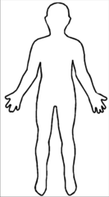

**Stream 2**

Vw (water)

Mc (carbon dioxide)

Q (heat)

**Stream 1**

Mo (oxygen)

**Figure 1:** System diagram. A soccer player’s body defines the system boundaries. The net components entering and leaving the system are oxygen, carbon dioxide, water, and heat. Environmental conditions and system specifications (listed below) affect how these inputs and outputs move between the system and environment.

## Model Inputs

* Ambient air temperature (°C)
* Relative ambient air humidity (%)
* Player’s mass (kg)
* Player’s height (m)
* Total time played (minutes)
* Player’s position (determines average velocity - m/s)

## Model Outputs

* Sweat volume produced (L) and sweat volume production rate (L/min)
* Time at which the player will begin to display dehydration symptoms (if at all) (minutes)
* Volume of water the player must drink to restore the fluids lost during the game (L)

## Relationships

* Mass balance of aerobic respiration reactants and products, assuming oxygen to be the limiting reactant
* Energy balance of energy produced, used, and lost by the body during play
* Rate of energy use in changes of running speed
* Enthalpy balance to determine heat production of body
* Mass balance of water production through respiration and loss through sweat to determine dehydration point (>5% body water content loss)
* Phase equilibrium/psychrometrics of water and vapor in ambient air determine the evaporation of sweat and thus the cooling of the body temperature

## Assumptions

(Highlighted assumptions are those which I plan to change in future iterations.)

1. Ambient temperature and humidity are constant during the game
2. Throughout the game, the body temperature is constant throughout the body at 37°C
3. There is no wind or precipitation to affect the body temperature
4. Uniform has no effect on heat loss
5. Emotional stress of the game has no effect on sweat production
6. The player starts playing at time t=0
7. There is no extra time added at the end of either half
8. There are no pauses in game play
9. The player plays the full 90 minutes
10. Water is not consumed by the player during the game time
11. Dehydration occurs at a loss of 5% of water content of the body (“Water Purification”, 2008)
12. The body is composed of 60% water by mass (Perlman, 2016)
13. The player’s normal body metabolism is negligent, does not produce heat to warm the body up to normal temperature
14. Sweat is the only means by which the body loses heat
15. Humidity has no effect on evaporation
16. The player is cylindrical in shape
17. The player’s shoulder width is ¼ the height of the player (Ida, 2012)
18. The player moves at a constant speed throughout the game.
19. Average speed of the player is not affected by the position played.
20. Oxygen is the limiting reactant in metabolism to create energy
21. The energy required to kick/dribble/tackle etc. is negligent to the energy required to run/sprint/jog
22. Volumes of other gases inhaled (e.g. nitrogen, hydrogen, etc.) is exhaled, meaning the net intake of these gases is zero; the only gas inhalation measured in this model is oxygen, the only gas exhalation measured in this model is carbon dioxide
23. Oxygen and carbon dioxide mass balances are at steady state
24. There is no change in elevation on the field
25. Conversion from chemical energy to kinetic energy is 50% efficient, and the rest is released as heat into the body (“Efficiency of ATP Production”, 1999)

# Deliverable Four

## Iteration Four

### Assumptions:

1. ~~The player moves at a constant speed throughout the game.~~ The player accelerates randomly throughout the game between a velocity of zero and the maximum velocity of a player.

### Model Inputs:

* Tair [°C]
* Mplayer [kg]
* hplayer [m]
* vmax [m/s]

### Model Outputs:

* dVw/dt [L/min]
* Vw [L]
* tdehydration [min], if applicable

### Fundamental Relationships:

* Cellular respiration
* Steady state mass balance
* Unsteady state mass balance
* Steady state energy
* Kinetic energy
* Internal energy
* Surface area of a cylinder
* Heat

### Calculations:

* Mass balances
  + Oxygen:

|  |  |  |
| --- | --- | --- |
|  |  | [1] |

* + Carbon Dioxide:

|  |  |  |
| --- | --- | --- |
|  |  | [2] |

* + ATP:

|  |  |  |
| --- | --- | --- |
|  |  | [3] |

* + Water:

|  |  |  |
| --- | --- | --- |
|  |  | [4] |

* Energy balance:

|  |  |  |
| --- | --- | --- |
|  |  | [5] |
|  |  | [6] |
|  |  | [7] |
|  |  | [8] |
|  |  |  |
|  |  | [9] |
|  |  | [10] |
|  |  |  |
|  |  | [11] |
|  |  | [12] |

### Nomenclature:

|  |  |  |
| --- | --- | --- |
| **Symbol** | **Meaning** | **Units** |
|  | surface area of player | [m2] |
|  | enthalpy of cellular respiration | [kJ] |
|  | energy of one mole of ATP | [kJ/mol] |
|  | kinetic energy | [kJ] |
|  | convective heat transfer coefficient of air | [W/m2K] |
|  | heat of vaporization of water | [kJ/mol] |
|  | mass of ATP | [kg] |
|  | mass of carbon dioxide | [kg] |
|  | mass of oxygen | [kg] |
|  | mass of player | [kg] |
|  | molecular weight of oxygen | [kg/mol] |
|  | molecular weight of water | [kg/mol] |
|  | mathematical constant pi | [-] |
|  | heat | [kJ] |
|  | rate of reaction of cellular respiration | [s-1] |
|  | density of water | [kg/m3] |
|  | time | [s] |
|  | ambient temperature | [°C] |
|  | player temperature | [°C] |
|  | speed of player | [m/s] |
|  | volume of water in player at which player is dehydrated | [L] |
|  | stoichiometric coefficient of glucose | [-] |
|  | stoichiometric coefficient of oxygen | [-] |
|  | volume of water | [L] |

### Model and Output:

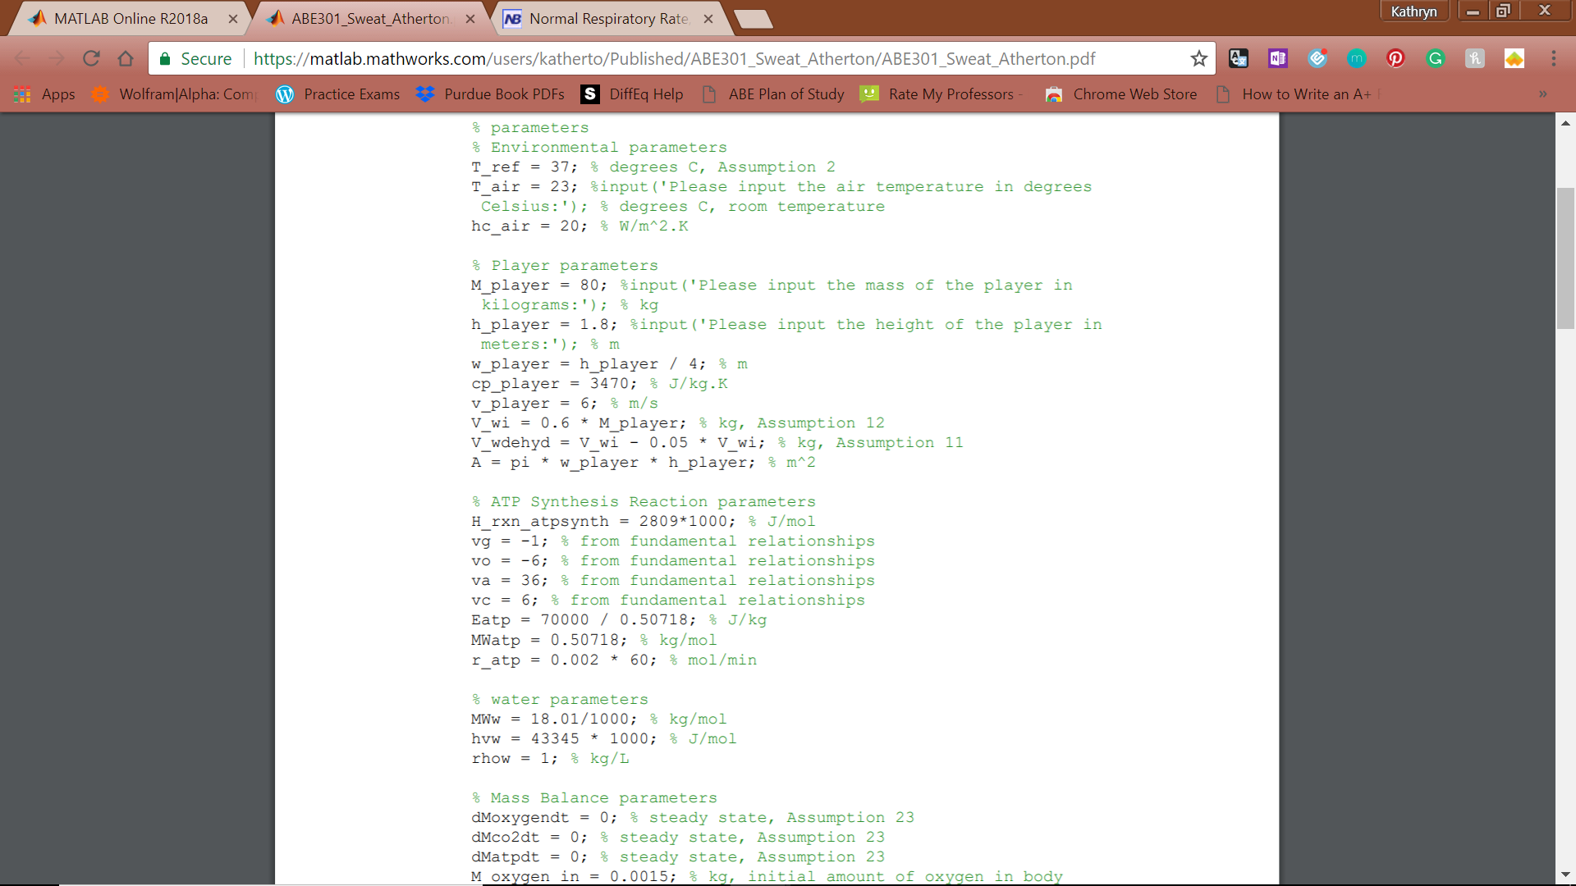

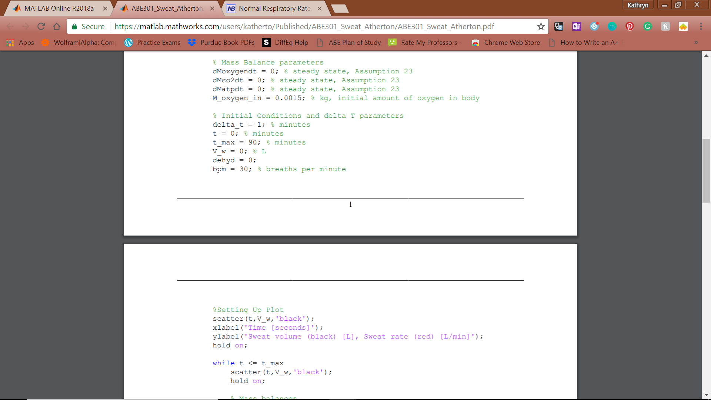

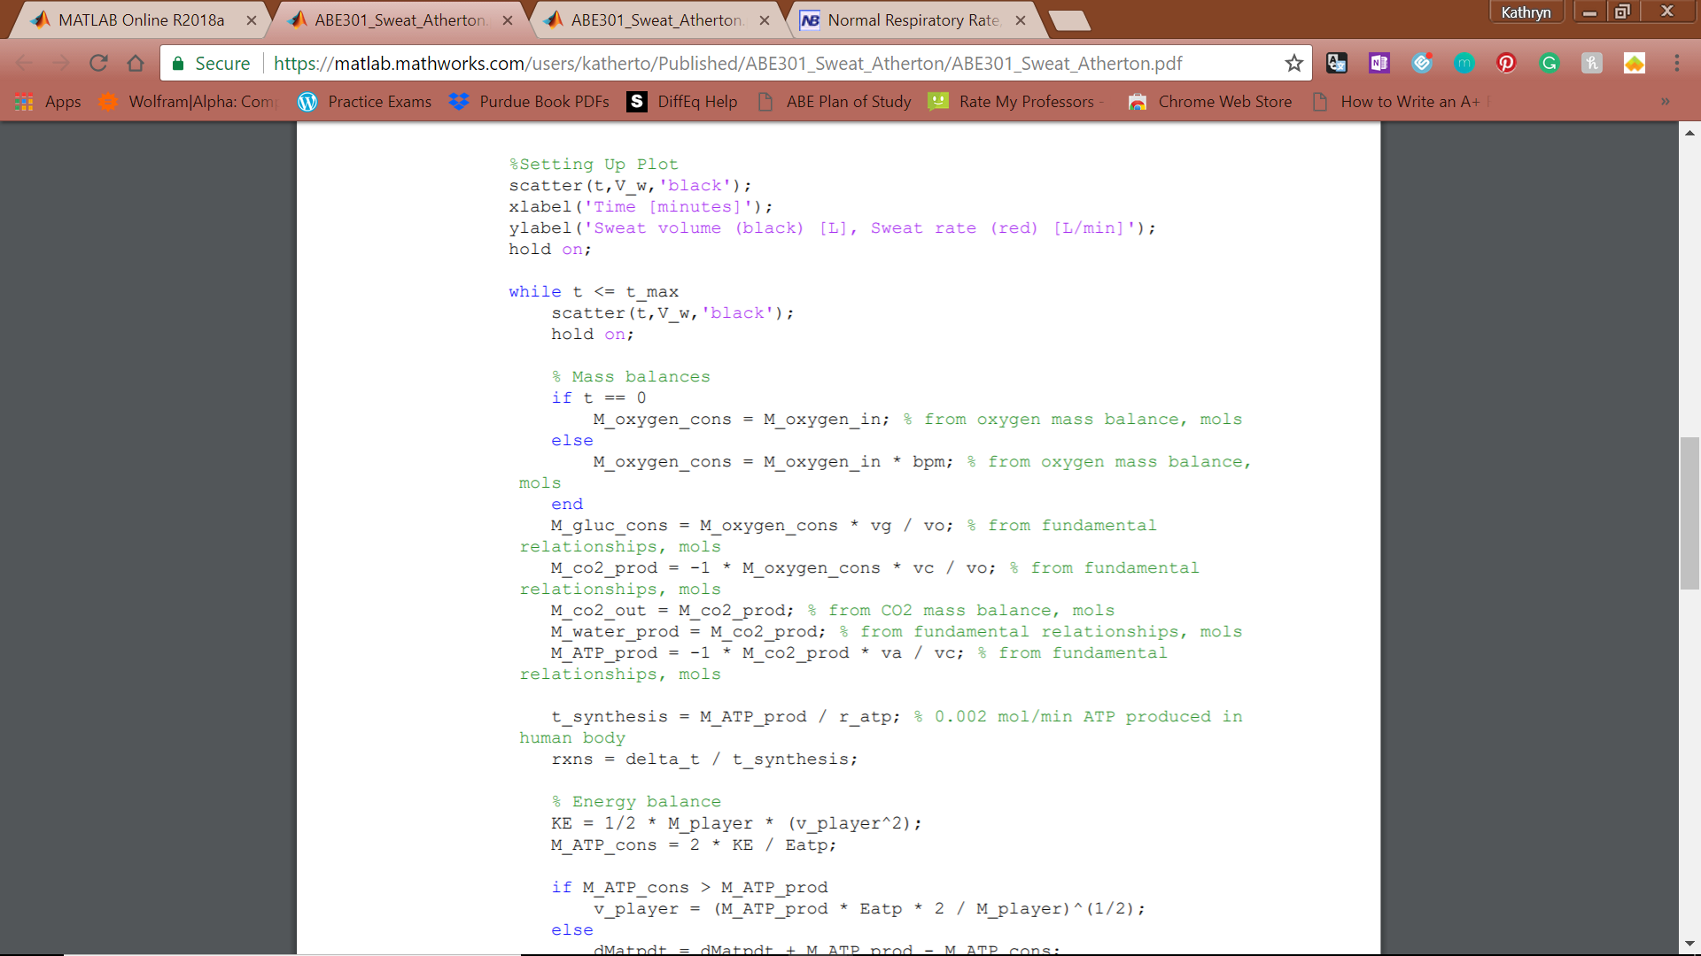

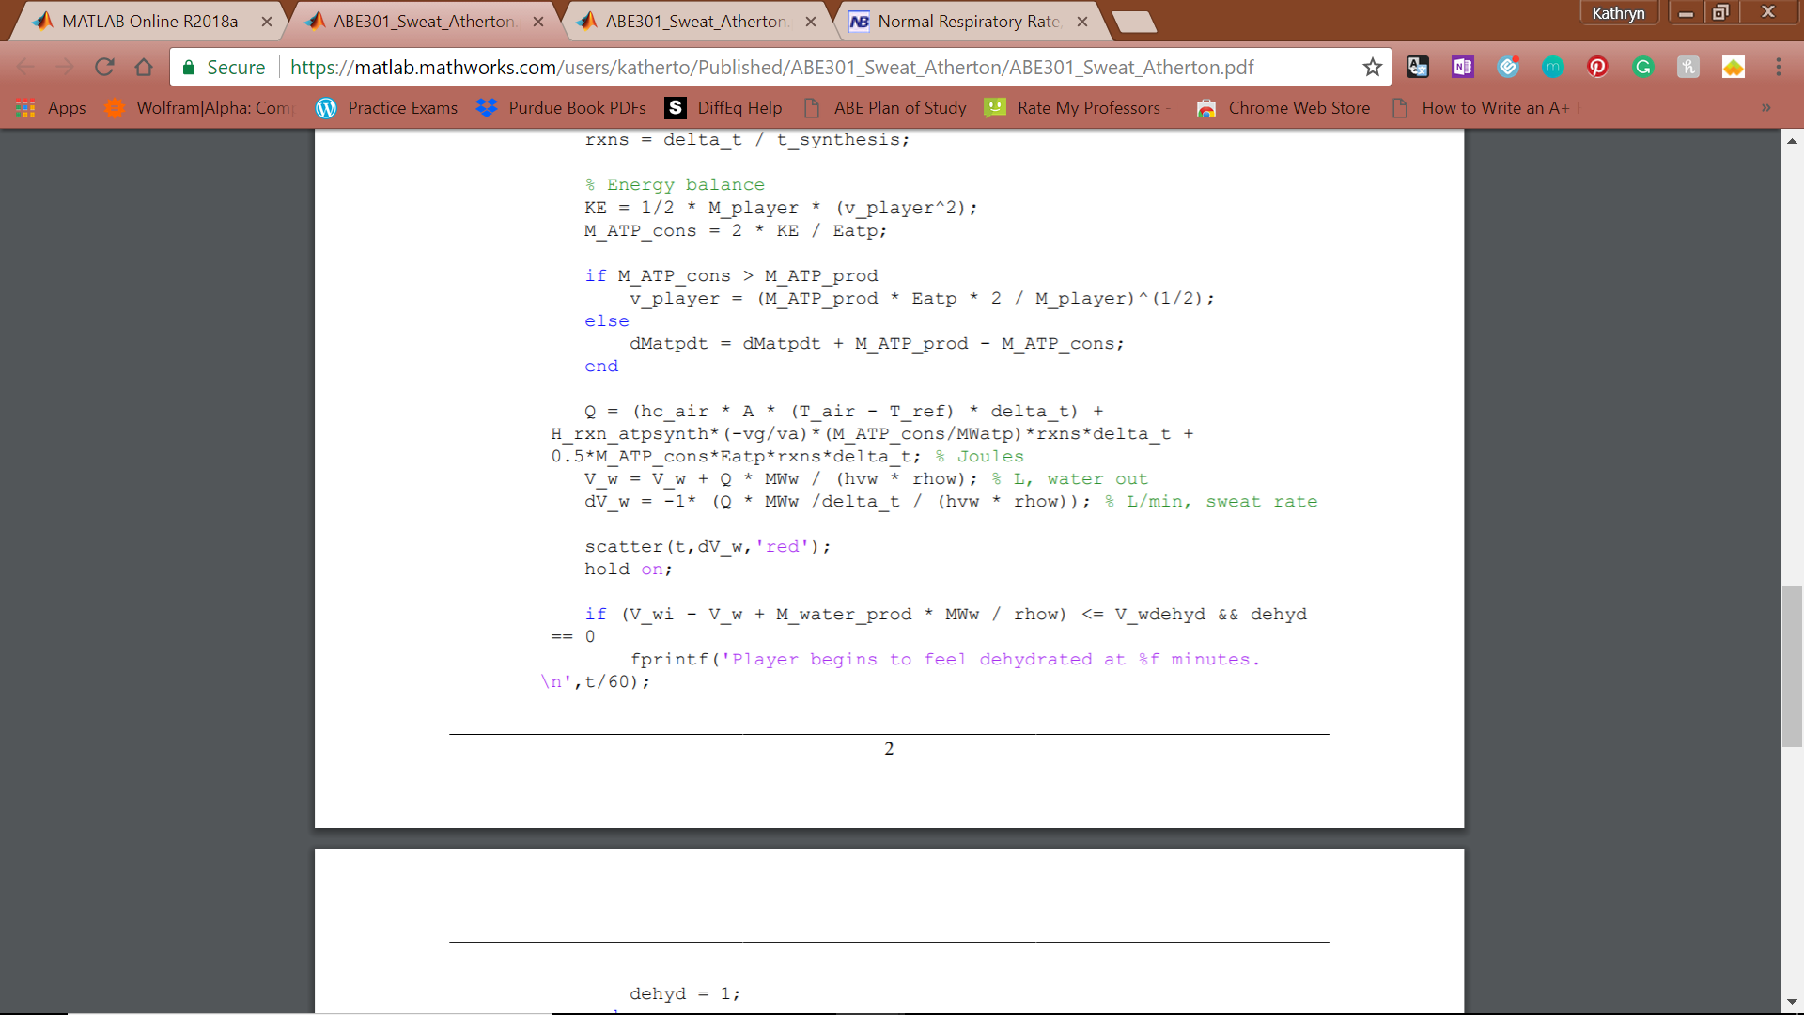

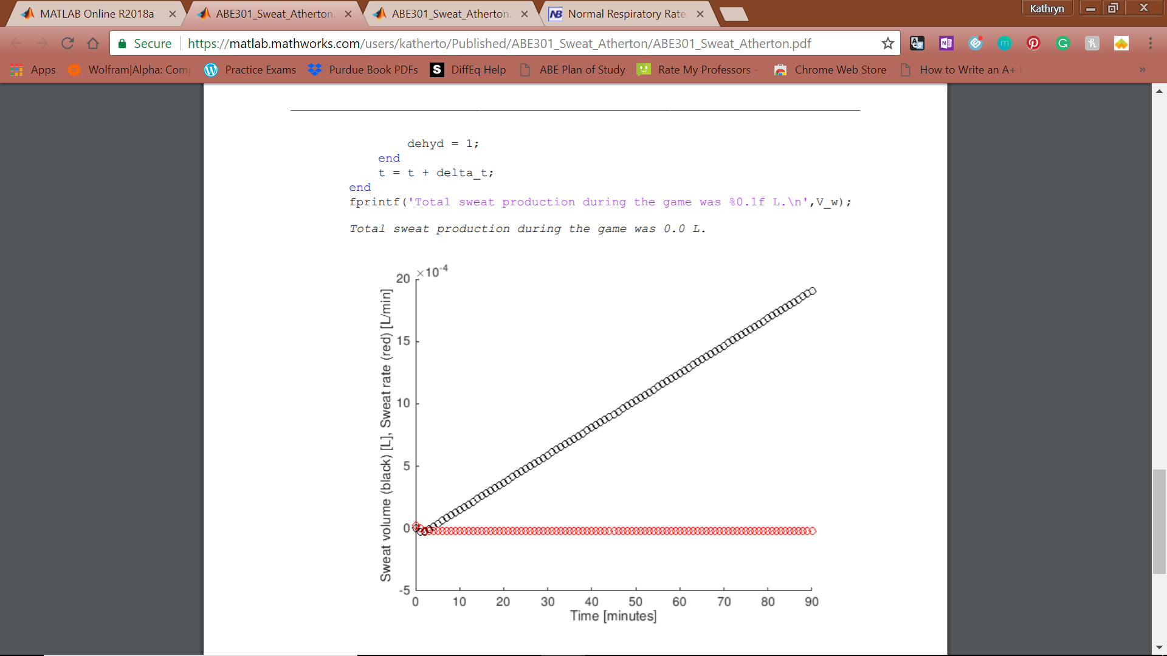

**Figure 2:** Iteration 4 MATLAB model code



**Figure 3:** Iteration 4 graphed output.

### Justification for Next Iteration:

While the final sweat volume improved from the last iteration, it is still too low for the model to be considered adequate. Additionally, thus far, algebraic methods have been used to solve for all parameters as most were assumed to be constant throughout the time modeled. The next iteration will include differential equations and vary the velocity, which will in turn vary the energy required to move throughout the game.

# Deliverable Three

## Iteration Three

### Assumptions:

1. Conversion from chemical energy to kinetic energy is 50% efficient

### Model Inputs:

* Tair [°C]
* Mplayer [kg]
* hplayer [m]
* v [m/s]

### Model Outputs:

* dVw/dt [L/min]
* Vw [L]
* tdehydration [min], if applicable

### Fundamental Relationships:

* Cellular respiration
* Steady state mass balance
* Unsteady state mass balance
* Steady state energy
* Kinetic energy
* Internal energy
* Surface area of a cylinder
* Heat

### Calculations:

* Mass balances
  + Oxygen:

|  |  |  |
| --- | --- | --- |
|  |  | [1] |

* + Carbon Dioxide:

|  |  |  |
| --- | --- | --- |
|  |  | [2] |

* + ATP:

|  |  |  |
| --- | --- | --- |
|  |  | [13] |

* + Water:

|  |  |  |
| --- | --- | --- |
|  |  | [4] |

* Energy balance:

|  |  |  |
| --- | --- | --- |
|  |  | [14] |
|  |  | [15] |
|  |  | [16] |
|  |  | [17] |
|  |  |  |
|  |  | [18] |
|  |  | [12] |

### Nomenclature:

|  |  |  |
| --- | --- | --- |
| **Symbol** | **Meaning** | **Units** |
|  | surface area of player | [m2] |
|  | enthalpy of cellular respiration | [kJ] |
|  | energy of one mole of ATP | [kJ/mol] |
|  | convective heat transfer coefficient of air | [W/m2K] |
|  | heat of vaporization of water | [kJ/mol] |
|  | mass of ATP | [kg] |
|  | mass of carbon dioxide | [kg] |
|  | mass of oxygen | [kg] |
|  | mass of player | [kg] |
|  | molecular weight of oxygen | [kg/mol] |
|  | molecular weight of water | [kg/mol] |
|  | mathematical constant pi | [-] |
|  | rate of reaction of cellular respiration | [s-1] |
|  | density of water | [kg/m3] |
|  | time | [s] |
|  | ambient temperature | [°C] |
|  | player temperature | [°C] |
|  | reference temperature of player | [°C] |
|  | speed of player | [m/s] |
|  | volume of water in player at which player is dehydrated | [L] |
|  | stoichiometric coefficient of glucose | [-] |
|  | stoichiometric coefficient of oxygen | [-] |
|  | volume of water | [L] |

### Model and Output:











**Figure 4:** Iteration 3 MATLAB model code



**Figure 5:** Iteration 3 graphed output.

### Justification for Next Iteration:

While the final sweat volume improved from the last iteration, it is still too low for the model to be considered adequate. Additionally, thus far, algebraic methods have been used to solve for all parameters as most were assumed to be constant throughout the time modeled. The next iteration will include differential equations and vary the velocity, which will in turn vary the energy required to move throughout the game.

## Iteration Two

### Assumptions:

1. ~~The player does not move throughout the game~~ The player moves at a constant speed throughout the game.
2. Average speed of the player is not affected by the position played.
3. Oxygen is the limiting reactant in metabolism to create energy
4. The energy required to kick/dribble/tackle etc. is negligent to the energy required to run/sprint/jog
5. Volumes of other gases inhaled (e.g. nitrogen, hydrogen, etc.) is exhaled, meaning the net intake of these gases is zero; the only gas inhalation measured in this model is oxygen, the only gas exhalation measured in this model is carbon dioxide
6. Oxygen and carbon dioxide mass balances are at steady state
7. There is no change in elevation on the field

### Model Inputs:

* Tair [°C]
* Mplayer [kg]
* hplayer [m]
* v [m/s]
  + This input is used to determine how much kinetic energy is needed to be produced by the player.
  + For model testing purposes, this value was set to 6 m/s.

### Model Outputs:

* dVw/dt [L/min]
* Vw [L]
* tdehydration [min], if applicable

### Fundamental Relationships:

* Cellular respiration: C6H12O6 + 6O2 🡪 6CO2 + 6H2O + 36 ATP
* Steady state mass balance: in – out + generation – consumption = 0
* Unsteady state mass balance: in – out + generation – consumption = accumulation
* Steady state energy balance internal energy + kinetic energy + potential energy = heat + work + enthalpy
  + U + EK + EP = Q + W + H
* Kinetic energy: ½ * mass * velocity2 (Assumption 21)
  + ½ * Mp * v2
* Internal energy
* Surface area of a cylinder
* Heat
  + Heat = heat of reaction + heat transfer due to convection + energy from ATP
    - Heat of reaction = enthalpy of reaction * mass of glucose reacted
    - Heat transfer due to convection = heat transfer coefficient of air * surface area of player * difference in temperature between player and air
    - Energy from ATP = moles of ATP * energy released by hydrolysis of ATP

### Calculations:

* Mass balances
  + Oxygen:

|  |  |  |
| --- | --- | --- |
|  |  | [1] |

* + Carbon Dioxide:

|  |  |  |
| --- | --- | --- |
|  |  | [2] |

* + ATP:

|  |  |  |
| --- | --- | --- |
|  |  | [13] |

* + Water:

|  |  |  |
| --- | --- | --- |
|  |  | [4] |

* Energy balance:

|  |  |  |
| --- | --- | --- |
|  |  | [14] |
|  |  | [19] |
|  |  | [20] |
|  |  | [17] |
|  |  |  |
|  |  | [18] |
|  |  | [12] |

### Nomenclature:

|  |  |  |
| --- | --- | --- |
| **Symbol** | **Meaning** | **Units** |
|  | surface area of player | [m2] |
|  | enthalpy of cellular respiration | [kJ] |
|  | energy of one mole of ATP | [kJ/mol] |
|  | convective heat transfer coefficient of air | [W/m2K] |
|  | heat of vaporization of water | [kJ/mol] |
|  | mass of ATP | [kg] |
|  | mass of carbon dioxide | [kg] |
|  | mass of oxygen | [kg] |
|  | mass of player | [kg] |
|  | molecular weight of oxygen | [kg/mol] |
|  | molecular weight of water | [kg/mol] |
|  | mathematical constant pi | [-] |
|  | rate of reaction of cellular respiration | [s-1] |
|  | density of water | [kg/m3] |
|  | time | [s] |
|  | ambient temperature | [°C] |
|  | player temperature | [°C] |
|  | reference temperature of player | [°C] |
|  | speed of player | [m/s] |
|  | volume of water in player at which player is dehydrated | [L] |
|  | stoichiometric coefficient of glucose | [-] |
|  | stoichiometric coefficient of oxygen | [-] |
|  | volume of water | [L] |

### Model and Output:





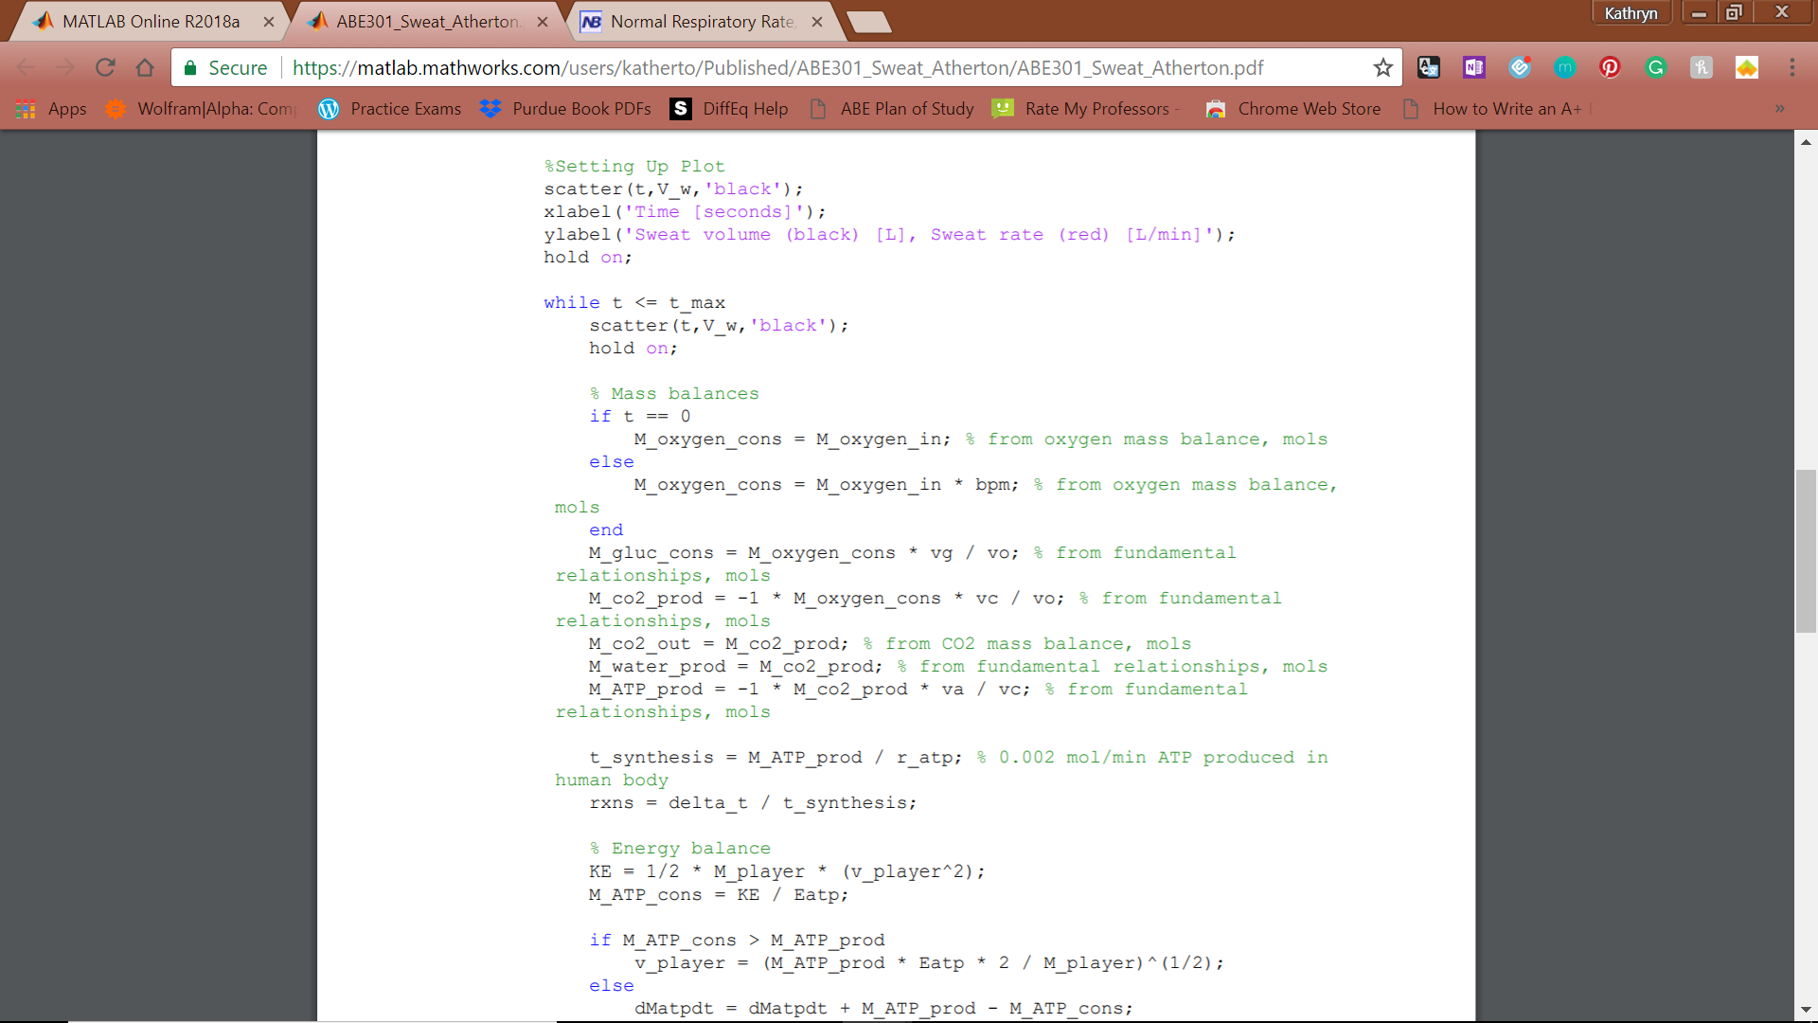

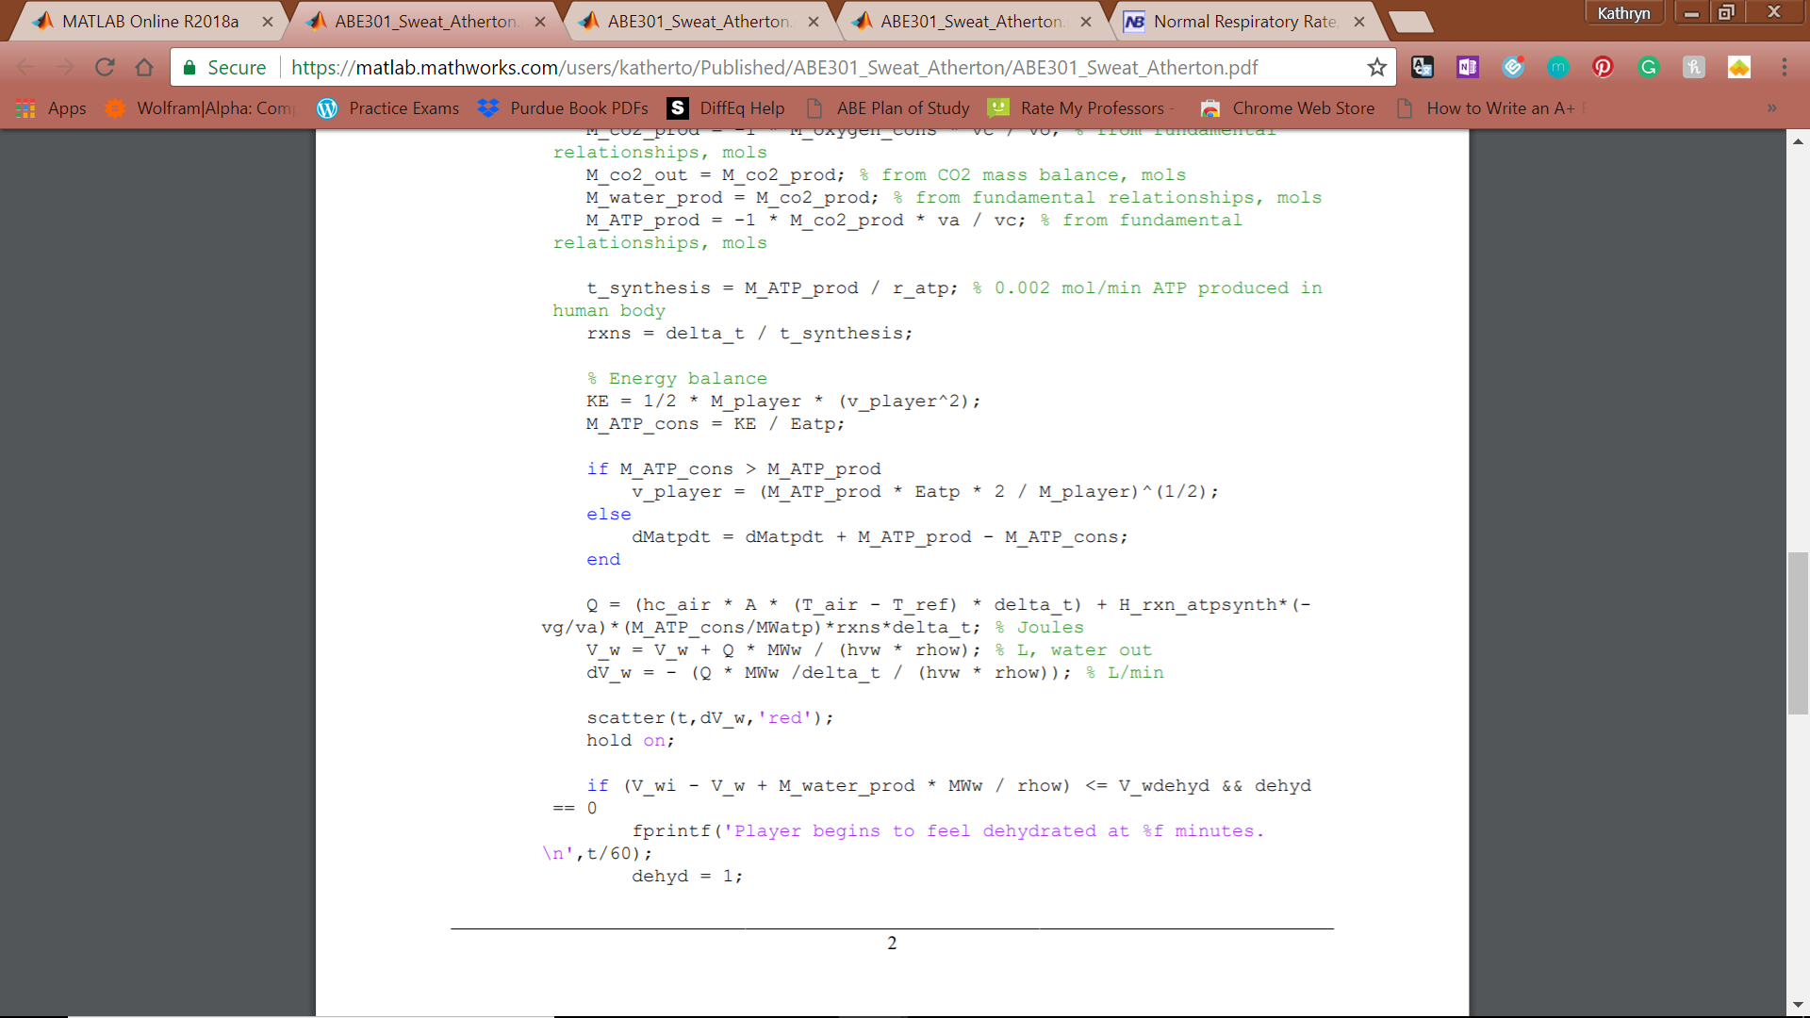



**Figure 6:** Iteration 2 MATLAB model code

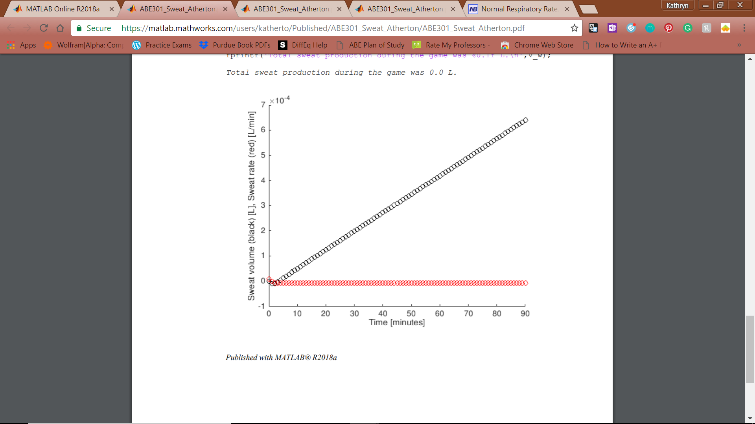

**Figure 7:** Iteration 2 graphed output.

### Justification for Next Iteration:

A final sweat volume of 0.0007 L is unrealistic for a 90-minute game. The model does not realistically show how efficient the process of ATP synthesis is. In the next iteration, I will take the inefficient release of heat into account.

## Iteration One

### Assumptions:

1. Ambient temperature and humidity are constant during the game
2. Throughout the game, the body temperature is constant throughout the body at 37°C
3. There is no wind or precipitation to affect the body temperature
4. Uniform has no effect on heat loss
5. Emotional stress of the game has no effect on sweat production
6. The player starts playing at time t=0
7. There is no extra time added at the end of either half
8. There are no pauses in game play
9. The player plays the full 90 minutes
10. Water is not consumed by the player during the game time
11. Dehydration occurs at a loss of 5% of water content of the body (“Water Purification”, 2008)
12. The body is composed of 60% water by mass (Perlman, 2016)
13. The player’s normal body metabolism is negligent, does not produce heat to warm the body up to normal temperature
14. Sweat is the only means by which the body loses heat
15. Humidity has no effect on evaporation
16. The player is cylindrical in shape
17. The player’s shoulder width is ¼ the height of the player (Ida, 2012)
18. The player does not move throughout the game

### Model Inputs:

* Tair [°C]
  + This parameter may change the rate at which the player sweats.
  + If the temperature is greater than room temperature, the player’s sweat rate will increase as the body must produce even more sweat to get the body down to a normal, functional temperature.
  + If the temperature is less than room temperature, the player’s sweat rate will decrease as some of the heat produced by the body is used to bring the body temperature up to a normal, functional temperature.
  + Stays constant over time (Assumption 1)
  + For model testing purposes, this value was set at 23°C (room temperature)
* Mplayer [kg]
  + This parameter determines how much work a player must do to move himself.
  + Additionally, the parameter helps to determine how much water the player can lose before becoming dehydrated.
  + For model testing purposes, this value was set at 80 kg (mass of Jordan Henderson, my favorite player)
* hplayer [m]
  + This parameter helps determine the surface area of the player which is used in determining the convective heat transfer with the air. (Assumption 15)
  + For model testing purposes, this value was set at 1.8 m (height of Jordan Henderson, my favorite player)

### Model Outputs:

* dVw/dt [L/min]
  + As the player runs and adjusts to the game environment, the rate of sweat (water) leaving the body changes.
  + This output will be shown as a graph of rate of sweat production versus time.
* Vw [L]
  + By integrating the graph of rate of sweat production versus time, the total volume of sweat produced in a unit of time (e.g. one minute, one half, one game, etc.) will be calculated.
  + This output will be shown as a graph and a numerical value after each half of the game (volume = x L at t = 45 minutes, t = 90 minutes).
* tdehydration [min], if applicable
  + By comparing the total amount of sweat produced by the player and the amount of water in the body at time t = 0, the time at which the player is dehydrated can be found. If a player loses more than 5% of the water in their body, they will begin to show signs of dehydration.
  + This output will be shown as a numerical value (t = x minutes).
  + Does not exceed 90 minutes (Assumption 9)

### Fundamental Relationships:

* Steady state energy balance: internal energy + kinetic energy + potential energy = heat + work + enthalpy

|  |  |  |
| --- | --- | --- |
|  |  | [21] |

* Internal energy = mass * specific heat * change in temperature

|  |  |  |
| --- | --- | --- |
|  |  | [22] |

* Convective heat = convective heat transfer coefficient * surface area * difference in temperature * time

|  |  |  |
| --- | --- | --- |
|  |  | [23] |

* Surface area of a cylinder = pi * diameter * height

|  |  |  |
| --- | --- | --- |
|  |  | [24] |

* Heat of evaporation = heat of vaporization of water * volume of water * density / molecular weight of water

|  |  |  |
| --- | --- | --- |
|  |  | [25] |

### Calculations:

* Mass balances
  + Water:

|  |  |  |
| --- | --- | --- |
|  |  | [26] |

* Energy balance:

|  |  |  |
| --- | --- | --- |
|  |  | [27] |
|  |  | [28] |
|  |  | [29] |
|  |  |  |
|  |  | [30] |
|  |  | [12] |

### Nomenclature:

|  |  |  |
| --- | --- | --- |
| **Symbol** | **Meaning** | **Units** |
| 𝐴 | surface area of player | [m2] |
|  | specific heat | [kJ/kg.K] |
|  | kinetic energy | [kJ] |
| PE | potential energy | [kJ] |
|  | convective heat transfer coefficient of air | [W/m2K] |
|  | height of player | [m] |
|  | heat of vaporization of water | [kJ/mol] |
|  | mass of player | [kg] |
|  | molecular weight of water | [kg] |
|  | mathematical constant pi | [-] |
|  | heat | [kJ] |
|  | rate of reaction of cellular respiration | [s-1] |
|  | density of water | [kg/m3] |
|  | time | [s] |
|  | ambient temperature | [°C] |
|  | time of dehydration | [min] |
|  | player temperature | [°C] |
|  | normal player temperature | [°C] |
|  | internal energy | [kJ] |
|  | speed of player | [m/s] |
|  | volume of water in player at which player is dehydrated | [L] |
|  | maximum velocity of player | [m/s] |
|  | stoichiometric coefficient of glucose | [-] |
|  | stoichiometric coefficient of oxygen | [-] |
|  | Volume of Water | [L] |
|  | work | [kJ] |

### Model and Output:

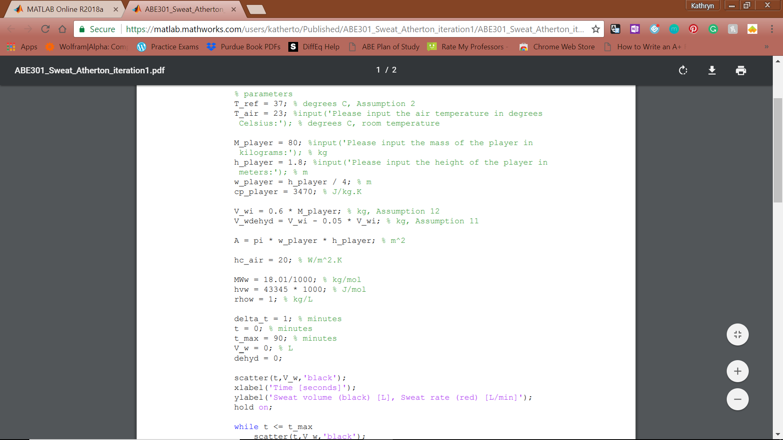

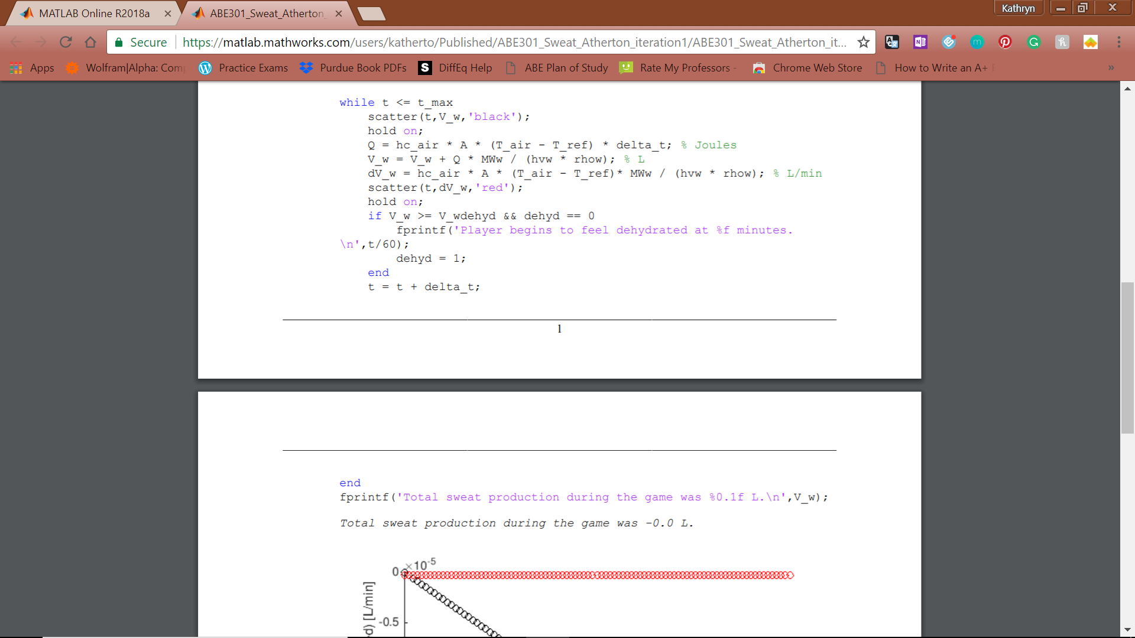



**Figure 8:** Iteration 1 MATLAB model code

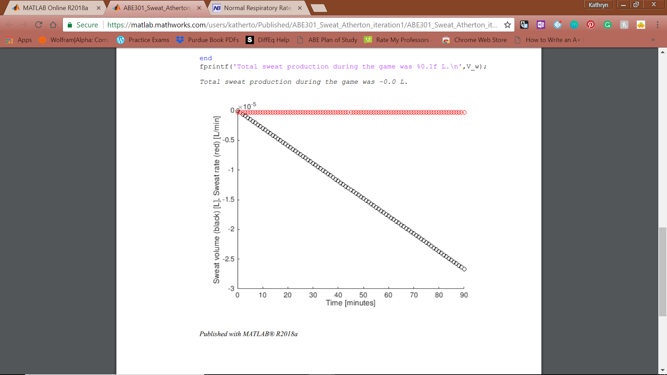

**Figure 9:** Iteration 1 graphed output.

### Justification for Next Iteration:

This iteration yielded a negative sweat rate, which is unrealistic for the temperature used for modeling, room temperature. The model needs to include the heat produced by the body in creating ATP in order to make the model more realistic.

# Deliverable Two

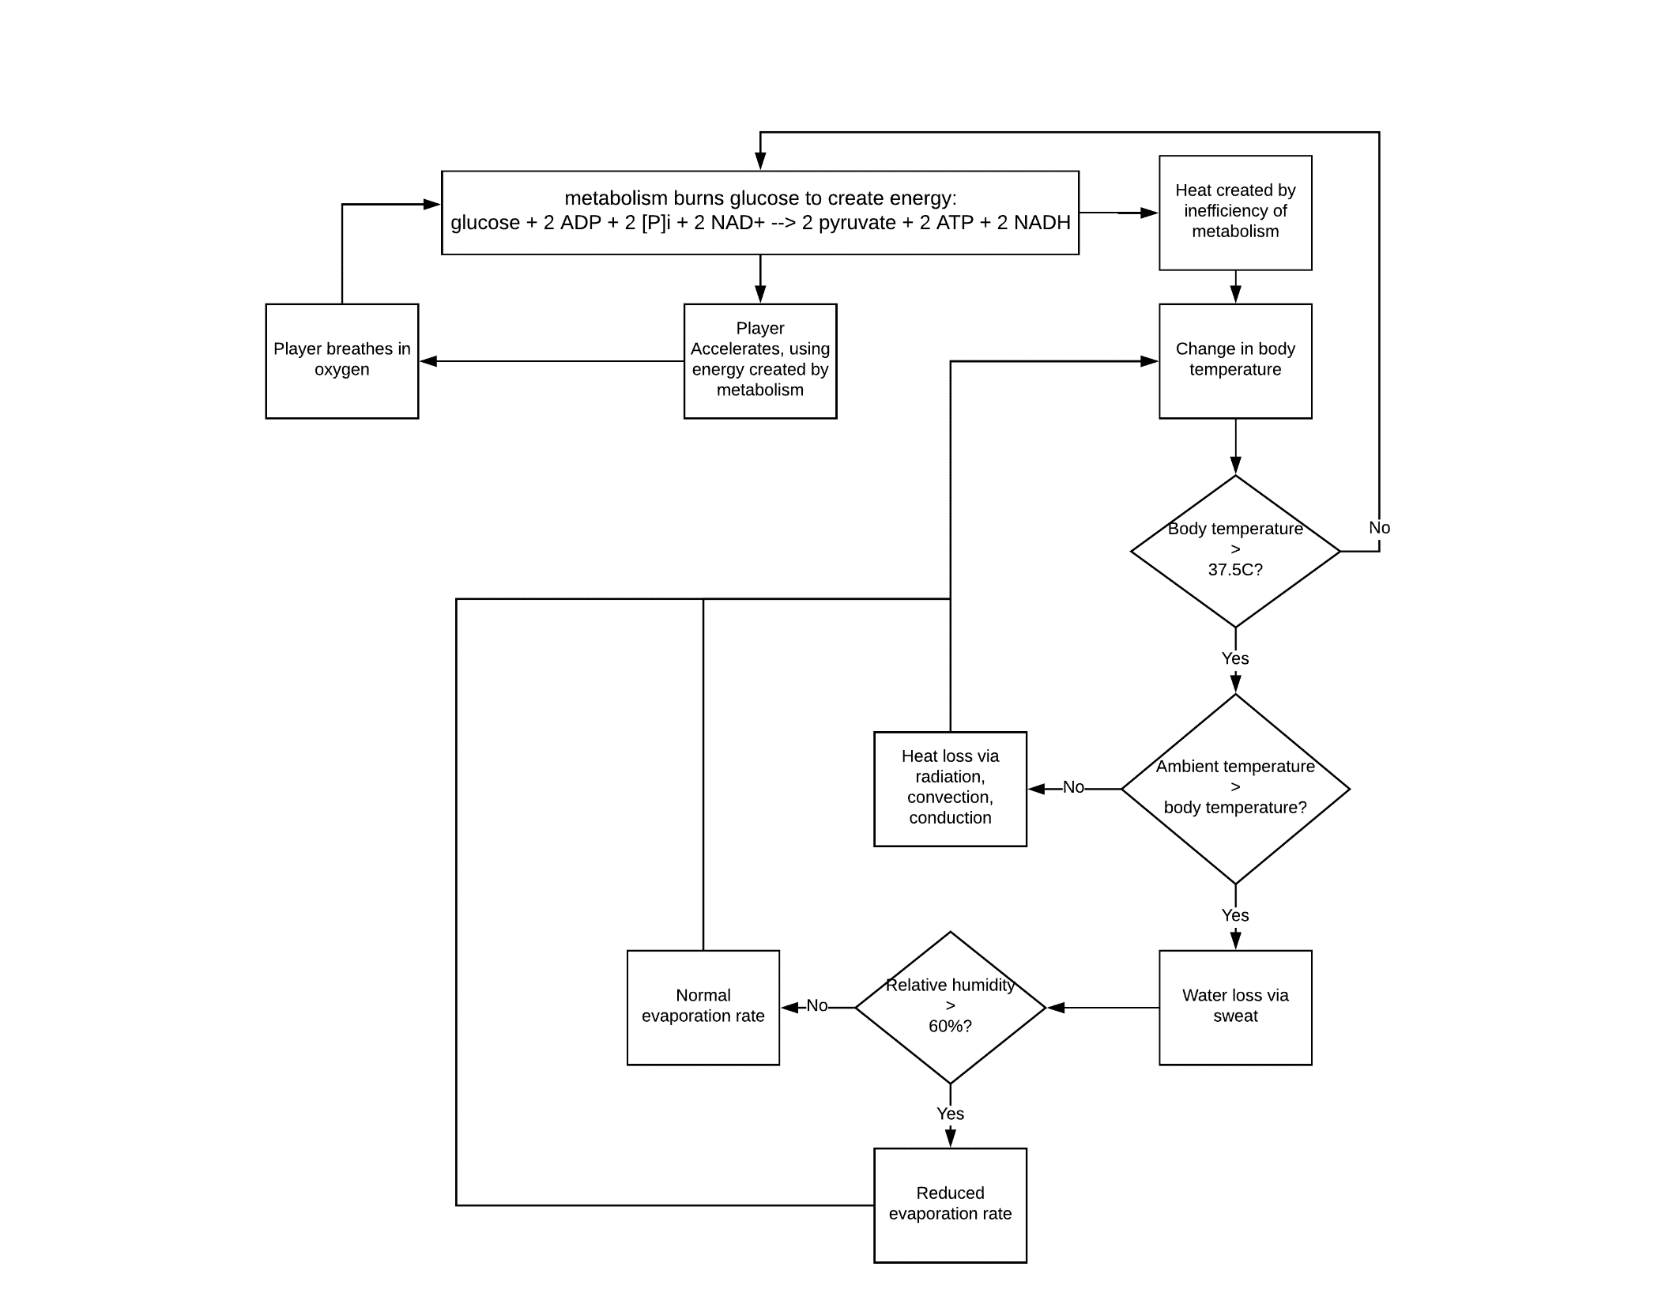

**Figure 9:** Process flow diagram. Shaded area represents the boundaries of the system.

## List of equations:

* Mass balance of aerobic respiration reactants and products
  + C6H12O6 + 6 O2 🡪 6 CO2 + 6 H2O + heat
    - O2 limiter
    - H2O added to total body water content
* Energy balance of heat created by metabolism
  + Heat = mass * specific heat * Tfinal – Tinitial
    - Mass – input
    - Specific heat = 3500J/kg.K
    - Starting temperature = 37oC
* Heat loss via sweat
  + Psychrometric charts
    - Dry bulb temperature = ambient temperature = input
    - Relative humidity = input
    - Find where relative humidity curve = dry bulb temperature, follow diagonal line to wet bulb temperature
  + Heat lost = mass * specific heat * Tfinal – Tinitial
    - Tfinal = wet bulb temperature
    - Tinitial = Tfinal from metabolism energy balance
    - Specific heat = specific heat of water
    - Mass = surface area of player * 0.01 mm * density of water
  + Heat lost = mass * specific heat * Tfinal – Tinitial
    - Heat lost = heat calculated from above
    - Mass = player mass
    - Specific heat = 3500J/kg.K
    - Tinitial = Tfinal from metabolism energy balance
* Water mass balance – solving for how much water must be consumed between halves/after game
  + In – Out + Generation – Consumption = Accumulation
    - Accumulation = 0
    - Consumption = 0
    - Generation = water created in aerobic respiration
    - Out = mass lost via sweat
  + ((60% * mass – water out) / 60%*mass) * 100% = % body water loss
    - If > 5%, dehydration symptoms shown
* Oxygen mass balance
  + In – Out + Generation – Consumption = accumulation
    - Accumulation = 0
    - Consumption = oxygen used in aerobic respiration
    - Generation = 0
    - Out = 0
    - In α acceleration of player

# Deliverable One

## Description:

The model I will construct will output the rate of sweat production volume of a professional soccer player over a 90-minute game.  The human body can only operate normally between 36.5°C and 37.5°C and temperatures outside this range impair the body’s regular function.  Additionally, the body produces heat as a byproduct of metabolic reactions (Vella & Kravitz). In converting chemical energy into mechanical energy, 75% of the energy is lost as heat through radiation, convection, conduction, and sweat evaporation (Vella & Kravitz).  During exercise, heat is generated at a higher rate and the body adjusts to this by increasing blood flow to sweat glands at the skin’s surface, producing sweat so that it evaporates and cools the body (Vella & Kravitz). As sweat is mostly composed of water, sweating causes the body to lose its water content. A loss of more than 5% of the body’s water content causes mild dehydration symptoms, including fatigue, dizziness, and thirst (Dehydration).

## Model Inputs:

* Ambient air temperature (°C)
* Relative ambient air humidity (%)
* Player’s mass (kg)
* Player’s height (m)
* Total time played (minutes)
* Player’s position (determines average velocity - m/s)

## Model Outputs:

* Sweat volume produced (L) and sweat volume production rate (L/min)
* Time at which the player will begin to display dehydration symptoms (if at all) (minutes)
* Volume of water the player must drink to restore the fluids lost during the game (L)

## Relationships:

* Mass balance of aerobic respiration reactants and products, assuming oxygen to be the limiting reactant
* Energy balance of energy produced, used, and lost by the body during play
* Rate of energy use in changes of running speed
* Enthalpy balance to determine heat production of body
* Mass balance of water production through respiration and loss through sweat to determine dehydration point (>5% body water content loss)

Phase equilibrium/psychrometrics of water and vapor in ambient air determine the evaporation of sweat and thus the cooling of the body temperature

# References

Beals, M., Gross, L., Harrell, S. (1999). Efficiency of ATP Production. Retrieved April 03, 2018, from http://www.tiem.utk.edu/~gross/bioed/webmodules/ATPEfficiency.htm

Convective Heat Transfer. (n.d.). Retrieved March 06, 2018, from https://www.engineeringtoolbox.com/convective-heat-transfer-d_430.html

Dehydration. (2017, November 17). Retrieved January 21, 2018, from https://www.mayoclinic.org/diseases-conditions/dehydration/symptoms-causes/syc-20354086

Ida, T. (2012, June 18). “Vitruvian Man” by Leonardo da Vinci and the Golden Ratio. Retrieved March 06, 2018, from http://www.crl.nitech.ac.jp/~ida/education/VitruvianMan/

Perlman, U. H. (2016, December 2). The water in you. Retrieved March 06, 2018, from https://water.usgs.gov/edu/propertyyou.html

Miñano-Espin, J., Casáis, L., Lago-Peñas, C., & Gómez-Ruano, M. Á. (2017). High Speed Running and Sprinting Profiles of Elite Soccer Players. Journal of Human Kinetics, 58, 169–176. http://doi.org/10.1515/hukin-2017-0086

SPECIFIC HEAT CAPACITIES. (n.d.). Retrieved March 06, 2018, from http://www.physics.usyd.edu.au/teach_res/db/d0005c.htm

Vella, C. A., M.S., & Kravitz, L., Ph.D. (n.d.). Staying Cool When Your Body is Hot. Retrieved January 21, 2018, from https://www.unm.edu/~lkravitz/Article%20folder/thermoregulation.html

Water – Heat of Vaporization. (n.d.). Retrieved March 06, 2018, from https://www.engineeringtoolbox.com/water-properties-d_1573.html

Water Purification: Human Need for Water. (2008). Retrieved March 06, 2018, from http://www.ciese.org/curriculum/purification/lp_intro.content.html