ABE 301 Modeling and Computational Tools in Biological Engineering Final Report

Using Myofibrillar Hypertrophy to Predict Muscle Fiber Growth

Mohammed D. Ghazali

Agricultural and Biological Engineering

Purdue University

April 27, 2017

Date: 27th April 2017

From:

Mohammed D. Ghazali

Bioengineering Modelling Consultant

West Lafayette, IN

To:

National Strength and Conditioning Association Board of Directors

Colorado Springs, CO

Subject: Computational Model of Muscle Fiber Growth over Time

Reference: Deloitte Global

Dear NSCA Board of Directors,

As requested, a computational model of human muscle fiber growth was created such that the recovery and muscle growth of professional athletes could be accurately predicted over a given time. The program takes in inputs readily available to trainers and nutritionists working with the professional athletes who will directly benefit from the model. As instructed, the model’s main purpose is to provide an ideal growth scenario for the given nutritional inputs of the professional athlete. The model also includes growth scenarios for expected growth in non-ideal situations as well as growth predictions for underachievement. This model thus provides trainers with a ceiling for how the athlete they are training could possibly grow, as well as benchmark statistics for where the growth is presently.

The model provided comes with a) the final product b) an outline of use and c) an iterative guide of its creation. This is provided so if any other modifications or additions need to be done, they can be implemented without disabling the key features of the computational model.

The vision, values, and strategy here at DTTL help us focus on working and striving to provide the exact services to our customers that they need in order to attain greater success on a daily basis. Our reputation is of utmost importance, and as such, if the product provided does not meet the highest standards and expectations that were promised, please contact DTTL, and we will work together with our clientele until the quality of service that was promised has been reached.

Sincerely,

Mohammed D. Ghazali

Mohammed D. Ghazali

**Table of Contents**

Background Introduction Page 3

Derivation of Final Model Page 6

System Definition Page 6

Variable and Parameter Nomenclature Page 6

Assumptions Page 8

Model Overall and Component Mass Balances

For Amino Acids Page 9

For Water Page 10

For G-Actin Page 10

For ATP Page 11

For ADP Page 11

For Pi Page 12

For F-Actin Page 12

For Myosin II Page 13

For Glucose Page 13

Computation Program Page 13

Analysis of Water Concentration in Myofibril Page 16

Analysis of F-Actin and Myosin Concentration in Myofibril Page 17

Analysis of ATP Concentration in Myofibril Page 17

Analysis of G-Actin Concentration in Myofibril Page 18

Analysis of Amino Acids Concentration in Myofibril Page 18

Analysis of ADP and Pi Concentration in Myofibril Page 19

Analysis of Glucose Concentration in Myofibril Page 20

Analysis of Model Page 21

Conclusions Drawn for Model Page 22

Appendix A: Works Cited Page 23

Appendix B: Complete Iterative Process Page 24

Iteration 1 Page 24

Iteration 2 Page 26

Iteration 3 Page 29

Iteration 4 Page 32

Iteration 5 Page 36

Iteration 6 Page 40

Iteration 7 Page 45

Iteration 8 Page 49

Iteration 9 Page 54

Iteration 10 Page 59

Iteration 11 Page 64

**1.1 Background Information**

Muscular hypertrophy is an increase in muscle mass as a response to trauma. Specifically, the increase in muscle mass leads to a proportional increase in cross-sectional area, since the muscle fibers are not increasing in length, but rather, width and depth. Skeletal muscle responds to trauma or stress by adapting, by ideally increasing the size of the muscle fiber by increasing the amount of contractile proteins, F-Actin and Myosin II, that make up the individual myofibrils that then make up the muscle fibers. As shown below in Figure 1, F-Actin and Myosin II are the incremental building blocks of which myofibrils are composed.

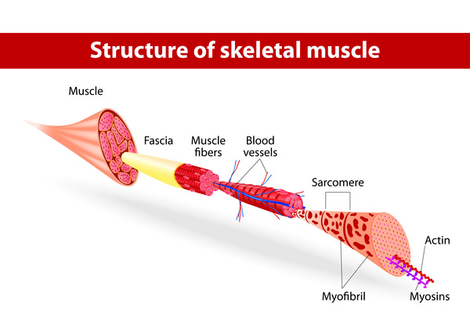

Figure 1. A component breakdown of muscle tissue from the high-order level of tissue to the lowest-order level of F-Actin and Myosin II, which are the smallest components involved in the make-up of muscle tissue (National Institutes of Health, 2012).

The myofibrils bundle together to form individual, single cell, muscle fibers. Muscle fibers, as shown in Figure 1, then make up the muscle tissue. Thus, in order to generate muscle mass, skeletal muscle hypertrophy must be undergone, such that there is an increase in contractile proteins in each myofibril.

Muscular hypertrophy can be simplified into sarcoplasmic hypertrophy and myofibrillar hypertrophy, and will be considered two phases that muscle fibers undergo, with the end outcome resulting in a muscle fiber. Sarcoplasmic hypertrophy is the volumetric growth of a muscle fiber, by an influx of water, collagen, glycogen, and other minerals that make up the sarcoplasm of a muscle cell. Sarcoplasmic hypertrophy does not result in an increase in contractile protein mass or strength to the muscle tissue. Thus, sarcoplasmic hypertrophy cannot be considered as a measure of muscle growth, since the main goal of an increase in contractile protein mass is not achieved.

Myofibrillar hypertrophy, in contrast, is results in the increase of myofibrils in the newly developed space by sarcoplasmic hypertrophy. The result is an increase of functional contractile proteins, F-Actin and Myosin II, in new myofibrils inside the muscle fiber. The schematic in Figure 2 shown below demonstrates the process of sarcoplasmic hypertrophy followed by myofibrillar hypertrophy.

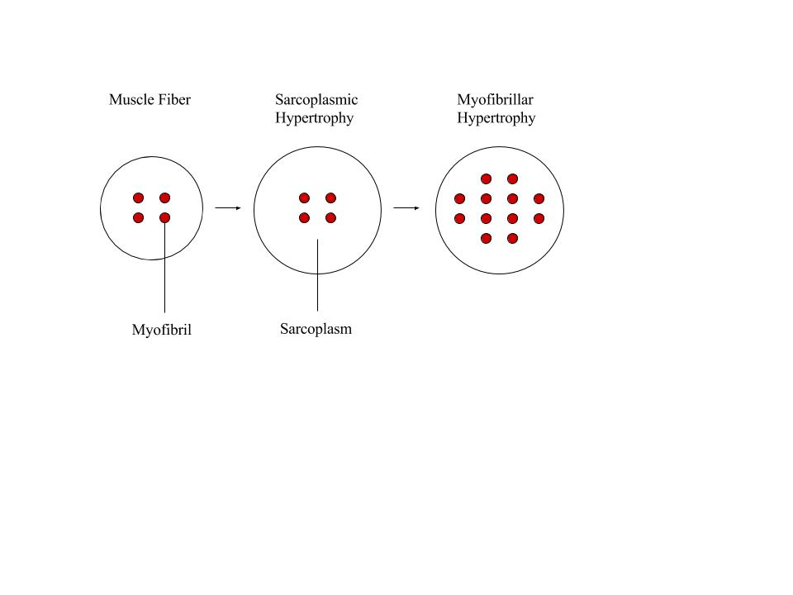

Figure 2. Muscular Hypertrophy by means of the two-step regenerative process of first undergoing sarcoplasmic hypertrophy, and then myofibrillar hypertrophy.

F-Actin is the result of G-Actin polymerization, where the globular form of the protein is transformed, through nucleotide hydrolysis, into the filamentous, helical, F-Actin protein that can be used in muscle contraction. The polymerization of G-Actin relies on energy, in the form of ATP, to occur, as well as the presence of several other complexes and ions, such as calcium and several growth hormones. G-Actin monomers are made through the process of intracellular mRNA translation, as ribosomes create peptide bonds between amino acids. These amino acids, with an average molecular weight of 100 kDa, have previously entered the muscle fiber due to pro-myogenic signaling during sarcoplasmic hypertrophy as part of the inflammatory response. Pro-myogenic signaling was the response to muscular trauma the cell endured due to the trauma it received. The polymerization of F-Actin from G-Actin monomers is shown in Figure 3

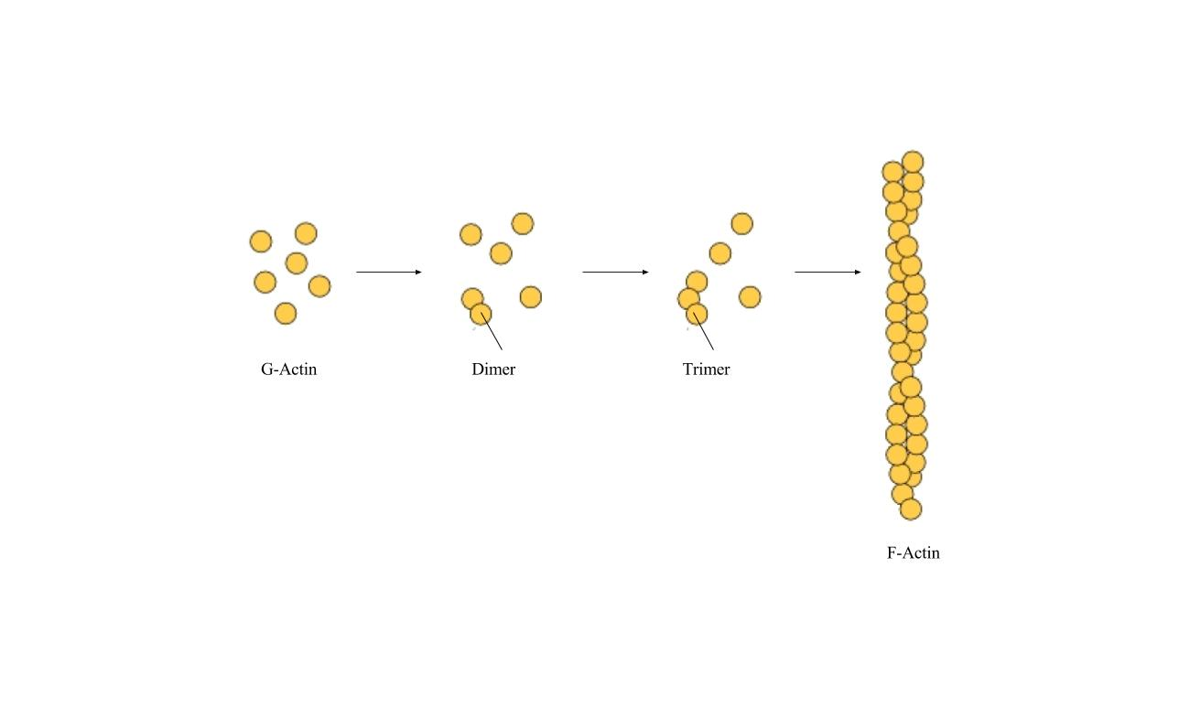

Figure 3. The sequential polymerization of G-Actin monomers into helical F-Actin

Myosin II is built in a similar fashion, the only difference being that Myosin II is comprised of two different components: two heavy chains of amino acids, which make up the head and tail end of the protein, and four light chains that serve as a bridge between the head and tail ends of the protein. Tail ends of Myosin II forms dimers, while the heads bind to actin filaments, creating a complex that allows for muscle fibers to be able to contract and expand. The interaction between the tail ends of Myosin II as well as the binding between F-Actin and the Myosin II head is shown in Figure 4 below.

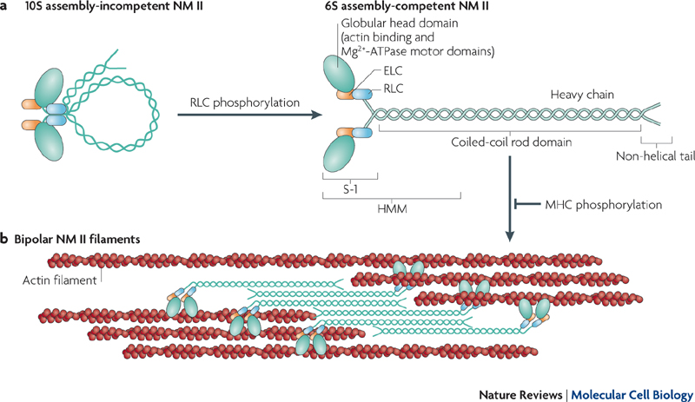

Figure 4. Illustration adapted from Vicente-Manzanares, the interaction between the Myosin II tail chains can be seen as the helical end segments form thick dimers. The interaction between the Myosin II head components and the F-Actin filament is also apparent as the globular head is attached to the actin filament (Vicente-Manzanares, 2009).

In order to create a computational model for this biological process, the total sarcoplasmic hypertrophy and the processes of F-Actin and Myosin II generation were the driving formation objective reactions that were determined to control the extent to which muscular hypertrophy occurred. Thus, these parameters will help define how the computational model is able to predict the amount of muscle mass growth over time.

**2.1 Final Model**

***System Definition***

Defining a system and its boundaries is the first step in creating an adequate computational model. Hence, Figure 5 below depicts the differential system chosen as the basis of the model.

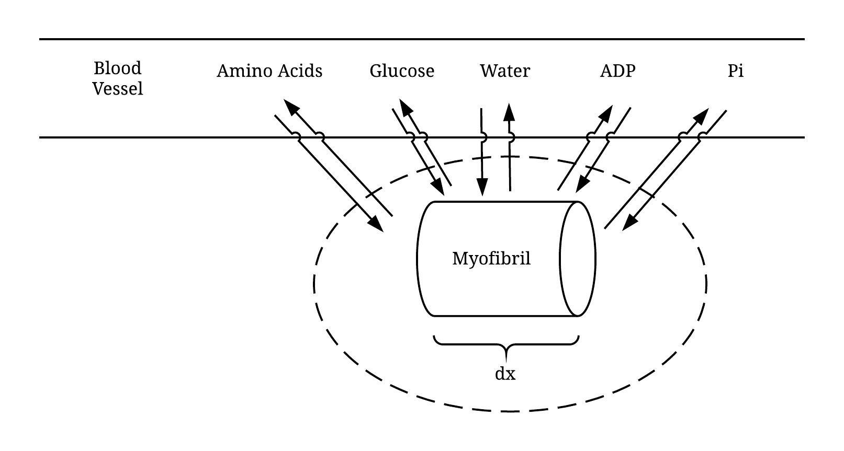

Figure 5. The system definition of the model is of a myofibril of differential length, with the boundaries of the system being clearly defined by the dashed circle as the entirety of the myofibril but excluding the blood vessel and sarcolemma. The mass and energy flows of amino acids, glucose, water, ADP (Adenosine Diphosphate), and inorganic phosphate (Pi) are depicted with arrows indicating the direction of flow.

***Variable and Parameter Nomenclature***

Tables of variable and parameter nomenclature are listed below, and will be referenced for the rest of the report.

|  |  |
| --- | --- |
| Variable | Symbol/Abbreviation |
| Amino Acids | AA |
| Adenosine Diphosphate | ADP |
| Adenosine Triphosphate | ATP |
| Inorganic Phosphate | Pi |
| F-Actin Protein | F |
| G-Actin Protein | G |
| Glucose Monomer | Glucose |
| Myosin II Protein | Myosin |
| Water | W |

Table 1. A list of model variables for which component ordinary differential equations will be created through derivation and then solved using numerical methods.

|  |  |  |
| --- | --- | --- |
| Parameter | Symbol | Units of Parameter |
| Concentration of Component X | Cx |  |
| Diffusion Coefficient for Diffusion into Myofibril | D |  |
| Differential Length of Myofibril | dx |  |
| Hydraulic Permeability | Khydra |  |
| Hydrostatic Pressure Gradient | Ps |  |
| Kinetic Reaction Constant for Conversion of G and ATP to F, ADP, and PI | k2 |  |
| Kinetic Reaction Constant for Conversion of Glucose to ATP | k4 |  |
| Length of Myofibril | L |  |
| Mass Flux | J |  |
| Michaelis-Menten Reaction Maximum Rate Constant for Conversion of AA to Myosin and W | V1 |  |
| Michaelis-Menten Reaction ½ Vmax Substrate Concentration for Conversion of AA to Myosin and W | K1 |  |
| Michaelis-Menten Reaction Maximum Rate Constant for Conversion of AA to G and W | V2 |  |
| Michaelis-Menten Reaction ½ Vmax Substrate Concentration for Conversion of AA to G and W | K2 |  |
| Molecular Weight of Component X | MWx |  |
| Radius of Myofibril | r |  |
| Volume of Myofibril | V |  |

Table 2. A list of Model Parameters. These constants will be used in the definition of equations and laws such that solutions to the derived ordinary differential equations can be accurately solved.

***Assumptions***

Assumptions made in order to define the system and simplify the model into one numerically solvable one are listed below.

Assumption 1: Treat the differential myofibril segment as a lumped parameter system, with no change in system properties in regard to position.

Assumption 2: The main objective of the model is to measure the entire body tissue growth.

Assumption 3: The body is either muscle or non-muscle, the ratio of which is known to nutritionist and trainer using the computational program.

Assumption 4: Growth in myofibril is defined as the accumulation of F-Actin and Myosin II contractile proteins.

Assumption 5: Growth of muscle tissue can be approximated as the total accumulation of the growth of myofibrils, with no difference in cumulative growth.

Assumption 6: Amino Acids can be grouped together into one generic amino acid AA.

Assumption 7: The average amino acid molecular weight is 110 Da, which is 110 grams/mole.

Assumption 8: No mass or energy is lost during conversion from one component to another.

Assumption 9: Assume a constant volume in the differential myofibril segment.

Assumption 10: Water influx is treated as passive osmosis, controlled by the water concentration gradient.

Assumption 11: Other component influx and out flux is treated as passive diffusion, with the controlling factor being the concentration gradient of the component inside and outside the cell.

Assumption 12: Assume reactions below follow first and second order reaction kinetics, respectively.

Assumption 13: Assume reactions above are only progressing in the forward direction

Assumption 14: Assume reactions below follow first order Michaelis-Menten reaction kinetics.

Assumption 15: Assume basic relationship

Assumption 16: Ignore all energy involved with protein folding

* Note that known values input into the model are in terms of molarity, not mass, since the concentration of variables such as AA and ATP are readily available to nutritionists and trainers, but mass of such variables are unlikely to be known.

***Model Overall and Component Mass Balances***

Final Model Overall Mass Balance:

Overall Differential Mass Balance:

Component Mass Balances:

1. ***For Amino Acids:***

Thus the Amino Acid Differential Component Mass Balance is:

Where:

Thus:

1. ***For Water:***

Thus the Water Differential Component Mass Balance is:

Where:

Thus:

1. ***For G-Actin:***

Thus the G-Actin Differential Component Mass Balance is:

Where:

Thus:

1. ***For ATP:***

Thus the ATP Differential Component Mass Balance is:

Where:

Thus:

1. ***For ADP:***

Thus the Water Differential Component Mass Balance is:

Where:

Thus:

1. ***For Pi:***

Thus the Water Differential Component Mass Balance is:

Where:

Thus:

1. ***For F-Actin:***

Thus the F-Actin Differential Component Mass Balance is:

Where:

Thus:

1. ***For Myosin:***

Thus the Myosin Differential Component Mass Balance is:

Where:

Thus:

1. ***For Glucose:***

Thus the Glucose Differential Component Mass Balance is:

Where:

Thus:

**3.1 Computational Model**

Below is the final iteration of the complete computational model, along with the graphical outputs, is given in Figures 6 through 10. The graphical outputs have been split up, with an analysis of each graph in its caption.

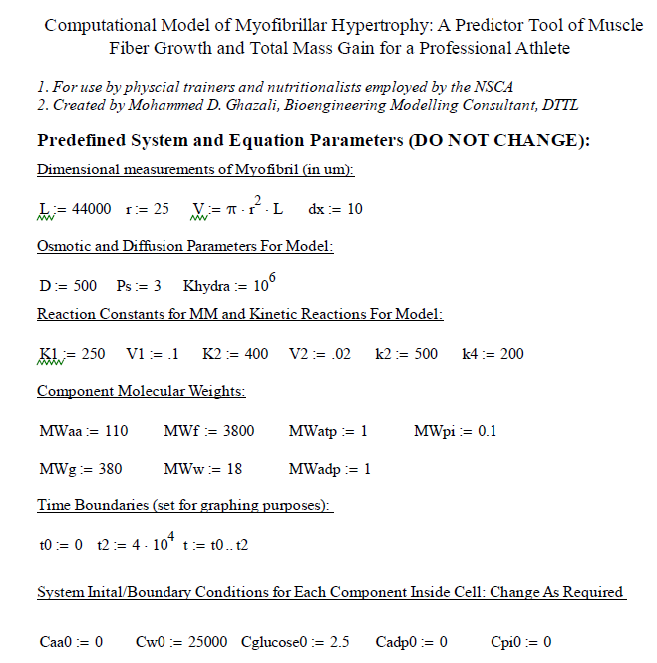

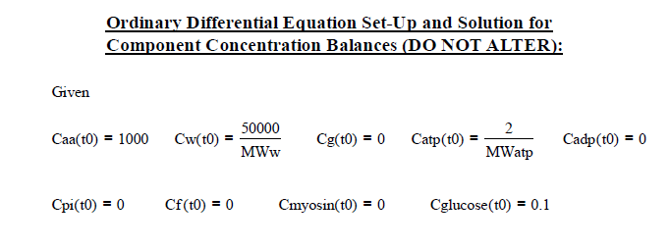

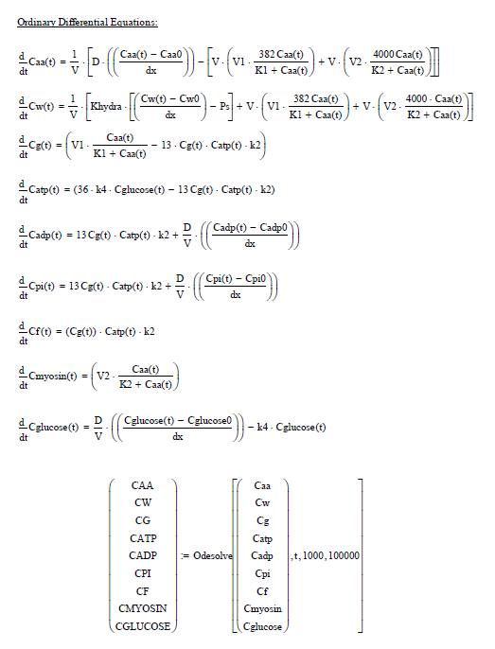

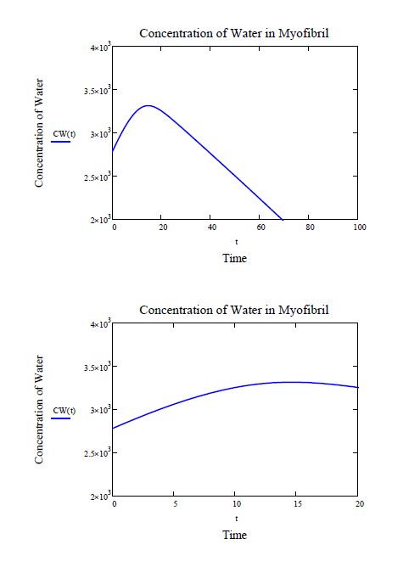

Figure 6. A graphical representation of the concentration of water inside the cell as a function of time. Note how the concentration increases by approximately 15% before decreasing linearly. This increase in concentration can be attributed to the influx of water due to inflammation, and is a sign of sarcoplasmic hypertrophy. The reduction in concentration of water can be expected as the inflammation would subside within the first day or so, which is apparent in the Figure, as time is given in hours.



Figure 7. A more exact representation of how concentration changes with respect to time within the first 20 hours. While there is an increase in concentration of water with the influx of mass, the increase is not of a great proportion. This is important to note since an increase of more than 10-15% would not make sense, since the cell would be likely to undergo cytolysis.

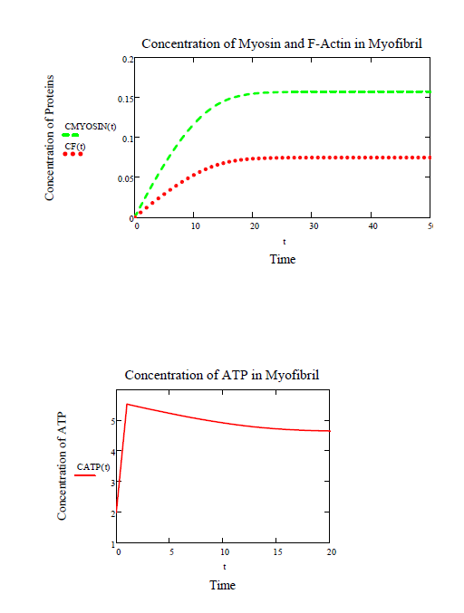

Figure 8. The concentrations of Myosin II and F-Actin over a 50 hour period accumulate at a controlled and relatively acceptable rate. The rates of accumulation both halt as the concentration of amino acids runs out, and since there is no more influx of amino acid, nor any consumption or out flux of the amino acids, the concentrations stagnate. This makes physical sense as well, since the end result of myofibrillar hypertrophy is to create both of these contractile proteins. The enzymatic reaction constants responsible to the concentration of Myosin II to be greater than F-Actin were set to yield a higher percent of Myosin than F-Actin, as per literature review.



Figure 9. The concentration of ATP in the myofibril over time increases quickly as glucose is transported into the cell, and then stagnates after the ATP consumption by the F-Actin creation reaction has reached completion. This is expected as the conversion from glucose to ATP is a one-way reaction and once the ATP has been made, it can be used to drive forward reactions. In this case, the only reaction requiring ATP comes to completion, thus the remaining concentration of available ATP. In real biological systems, ATP is used in many reactions taking place in the cell. The high concentration of ATP left in the cell therefore makes sense since usually this energy would get used in other cell processes.

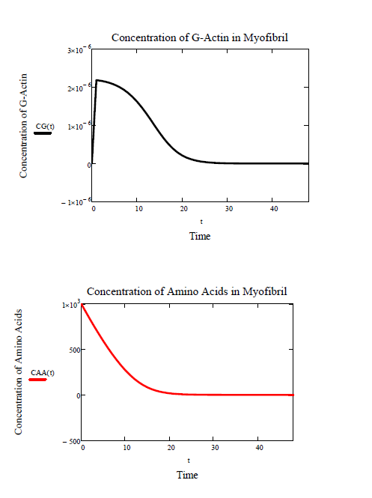

Figure 10. The concentration of G-Actin acts exactly as expected, since it is an intermediate in the overall conversion of amino acids into F-Actin. As this is the case, there is an expected jump in concentration of G-Actin right as time starts and the influx of amino acids has just started. However, as the concentration of amino acids diminishes, the G-Actin is converted into F-Actin and since there is no more generation, the G-Actin concentration curves towards and becomes zero.



Figure 11. The concentration of amino acids of a 50-hour window shows the expected drop in amino acid concentration as the influx of amino acids is converted into the contractile proteins Myosin II and F-Actin. The consumption of the amino acids in the system should drive it to equilibrium, which is does as the source of amino acids runs out and the flow of amino acids into the cell decreases. This causes the concentration of amino acids in the cell to decrease since the amino acids are being converted faster than the amino acids are flowing

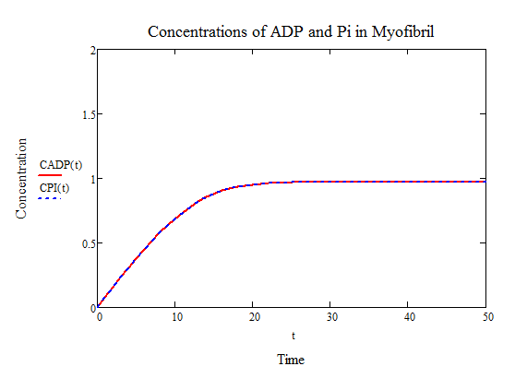

Figure 12. The concentration of ADP and inorganic phosphate act appropriately, as they are being generated as a result of the polymerization reaction converting G-Actin monomers to an F-Actin contractile protein. The leveling off of concentration for both of the components also makes sense as the diffusion in and out of the cell causes the concentration of the components to equal the concentration of these components outside the cell, which is 1 M, as seen above.

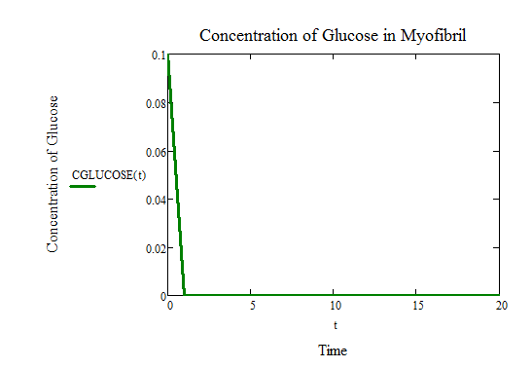

Figure 13. The concentration of glucose in the cell drops rapidly, as the influx of glucose does not make up for the rate of consumption. As such, the concentration of glucose in the cell drops until all of it has been consumed. The model adequately depicts this, and all of the glucose is consumed within the first few hours. Without a constant influx of glucose, this would be expected in a cell, as energy is constantly needed, and thus glucose would constantly be converted into ATP.

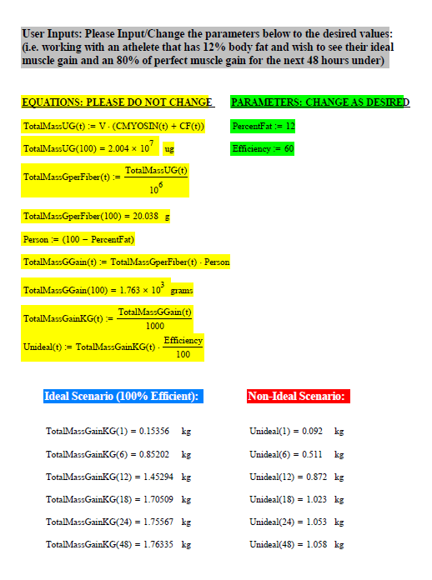

**4.1 Overall Analysis of Model**

The individual component analysis of the solutions to the ordinary differential equations are given above, with their corresponding graphical outputs. The model performs as expected, solving the nine differential equations and providing a numeric solution for a) the weight of contractile protein per myofibril, and b) total muscle mass gained in 1 hour, 6 hours, 12 hours, 18 hours, 24 hours, and 48 hours for both an ideal situation as well as for a more realistic non-ideal situation. The final weight outputs of the model, for both the ideal and non-ideal scenarios is approximately the weight gain that would be expected for professional athletes on rigorous exercise and dietary regimens. The model takes into account both sarcoplasmic and myofibrillar muscular hypertrophy, solves, and graphs results that show the gain in both fluid, with little to no gain in contractile protein mass, and then a progressive increase in contractile protein mass and both the concentrations of Myosin II and F-Actin increase until the amino acids made available by diffusion from the blood stream. Overall, the outputs of the model are reasonable, both in depicting the individual component behaviors as well as in predicting the muscle mass gain.

The model is user friendly, and does take in user inputs to calculate total muscle gain. The provided set of numeric values represent possible biological values for the system. For instance, the initial concentrations for amino acids and water, as well as the input values for concentrations in the bloodstream that are being made available to the cell are reasonable in the regard that they are on the same scale, and that diffusion in this situation would be from a blood vessel full of blood, which includes water and amino acids, into a cell deprived of both. Thus, the parameters can be changed, but should be done with caution since concentrations in the body are usually maintained in certain ranges of magnitude in order to sustain certain concentration gradients.

Limitations of the model include the absence of signaling molecules. While not directly responsible for the increase in contractile proteins, signaling molecules, ions, and growth factors all are responsible for controlling the timing of the growth and speed at which the growth occurs. Some signaling molecules are in charge of starting the growth process, and this fact is completely ignored in the current model. The model instead starts growth right away. The model also does not account for the severity of trauma from exercise, nor the likelihood of fluctuating amino acid and glucose concentrations as the athlete would eat more than once a day. The model also fails to account for growth while exercise is taking place, since the athlete would not likely be instructed to neither eat nor exercise for the longer durations, such as 24 and 48 hours, for which muscle growth was predicted.

**5.1 Conclusions Drawn from Model**

Thus, while the model does indeed have some definite limitations, its use as a predictor tool of muscle growth, especially within the first 12-18 hours since an uptake of amino acids and glucose, is promising. The model does predict a reasonable amount of weight gain and could help trainers increase or decrease the amount of amino acids and glucose their athletes are taking in, given their percent muscle. The model does also help demonstrate that within the 24 hours of muscle trauma and food intake (the source of the amino acids and glucose), there is a definite increase in muscle growth activity and can lead to successful increases in muscle generation.

**6.1 Appendix A: Works Cited**

"Actin." *Actin - Worthington Enzyme Manual*. N.p., n.d. Web. 01 May 2017.

"Actin-accumulation myopathy." *U.S. National Library of Medicine*. National Institutes of Health, Apr. 2012. Web. 29 Apr. 2017.

De, I. M., P. Gervais, and P. Molin. "Determination of cells' water membrane permeability: unexpected high osmotic permeability of Saccharomyces cerevisiae." *Biotechnology and bioengineering.* U.S. National Library of Medicine, 05 Oct. 1997. Web. 01 May 2017.

Koch, A. L. "What size should a bacterium be? A question of scale." *Annual review of microbiology.* U.S. National Library of Medicine, n.d. Web. 01 May 2017.

Maurel, C., J. Reizer, J. I. Schroeder, and M. J. Chrispeels. "The vacuolar membrane protein gamma-TIP creates water specific channels in Xenopus oocytes." *The EMBO journal.* U.S. National Library of Medicine, June 1993. Web. 01 May 2017.

R. Hober (1967) "Physical Chemistry of cells and tissues" Churchill, London and Daniels and Alberty (1961) "Physical Chemistry" Wiley, New York

Vicente-Manzanares, Miguel, Xuefei Ma, Robert S. Adelstein, and Alan Rick Horwitz. "Non-muscle myosin II takes centre stage in cell adhesion and migration." *Nature Reviews Molecular Cell Biology* 10.11 (2009): 778-90. *Nature*. Web. 29 Apr. 2017.

Zaher, H. S., and R. Green. "Fidelity at the molecular level: lessons from protein synthesis." *Cell.* U.S. National Library of Medicine, 20 Feb. 2009. Web. 01 May 2017.

Zeuthen, T., E. Zeuthen, and N. Macaulay. "Water transport by GLUT2 expressed in Xenopus laevis oocytes." *The Journal of physiology.* U.S. National Library of Medicine, 01 Mar. 2007. Web. 01 May 2017.

**7.1 Appendix B: Model Iterations**

Iteration 1:

System Definition, Boundaries, and Mass/Energy Flow across Boundaries.

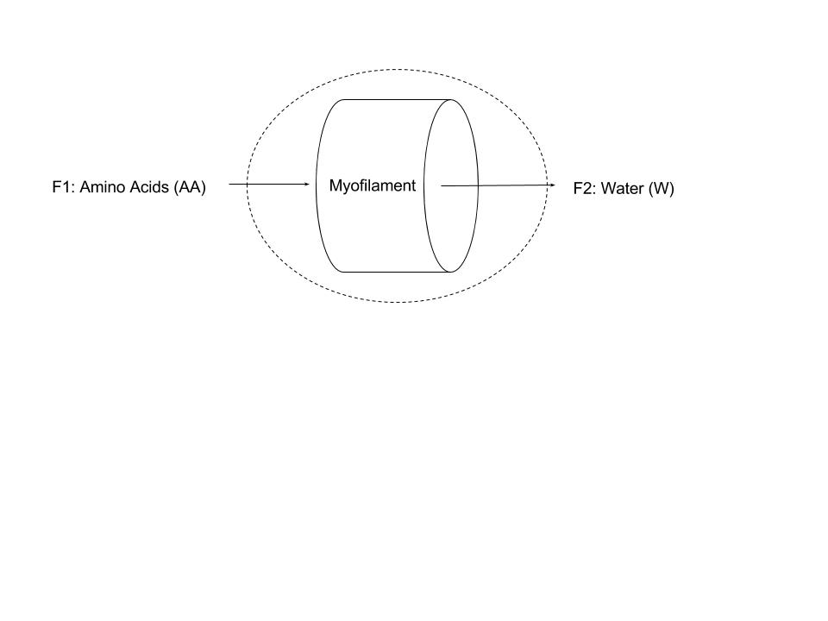

Assumptions:

* Lumped Parameter System such that this is a steady state reaction in regards to position
* Measuring growth of myofilament
* Growth is defined as accumulation of F-Actin.
* Assume constant flow rates in and out
* Assume one kind of amino acid instead of 20 amino acids
* No energy or mass lost during conversions
* Assume an initial concentration of AA of 380 mol/L
* The average amino acid molecular weight is 110 Da = 110 g/mol
* The molecular weight of a G-Actin protein is 41785 Da
* Assume volume is constant such that with an L = 3 mm and r = 7.5 nm.
* Assume reaction for conversion of amino acids:
* Assume first order rate law for reaction for conversion of amino acids:
* Assume basic relationship
* Note that all have the same units of, since and since.

Nomenclature:

|  |  |  |
| --- | --- | --- |
| Parameter | Symbol | Units |
| Concentration of component x | C |  |
| Molecular Weight | MW |  |
| Volumetric Flow Rate | F |  |
| First Order Rate Constant | K |  |
| Volume | V |  |
| Mass | Mass |  |

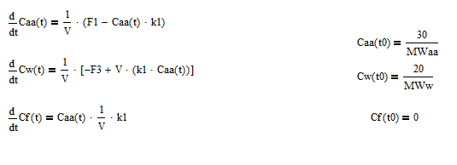

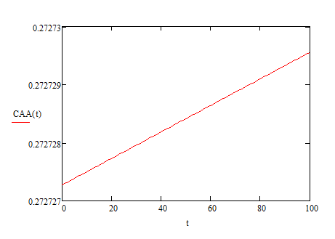

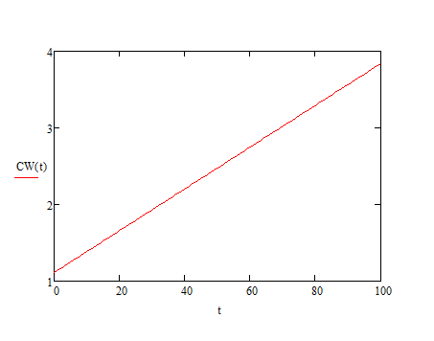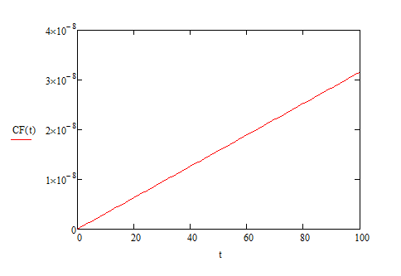

Iteration 2:

System Definition, Boundaries, and Mass/Energy Flow across Boundaries.

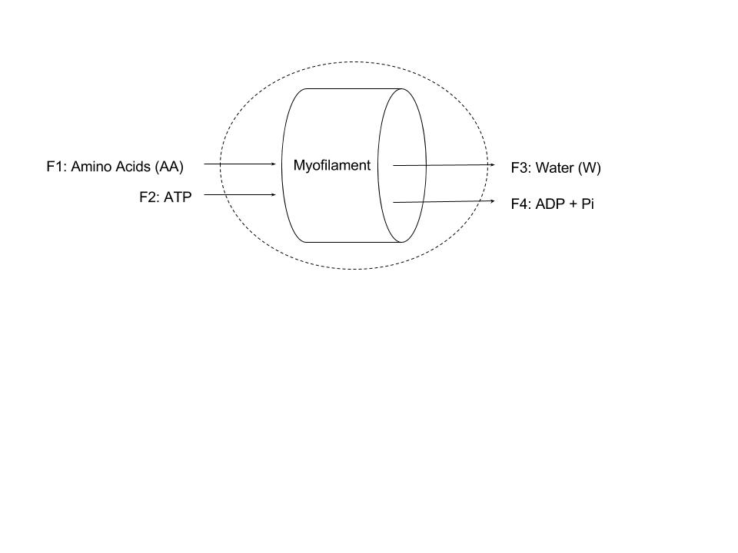

Assumptions:

* Lumped Parameter System such that this is a steady state reaction in regards to position
* Measuring growth of myofilament
* Growth is defined as accumulation of F-Actin.
* Assume one kind of amino acid instead of 20 amino acids
* No energy or mass lost during conversions
* Assume an initial concentration of AA of 380 mmol/mL
* The average amino acid molecular weight is 110 Da = 110 g/mol
* The molecular weight of a G-Actin protein is 41785 Da
* Assume volume is constant such that with an L = 3 mm and r = 7.5 nm.
* CHANGED ASSUMPTION: Assume reaction for conversion of amino acids:
  + 1)
  + 2)
* CHANGED ASSUMPTION: Assume first order rate law for reaction for conversion of amino acids:
  + 1)
  + 2)
* Assume constant flow rates in and out

Nomenclature:

|  |  |  |
| --- | --- | --- |
| Parameter | Symbol | Units |
| Concentration of component x | C |  |
| Molecular Weight | MW |  |
| Volumetric Flow Rate | F |  |
| First Order Rate Constant for Conversion of Amino Acid to G-Actin | k1 |  |
| First Order Rate Constant for Conversion of G-Actin to F-Actin | k2 |  |
| Volume | V |  |
| Mass | Mass |  |
| Mole Fraction of component y |  |  |
| Density | den |  |

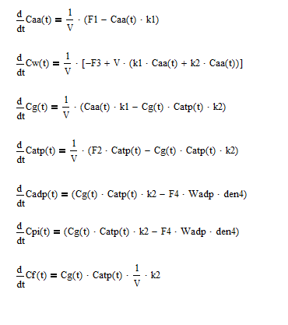

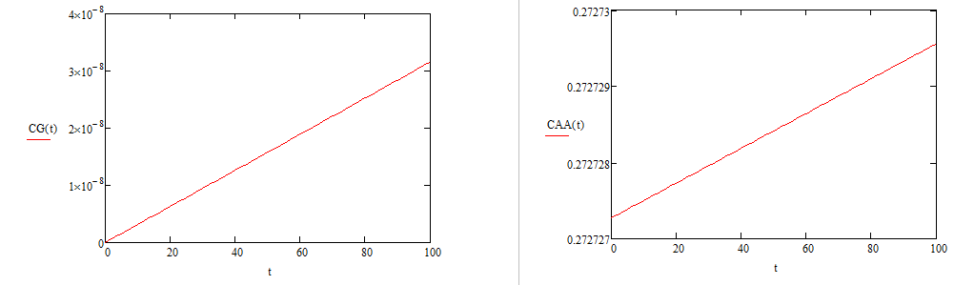

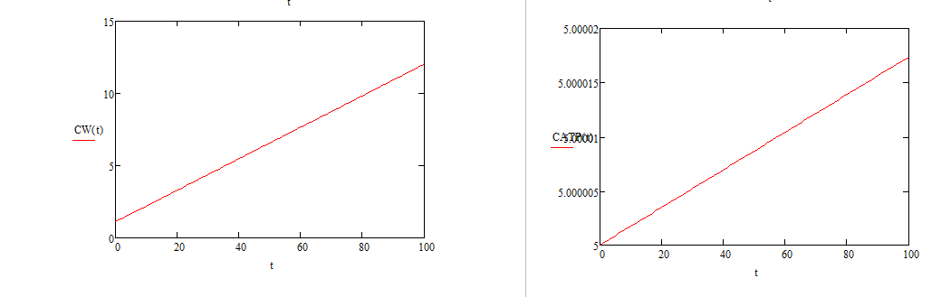

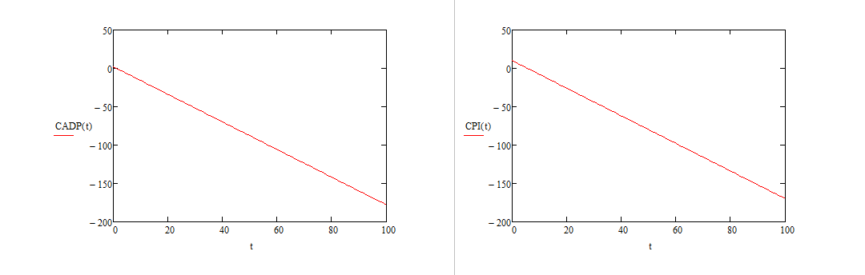

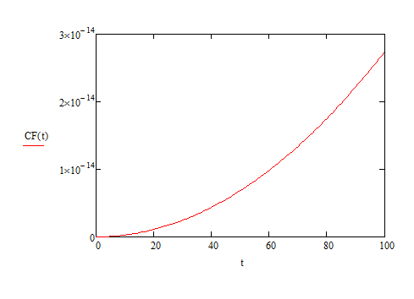

Iteration 3:

System Definition, Boundaries, and Mass/Energy Flow across Boundaries.



Assumptions:

* Lumped Parameter System such that this is a steady state reaction in regards to position
* Measuring growth of myofilament
* Growth is defined as accumulation of F-Actin.
* Assume one kind of amino acid instead of 20 amino acids
* No energy or mass lost during conversions
* Assume an initial concentration of AA of 380 mmol/mL
* The average amino acid molecular weight is 110 Da = 110 g/mol
* The molecular weight of a G-Actin protein is 41785 Da
* Assume volume is constant such that with an L = 44000 um and r = 25 um.
* Assume reaction for conversion of amino acids:
  + 1)
  + 2)
* CHANGED ASSUMPTION: Assume MM rate law for reaction for conversion of amino acids:
  + 1)
  + 2)
* Assume constant flow rates in and out

Nomenclature:

|  |  |  |
| --- | --- | --- |
| Parameter | Symbol | Units |
| Concentration of component x | [x] |  |
| Molecular Weight | MW |  |
| Volumetric Flow Rate | F |  |
| First Order Rate Constant for Conversion of Amino Acid to G-Actin | k1 |  |
| First Order Rate Constant for Conversion of G-Actin to F-Actin | k2 |  |
| Volume | V |  |
| Mass | Mass |  |
| Mole Fraction of component y |  |  |
| Density | den |  |

ODE for iteration 3 below:

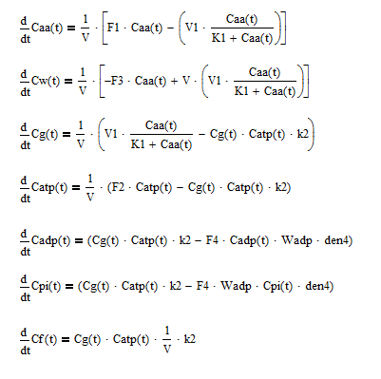

Plot output for iteration 3:

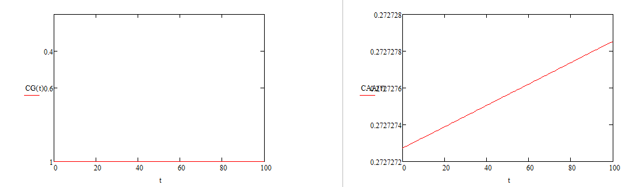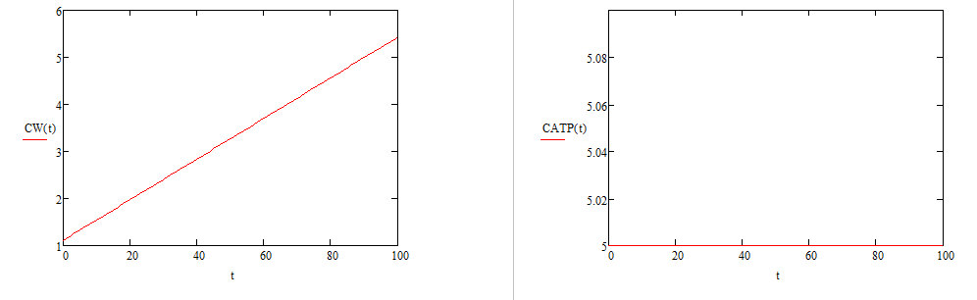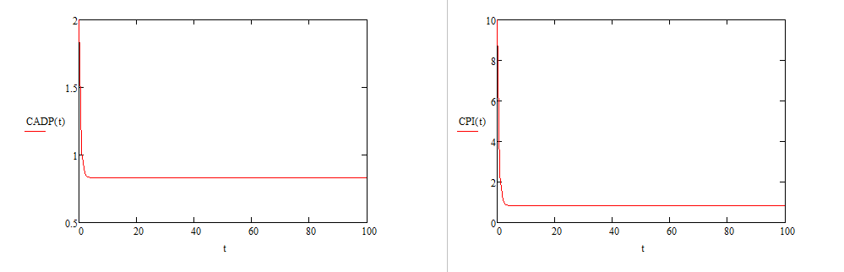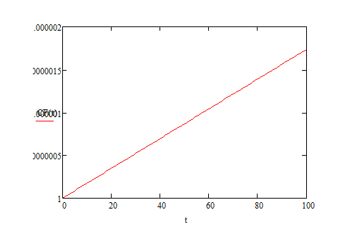

Iteration 4:

System Definition, Boundaries, and Mass/Energy Flow across Boundaries.



Assumptions:

* Lumped Parameter System such that this is a steady state reaction in regards to position
* Measuring growth of myofilament
* Growth is defined as accumulation of F-Actin.
* Assume one kind of amino acid instead of 20 amino acids
* No energy or mass lost during conversions
* Assume an initial concentration of AA of 380 mmol/mL
* The average amino acid molecular weight is 110 Da = 110 g/mol
* The molecular weight of a G-Actin protein is 41785 Da
* Assume volume is constant such that with an L = 44000 um and r = 25 um.
* CHANGED ASSUMPTION: Assume reaction for conversion of amino acids:
  + 1)
  + 2)
  + 3)
* CHANGED ASSUMPTION: Assume MM rate law for reaction for conversion of amino acids:
  + 1)
  + 2)
* Assume constant flow rates in and out

Nomenclature:

|  |  |  |
| --- | --- | --- |
| Parameter | Symbol | Units |
| Concentration of component x | [x] |  |
| Molecular Weight | MW |  |
| Volumetric Flow Rate | F |  |
| First Order Rate Constant for Conversion of Amino Acid to G-Actin | k1 |  |
| First Order Rate Constant for Conversion of G-Actin to F-Actin | k2 |  |
| Volume | V |  |
| Mass | Mass |  |
| Mole Fraction of component y |  |  |
| Density | den |  |

ODE for iteration 4 below:

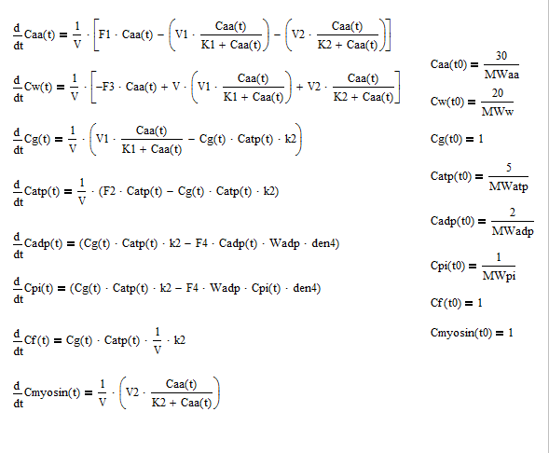

Plot output for iteration 4:

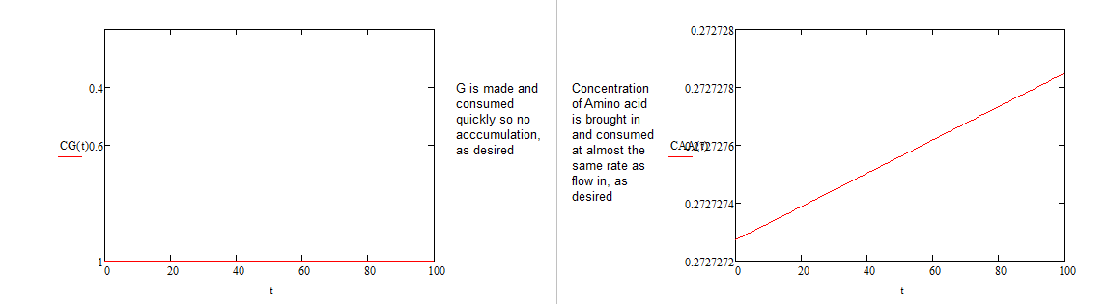

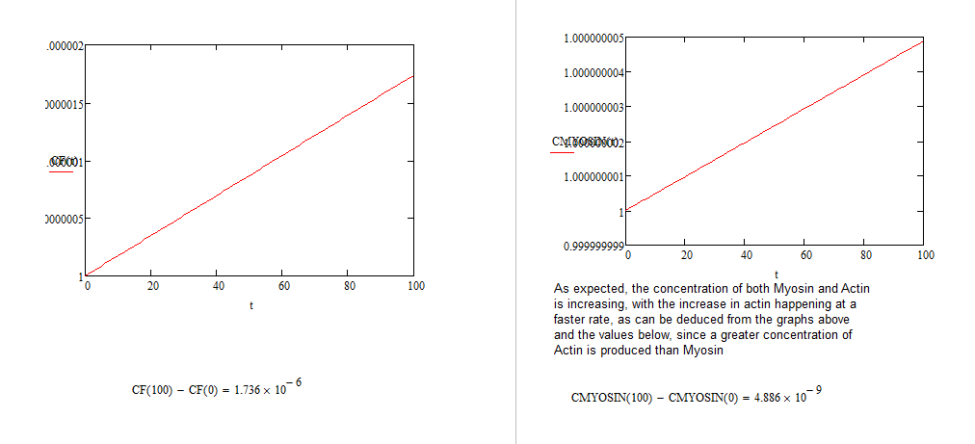

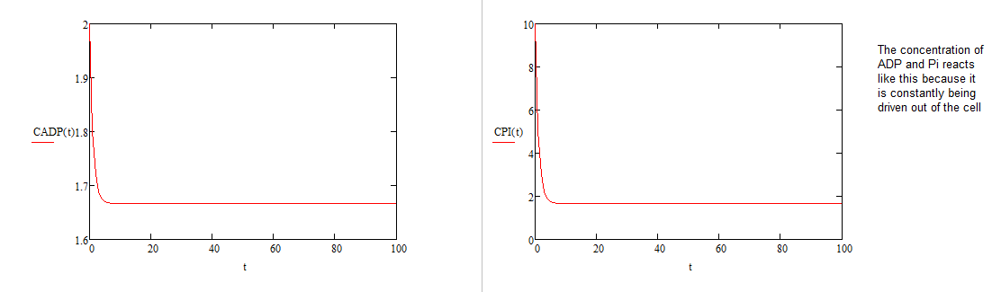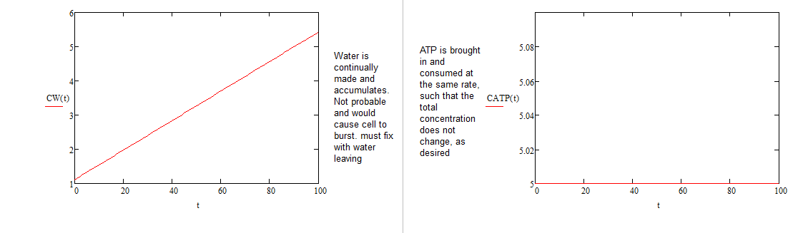

Iteration 5:

System Definition, Boundaries, and Mass/Energy Flow across Boundaries.



Assumptions:

* Lumped Parameter System such that this is a steady state reaction in regards to position
* Measuring growth of myofilament
* Growth is defined as accumulation of F-Actin.
* Assume one kind of amino acid instead of 20 amino acids
* No energy or mass lost during conversions
* Assume an initial concentration of AA of 380 mmol/mL
* The average amino acid molecular weight is 110 Da = 110 g/mol
* The molecular weight of a G-Actin protein is 41785 Da
* Assume volume is constant such that with an L = 44000 um and r = 25 um.
* Assume reaction for conversion of amino acids:
  + 1)
  + 2)
  + 3)
* Assume MM rate law for reaction for conversion of amino acids:
  + 1)
  + 2)
* CHANGED ASSUMPTION: Assume constant flow rates in and out - Fixed flux in and out such that the dependencies are on relevant concentrations of components. Was mistake that was not caught until later.

Nomenclature:

|  |  |  |
| --- | --- | --- |
| Parameter | Symbol | Units |
| Concentration of component x | [x] |  |
| Molecular Weight | MW |  |
| Volumetric Flow Rate | F |  |
| First Order Rate Constant for Conversion of Amino Acid to G-Actin | k1 |  |
| First Order Rate Constant for Conversion of G-Actin to F-Actin | k2 |  |
| Volume | V |  |
| Mass | Mass |  |
| Mole Fraction of component y |  |  |
| Density | den |  |

ODE for iteration 5 below:

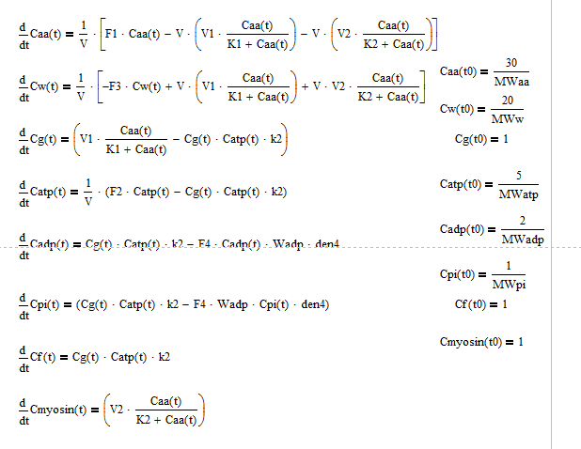

Graphical Output for iteration 5:

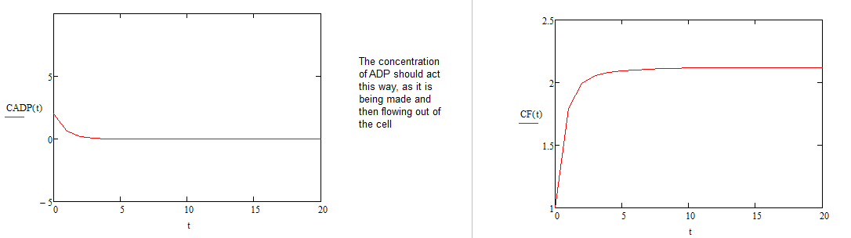

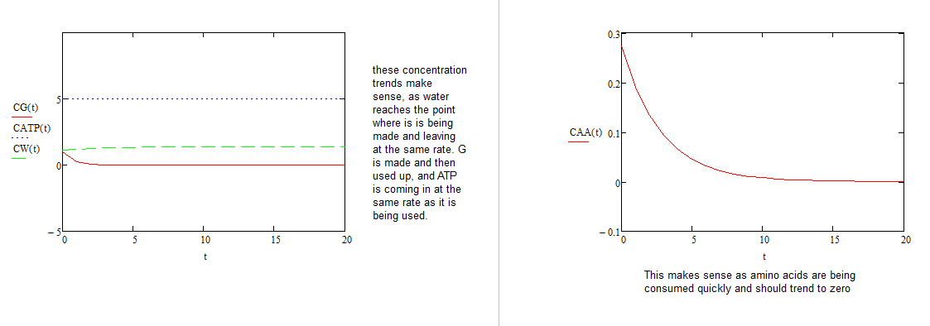

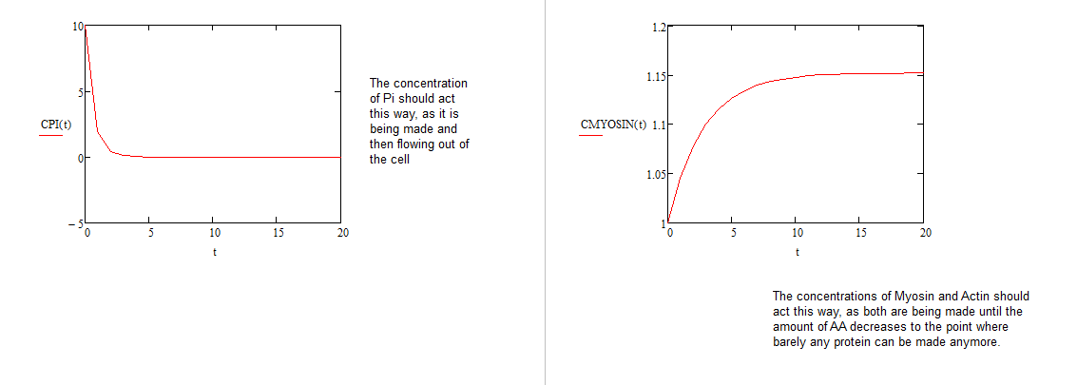

Iteration 6:

System Definition, Boundaries, and Mass/Energy Flow across Boundaries.

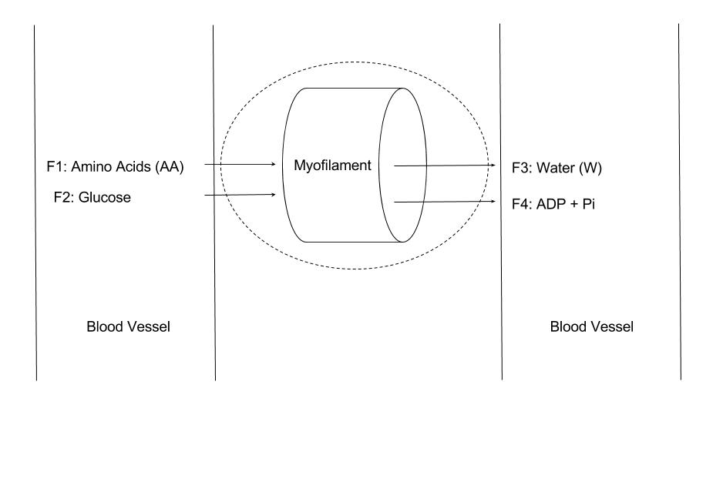

Assumptions:

* Lumped Parameter System such that this is a steady state reaction in regards to position
* Measuring growth of myofilament
* Growth is defined as accumulation of F-Actin.
* Assume one kind of amino acid instead of 20 amino acids
* No energy or mass lost during conversions
* Assume an initial concentration of AA of 380 mmol/mL
* The average amino acid molecular weight is 110 Da = 110 g/mol
* The molecular weight of a G-Actin protein is 41785 Da
* Assume volume is constant such that with an L = 44000 um and r = 25 um.
* Assume reaction for conversion of amino acids:
  + 1)
  + 2)
  + 3)
* Assume MM rate law for reaction for conversion of amino acids:
  + 1)
  + 2)
* CHANGED ASSUMPTION: Glucose flux in, and conversion of Glucose to 36 ATP via a first order kinetic reaction.

Nomenclature:

|  |  |  |
| --- | --- | --- |
| Parameter | Symbol | Units |
| Concentration of component x | [x] |  |
| Molecular Weight | MW |  |
| Volumetric Flow Rate | F |  |
| First Order Rate Constant for Conversion of Amino Acid to G-Actin | k1 |  |
| First Order Rate Constant for Conversion of G-Actin to F-Actin | k2 |  |
| Volume | V |  |
| Mass | Mass |  |
| Mole Fraction of component y |  |  |
| Density | den |  |

ODE for iteration 6 below:

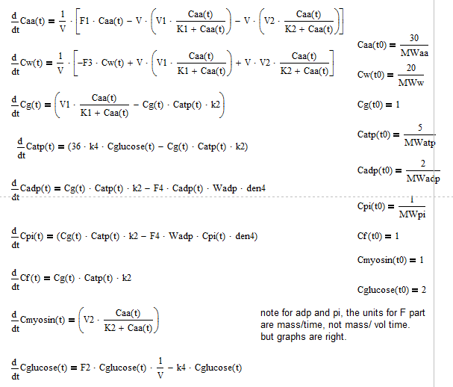

Graphical Output for iteration 6 below:



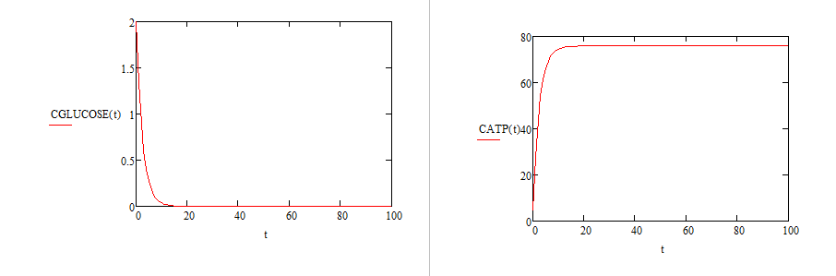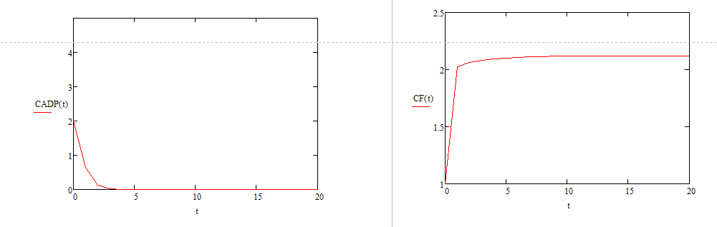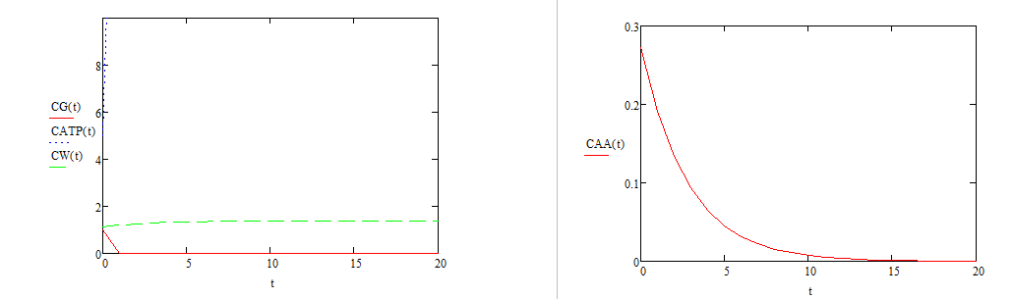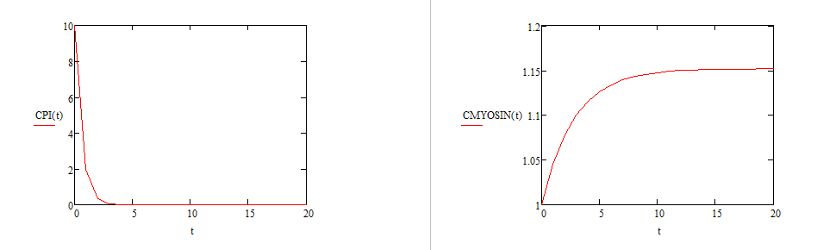

Concentration of amino acids decrease as expected. Concentration of water increase and then decrease as expected. Concentration of G-Actin increases barely and then decreases, as desired. Concentrations of ADP and Pi respond similarly, and come to an equilibrium of 1 M, as expected, since mass transport due to diffusion is occurring. Concentration of Myosin and F-Actin increase as amino acids are present and then taper off to a standstill as the amino acids concentration ran out. Concentration of Glucose falls to 0 as expected. The concentration of ATP increases rapidly as glucose is converted to ATP, and then decreases as it is used. The accumulation of extra ATP is accounted for by the fact that in a real cell, this ATP would be used by other processes as well.

Iteration 7: CHANGED ASSUMPTION: Diffusion of water and in and out

System Definition, Boundaries, and Mass/Energy Flow across Boundaries.



Assumptions:

* Lumped Parameter System such that this is a steady state reaction in regards to position
* Measuring growth of myofilament
* Growth is defined as accumulation of F-Actin.
* Assume one kind of amino acid instead of 20 amino acids
* No energy or mass lost during conversions
* Assume an initial concentration of AA of 380 mmol/mL
* The average amino acid molecular weight is 110 Da = 110 g/mol
* The molecular weight of a G-Actin protein is 41785 Da
* Assume volume is constant such that with an L = 44000 um and r = 25 um.
* Assume reaction for conversion of amino acids:
  + 1)
  + 2)
  + 3)
* Assume MM rate law for reaction for conversion of amino acids:
  + 1)
  + 2)
* Glucose flux in, and conversion of Glucose to 36 ATP via a first order kinetic reaction.
* Diffusion defined as

Nomenclature:

|  |  |  |  |  |
| --- | --- | --- | --- | --- |
| Parameter | Symbol | | Units of Parameter | |
| Concentration of Component X | Cx | |  | |
| Diffusion Coefficient for Diffusion into Myofibril | D | |  | |
| Differential Length of Myofibril | dx | |  | |
| Hydraulic Permeability | Khydra | |  | |
| Hydrostatic Pressure Gradient | Ps | |  | |
| Kinetic Reaction Constant for Conversion of G and ATP to F, ADP, and PI | k2 | |  | |
| Kinetic Reaction Constant for Conversion of Glucose to ATP | k4 | |  | |
| Length of Myofibril | L | |  | |
| Mass Flux | J | |  | |
| Michaelis-Menten Reaction Maximum Rate Constant for Conversion of AA to Myosin and W | V1 | |  | |
| Michaelis-Menten Reaction ½ Vmax Susbstrate Concentration for Conversion of AA to Myosin and W | K1 | |  | |
| Michaelis-Menten Reaction Maximum Rate Constant for Conversion of AA to G and W | V2 | |  | |
| Michaelis-Menten Reaction ½ Vmax Susbstrate Concentration for Conversion of AA to G and W | K2 | |  | |
| Molecular Weight of Component X | MWx | |  | |
| Radius of Myofibril | r | |  | |
| Volume of Myofibril | V | |  | |
| Parameter | | Symbol | | Units | |
| Concentration of component x | | [x] | |  | |
| Molecular Weight | | MW | |  | |
| Volumetric Flow Rate | | F | |  | |
| First Order Rate Constant for Conversion of Amino Acid to G-Actin | | k1 | |  | |
| First Order Rate Constant for Conversion of G-Actin to F-Actin | | k2 | |  | |
| Volume | | V | |  | |
| Mass | | Mass | |  | |
| Mole Fraction of component y | |  | |  | |
| Density | | den | |  | |

ODE for iteration 7 below:

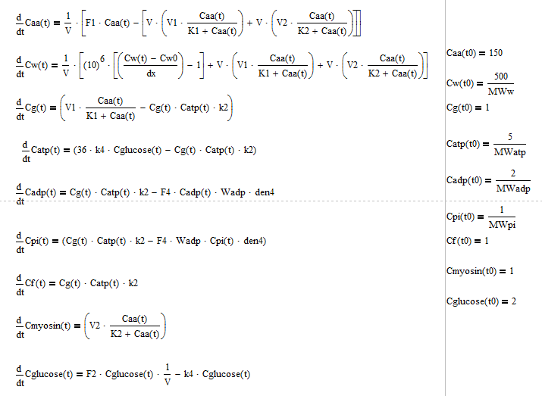

Graphical Output for iteration 7:

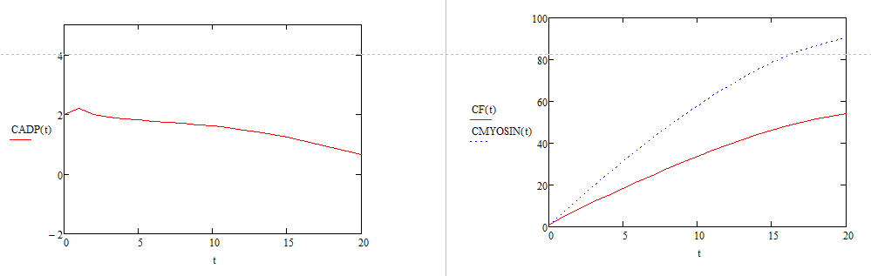

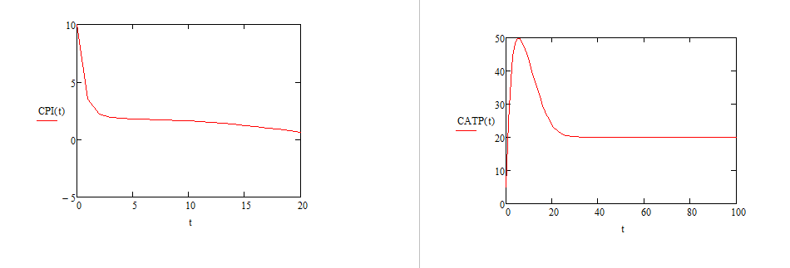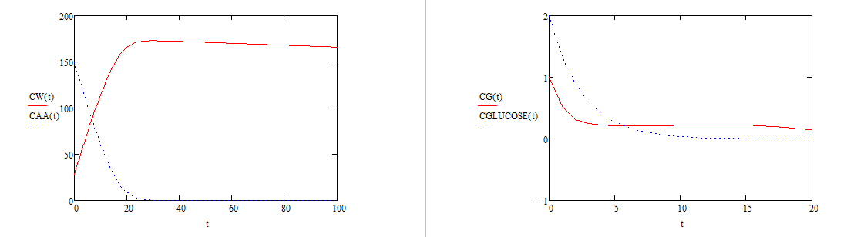

Concentration of amino acids decrease as expected. Concentration of water increase and then decrease as expected. Concentration of G-Actin increases barely and then decreases, as desired. Concentrations of ADP and Pi respond similarly, and come to an equilibrium of 1 M, as expected, since mass transport due to diffusion is occurring. Concentration of Myosin and F-Actin increase as amino acids are present and then taper off to a standstill as the amino acids concentration ran out. Concentration of Glucose falls to 0 as expected. The concentration of ATP increases rapidly as glucose is converted to ATP, and then decreases as it is used. The accumulation of extra ATP is accounted for by the fact that in a real cell, this ATP would be used by other processes as well.

Iteration 8: CHANGED ASSUMPTION: Diffusion for AA and Glucose added – replace flowrates

System Definition, Boundaries, and Mass/Energy Flow across Boundaries.



Assumptions:

* Lumped Parameter System such that this is a steady state reaction in regards to position
* Measuring growth of myofilament
* Growth is defined as accumulation of F-Actin.
* Assume one kind of amino acid instead of 20 amino acids
* No energy or mass lost during conversions
* Assume an initial concentration of AA of 380 mmol/mL
* The average amino acid molecular weight is 110 Da = 110 g/mol
* The molecular weight of a G-Actin protein is 41785 Da
* Assume volume is constant such that with an L = 44000 um and r = 25 um.
* Assume reaction for conversion of amino acids:
  + 1)
  + 2)
  + 3)
* Assume MM rate law for reaction for conversion of amino acids:
  + 1)
  + 2)
* Glucose flux in, and conversion of Glucose to 36 ATP via a first order kinetic reaction.
* Diffusion defined as

Nomenclature:

|  |  |  |  |  |
| --- | --- | --- | --- | --- |
| Parameter | Symbol | | Units of Parameter | |
| Concentration of Component X | Cx | |  | |
| Diffusion Coefficient for Diffusion into Myofibril | D | |  | |
| Differential Length of Myofibril | dx | |  | |
| Hydraulic Permeability | Khydra | |  | |
| Hydrostatic Pressure Gradient | Ps | |  | |
| Kinetic Reaction Constant for Conversion of G and ATP to F, ADP, and PI | k2 | |  | |
| Kinetic Reaction Constant for Conversion of Glucose to ATP | k4 | |  | |
| Length of Myofibril | L | |  | |
| Mass Flux | J | |  | |
| Michaelis-Menten Reaction Maximum Rate Constant for Conversion of AA to Myosin and W | V1 | |  | |
| Michaelis-Menten Reaction ½ Vmax Susbstrate Concentration for Conversion of AA to Myosin and W | K1 | |  | |
| Michaelis-Menten Reaction Maximum Rate Constant for Conversion of AA to G and W | V2 | |  | |
| Michaelis-Menten Reaction ½ Vmax Susbstrate Concentration for Conversion of AA to G and W | K2 | |  | |
| Molecular Weight of Component X | MWx | |  | |
| Radius of Myofibril | r | |  | |
| Volume of Myofibril | V | |  | |
| Parameter | | Symbol | | Units | |
| Concentration of component x | | [x] | |  | |
| Molecular Weight | | MW | |  | |
| Volumetric Flow Rate | | F | |  | |
| First Order Rate Constant for Conversion of Amino Acid to G-Actin | | k1 | |  | |
| First Order Rate Constant for Conversion of G-Actin to F-Actin | | k2 | |  | |
| Volume | | V | |  | |
| Mass | | Mass | |  | |
| Mole Fraction of component y | |  | |  | |
| Density | | den | |  | |

ODE for iteration 8 below:

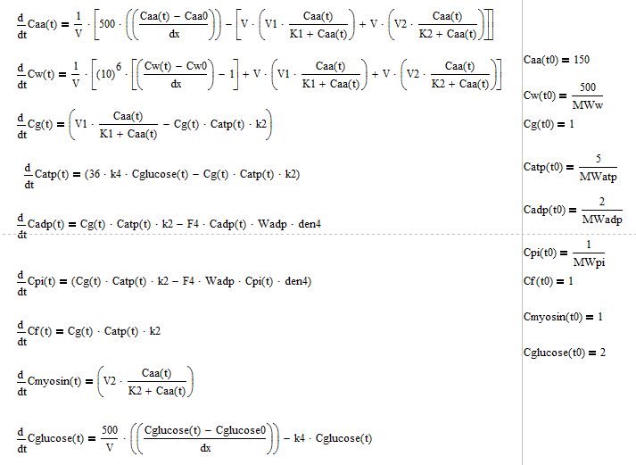

Graphical output for iteration 8 below:

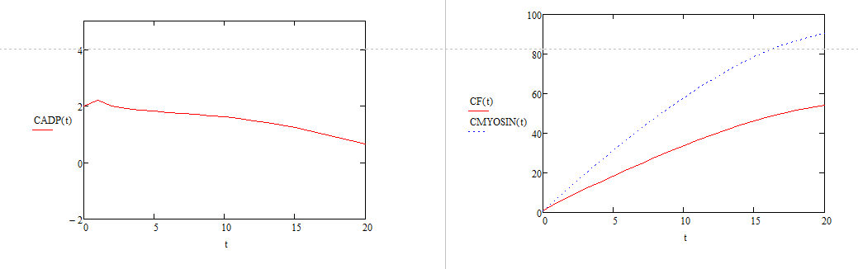

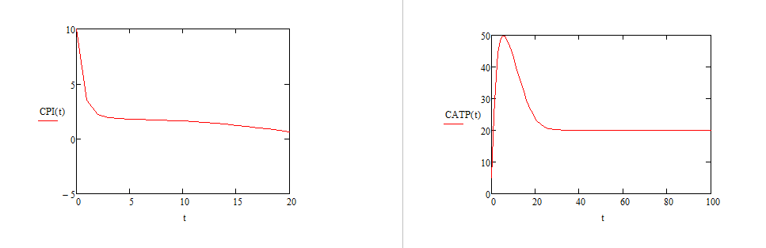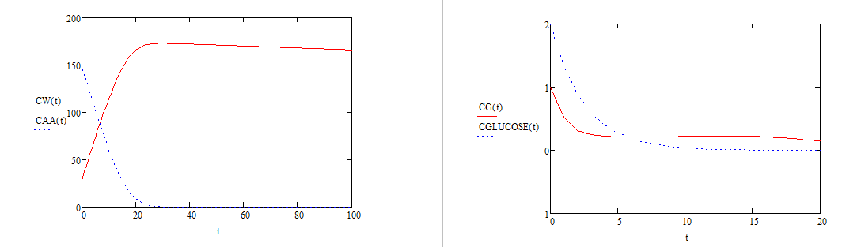\

Concentration of amino acids decrease as expected. Concentration of water increase and then decrease as expected. Concentration of G-Actin increases barely and then decreases, as desired. Concentrations of ADP and Pi respond similarly, and come to an equilibrium of 1 M, as expected, since mass transport due to diffusion is occurring. Concentration of Myosin and F-Actin increase as amino acids are present and then taper off to a standstill as the amino acids concentration ran out. Concentration of Glucose falls to 0 as expected. The concentration of ATP increases rapidly as glucose is converted to ATP, and then decreases as it is used. The accumulation of extra ATP is accounted for by the fact that in a real cell, this ATP would be used by other processes as well.

Iteration 9: CHANGED ASSUMPTION: Correct reaction order for G actin

System Definition, Boundaries, and Mass/Energy Flow across Boundaries.



Assumptions:

* Lumped Parameter System such that this is a steady state reaction in regards to position
* Measuring growth of myofilament
* Growth is defined as accumulation of F-Actin.
* Assume one kind of amino acid instead of 20 amino acids
* No energy or mass lost during conversions
* Assume an initial concentration of AA of 380 mmol/mL
* The average amino acid molecular weight is 110 Da = 110 g/mol
* The molecular weight of a G-Actin protein is 41785 Da
* Assume volume is constant such that with an L = 44000 um and r = 25 um.
* Assume reaction for conversion of amino acids:
  + 1)
  + 2)
  + 3)
* Assume MM rate law for reaction for conversion of amino acids:
  + 1)
  + 2)
* Glucose flux in, and conversion of Glucose to 36 ATP via a first order kinetic reaction.
* Osmosis defined as
* Diffusion for AA and Glucose added – replace flowrates
* Diffusion defined as

Nomenclature:

|  |  |  |  |  |
| --- | --- | --- | --- | --- |
| Parameter | Symbol | | Units of Parameter | |
| Concentration of Component X | Cx | |  | |
| Diffusion Coefficient for Diffusion into Myofibril | D | |  | |
| Differential Length of Myofibril | dx | |  | |
| Hydraulic Permeability | Khydra | |  | |
| Hydrostatic Pressure Gradient | Ps | |  | |
| Kinetic Reaction Constant for Conversion of G and ATP to F, ADP, and PI | k2 | |  | |
| Kinetic Reaction Constant for Conversion of Glucose to ATP | k4 | |  | |
| Length of Myofibril | L | |  | |
| Mass Flux | J | |  | |
| Michaelis-Menten Reaction Maximum Rate Constant for Conversion of AA to Myosin and W | V1 | |  | |
| Michaelis-Menten Reaction ½ Vmax Susbstrate Concentration for Conversion of AA to Myosin and W | K1 | |  | |
| Michaelis-Menten Reaction Maximum Rate Constant for Conversion of AA to G and W | V2 | |  | |
| Michaelis-Menten Reaction ½ Vmax Susbstrate Concentration for Conversion of AA to G and W | K2 | |  | |
| Molecular Weight of Component X | MWx | |  | |
| Radius of Myofibril | r | |  | |
| Volume of Myofibril | V | |  | |
| Parameter | | Symbol | | Units | |
| Concentration of component x | | [x] | |  | |
| Molecular Weight | | MW | |  | |
| Volumetric Flow Rate | | F | |  | |
| First Order Rate Constant for Conversion of Amino Acid to G-Actin | | k1 | |  | |
| First Order Rate Constant for Conversion of G-Actin to F-Actin | | k2 | |  | |
| Volume | | V | |  | |
| Mass | | Mass | |  | |
| Mole Fraction of component y | |  | |  | |
| Density | | den | |  | |

ODE for iteration 9 below:

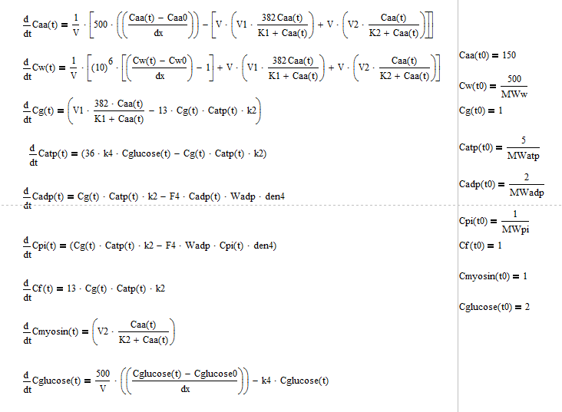

Graphical Output for iteration 9:

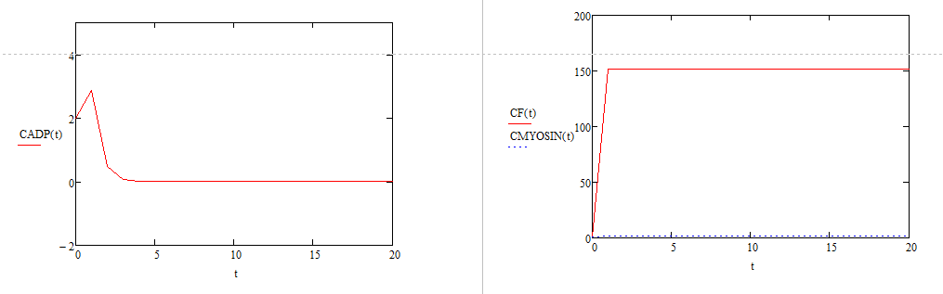

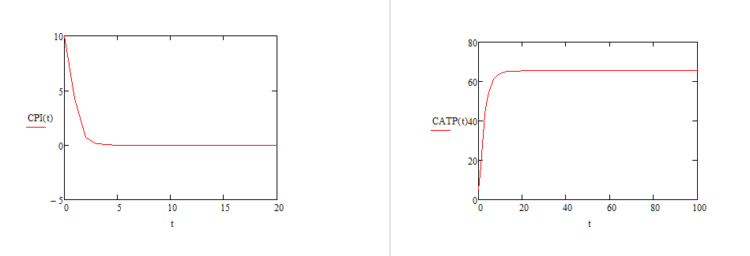

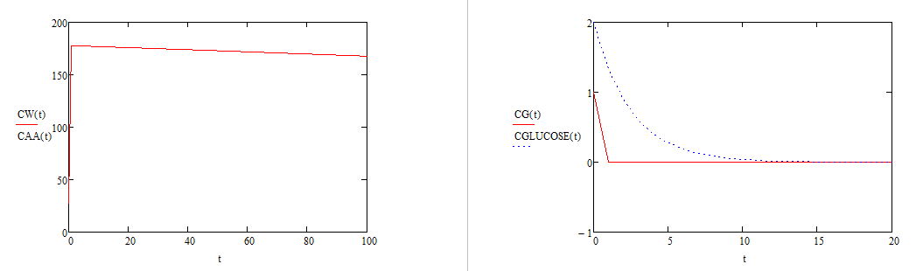

Concentration of amino acids decrease as expected. Concentration of water increase and then decrease as expected. Concentration of G-Actin increases barely and then decreases, as desired. Concentrations of ADP and Pi respond similarly, and come to an equilibrium of 1 M, as expected, since mass transport due to diffusion is occurring. Concentration of Myosin and F-Actin increase as amino acids are present and then taper off to a standstill as the amino acids concentration ran out. Concentration of Glucose falls to 0 as expected. The concentration of ATP increases rapidly as glucose is converted to ATP, and then decreases as it is used. The accumulation of extra ATP is accounted for by the fact that in a real cell, this ATP would be used by other processes as well. The reaction terms have been changed but not the starting concentrations and as such, the graphs do not have the right initial values to create the correct cures. The trends shown are still valid however.

Iteration 10: CHANGED ASSUMPTION: Fixed reaction orders/terms see below

System Definition, Boundaries, and Mass/Energy Flow across Boundaries.



Assumptions:

* Lumped Parameter System such that this is a steady state reaction in regards to position
* Measuring growth of myofilament
* Growth is defined as accumulation of F-Actin.
* Assume one kind of amino acid instead of 20 amino acids
* No energy or mass lost during conversions
* Assume an initial concentration of AA of 380 mmol/mL
* The average amino acid molecular weight is 110 Da = 110 g/mol
* The molecular weight of a G-Actin protein is 41785 Da
* Assume volume is constant such that with an L = 44000 um and r = 25 um.
* Assume reaction for conversion of amino acids:
  + 1)
  + 2) 13
  + 3)
* Assume MM rate law for reaction for conversion of amino acids:
  + 1)
  + 2)
* Glucose flux in, and conversion of Glucose to 36 ATP via a first order kinetic reaction.
* Osmosis defined as
* Diffusion for AA and Glucose added – replace flowrates
* Diffusion defined as

Nomenclature:

|  |  |  |  |  |
| --- | --- | --- | --- | --- |
| Parameter | Symbol | | Units of Parameter | |
| Concentration of Component X | Cx | |  | |
| Diffusion Coefficient for Diffusion into Myofibril | D | |  | |
| Differential Length of Myofibril | dx | |  | |
| Hydraulic Permeability | Khydra | |  | |
| Hydrostatic Pressure Gradient | Ps | |  | |
| Kinetic Reaction Constant for Conversion of G and ATP to F, ADP, and PI | k2 | |  | |
| Kinetic Reaction Constant for Conversion of Glucose to ATP | k4 | |  | |
| Length of Myofibril | L | |  | |
| Mass Flux | J | |  | |
| Michaelis-Menten Reaction Maximum Rate Constant for Conversion of AA to Myosin and W | V1 | |  | |
| Michaelis-Menten Reaction ½ Vmax Susbstrate Concentration for Conversion of AA to Myosin and W | K1 | |  | |
| Michaelis-Menten Reaction Maximum Rate Constant for Conversion of AA to G and W | V2 | |  | |
| Michaelis-Menten Reaction ½ Vmax Susbstrate Concentration for Conversion of AA to G and W | K2 | |  | |
| Molecular Weight of Component X | MWx | |  | |
| Radius of Myofibril | r | |  | |
| Volume of Myofibril | V | |  | |
| Parameter | | Symbol | | Units | |
| Concentration of component x | | [x] | |  | |
| Molecular Weight | | MW | |  | |
| Volumetric Flow Rate | | F | |  | |
| First Order Rate Constant for Conversion of Amino Acid to G-Actin | | k1 | |  | |
| First Order Rate Constant for Conversion of G-Actin to F-Actin | | k2 | |  | |
| Volume | | V | |  | |
| Mass | | Mass | |  | |
| Mole Fraction of component y | |  | |  | |
| Density | | den | |  | |

ODE for iteration 10 below:

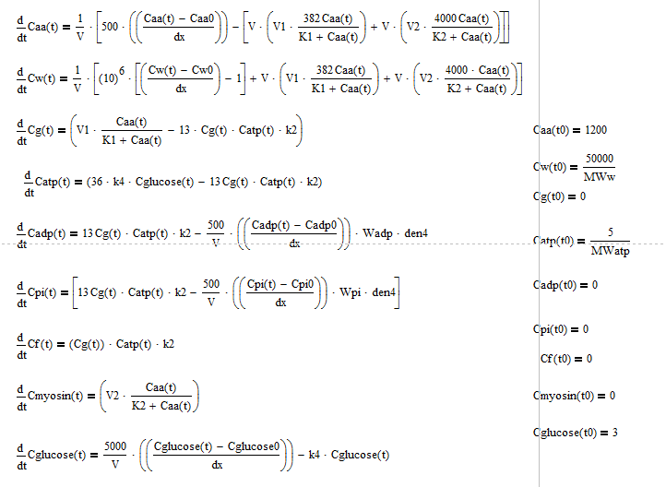

Graphical Output for Iteration 10:

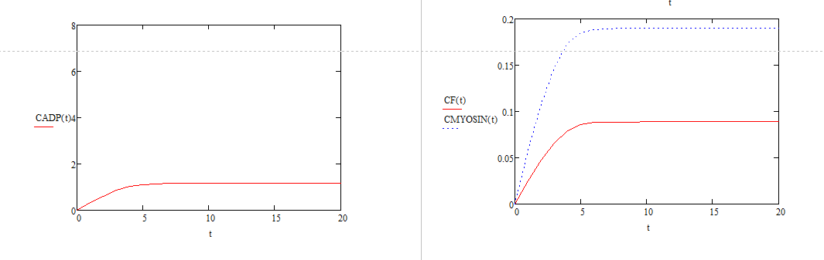

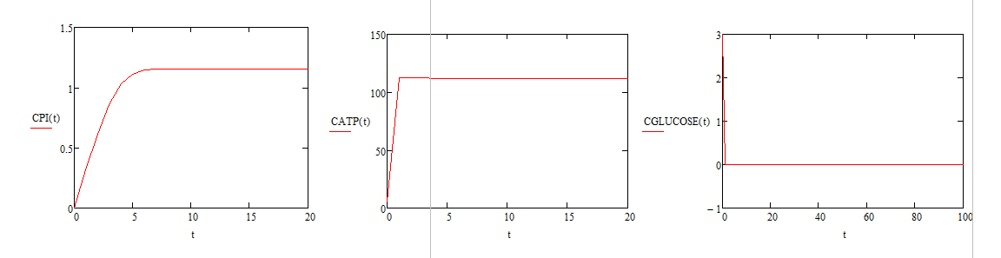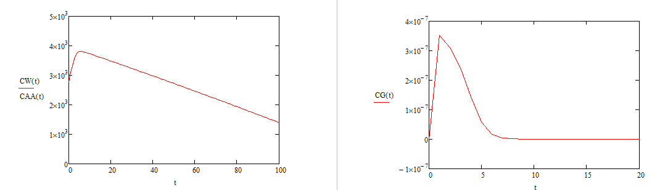

Concentration of amino acids decrease as expected. Concentration of water increase and then decrease as expected. Concentration of G-Actin increases barely and then decreases, as desired. Concentrations of ADP and Pi respond similarly, and come to an equilibrium of 1 M, as expected, since mass transport due to diffusion is occurring. Concentration of Myosin and F-Actin increase as amino acids are present and then taper off to a standstill as the amino acids concentration ran out. Concentration of Glucose falls to 0 as expected. The concentration of ATP increases rapidly as glucose is converted to ATP, and then decreases as it is used. The accumulation of extra ATP is accounted for by the fact that in a real cell, this ATP would be used by other processes as well.

Iteration 11: Final Iteration – Please Reference body of report for this iteration and its analysis