|  |
| --- |
| ABE 30100 |
| Microbial Consortium Modeling |
| Deliverable IV |

|  |
| --- |
| Kathryn Atherton  4-9-2019 |

Contents

Review of Deliverable I 2

Background 2

Concept in Literature 2

Model Proposal 3

Model Description 3

Quantitative Outputs 3

Input Parameters 3

Principles and Processes Modeled 3

Review of Deliverable II 4

Defining the Model 4

Mathematical Equations 4

Overall Mass Balance 4

Mass Balance on Individual Components 5

Overall Energy Balance 7

Relevant Parameters, Relationships, and Principles 7

Parameters 7

Relationships 7

Principles 8

Assumptions 8

Review of Deliverable III 8

Iteration I 8

Assumptions 8

Mathematical Model 9

Model Evaluation 10

Iteration II 10

Assumptions 10

Mathematical Model 11

Model Evaluation 12

Iteration III 12

Assumptions 12

Mathematical Model 12

Model Evaluation 13

Iteration IV 13

Assumptions 13

Mathematical Model 14

Model Evaluation 15

Iteration V 15

Assumptions 15

Mathematical Model 16

Model Evaluation 17

Iteration VI 17

Assumptions 17

Mathematical Model 18

Model Evaluation 19

Iteration VII 19

Assumptions 19

Mathematical Model 20

Model Evaluation 21

Appendix A: Table of Nomenclature 22

Appendix B: Supplemental Figures 24

Appendix C: Model Code 28

Iteration I 28

Iteration II 30

Iteration III 33

Iteration IV 35

Iteration V 38

Iteration VI 41

Iteration VII 43

Appendix D: References 47

# Review of Deliverable I

## Background

### Concept in Literature

Fermentation is a process used to exploit microorganisms’ ability to produce natural metabolites to the benefit of humans. Organisms such as *Escherichia coli* and *Saccharomyces cerevisiae* have been engineered to ferment products such as insulin and ethanol for human consumption. However, there is a limit to the ability of single-organism fermentations to produce more complex molecules whose building blocks require compartmentalized production to most efficiently create the final product.

In their 2015 Nature Biotechnology paper, Zhou, Qiao, Edgar, and Stephanopoulos fermented *E. coli* and *S. cerevisiae* together to create paclitaxel, a chemotherapy drug (Figure 1).

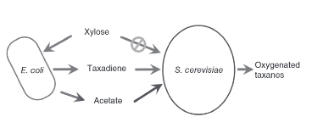

Figure 1: Picture of the fermentation process to be modeled. The E. coli consumes xylose and produces acetate for the S. cerevisiae to uses as a carbon source. E. coli produce taxadiene for the S. cerevisiae to oxygenate and use to produce the final product, paclitaxel (Zhou, Qiao, Edgar, & Stephanopoulos, Distributing a metabolic pathway among a microbial consortium enhances production of natural products, 2015).

The simpler *E. coli* cells were engineered to produce the building blocks of the final product while the *S. cerevisiae* was programmed to fold these building blocks together to produce paclitaxel (Figure 2, Figure 10). The co-culture was fed xylose, a carbon source that only the *E. coli* cells could metabolize to then produce acetate, a toxin to *E. coli* which *S. cerevisiae* cells could consume for carbon. This, among other genetically engineered tweaks to make the process more streamlined, ensured that neither the *E. coli* nor the *S. cerevisiae* populations overgrew.

### Model Proposal

While the authors proved this concept in the lab, a mathematical model of the process was never made, or at least never published. As such, I would like to create a model of the final system that the authors described in their paper, outlined above. My model would output the amount of paclitaxel produced by a certain number of *E. coli* and *S. cerevisiae* cells given an initial amount of xylose in a reactor of specified volume with a defined initial temperature and pH.

## Model Description

### Quantitative Outputs

* Rate of paclitaxel produced [mass/time]

### Input Parameters

* Initial temperature
* Initial pH
* Volume of fermenter
* Initial number of *E. coli* cells
* Initial number of *S. cerevisiae* cells
* Initial amount of xylose [mass]

### Principles and Processes Modeled

* Conservation of mass
* Conservation of energy
* Mass balance with reaction
* Enzymatic reactions
* Reaction kinetics
* Heat of reaction
* Batch reactor process
* Mass transfer across a membrane
* Diffusion
* Heat transfer
* Cell growth and death

# Review of Deliverable II

## Defining the Model

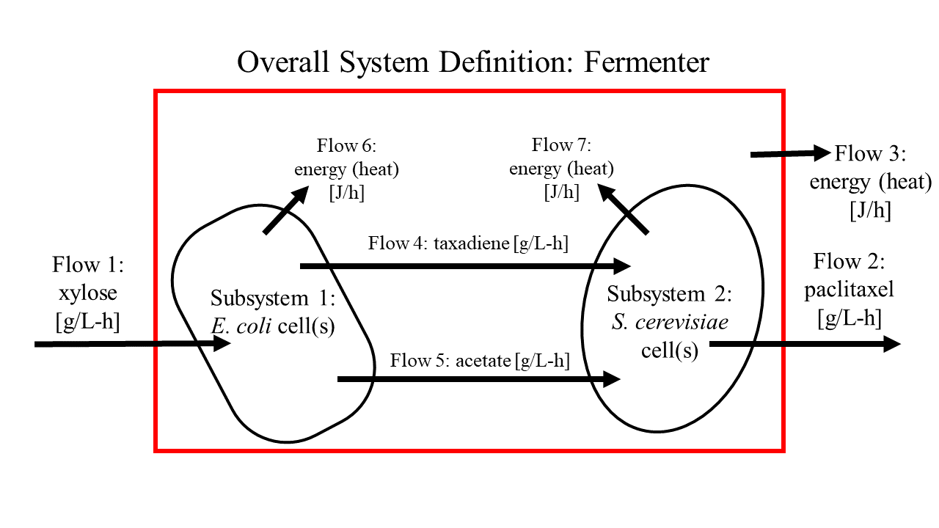

Figure 2: System definition with input and output flows.

## Mathematical Equations

### Overall Mass Balance

Accumulation = In – Out + Generation – Consumption

* Law of Conservation of Mass: mass can neither be created nor destroyed
  + Generation = Consumption = 0

Accumulation = In – Out

* Figure 2: In = Flow 1; Out = Flow 2

|  |  |  |
| --- | --- | --- |
|  | $$\frac{∂m}{∂t}=F_{1}C_{1}-F_{2}C_{2}$$ | [*1*] |

Unit Analysis: $\left[\frac{mass}{time}\right]=\left[\frac{volume}{time}∙\frac{mass}{volume}\right]-\left[\frac{volume}{time}∙\frac{mass}{volume}\right]=\left[\frac{mass}{time}\right]$

#### Subsystem 1 Overall Mass Balance

Accumulation = In – Out + Generation – Consumption

* Law of Conservation of Mass: mass can neither be created nor destroyed
  + Generation = Consumption = 0

Accumulation = In – Out

* Figure 2: In = Flow 1; Out = Flow 4, Flow 5

|  |  |  |
| --- | --- | --- |
|  | $$\frac{∂m_{s1}}{∂t}=F_{1}C_{1}-(r_{x,d}+r_{x,a})W_{x}V_{s1}$$ | [*2*] |

Unit Analysis: $\left[\frac{mass}{time}\right]=\left[\frac{volume}{time}∙\frac{mass}{volume}\right]-\left(\left[\frac{mol}{volume∙time}\right]+\left[\frac{mol}{volume∙time}\right]\right)\left[\frac{mass}{mol}\right][volume]=\left[\frac{mass}{time}\right]$

#### Subsystem 2 Overall Mass Balance

Accumulation = In – Out + Generation – Consumption

* Law of Conservation of Mass: mass can neither be created nor destroyed
  + Generation = Consumption = 0

Accumulation = In – Out

* Figure 2: In = Flow 4, Flow 5; Out = Flow 2

|  |  |  |
| --- | --- | --- |
|  | $$\frac{∂m_{s2}}{∂t}=\left(r_{x,d}+r_{x,a}\right)W_{x}V_{s1}-F_{2}C_{2}$$ | [*3*] |

Unit Analysis: $\left[\frac{mass}{time}\right]=\left(\left[\frac{mol}{volume∙time}\right]+\left[\frac{mol}{volume∙time}\right]\right)\left[\frac{mass}{mol}\right]\left[volume\right]-\left[\frac{volume}{time}∙\frac{mass}{volume}\right]=\left[\frac{mass}{time}\right]$

### Mass Balance on Individual Components

#### Xylose

Accumulation = In – Out + Generation – Consumption

* Figure 2: In = Flow 1; Out = 0
* Assumption #: Generation = 0
* Figures 10 – 12: Consumption = metabolism of xylose to produce taxadiene, acetate, and *E. coli* cell growth

|  |  |  |
| --- | --- | --- |
|  | $$\frac{∂x}{∂t}=F_{1}C_{1}-\left(r_{x,e}+r_{x,d}+r_{x,a}\right){W_{x}V}_{s1}$$ | [*4*] |

Unit Analysis: $\left[\frac{mass}{time}\right]=\left[\frac{volume}{time}∙\frac{mass}{volume}\right]-\left(\left[\frac{mol}{volume∙time}\right]+\left[\frac{mol}{volume∙time}\right]+\left[\frac{mass}{volume∙time}\right]\right)\left[\frac{mass}{mol}\right]\left[volume\right]=\left[\frac{mass}{time}\right]$

* Note: The consumption of xylose to produce cell growth (rx,e) is dependent upon the concentration of xylose, the concentration of acetate (as acetate inhibits *E. coli* cell growth), and the total concentration of cells in the reactor (due to space constraint inhibition). The inhibition considerations will be reflected in future iterations.

#### Paclitaxel

Accumulation = In – Out + Generation – Consumption

* Figure 2: In = 0; Out = Flow 2
* Assumption #: Consumption = 0
* Figure 10: Generation = metabolism of taxadiene to produce paclitaxel

|  |  |  |
| --- | --- | --- |
|  | $$\frac{∂p}{∂t}=r_{d,p}W_{d}V_{s2}-F_{2}C_{2}$$ | [*5*] |

Unit Analysis: $\left[\frac{mass}{time}\right]=\left[\frac{mol}{volume∙time}\right]\left[\frac{mass}{mol}\right]\left[volume\right]-\left[\frac{volume}{time}∙\frac{mass}{volume}\right]=\left[\frac{mass}{time}\right]$

#### Taxadiene

Accumulation = In – Out + Generation – Consumption

* Figure 2: In = 0; Out = 0
* Figures 10 – 12: Generation = metabolism of xylose to produce taxadiene; Consumption = metabolism of taxadiene to produce paclitaxel

|  |  |  |
| --- | --- | --- |
|  | $$\frac{∂d}{∂t}=r_{x,d}W_{x}V_{s1}-r_{d,p}W_{d}V_{s2}$$ | [*6*] |

Unit Analysis: $\left[\frac{mass}{time}\right]=\left[\frac{mol}{volume∙time}\right]\left[\frac{mass}{mol}\right]\left[volume\right]-\left[\frac{mol}{volume∙time}\right]\left[\frac{mass}{mol}\right]\left[volume\right]=\left[\frac{mass}{time}\right]$

#### Acetate

Accumulation = In – Out + Generation – Consumption

* Figure 2: In = 0; Out = 0
* Figures 12 – 13: Generation = metabolism of xylose to produce acetate; Consumption = metabolism of acetate to produce *S. cerevisiae* cell growth

|  |  |  |
| --- | --- | --- |
|  | $$\frac{∂a}{∂t}=r_{x,a}W_{x}V_{s1}-r_{a,s}W_{a}V_{s2}$$ | [*7*] |

Unit Analysis: $\left[\frac{mass}{time}\right]=\left[\frac{mol}{volume∙time}\right]\left[\frac{mass}{mol}\right]\left[volume\right]-\left[\frac{mol}{volume∙time}\right]\left[\frac{mass}{mol}\right]\left[volume\right]=\left[\frac{mass}{time}\right]$

#### *E. Coli* Cells

Accumulation = In – Out + Generation – Consumption

* Figure 2: In = 0; Out = 0
* Figure 12: Generation = metabolism of xylose to produce cell growth; Consumption = cell death

|  |  |  |
| --- | --- | --- |
|  | $$\frac{∂e}{∂t}=r_{x,e}W_{x}V_{s1}-f(x,a,\left(e+s\right), T)$$ | [*8*] |

Unit Analysis: $\left[\frac{mass}{time}\right]=\left[\frac{mol}{volume∙time}\right]\left[\frac{mass}{mol}\right]\left[volume\right]-\left[\frac{mass}{time}\right]=\left[\frac{mass}{time}\right]$

* Note that cell death is defined as a function of the concentrations of xylose, acetate, and total cell mass and temperature. This function will be fleshed out in future iterations where cell death is assumed to be nonzero.

#### *S. Cerevisiae* Cells

Accumulation = In – Out + Generation – Consumption

* Figure 2: In = 0; Out = 0
* Figures 13: Generation = metabolism of acetate to produce cell growth; Consumption = cell death

|  |  |  |
| --- | --- | --- |
|  | $$\frac{∂s}{∂t}=r_{a,s}W_{a}V_{s2}-f(a,\left(e+s\right), T)$$ | [*9*] |

Unit Analysis: $\left[\frac{mass}{time}\right]=\left[\frac{mol}{volume∙time}\right]\left[\frac{mass}{mol}\right]\left[volume\right]-\left[\frac{mass}{time}\right]=\left[\frac{mass}{time}\right]$

* Note that cell death is defined as a function of the concentration of acetate and total cell mass and temperature. This function will be fleshed out in future iterations where cell death is assumed to be nonzero.

### Overall Energy Balance

Accumulation = In – Out + Generation – Consumption

* Figure 2: In = 0; Out = Flow 3; Generation = Flow 6, Flow 7

|  |  |  |
| --- | --- | --- |
|  | $$\frac{∂E}{∂t}=F_{6}+F_{7}-F_{3}$$ | [*10*] |

Unit Analysis: $\left[\frac{energy}{time}\right]=\left[\frac{energy}{time}\right]+\left[\frac{energy}{time}\right]-\left[\frac{energy}{time}\right]=\left[\frac{energy}{time}\right]$

#### Subsystem 1 energy Balance

Accumulation = In – Out + Generation – Consumption

* Figure 2: In = 0; Out = Flow 6
* Figures 10 – 12: [Generation – Consumption] = lumped heats of reactions of metabolism of xylose to produce taxadiene, acetate, and *E. coli* cell growth

|  |  |  |
| --- | --- | --- |
|  | $$\frac{∂E_{s1}}{∂t}=\left(H_{x,d}r_{x,d}+H_{x,a}r_{x,a}+H_{x,e}r_{x,e}\right)W_{x}V_{s1}{-F}_{6}$$ | [*11*] |

Unit Analysis: $\left[\frac{energy}{time}\right]=\left(\left[\frac{energy}{mole}\right]\left[\frac{mole}{mass}\right]\left[\frac{mass}{volume∙time}\right]\left[volume\right]+\left[\frac{energy}{mole}\right]\left[\frac{mole}{mass}\right]\left[\frac{mass}{volume∙time}\right]\left[volume\right]+\left[\frac{energy}{mole}\right]\left[\frac{mole}{mass}\right]\left[\frac{mass}{volume∙time}\right]\left[volume\right]\right)-\left[\frac{energy}{time}\right]=\left[\frac{energy}{time}\right]$

#### Subsystem 2 Energy Balance

Accumulation = In – Out + Generation – Consumption

* Figure 2: In = 0; Out = Flow 7
* Figures 10, 13: [Generation – Consumption] = lumped heats of reactions of metabolism of taxadiene and acetate to produce paclitaxel and *S. cerevisiae* cell growth

|  |  |  |
| --- | --- | --- |
|  | $$\frac{∂E_{s2}}{∂t}=\left(H_{d,p}W_{d}r_{d,p}+H_{a,s}W_{a}r_{a,s}\right)V_{s2}{-F}_{7}$$ | [*12*] |

Unit Analysis: $\left[\frac{energy}{time}\right]=\left(\left[\frac{energy}{mole}\right]\left[\frac{mole}{mass}\right]\left[\frac{mass}{volume∙time}\right]\left[volume\right]+\left[\frac{energy}{mole}\right]\left[\frac{mole}{mass}\right]\left[\frac{mass}{volume∙time}\right]\left[volume\right]\right)-\left[\frac{energy}{time}\right]=\left[\frac{energy}{time}\right]$

## Relevant Parameters, Relationships, and Principles

### Parameters

* See Appendix A for parameter nomenclature and descriptions

### Relationships

* + This is used to determine the reaction rates based on the concentration(s) of the reactant(s)
 $\frac{dE}{dt}=UA\frac{dT}{dt}$

 + This is used for determining the temperature of the cells, of the broth, and of the water used to cool the broth based on the energy produced by the cellular reactions
 $V=\frac{m}{ρ}$

 + This is used for determining the volume of cells based upon their concentration in the reactor

### Principles

* Conservation of mass
* Conservation of energy
* Reaction kinetics
* Heat transfer

## Assumptions

1. The fermentation broth is perfectly homogeneous in composition and temperature
2. The fermentation broth is kept at a constant temperature
3. The fermentation broth is kept at a constant volume
4. The fermentation broth is kept at a constant pH
5. All *E. coli* cells are identical to each other and all *S. cerevisiae* cells are identical to each other
6. Cells neither grow nor die
7. Each reaction is zeroth order
8. Paclitaxel is able to be produced infinitely with no bounds.
9. Transportation across the cell membrane is instantaneous and requires no energy
10. The cells have enough enzymes and cellular resources to perform each reaction
11. There is no wait time between reactions (i.e. no need for reaction products to diffuse within the cell or between cells before the next reaction occurs)
12. The output flow is filtered and does not remove any cells, only the desired product and water
13. The mass of water that enters the reactor is equal to the mass of water that leaves the reactor
14. The normal metabolisms of the *E. coli* and *S. cerevisiae* cells do not produce any additional heat
15. All reactions occur to completion
16. If there is more than one pathway to a desired product, only the most direct pathway is taken (i.e. the pathway with the least number of reactions)
17. Reactions only occur in the forward direction
18. Reaction rates are the same at all temperatures

# Review of Deliverable III

## Iteration I

### Assumptions

1. The fermentation broth is perfectly homogeneous in composition and temperature
2. The fermentation broth is kept at a constant temperature
3. The fermentation broth is kept at a constant volume
4. The fermentation broth is kept at a constant pH
5. All *E. coli* cells are identical to each other and all *S. cerevisiae* cells are identical to each other
6. Cells neither grow nor die
7. Each reaction is zeroth order
8. Paclitaxel is able to be produced infinitely with no bounds
9. Transportation across the cell membrane is instantaneous and requires no energy
10. The cells have enough enzymes and cellular resources to perform each reaction
11. There is no wait time between reactions (i.e. no need for reaction products to diffuse within the cell or between cells before the next reaction occurs)
12. The output flow is filtered and does not remove any cells, only the desired product and water
13. The mass of water that enters the reactor is equal to the mass of water that leaves the reactor
14. The normal metabolisms of the *E. coli* and *S. cerevisiae* cells do not produce any additional heat
15. All reactions occur to completion
16. If there is more than one pathway to a desired product, only the most direct pathway is taken (i.e. the pathway with the least number of reactions)
17. Reactions only occur in the forward direction
18. Reaction rates are the same at all temperatures

### Mathematical Model

See Appendix C for the code used to produce the below output.

Values for reaction rates come from references found in BRENDA: (Agranoff, Eggerer, Henning, & Lynen, 1960), (Bloch, Chaykin, Phillips, & De Waard, 1959), (Cane, Chow, Lillo, & Kang, 2001), (Chau, Walker, Long, & Croteau, 2004), (Chesters, Wilding, Goodall, & Micklefield, 2012), (Durr & Rudney, 1960), (Fang & Ewald, 2004), (Feigenbaum & Schulz, 1975), (Gogerty & Bobik, 2010), (Hahn, et al., 2001), (Inui, Miyatake, Nakano, & Kitaoka, 1990), (Jennewein, Long, Williams, & Croteau, 2004), (Lee, Cheong, & Kim, 2008), (Malcovati & Valentini, 1982), (Mercade, Cocaign-Bousquet, & Loubiere, 2006), (Middleton, 1972), (Nawarathne & Walker, 2010), (Takenoya, et al., 2010), (Voronovsky, et al., 2005), (Walker, Fujisaki, Long, & Croteau, 2002), (Wolff, et al., 2003), and (Yu, Ladapo, & Whitman, 1994).

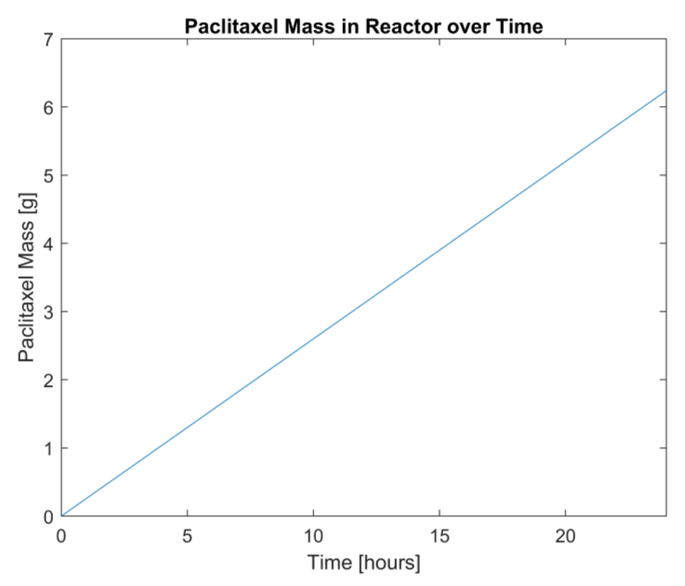

Figure 3: Graphical output of Microbial Consortium Model Iteration I

### Model Evaluation

The model is very inaccurate. It shows a linear relationship between the output of Paclitaxel mass and the reaction time with no consideration of a limit on the mass of Paclitaxel that can be produced from the initial xylose mass (5 g). The next iteration will impose limits on the mass of Paclitaxel that can be produced from the xylose.

## Iteration II

### Assumptions

1. The fermentation broth is perfectly homogeneous in composition and temperature
2. The fermentation broth is kept at a constant temperature
3. The fermentation broth is kept at a constant volume
4. The fermentation broth is kept at a constant pH
5. All *E. coli* cells are identical to each other and all *S. cerevisiae* cells are identical to each other
6. Cells neither grow nor die
7. Each reaction is zeroth order
8. **Xylose mass is the overall limiter of paclitaxel production.**
9. Transportation across the cell membrane is instantaneous and requires no energy
10. The cells have enough enzymes and cellular resources to perform each reaction
11. There is no wait time between reactions (i.e. no need for reaction products to diffuse within the cell or between cells before the next reaction occurs)
12. The output flow is filtered and does not remove any cells, only the desired product and water
13. The mass of water that enters the reactor is equal to the mass of water that leaves the reactor
14. The normal metabolisms of the *E. coli* and *S. cerevisiae* cells do not produce any additional heat
15. All reactions occur to completion
16. If there is more than one pathway to a desired product, only the most direct pathway is taken (i.e. the pathway with the least number of reactions)
17. Reactions only occur in the forward direction
18. Reaction rates are the same at all temperatures

### Mathematical Model

See Appendix C for the code used to produce the below output.

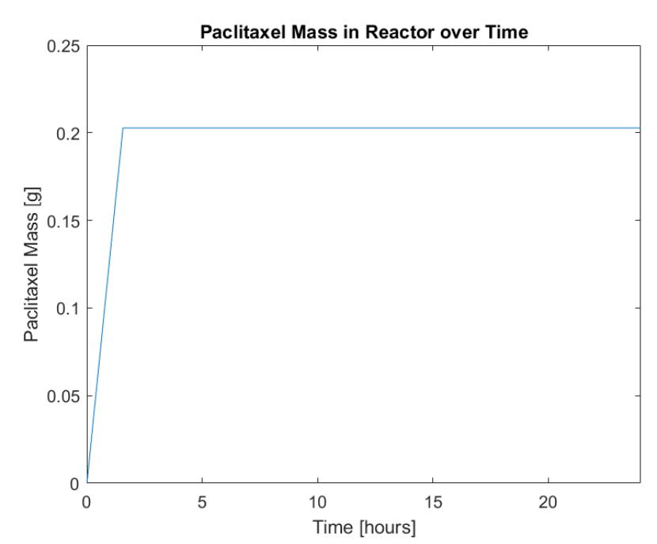

Figure 4: Graphical output of Microbial Consortium Model Iteration II. Notice that the paclitaxel mass remains constant once a mass limit has been reached.

### Model Evaluation

The model still shows a linear relationship between the output of Paclitaxel mass and the reaction time until all of the reactants have been consumed. However, the rate of reaction (slope of the output line) should not remain constant as the resources decrease. The next iteration will change the assumption that the reactions are all zeroth order.

## Iteration III

### Assumptions

1. The fermentation broth is perfectly homogeneous in composition and temperature
2. The fermentation broth is kept at a constant temperature
3. The fermentation broth is kept at a constant volume
4. The fermentation broth is kept at a constant pH
5. All *E. coli* cells are identical to each other and all *S. cerevisiae* cells are identical to each other
6. Cells neither grow nor die
7. **Each reaction is first order**
8. Transportation across the cell membrane is instantaneous and requires no energy
9. The cells have enough enzymes and cellular resources to perform each reaction
10. There is no wait time between reactions (i.e. no need for reaction products to diffuse within the cell or between cells before the next reaction occurs)
11. The output flow is filtered and does not remove any cells, only the desired product and water
12. The mass of water that enters the reactor is equal to the mass of water that leaves the reactor
13. The normal metabolisms of the *E. coli* and *S. cerevisiae* cells do not produce any additional heat
14. All reactions occur to completion
15. If there is more than one pathway to a desired product, only the most direct pathway is taken (i.e. the pathway with the least number of reactions)
16. Reactions only occur in the forward direction
17. Reaction rates are the same at all temperatures

### Mathematical Model

See Appendix C for the code used to produce the below output.

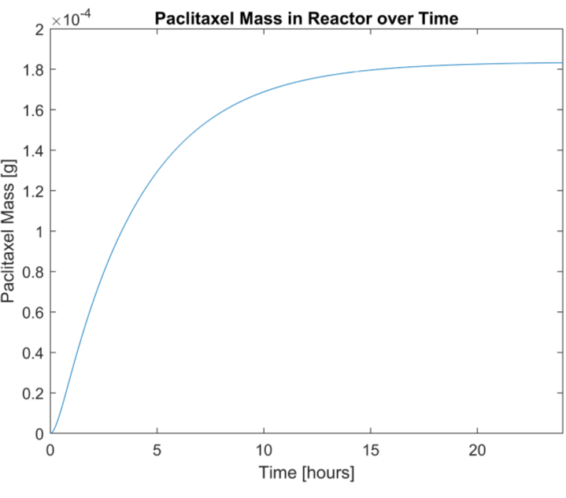

Figure 5: Graphical output of Microbial Consortium Model Iteration III. Notice that there is no longer a linear relationship between the paclitaxel mass and time and that the maximum amount of paclitaxel produced has decreased from 0.2 g to 1.8x10-4g.

### Model Evaluation

The shape of the curve is more realistic and closer to what I had expected the output of the model to be. However, the model assumes that the rates of reaction in the *E. coli* cells are determined by the entire concentration of xylose even though all the xylose is not used by both reactions. The next iteration will add an assumption to correct this.

## Iteration IV

### Assumptions

1. The fermentation broth is perfectly homogeneous in composition and temperature
2. The fermentation broth is kept at a constant temperature
3. The fermentation broth is kept at a constant volume
4. The fermentation broth is kept at a constant pH
5. All *E. coli* cells are identical to each other and all *S. cerevisiae* cells are identical to each other
6. Cells neither grow nor die
7. Each reaction is first order
8. Transportation across the cell membrane is instantaneous and requires no energy
9. The cells have enough enzymes and cellular resources to perform each reaction
10. There is no wait time between reactions (i.e. no need for reaction products to diffuse within the cell or between cells before the next reaction occurs)
11. The output flow is filtered and does not remove any cells, only the desired product and water
12. The mass of water that enters the reactor is equal to the mass of water that leaves the reactor
13. The normal metabolisms of the *E. coli* and *S. cerevisiae* cells do not produce any additional heat
14. All reactions occur to completion
15. If there is more than one pathway to a desired product, only the most direct pathway is taken (i.e. the pathway with the least number of reactions)
16. Reactions only occur in the forward direction
17. Reaction rates are the same at all temperatures
18. **If a reactant is used in more than one reaction, the mass of the reactant will be split evenly between the reactions.**

### Mathematical Model

See Appendix C for the code used to produce the below output.



Figure 6: Graphical output of Microbial Consortium Model Iteration IV. There is not much change between this iteration and the previous iteration.

### Model Evaluation

Assuming the cells do not divide, this model is relatively accurate. The next iteration will include cell growth and the use of resources to produce the cell growth.

## Iteration V

### Assumptions

1. The fermentation broth is perfectly homogeneous in composition and temperature
2. The fermentation broth is kept at a constant temperature
3. The fermentation broth is kept at a constant volume
4. The fermentation broth is kept at a constant pH
5. All *E. coli* cells are identical to each other and all *S. cerevisiae* cells are identical to each other
6. **Cells grow but do not die**
7. Each reaction is first order
8. Transportation across the cell membrane is instantaneous and requires no energy
9. The cells have enough enzymes and cellular resources to perform each reaction
10. There is no wait time between reactions (i.e. no need for reaction products to diffuse within the cell or between cells before the next reaction occurs)
11. The output flow is filtered and does not remove any cells, only the desired product and water
12. The mass of water that enters the reactor is equal to the mass of water that leaves the reactor
13. The normal metabolisms of the *E. coli* and *S. cerevisiae* cells do not produce any additional heat
14. All reactions occur to completion
15. If there is more than one pathway to a desired product, only the most direct pathway is taken (i.e. the pathway with the least number of reactions)
16. Reactions only occur in the forward direction
17. Reaction rates are the same at all temperatures
18. If a reactant is used in more than one reaction, the mass of the reactant will be split evenly between the reactions.

### Mathematical Model

To model the growth of the cells, Equations 8 and 9 must be updated to include a mathematical growth relationship. The cellular growth model is based upon Michaelis-Menten reaction kinetics and is determined by the variables of concentration of the main carbon source of the cells and the mass of cells. Other parameters in this growth model include the maximum growth rate of the cells, the concentration of substrate which allows for half of the maximum growth rate by the cells, and ratio of how much cell mass can be produced by substrate mass. Values for these parameters were found in literature (Daran-Lapujade, et al.; Kayser, Weber, Hecht, & Rinas, 2004; Senn, Lendenmann, Snozzi, Hamer, & Egli, 1994; Snoep, Mrwebi, Schuurmans, Rohwer, & Teixeira de Mattos, 2009). Below are the updated versions of Equations 8 and 9 from Deliverable II:

|  |  |
| --- | --- |
| $$\frac{∂e}{∂t}=\frac{μ_{max,e}x}{K_{s,e}+x} \frac{eV}{Y_{e/x}}-f(x,a,\left(e+s\right), T)$$ | [*8*] |
| $$\frac{∂s}{∂t}=\frac{μ_{max,s}a}{K_{s,s}+x} \frac{sV}{Y_{s/a}}-f(a,\left(e+s\right), T)$$ | [*9*] |

For this iteration, the death function is assumed to be zero (Assumption 6).

See Appendix C for the code used to produce the below output.

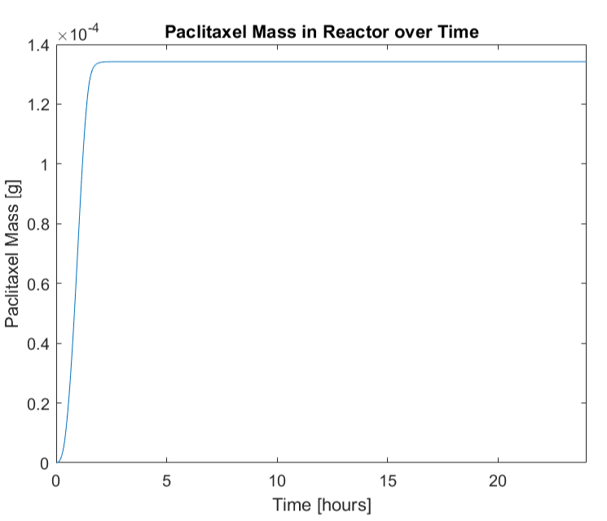

Figure 7: Graphical output of Microbial Consortium Model Iteration V. Notice that the maximum amount of paclitaxel produced is reached much faster than in the previous iteration and that more the maximum amount of paclitaxel produced decreases from 1.8x10-4 g to 1.4x10-4 g.

### Model Evaluation

With the growth of the cells, the reaction occurs much more quickly as there are more “reactors” in the form of cells performing the reaction and the maximum amount of paclitaxel produced decreases as more of the reactant mass goes toward producing cell mass when the cells divide. However, the model does not currently reflect that acetate inhibits the growth of *E. coli* and this will be incorporated into the next iteration.

## Iteration VI

### Assumptions

1. The fermentation broth is perfectly homogeneous in composition and temperature
2. The fermentation broth is kept at a constant temperature
3. The fermentation broth is kept at a constant volume
4. The fermentation broth is kept at a constant pH
5. All *E. coli* cells are identical to each other and all *S. cerevisiae* cells are identical to each other
6. Cells grow but do not die
7. ***E. coli* cell growth is inhibited by the presence of acetate**
8. Each reaction is first order
9. Transportation across the cell membrane is instantaneous and requires no energy
10. The cells have enough enzymes and cellular resources to perform each reaction
11. There is no wait time between reactions (i.e. no need for reaction products to diffuse within the cell or between cells before the next reaction occurs)
12. The output flow is filtered and does not remove any cells, only the desired product and water
13. The mass of water that enters the reactor is equal to the mass of water that leaves the reactor
14. The normal metabolisms of the *E. coli* and *S. cerevisiae* cells do not produce any additional heat
15. All reactions occur to completion
16. If there is more than one pathway to a desired product, only the most direct pathway is taken (i.e. the pathway with the least number of reactions)
17. Reactions only occur in the forward direction
18. Reaction rates are the same at all temperatures
19. If a reactant is used in more than one reaction, the mass of the reactant will be split evenly between the reactions.

### Mathematical Model

The inhibition of *E. coli* growth is modeled by product inhibition Michaelis-Menten kinetics. The concentrations of both xylose and acetate affect the growth rate of *E. coli* (Roe, O'Byrne, McLaggan, & Booth, 2002). This new growth rate equation is reflected in the following updated version of Equation 8 from Iteration V.

|  |  |
| --- | --- |
| $$\frac{∂e}{∂t}=\frac{μ_{max,e}x}{K_{s,e}(1+\frac{a}{K_{i}})+x} \frac{eV}{Y_{e/x}}-f(x,a,\left(e+s\right), T)$$ | [*8*] |

For this iteration, the death function is assumed to be zero (Assumption 6).

See Appendix C for the code used to produce the below output.

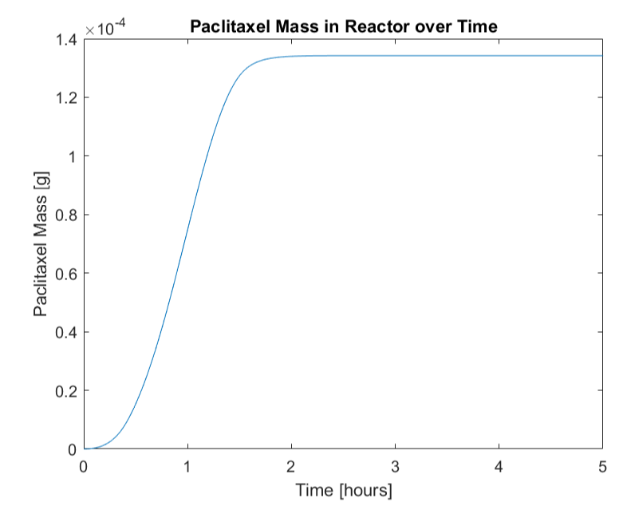

Figure 8: Graphical output of Microbial Consortium Model Iteration VI. Note the change in the time scale from 24 hours to 5 hours to better show the model output prior to the substrate being completely consumed. There seems to be little change in the actual rate of reaction and maximum paclitaxel production.

### Model Evaluation

Though there is little change between the output of this iteration and the previous iteration, this may be because the acetate which inhibits the *E.* coli growth is immediately metabolized by the yeast cells. As such, the growth models of the different cell types have been addressed. The death rates of the cells will be incorporated in the next iteration.

## Iteration VII

### Assumptions

1. The fermentation broth is perfectly homogeneous in composition and temperature
2. The fermentation broth is kept at a constant temperature
3. The fermentation broth is kept at a constant volume
4. The fermentation broth is kept at a constant pH
5. All *E. coli* cells are identical to each other and all *S. cerevisiae* cells are identical to each other
6. **Cells grow and die**
7. *E. coli* cell growth is inhibited by the presence of acetate
8. Each reaction is first order
9. Transportation across the cell membrane is instantaneous and requires no energy
10. The cells have enough enzymes and cellular resources to perform each reaction
11. There is no wait time between reactions (i.e. no need for reaction products to diffuse within the cell or between cells before the next reaction occurs)
12. The output flow is filtered and does not remove any cells, only the desired product and water
13. The mass of water that enters the reactor is equal to the mass of water that leaves the reactor
14. The normal metabolisms of the *E. coli* and *S. cerevisiae* cells do not produce any additional heat
15. All reactions occur to completion
16. If there is more than one pathway to a desired product, only the most direct pathway is taken (i.e. the pathway with the least number of reactions)
17. Reactions only occur in the forward direction
18. Reaction rates are the same at all temperatures
19. If a reactant is used in more than one reaction, the mass of the reactant will be split evenly between the reactions.

### Mathematical Model

For this iteration, it is assumed that cells only die due to “natural causes” (i.e. DNA damage causing the cell to enter apoptosis) rather than due to starvation or environmental temperature changes. As such, the cellular death equation is similar to that of a first order reaction and models that a certain portion of the cellular populations die on a regular basis. The updated cellular accumulation equations (Equations 8 and 9 from Iterations VI and V, respectively) can be found below:

|  |  |
| --- | --- |
| $$\frac{∂e}{∂t}=\frac{μ_{max,e}x}{K_{s,e}(1+\frac{a}{K_{i}})+x} \frac{eV}{Y_{e/x}}-αe$$ | [*8*] |
| $$\frac{∂s}{∂t}=\frac{μ_{max,s}a}{K_{s,s}+x} \frac{sV}{Y_{s/a}}-αs$$ | [*9*] |

See Appendix C for the code used to produce the below output.

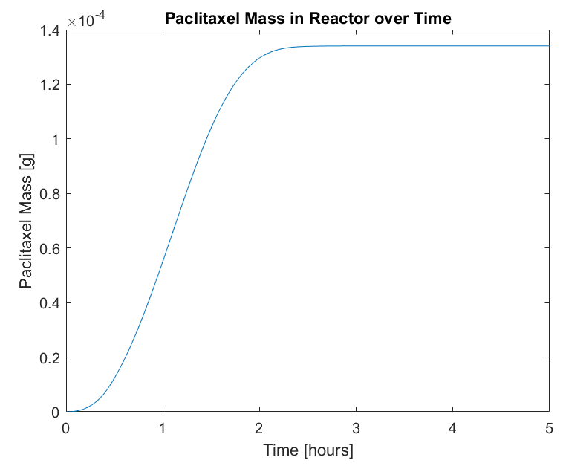

Figure 9: Graphical output of Microbial Consortium Model Iteration VII. Notice that the time to produce the maximum amount of paclitaxel nearly doubles.

### Model Evaluation

The incorporation of a death model shows that the reaction takes more time to consume all of the substrate and produce the maximum amount of paclitaxel, as expected, because there are fewer cells performing the reaction than in the previous iteration. Future iterations will incorporate the concentration of substrate, available reactor volume, and temperature into the growth and death models.

# Appendix A: Table of Nomenclature

|  |  |  |
| --- | --- | --- |
| Symbol | Parameter Meaning | Units |
| a | Concentration of acetate in the reactor | [g/L] |
| C | Concentration in a flow | [g/L] |
| d | Concentration of taxadiene in the reactor | [g/L] |
| E | Energy | [J] |
| e | Concentration of *E. coli* cells in the reactor | [g/L] |
| F | Flow rate | [L/h] |
| H | Heat of reaction | [J/mol] |
| Ks | Substrate concentration to produce half of the maximum cellular growth rate | [g/L] |
| m | Mass in a system | [g] |
| p | Concentration of paclitaxel in the reactor | [g/L] |
| r | Reaction rate | [mol/L-h] |
| s | Concentration of *S. cerevisiae* cells in the reactor | [g/L] |
| T | Temperature | [K] |
| t | Time | [h] |
| V | Volume of a system | [L] |
| W | Molecular weight | [g/mol] |
| x | Concentration of xylose in the reactor | [g/L] |
| Y | Yield coefficient | [g/g] |
| α | Cellular death constant | [1/h] |
| µ­ | Specific cellular growth rate | [1/h] |

|  |  |
| --- | --- |
| Subscript | Meaning |
| 1 | Property of Flow 1 |
| 2 | Property of Flow 2 |
| 3 | Property of Flow 3 |
| 4 | Property of Flow 4 |
| 5 | Property of Flow 5 |
| 6 | Property of Flow 6 |
| 7 | Property of Flow 7 |
| a | Property of acetate |
| a,s | Property of lumped reactions to convert acetate to *S. cerevisiae* cell growth |
| d | Property of taxadiene |
| d,p | Property of lumped reactions to convert taxadiene to paclitaxel |
| e | Property of *E. coli* cells |
| e/x | Ratio of *E. coli* mass to xylose mass |
| max | Maximum value of a property |
| p | Property of paclitaxel |
| s | Property of *S. cerevisiae* cells |
| s/a | Ratio of *S. cerevisiae* mass to acetate mass |
| s1 | Property of Subsystem 1 |
| s2 | Property of Subsystem 2 |
| x,a | Property of lumped reactions to convert xylose to acetate |
| x,d | Property of lumped reactions to convert xylose to taxadiene |
| x,e | Property of lumped reactions to convert xylose to *E. coli* cell growth |

# Appendix B: Supplemental Figures

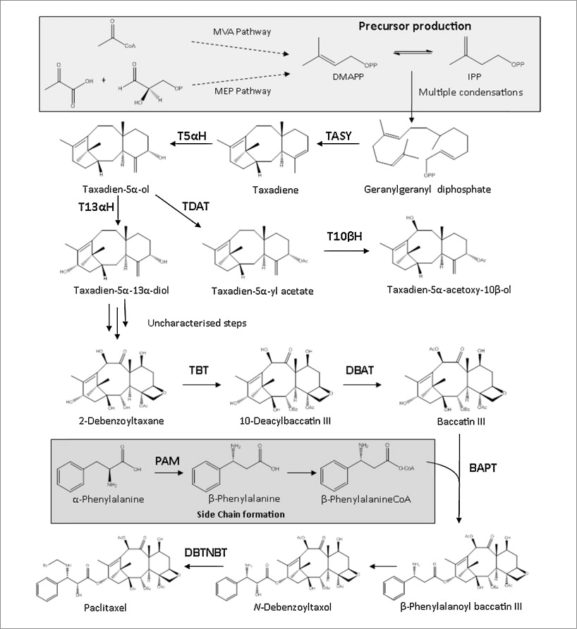

Figure 10: Paclitaxel biosynthesis pathway (Howat S. , et al., 2014). The first half of the pathway, up to the production of taxadiene, is performed in the E. coli cell while the rest of the pathway is performed in the S. cerevisiae cell.

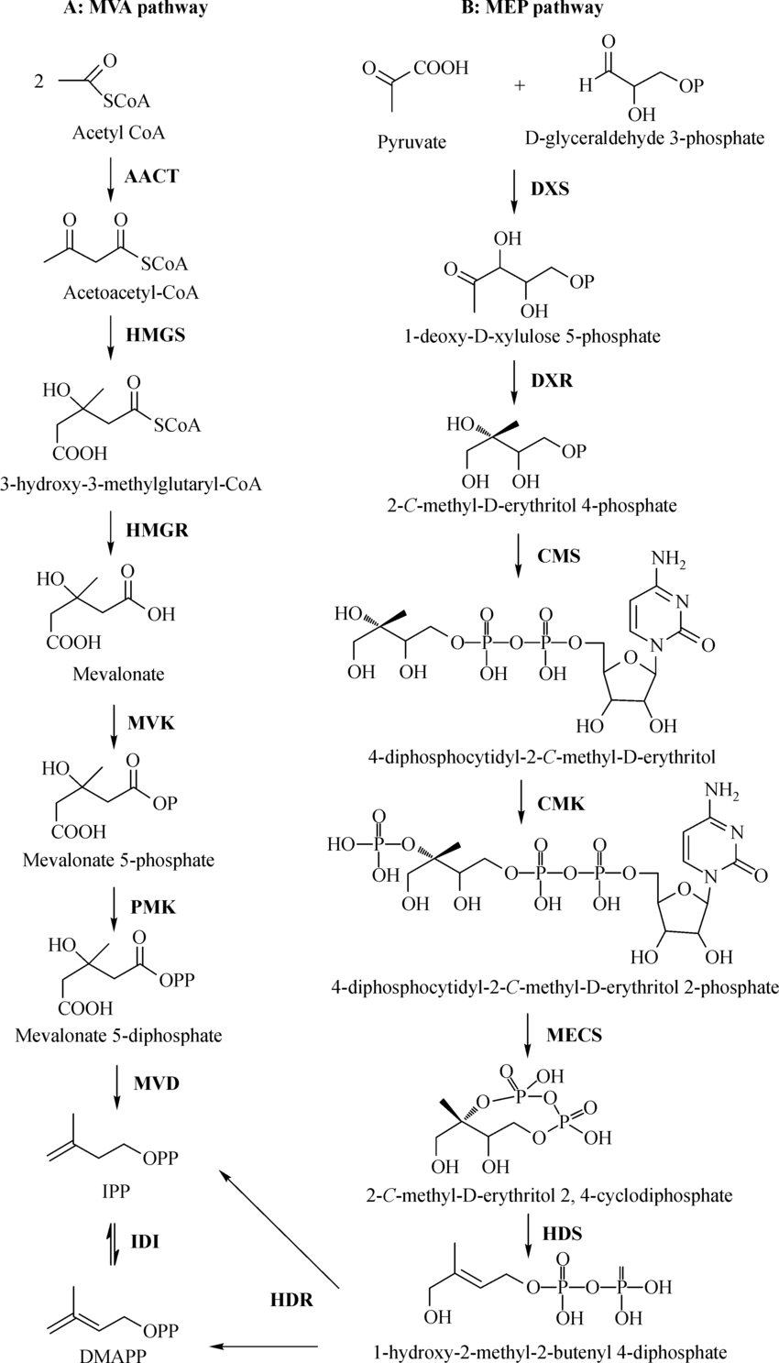

Figure 11: The MEV and MEP pathways referenced in Figure 10 (Zhu, Zeng, Sun, & Chen, 2014). These pathways are performed in the E. coli cell.

An external file that holds a picture, illustration, etc.
Object name is nihms940987f6.jpg

Figure 12: E. coli aerobic metabolism of xylose (Gonzalez, Long, & Antoniewicz, 2017). The E. coli cell produces the acetate and then transports the molecule to the fermentation broth, where it is then taken up by S. cerevisiae.

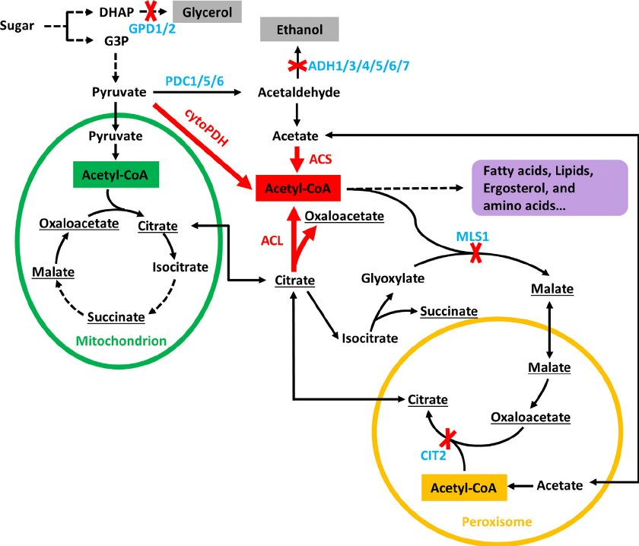

Figure 13: Metabolism of acetate in S. cerevisiae (Lian, Si, Nair, & Zhao, 2014). The acetate is produced in E. coli before being taken up by the S. cerevisiae and being incorporated into the metabolism.

# Appendix C: Model Code

## Iteration I

clear;

% Constants and Initial Conditions

F1 = 0; % [L/h]

C1 = 5; % [g/L]

F2 = 0; % [L/h]

V = 1; % [L]

T = 273 + 30; % [K]

cp = 4.186; % [J/g-K]

e = 2; % [g/L]

s = 2; % [g/L]

rho_cell = 200; % [g/L]

Vs1 = e * V / rho_cell; % [L]

Vs2 = s * V / rho_cell; % [L]

rho_water = 1000; % g/L

x = 5; % [g/L]

p = 0; % [g/L]

d = 0; % [g/L]

a = 0; % [g/L]

Wx = 150.13; % [g/mol]

Wd = 272.476; % [g/mol]

Wa = 60.052; % [g/mol]

Wp = 853.906; % [g/mol]

Hxd = 15; % [J/mol]

Hxa = 7; % [J/mol]

Hxe = 0; % [J/mol]

Hdp = 8; % [J/mol]

Has = 0; % [J/mol]

m = (e + s + x + p + d + a) * V; % [g]

ms1 = e; % [g]

ms2 = s; % [g]

time = 0:0.01:24; % [h]

p_t = zeros(length(time),1);

i = 1;

delt = 0.01;

for i = 1:length(time)

p_t(i) = p; % [g]

rxe = 0;

rxd = 1 / (1/0.65 + 1/0.57 + 1/0.891 + 1/0.078 + 1/0.52 + 1/0.134 + 1/0.0003 + 1/506 + 1/2 ...

+ 1/0.0035 + 1/0.06 + 1/0.06 + 1/0.00000133 + 1/0.109 + 1/3 + 1/1.6 + 1/23 + 1/33 ...

+ 1/0.75 + 1/0.099 + 1/0.03); % [mol/L-min]

rxd = rxd * 60; % [mol/L-h]

rxa = 1 / (1/0.65 + 1/0.57 + 1/0.891 + 1/0.078 + 1/0.52 + 1/0.134 + 1/0.885); % [mol/L-min]

rxa = rxa * 60; % [mol/L-h]

rdp = 1 / (1/0.016 + 1/5.77 + 1/0.00635 + 1/6.1 + 1/2.2 + 1/0.0049 + 1/0.0049); % [mol/L-min]

rdp = rdp * 60; % [mol/L-h]

ras = 0;

% integrate dxdt = F1 * C1 - (rxe + rxd + rxa) * Wx * Vs1; % [g/h]

x = x + F1 * C1 * delt - (rxe + rxd + rxa) * Wx * Vs1 * delt; % [g]

if x < 0

x = 0;

end

% integrate dddt = rxd * Wx * Vs1 - rdp * Wd * Vs2; % [g/h]

d = d + rxd * Wx * Vs1 * delt - rdp * Wd * Vs2 * delt; % [g]

if d < 0

d = 0;

end

% integrate dadt = rxa * Wx * Vs1 - ras * Wa * Vs2; % [g/h]

a = a + rxa * Wx * Vs1 * delt - ras * Wa * Vs2 * delt; % [g]

if a < 0

a = 0;

end

% integrate dedt = rxe * Wx * Vs1; % [g/h]

e = e + rxe * Wx * Vs1 * delt; % [g]

if e < 0

e = 0;

end

% integrate dsdt = ras * Wa * Vs2; % [g/h]

s = s + ras * Wa * Vs2 * delt;

if s < 0

s = 0;

end

C2 = p / V; % [g/L]

% integrate dpdt = rdp * Vs2 - F2 * C2

p = p + rdp * Vs2 * Wd * delt - F2 * C2 * delt; % [g]

if p < 0

p = 0;

end

% integrate dmdt = F1 * C1 - F2 * C2; % [g/h]

m = m + F1 * C1 * delt - F2 * C2 * delt; % [g]

if m < 0

m = 0;

end

% integrate dms1dt = F1 * C1 - Vs1 * Wx * (rxd + rxa); % [g/h]

ms1 = ms1 + F1 * C1 * delt - Vs1 * Wx * (rxd + rxa) * delt; % [g]

if ms1 < 0

ms1 = 0;

end

% integrate dms2dt = Vs1 * Wx * (rxd + rxa) - F2 * C2; % [g/h]

ms2 = ms2 + Vs1 * Wx * (rxd + rxa) * delt - F2 * C2 * delt; % [g]

if ms2 < 0

ms2 = 0;

end

% Assuming Subsystems Maintain a constant temperature

% dhs1dt = Vs1 * (Hxd * Wd * rxd + Hxa * Wa * rxa + Hxe * We * rxe) - F6

F6 = Vs1 * Wx * (Hxd * rxd + Hxa * rxa + Hxe * rxe);

if F6 < 0

F6 = 0;

end

% dhs2dt = Vs2 * (Hdp * Wp * rdp + Has * Ws * ras) - F7

F7 = Vs2 * (Hdp * Wd * rdp + Has * Wa * ras);

if F7 < 0

F7 = 0;

end

% Assume F3 = 0

F3 = 0; % [J/h]

dhdt = F6 + F7 - F3;

if dhdt < 0

dhdt = 0;

end

T = T + dhdt / (e + s + (rho_water - (e + s)) * V * cp); % [K]

end

plot(time, p_t)

title('Paclitaxel Mass in Reactor over Time')

xlabel('Time [hours]')

xlim([0,24])

ylabel('Paclitaxel Mass [g]')

## Iteration II

clear;

% Constants and Initial Conditions

F1 = 0; % [L/h]

C1 = 5; % [g/L]

F2 = 0; % [L/h]

V = 1; % [L]

T = 273 + 30; % [K]

cp = 4.186; % [J/g-K]

e = 2; % [g/L]

s = 2; % [g/L]

rho_cell = 200; % [g/L]

Vs1 = e * V / rho_cell; % [L]

Vs2 = s * V / rho_cell; % [L]

rho_water = 1000; % g/L

x = 5; % [g/L]

p = 0; % [g/L]

d = 0; % [g/L]

a = 0; % [g/L]

Wx = 150.13; % [g/mol]

Wd = 272.476; % [g/mol]

Wa = 60.052; % [g/mol]

Wp = 853.906; % [g/mol]

Hxd = 15; % [J/mol]

Hxa = 7; % [J/mol]

Hxe = 0; % [J/mol]

Hdp = 8; % [J/mol]

Has = 0; % [J/mol]

m = (e + s + x + p + d + a) * V; % [g]

ms1 = e; % [g]

ms2 = s; % [g]

time = 0:0.01:24; % [h]

p_t = zeros(length(time),1);

i = 1;

delt = 0.01;

for i = 1:length(time)

p_t(i) = p; % [g]

rxe = 0;

rxd = 1 / (1/0.65 + 1/0.57 + 1/0.891 + 1/0.078 + 1/0.52 + 1/0.134 + 1/0.0003 + 1/506 + 1/2 ...

+ 1/0.0035 + 1/0.06 + 1/0.06 + 1/0.00000133 + 1/0.109 + 1/3 + 1/1.6 + 1/23 + 1/33 ...

+ 1/0.75 + 1/0.099 + 1/0.03); % [mol/L-min]

rxd = rxd * 60; % [mol/L-h]

rxa = 1 / (1/0.65 + 1/0.57 + 1/0.891 + 1/0.078 + 1/0.52 + 1/0.134 + 1/0.885); % [mol/L-min]

rxa = rxa * 60; % [mol/L-h]

rdp = 1 / (1/0.016 + 1/5.77 + 1/0.00635 + 1/6.1 + 1/2.2 + 1/0.0049 + 1/0.0049); % [mol/L-min]

rdp = rdp * 60; % [mol/L-h]

if x < 272.5 / 6.02e23 % mass of one molecule of taxadiene

rxd = 0;

end

if x < 60 / 6.02e23 % mass of one molecule of acetate

rxa = 0;

end

if d < 853.9 / 6.02e23 % mass of one molecule of paclitaxel

rdp = 0;

end

ras = 0;

% integrate dxdt = F1 * C1 - (rxe + rxd + rxa) * Wx * Vs1; % [g/h]

x = x + F1 * C1 * delt - (rxe + rxd + rxa) * Wx * Vs1 * delt; % [g]

if x < 0

x = 0;

end

% integrate dddt = rxd * Wx * Vs1 - rdp * Wd * Vs2; % [g/h]

d = d + rxd * Wx * Vs1 * delt - rdp * Wd * Vs2 * delt; % [g]

if d < 0

d = 0;

end

% integrate dadt = rxa * Wx * Vs1 - ras * Wa * Vs2; % [g/h]

a = a + rxa * Wx * Vs1 * delt - ras * Wa * Vs2 * delt; % [g]

if a < 0

a = 0;

end

% integrate dedt = rxe * Wx * Vs1; % [g/h]

e = e + rxe * Wx * Vs1 * delt; % [g]

if e < 0

e = 0;

end

% integrate dsdt = ras * Wa * Vs2; % [g/h]

s = s + ras * Wa * Vs2 * delt;

if s < 0

s = 0;

end

C2 = p / V; % [g/L]

% integrate dpdt = rdp * Vs2 - F2 * C2

p = p + rdp * Vs2 * Wd * delt - F2 * C2 * delt; % [g]

if p < 0

p = 0;

end

% integrate dmdt = F1 * C1 - F2 * C2; % [g/h]

m = m + F1 * C1 * delt - F2 * C2 * delt; % [g]

if m < 0

m = 0;

end

% integrate dms1dt = F1 * C1 - Vs1 * Wx * (rxd + rxa); % [g/h]

ms1 = ms1 + F1 * C1 * delt - Vs1 * Wx * (rxd + rxa) * delt; % [g]

if ms1 < 0

ms1 = 0;

end

% integrate dms2dt = Vs1 * Wx * (rxd + rxa) - F2 * C2; % [g/h]

ms2 = ms2 + Vs1 * Wx * (rxd + rxa) * delt - F2 * C2 * delt; % [g]

if ms2 < 0

ms2 = 0;

end

% Assuming Subsystems Maintain a constant temperature

% dhs1dt = Vs1 * (Hxd * Wd * rxd + Hxa * Wa * rxa + Hxe * We * rxe) - F6

F6 = Vs1 * Wx * (Hxd * rxd + Hxa * rxa + Hxe * rxe);

if F6 < 0

F6 = 0;

end

% dhs2dt = Vs2 * (Hdp * Wp * rdp + Has * Ws * ras) - F7

F7 = Vs2 * (Hdp * Wd * rdp + Has * Wa * ras);

if F7 < 0

F7 = 0;

end

% Assume F3 = 0

F3 = 0; % [J/h]

dhdt = F6 + F7 - F3;

if dhdt < 0

dhdt = 0;

end

T = T + dhdt / (e + s + (rho_water - (e + s)) * V * cp); % [K]

end

plot(time, p_t)

title('Paclitaxel Mass in Reactor over Time')

xlabel('Time [hours]')

xlim([0,24])

ylabel('Paclitaxel Mass [g]')

## Iteration III

clear;

% Constants and Initial Conditions

F1 = 0; % [L/h]

C1 = 5; % [g/L]

F2 = 0; % [L/h]

V = 1; % [L]

T = 273 + 30; % [K]

cp = 4.186; % [J/g-K]

e = 2; % [g/L]

s = 2; % [g/L]

rho_cell = 200; % [g/L]

Vs1 = e * V / rho_cell; % [L]

Vs2 = s * V / rho_cell; % [L]

rho_water = 1000; % g/L

x = 5; % [g/L]

p = 0; % [g/L]

d = 0; % [g/L]

a = 0; % [g/L]

Wx = 150.13; % [g/mol]

Wd = 272.476; % [g/mol]

Wa = 60.052; % [g/mol]

Wp = 853.906; % [g/mol]

Hxd = 15; % [J/mol]

Hxa = 7; % [J/mol]

Hxe = 0; % [J/mol]

Hdp = 8; % [J/mol]

Has = 0; % [J/mol]

m = (e + s + x + p + d + a) * V; % [g]

ms1 = e; % [g]

ms2 = s; % [g]

time = 0:0.01:24; % [h]

p_t = zeros(length(time),1);

i = 1;

delt = 0.01;

for i = 1:length(time)

p_t(i) = p; % [g]

rxe = 0 * x;

rxd = x * 1 / (1/0.65 + 1/0.57 + 1/0.891 + 1/0.078 + 1/0.52 + 1/0.134 + 1/0.0003 + 1/506 + 1/2 ...

+ 1/0.0035 + 1/0.06 + 1/0.06 + 1/0.00000133 + 1/0.109 + 1/3 + 1/1.6 + 1/23 + 1/33 + 1/0.75 ...

+ 1/0.099 + 1/0.03); % [mol/L-min]

rxd = rxd * 60; % [mol/L-h]

rxa = x * 1 / (1/0.65 + 1/0.57 + 1/0.891 + 1/0.078 + 1/0.52 + 1/0.134 + 1/0.885); % [mol/L-min]

rxa = rxa * 60; % [mol/L-h]

rdp = d * 1 / (1/0.016 + 1/5.77 + 1/0.00635 + 1/6.1 + 1/2.2 + 1/0.0049 + 1/0.0049); % [mol/L-min]

rdp = rdp * 60; % [mol/L-h]

if x < 272.5 / 6.02e23 % mass of one molecule of taxadiene

rxd = 0;

end

if x < 60 / 6.02e23 % mass of one molecule of acetate

rxa = 0;

end

if d < 853.9 / 6.02e23 % mass of one molecule of paclitaxel

rdp = 0;

end

ras = 0 * a;

% integrate dxdt = F1 * C1 - (rxe + rxd + rxa) * Wx * Vs1; % [g/h]

x = x + F1 * C1 * delt - (rxe + rxd + rxa) * Wx * Vs1 * delt; % [g]

if x < 0

x = 0;

end

% integrate dddt = rxd * Wx * Vs1 - rdp * Wd * Vs2; % [g/h]

d = d + rxd * Wx * Vs1 * delt - rdp * Wd * Vs2 * delt; % [g]

if d < 0

d = 0;

end

% integrate dadt = rxa * Wx * Vs1 - ras * Wa * Vs2; % [g/h]

a = a + rxa * Wx * Vs1 * delt - ras * Wa * Vs2 * delt; % [g]

if a < 0

a = 0;

end

% integrate dedt = rxe * Wx * Vs1; % [g/h]

e = e + rxe * Wx * Vs1 * delt; % [g]

if e < 0

e = 0;

end

% integrate dsdt = ras * Wa * Vs2; % [g/h]

s = s + ras * Wa * Vs2 * delt;

if s < 0

s = 0;

end

C2 = p / V; % [g/L]

% integrate dpdt = rdp * Vs2 - F2 * C2

p = p + rdp * Vs2 * Wd * delt - F2 * C2 * delt; % [g]

if p < 0

p = 0;

end

% integrate dmdt = F1 * C1 - F2 * C2; % [g/h]

m = m + F1 * C1 * delt - F2 * C2 * delt; % [g]

if m < 0

m = 0;

end

% integrate dms1dt = F1 * C1 - Vs1 * Wx * (rxd + rxa); % [g/h]

ms1 = ms1 + F1 * C1 * delt - Vs1 * Wx * (rxd + rxa) * delt; % [g]

if ms1 < 0

ms1 = 0;

end

% integrate dms2dt = Vs1 * Wx * (rxd + rxa) - F2 * C2; % [g/h]

ms2 = ms2 + Vs1 * Wx * (rxd + rxa) * delt - F2 * C2 * delt; % [g]

if ms2 < 0

ms2 = 0;

end

% Assuming Subsystems Maintain a constant temperature

% dhs1dt = Vs1 * (Hxd * Wd * rxd + Hxa * Wa * rxa + Hxe * We * rxe) - F6

F6 = Vs1 * Wx * (Hxd * rxd + Hxa * rxa + Hxe * rxe);

if F6 < 0

F6 = 0;

end

% dhs2dt = Vs2 * (Hdp * Wp * rdp + Has * Ws * ras) - F7

F7 = Vs2 * (Hdp * Wd * rdp + Has * Wa * ras);

if F7 < 0

F7 = 0;

end

% Assume F3 = 0

F3 = 0; % [J/h]

dhdt = F6 + F7 - F3;

if dhdt < 0

dhdt = 0;

end

T = T + dhdt / (e + s + (rho_water - (e + s)) * V * cp); % [K]

end

plot(time, p_t)

title('Paclitaxel Mass in Reactor over Time')

xlabel('Time [hours]')

xlim([0,24])

ylabel('Paclitaxel Mass [g]')

## Iteration IV

clear;

% Constants and Initial Conditions

F1 = 0; % [L/h]

C1 = 5; % [g/L]

F2 = 0; % [L/h]

V = 1; % [L]

T = 273 + 30; % [K]

cp = 4.186; % [J/g-K]

e = 2; % [g/L]

s = 2; % [g/L]

rho_cell = 200; % [g/L]

Vs1 = e * V / rho_cell; % [L]

Vs2 = s * V / rho_cell; % [L]

rho_water = 1000; % g/L

x = 5; % [g/L]

p = 0; % [g/L]

d = 0; % [g/L]

a = 0; % [g/L]

Wx = 150.13; % [g/mol]

Wd = 272.476; % [g/mol]

Wa = 60.052; % [g/mol]

Wp = 853.906; % [g/mol]

Hxd = 15; % [J/mol]

Hxa = 7; % [J/mol]

Hxe = 0; % [J/mol]

Hdp = 8; % [J/mol]

Has = 0; % [J/mol]

m = (e + s + x + p + d + a) * V; % [g]

ms1 = e; % [g]

ms2 = s; % [g]

time = 0:0.01:24; % [h]

p_t = zeros(length(time),1);

i = 1;

delt = 0.01;

for i = 1:length(time)

p_t(i) = p; % [g]

rxe = 0 * x;

rxd = x * 0.5 * 1 / (1/0.65 + 1/0.57 + 1/0.891 + 1/0.078 + 1/0.52 + 1/0.134 + 1/0.0003 + 1/506 + 1/2 ...

+ 1/0.0035 + 1/0.06 + 1/0.06 + 1/0.00000133 + 1/0.109 + 1/3 + 1/1.6 + 1/23 + 1/33 + 1/0.75 + ...

1/0.099 + 1/0.03); % [mol/L-min]

rxd = rxd * 60; % [mol/L-h]

rxa = x * 0.5 * 1 / (1/0.65 + 1/0.57 + 1/0.891 + 1/0.078 + 1/0.52 + 1/0.134 + 1/0.885); % [mol/L-min]

rxa = rxa * 60; % [mol/L-h]

rdp = d *1 / (1/0.016 + 1/5.77 + 1/0.00635 + 1/6.1 + 1/2.2 + 1/0.0049 + 1/0.0049); % [mol/L-min]

rdp = rdp * 60; % [mol/L-h]

if x < 272.5 / 6.02e23 % mass of one molecule of taxadiene

rxd = 0;

end

if x < 60 / 6.02e23 % mass of one molecule of acetate

rxa = 0 * a;

end

if d < 853.9 / 6.02e23 % mass of one molecule of paclitaxel

rdp = 0;

end

ras = 0 * a;

% integrate dxdt = F1 * C1 - (rxe + rxd + rxa) * Wx * Vs1; % [g/h]

x = x + F1 * C1 * delt - (rxe + rxd + rxa) * Wx * Vs1 * delt; % [g]

if x < 0

x = 0;

end

% integrate dddt = rxd * Wx * Vs1 - rdp * Wd * Vs2; % [g/h]

d = d + rxd * Wx * Vs1 * delt - rdp * Wd * Vs2 * delt; % [g]

if d < 0

d = 0;

end

% integrate dadt = rxa * Wx * Vs1 - ras * Wa * Vs2; % [g/h]

a = a + rxa * Wx * Vs1 * delt - ras * Wa * Vs2 * delt; % [g]

if a < 0

a = 0;

end

% integrate dedt = rxe * Wx * Vs1; % [g/h]

e = e + rxe * Wx * Vs1 * delt; % [g]

if e < 0

e = 0;

end

% integrate dsdt = ras * Wa * Vs2; % [g/h]

s = s + ras * Wa * Vs2 * delt;

if s < 0

s = 0;

end

C2 = p / V; % [g/L]

% integrate dpdt = rdp * Vs2 - F2 * C2

p = p + rdp * Vs2 * Wd * delt - F2 * C2 * delt; % [g]

if p < 0

p = 0;

end

% integrate dmdt = F1 * C1 - F2 * C2; % [g/h]

m = m + F1 * C1 * delt - F2 * C2 * delt; % [g]

if m < 0

m = 0;

end

% integrate dms1dt = F1 * C1 - Vs1 * Wx * (rxd + rxa); % [g/h]

ms1 = ms1 + F1 * C1 * delt - Vs1 * Wx * (rxd + rxa) * delt; % [g]

if ms1 < 0

ms1 = 0;

end

% integrate dms2dt = Vs1 * Wx * (rxd + rxa) - F2 * C2; % [g/h]

ms2 = ms2 + Vs1 * Wx * (rxd + rxa) * delt - F2 * C2 * delt; % [g]

if ms2 < 0

ms2 = 0;

end

% Assuming Subsystems Maintain a constant temperature

% dhs1dt = Vs1 * (Hxd * Wd * rxd + Hxa * Wa * rxa + Hxe * We * rxe) - F6

F6 = Vs1 * Wx * (Hxd * rxd + Hxa * rxa + Hxe * rxe);

if F6 < 0

F6 = 0;

end

% dhs2dt = Vs2 * (Hdp * Wp * rdp + Has * Ws * ras) - F7

F7 = Vs2 * (Hdp * Wd * rdp + Has * Wa * ras);

if F7 < 0

F7 = 0;

end

% Assume F3 = 0

F3 = 0; % [J/h]

dhdt = F6 + F7 - F3;

if dhdt < 0

dhdt = 0;

end

T = T + dhdt / (e + s + (rho_water - (e + s)) * V * cp); % [K]

end

plot(time, p_t)

title('Paclitaxel Mass in Reactor over Time')

xlabel('Time [hours]')

xlim([0,24])

ylabel('Paclitaxel Mass [g]')

## Iteration V

clear;

% Constants and Initial Conditions

F1 = 0; % [L/h]

C1 = 5; % [g/L]

F2 = 0; % [L/h]

V = 1; % [L]

T = 273 + 30; % [K]

cp = 4.186; % [J/g-K]

e_i = 2; % [g/L]

s_i = 2; % [g/L]

e = e_i; % [g/L]

s = s_i; % [g/L]

rho_cell = 200; % [g/L]

Vs1 = e * V / rho_cell; % [L]

Vs2 = s * V / rho_cell; % [L]

rho_water = 1000; % g/L

x = 5; % [g/L]

p = 0; % [g/L]

d = 0; % [g/L]

a = 0; % [g/L]

Wx = 150.13; % [g/mol]

Wd = 272.476; % [g/mol]

Wa = 60.052; % [g/mol]

Wp = 853.906; % [g/mol]

Hxd = 15; % [J/mol]

Hxa = 7; % [J/mol]

Hxe = 0; % [J/mol]

Hdp = 8; % [J/mol]

Has = 0; % [J/mol]

m = (e + s + x + p + d + a) * V; % [g]

ms1 = e; % [g]

ms2 = s; % [g]

time = 0:0.01:24; % [h]

p_t = zeros(length(time),1);

e_t = p_t;

s_t = p_t;

i = 1;

delt = 0.01;

for i = 1:length(time)

p_t(i) = p; % [g]

rxe = 0.76 * 0.33 * x / (7160e-6 + x) / 0.57; % [g/L-h]

rxd = x * 0.33 * 1 / (1/0.65 + 1/0.57 + 1/0.891 + 1/0.078 + 1/0.52 + 1/0.134 + 1/0.0003 + 1/506 + 1/2 ...

+ 1/0.0035 + 1/0.06 + 1/0.06 + 1/0.00000133 + 1/0.109 + 1/3 + 1/1.6 + 1/23 + 1/33 + 1/0.75 + ...

1/0.099 + 1/0.03); % [mol/L-min]

rxd = rxd * 60; % [mol/L-h]

rxa = x * 0.33 * 1 / (1/0.65 + 1/0.57 + 1/0.891 + 1/0.078 + 1/0.52 + 1/0.134 + 1/0.885); % [mol/L-min]

rxa = rxa * 60; % [mol/L-h]

rdp = d *1 / (1/0.016 + 1/5.77 + 1/0.00635 + 1/6.1 + 1/2.2 + 1/0.0049 + 1/0.0049); % [mol/L-min]

rdp = rdp * 60; % [mol/L-h]

if x < 272.5 / 6.02e23 % mass of one molecule of taxadiene

rxd = 0;

end

if x < 60 / 6.02e23 % mass of one molecule of acetate

rxa = 0 * a;

end

if d < 853.9 / 6.02e23 % mass of one molecule of paclitaxel

rdp = 0;

end

ras = 0.5 * a / (0.0054e-3 * Wa + a) / (8.4 / Wa); % [g/L-h]

Vs1 = e * V / rho_cell; % [L]

Vs2 = s * V / rho_cell; % [L]

% integrate dxdt = F1 * C1 - (rxe + rxd + rxa) * Wx * Vs1; % [g/h]

x = x + F1 * C1 * delt - (rxe + rxd + rxa) * Wx * Vs1 * delt; % [g]

if x < 0

x = 0;

end

% integrate dddt = rxd * Wx * Vs1 - rdp * Wd * Vs2; % [g/h]

d = d + rxd * Wx * Vs1 * delt - rdp * Wd * Vs2 * delt; % [g]

if d < 0

d = 0;

end

% integrate dadt = rxa * Wx * Vs1 - ras * Wa * Vs2; % [g/h]

a = a + rxa * Wx * Vs1 * delt - ras * Wa * Vs2 * delt; % [g]

if a < 0

a = 0;

end

% integrate dedt = rxe * Wx * Vs1; % [g/h]

e = e + rxe * e * V * delt; % [g]

if e < 0

e = 0;

end

e_t(i) = e;

% integrate dsdt = ras * Wa * Vs2; % [g/h]

s = s + ras * s * V * delt;

if s < 0

s = 0;

end

s_t(i) = s;

C2 = p / V; % [g/L]

% integrate dpdt = rdp * Vs2 - F2 * C2

p = p + rdp * Vs2 * Wd * delt - F2 * C2 * delt; % [g]

if p < 0

p = 0;

end

% Assuming Subsystems Maintain a constant temperature

% dhs1dt = Vs1 * (Hxd * Wd * rxd + Hxa * Wa * rxa + Hxe * We * rxe) - F6

F6 = Vs1 * Wx * (Hxd * rxd + Hxa * rxa + Hxe * rxe);

if F6 < 0

F6 = 0;

end

% dhs2dt = Vs2 * (Hdp * Wp * rdp + Has * Ws * ras) - F7

F7 = Vs2 * (Hdp * Wd * rdp + Has * Wa * ras);

if F7 < 0

F7 = 0;

end

% Assume F3 = 0

F3 = 0; % [J/h]

dhdt = F6 + F7 - F3;

if dhdt < 0

dhdt = 0;

end

T = T + dhdt / (e + s + (rho_water - (e + s)) * V * cp); % [K]

end

plot(time, p_t)

title('Paclitaxel Mass in Reactor over Time')

xlabel('Time [hours]')

xlim([0,24])

ylabel('Paclitaxel Mass [g]')

plot(time, e_t, time, s_t)

title('Paclitaxel Mass in Reactor over Time')

xlabel('Time [hours]')

xlim([0,24])

ylabel('Paclitaxel Mass [g]')

legend('E coli', 'S cerevisiae')

## Iteration VI

clear;

% Constants and Initial Conditions

F1 = 0; % [L/h]

C1 = 5; % [g/L]

F2 = 0; % [L/h]

V = 1; % [L]

T = 273 + 30; % [K]

cp = 4.186; % [J/g-K]

e_i = 2; % [g/L]

s_i = 2; % [g/L]

e = e_i; % [g/L]

s = s_i; % [g/L]

rho_cell = 200; % [g/L]

Vs1 = e * V / rho_cell; % [L]

Vs2 = s * V / rho_cell; % [L]

rho_water = 1000; % g/L

x = 5; % [g/L]

p = 0; % [g/L]

d = 0; % [g/L]

a = 0; % [g/L]

Wx = 150.13; % [g/mol]

Wd = 272.476; % [g/mol]

Wa = 60.052; % [g/mol]

Wp = 853.906; % [g/mol]

Hxd = 15; % [J/mol]

Hxa = 7; % [J/mol]

Hxe = 0; % [J/mol]

Hdp = 8; % [J/mol]

Has = 0; % [J/mol]

m = (e + s + x + p + d + a) * V; % [g]

ms1 = e; % [g]

ms2 = s; % [g]

time = 0:0.01:24; % [h]

p_t = zeros(length(time),1);

e_t = p_t;

s_t = p_t;

i = 1;

delt = 0.01;

for i = 1:length(time)

p_t(i) = p; % [g]

rxe = 0.76 * 0.33 * x / (7160e-6 * (1 + a/(8e-3 * Wa)) + x) / 0.57; % [g/L-h]

rxd = x * 0.33 * 1 / (1/0.65 + 1/0.57 + 1/0.891 + 1/0.078 + 1/0.52 + 1/0.134 + 1/0.0003 + 1/506 + 1/2 ...

+ 1/0.0035 + 1/0.06 + 1/0.06 + 1/0.00000133 + 1/0.109 + 1/3 + 1/1.6 + 1/23 + 1/33 + 1/0.75 + ...

1/0.099 + 1/0.03); % [mol/L-min]

rxd = rxd * 60; % [mol/L-h]

rxa = x * 0.33 * 1 / (1/0.65 + 1/0.57 + 1/0.891 + 1/0.078 + 1/0.52 + 1/0.134 + 1/0.885); % [mol/L-min]

rxa = rxa * 60; % [mol/L-h]

rdp = d *1 / (1/0.016 + 1/5.77 + 1/0.00635 + 1/6.1 + 1/2.2 + 1/0.0049 + 1/0.0049); % [mol/L-min]

rdp = rdp * 60; % [mol/L-h]

if x < 272.5 / 6.02e23 % mass of one molecule of taxadiene

rxd = 0;

end

if x < 60 / 6.02e23 % mass of one molecule of acetate

rxa = 0 * a;

end

if d < 853.9 / 6.02e23 % mass of one molecule of paclitaxel

rdp = 0;

end

ras = 0.5 * a / (0.0054e-3 * Wa + a) / (8.4 / Wa); % [g/L-h]

Vs1 = e * V / rho_cell; % [L]

Vs2 = s * V / rho_cell; % [L]

% integrate dxdt = F1 * C1 - (rxe + rxd + rxa) * Wx * Vs1; % [g/h]

x = x + F1 * C1 * delt - (rxe + rxd + rxa) * Wx * Vs1 * delt; % [g]

if x < 0

x = 0;

end

% integrate dddt = rxd * Wx * Vs1 - rdp * Wd * Vs2; % [g/h]

d = d + rxd * Wx * Vs1 * delt - rdp * Wd * Vs2 * delt; % [g]

if d < 0

d = 0;

end

% integrate dadt = rxa * Wx * Vs1 - ras * Wa * Vs2; % [g/h]

a = a + rxa * Wx * Vs1 * delt - ras * Wa * Vs2 * delt; % [g]

if a < 0

a = 0;

end

% integrate dedt = rxe * Wx * Vs1; % [g/h]

e = e + rxe * e * V * delt; % [g]

if e < 0

e = 0;

end

e_t(i) = e;

% integrate dsdt = ras * Wa * Vs2; % [g/h]

s = s + ras * s * V * delt;

if s < 0

s = 0;

end

s_t(i) = s;

C2 = p / V; % [g/L]

% integrate dpdt = rdp * Vs2 - F2 * C2

p = p + rdp * Vs2 * Wd * delt - F2 * C2 * delt; % [g]

if p < 0

p = 0;

end

% Assuming Subsystems Maintain a constant temperature

% dhs1dt = Vs1 * (Hxd * Wd * rxd + Hxa * Wa * rxa + Hxe * We * rxe) - F6

F6 = Vs1 * Wx * (Hxd * rxd + Hxa * rxa + Hxe * rxe);

if F6 < 0

F6 = 0;

end

% dhs2dt = Vs2 * (Hdp * Wp * rdp + Has * Ws * ras) - F7

F7 = Vs2 * (Hdp * Wd * rdp + Has * Wa * ras);

if F7 < 0

F7 = 0;

end

% Assume F3 = 0

F3 = 0; % [J/h]

dhdt = F6 + F7 - F3;

if dhdt < 0

dhdt = 0;

end

T = T + dhdt / (e + s + (rho_water - (e + s)) * V * cp); % [K]

end

plot(time, p_t)

title('Paclitaxel Mass in Reactor over Time')

xlabel('Time [hours]')

xlim([0,5])

ylabel('Paclitaxel Mass [g]')

plot(time, e_t, time, s_t)

title('Paclitaxel Mass in Reactor over Time')

xlabel('Time [hours]')

xlim([0,24])

ylabel('Paclitaxel Mass [g]')

legend('E coli', 'S cerevisiae')

## Iteration VII

clear;

% Constants and Initial Conditions

F1 = 0; % [L/h]

C1 = 5; % [g/L]

F2 = 0; % [L/h]

V = 1; % [L]

T = 273 + 30; % [K]

cp = 4.186; % [J/g-K]

e_i = 2; % [g/L]

s_i = 2; % [g/L]

e = e_i; % [g/L]

s = s_i; % [g/L]

rho_cell = 200; % [g/L]

Vs1 = e * V / rho_cell; % [L]

Vs2 = s * V / rho_cell; % [L]

rho_water = 1000; % g/L

x = 5; % [g/L]

p = 0; % [g/L]

d = 0; % [g/L]

a = 0; % [g/L]

Wx = 150.13; % [g/mol]

Wd = 272.476; % [g/mol]

Wa = 60.052; % [g/mol]

Wp = 853.906; % [g/mol]

Hxd = 15; % [J/mol]

Hxa = 7; % [J/mol]

Hxe = 0; % [J/mol]

Hdp = 8; % [J/mol]

Has = 0; % [J/mol]

m = (e + s + x + p + d + a) * V; % [g]

ms1 = e; % [g]

ms2 = s; % [g]

time = 0:0.01:24; % [h]

p_t = zeros(length(time),1);

e_t = p_t;

s_t = p_t;

i = 1;

delt = 0.01;

for i = 1:length(time)

p_t(i) = p; % [g]

rxe = 0.76 * 0.33 * x / (7160e-6 * (1 + a/(8e-3 * Wa)) + x) / 0.57; % [g/L-h]

rxd = x * 0.33 * 1 / (1/0.65 + 1/0.57 + 1/0.891 + 1/0.078 + 1/0.52 + 1/0.134 + 1/0.0003 + 1/506 + 1/2 ...

+ 1/0.0035 + 1/0.06 + 1/0.06 + 1/0.00000133 + 1/0.109 + 1/3 + 1/1.6 + 1/23 + 1/33 + 1/0.75 + ...

1/0.099 + 1/0.03); % [mol/L-min]

rxd = rxd * 60; % [mol/L-h]

rxa = x * 0.33 * 1 / (1/0.65 + 1/0.57 + 1/0.891 + 1/0.078 + 1/0.52 + 1/0.134 + 1/0.885); % [mol/L-min]

rxa = rxa * 60; % [mol/L-h]

rdp = d *1 / (1/0.016 + 1/5.77 + 1/0.00635 + 1/6.1 + 1/2.2 + 1/0.0049 + 1/0.0049); % [mol/L-min]

rdp = rdp * 60; % [mol/L-h]

if x < 272.5 / 6.02e23 % mass of one molecule of taxadiene

rxd = 0;

end

if x < 60 / 6.02e23 % mass of one molecule of acetate

rxa = 0 * a;

end

if d < 853.9 / 6.02e23 % mass of one molecule of paclitaxel

rdp = 0;

end

ras = 0.5 * a / (0.0054e-3 * Wa + a) / (8.4 / Wa); % [g/L-h]

Vs1 = e * V / rho_cell; % [L]

Vs2 = s * V / rho_cell; % [L]

% integrate dxdt = F1 * C1 - (rxe + rxd + rxa) * Wx * Vs1; % [g/h]

x = x + F1 * C1 * delt - (rxe + rxd + rxa) * Wx * Vs1 * delt; % [g]

if x < 0

x = 0;

end

% integrate dddt = rxd * Wx * Vs1 - rdp * Wd * Vs2; % [g/h]

d = d + rxd * Wx * Vs1 * delt - rdp * Wd * Vs2 * delt; % [g]

if d < 0

d = 0;

end

% integrate dadt = rxa * Wx * Vs1 - ras * Wa * Vs2; % [g/h]

a = a + rxa * Wx * Vs1 * delt - ras * Wa * Vs2 * delt; % [g]

if a < 0

a = 0;

end

% integrate dedt = rxe * Wx * Vs1; % [g/h]

e = e + rxe * e * V * delt - 0.5 * e * delt; % [g]

if e < 0

e = 0;

end

e_t(i) = e;

% integrate dsdt = ras * Wa * Vs2; % [g/h]

s = s + ras * s * V * delt - 0.5 * s * delt; % [g]

if s < 0

s = 0;

end

s_t(i) = s;

C2 = p / V; % [g/L]

% integrate dpdt = rdp * Vs2 - F2 * C2

p = p + rdp * Vs2 * Wd * delt - F2 * C2 * delt; % [g]

if p < 0

p = 0;

end

% Assuming Subsystems Maintain a constant temperature

% dhs1dt = Vs1 * (Hxd * Wd * rxd + Hxa * Wa * rxa + Hxe * We * rxe) - F6

F6 = Vs1 * Wx * (Hxd * rxd + Hxa * rxa + Hxe * rxe);

if F6 < 0

F6 = 0;

end

% dhs2dt = Vs2 * (Hdp * Wp * rdp + Has * Ws * ras) - F7

F7 = Vs2 * (Hdp * Wd * rdp + Has * Wa * ras);

if F7 < 0

F7 = 0;

end

% Assume F3 = 0

F3 = 0; % [J/h]

dhdt = F6 + F7 - F3;

if dhdt < 0

dhdt = 0;

end

T = T + dhdt / (e + s + (rho_water - (e + s)) * V * cp); % [K]

end

plot(time, p_t)

title('Paclitaxel Mass in Reactor over Time')

xlabel('Time [hours]')

xlim([0,5])

ylabel('Paclitaxel Mass [g]')

plot(time, e_t, time, s_t)

title('Paclitaxel Mass in Reactor over Time')

xlabel('Time [hours]')

xlim([0,24])

ylabel('Paclitaxel Mass [g]')

legend('E coli', 'S cerevisiae')

## 

# Appendix D: References

Agranoff, B. W., Eggerer, H., Henning, U., & Lynen, F. (1960). Biosynthesis of terpenes. VII. Isopentenyl pyrophosphate isomerase. *J. Biol. Chem., 235*, 326-332.

Bloch, K., Chaykin, S., Phillips, A. H., & De Waard, A. (1959). Mevalonic acid pyrophosphate and isopentenylpyrophosphate. *J. Biol. Chem, 234*, 2595-2604.

Cane, D. E., Chow, C., Lillo, A., & Kang, I. (2001). Molecular cloning, expression and characterization of the first three genes in the mevalonate-independent isoprenoid pathway in Streptomyces coelicolor. *Bioorg. Med. Chem., 9*, 1467-1477.

Chau, M., Walker, K., Long, R., & Croteau, R. (2004). Regioselectivity of taxoid-O-acetyltransferases: heterologous expression and characterization of a new taxadien-5alpha-ol-O-acetyltransferase. *Arch. Biochem. Biophys., 430*, 237-246.

Chesters, C., Wilding, M., Goodall, M., & Micklefield, J. (2012). Thermal bifunctionality of bacterial phenylalanine aminomutase and ammonia lyase enzymes. *Angew. chem. Int. Ed. Engl., 51*, 4344-4348.

Daran-Lapujade, P., Jansen, M. L., Daran, J.-M., van Gulik, W., de Winde, J. H., & Pronk, J. T. (n.d.). Role of Transcriptional Regulation in Controlling Fluxes in Central Carbon Metabolism of Saccharomyces cerevisiae, a Chemostat Culture Study.

Durr, I. F., & Rudney, H. (1960). The reduction of beta-hydroxy-beta-methylglutaryl coenzyme A to mevalonic acid. *J. Biol. Chem., 235*, 2572-2578.

Fang, J., & Ewald, D. (2004). Expression cloned cDNA for 10-deacetylbaccatin III-10-O-acetyltransferase in Escherichia coli: a comparative study of three fusion systems. *Protein Expr. Purif., 35*, 17-24.

Feigenbaum, J., & Schulz, H. (1975). Thiolases of Escherichia coli: purification and chain length specificities. *J. Bacteriol., 122*, 407-411.

Gogerty, D. S., & Bobik, T. A. (2010). Formation of isobutene from 3-hydroxy-3-methylbutyrate by diphosphomevalonate decarboxylase. *Appl. Environ. Microbiol., 76*, 85004-85010.

Gonzalez, J. E., Long, C. P., & Antoniewicz, M. R. (2017, January). Comprehensive analysis of glucose and xylose metabolism in Escherichia coli under aerobic and anaerobic conditions by 13C metabolic flux analysis. *Metabolic Engineering, 39*, 9-18.

Gonzalez, J. E., Long, C. P., & Antoniewicz, M. R. (2017, January). Comprehensive analysis of glucose and xylose metabolism in Escherichia coli under aerobic and anaerobic conditions by 13C metabolic flux analysis. *Metabolic Engineering, 39*, 9-18. doi:10.1016/j.ymben.2016.11.0003

Hahn, F. M., Eubanks, L. M., Testa, C. A., Blagg, B. S., Baker, J. A., & Poulter, C. D. (2001). 1-Deoxy-D-xylulose 5-phosphate synthase, the gene product of open reading frame (ORF) 2816 and ORF 2895 in Rhodobacter capsulatus. *J. Bacteriol., 183*, 1-11.

Howat, S., Park, B., Oh, I. S., Jin, Y.-W., Lee, E.-K., & Loake, G. J. (2014, May 25). Paclitaxel: biosynthesis, production, and future prospects. *New Biotechnology, 31*(3), 242-245. doi:10.1016/j.nbt.2014.02.010

Howat, S., Park, B., Oh, I., Jin, Y.-W., Lee, E.-K., & Loake, G. J. (2014, May 25). Paclitaxel: biosynthesis, production and future prospects. *New Biotechnology, 31*(3), 242-245.

Inui, H., Miyatake, K., Nakano, Y., & Kitaoka, S. (1990). Pyruvate: NADP+ oxidoreductase from Euglena gracilis: mechanism of O2-inactivation of the enzyme and its stability in the aerobe. *Arch. Biochem. Biophys, 280*, 292-298.

Jennewein, S., Long, R. M., Williams, R. M., & Croteau, R. (2004). Cytochrome p450 taxadiene 5alpha-hydroxylase, a mechanistically unusual monooxygenase catalyzing the first oxygenation step of taxol biosynthesis. *Chem. Biol., 11*, 379-387.

Kayser, A., Weber, J., Hecht, V., & Rinas, U. (2004, December 6). Metabolic flux analysis of Escherichia coli in glucose-limited continuous culture. I. Growth-rate-dependent metabolic efficiency at steady state. *Microbiology, 151*, 693-706.

Lee, J. Y., Cheong, D. E., & Kim, G. J. (2008). A novel assay system for the measurement of transketolase activity using xylulokinase from Saccharomyces cerevisiae. *Biotechnol. Lett., 30*, 899-904.

Lian, J., Si, T., Nair, N., & Zhao, H. (2014, July). Design and construction of acetyl-CoA overproducing Saccharomyces cerevisiae strains. *Metabolic Engineering, 24*, 139-149.

Liang, M. H., Qv, X. Y., Jin, H. H., & Jiang, J. G. (2016). Characterization and expression of AMP-forming acetyl-CoA synthetase from Dunaliella tertiolecta and its response to nitrogen starvation stress. *Sci. Rep., 6*, 23445.

Malcovati, M., & Valentini, G. (1982). AMP- and fructose 1,6-bisphosphate-activated pyruvate kinases from Escherichia coli. *Methods Enzymol., 90*, 170-179.

Mercade, M., Cocaign-Bousquet, M., & Loubiere, P. (2006). Glyceraldehyde-3-phosphate dehydrogenase regulation in Lactococcus lactis ssp. cremoris MG1363 or relA mutant at low pH. *J. Appl. Microbiol., 100*, 1364-1372.

Middleton, B. (1972). The kinetic mechanism of 3-hydroxy-3-methylglutaryl-coenzyme a synthase from baker's yeast. *Biochem. J., 126*, 35-47.

Nawarathne, I. N., & Walker, K. D. (2010). Point mutations (Q19P and N23K) increase the operational solubility of a 2alpha-O-benzoyltransferase that conveys various acyl groups from CoA to a taxane acceptor. *J. Nat. Prod., 73*, 151-159.

Roe, A. J., O'Byrne, C., McLaggan, D., & Booth, I. R. (2002). Inhibition of Escherichia coli growth by acetic acid: a problem with methionine biosynthesis and homocysteine toxicity. *Microbiology*, 2215-2222.

Senn, H., Lendenmann, U., Snozzi, M., Hamer, G., & Egli, T. (1994, December 15). The growth of Escherichia coli in glucose-limited chemostat cultures: a re-examination of the kinetics. *Biochim. Biophys. Acta., 1201*(3), 424-436.

Snoep, J. L., Mrwebi, M., Schuurmans, J. M., Rohwer, J. M., & Teixeira de Mattos, M. J. (2009). Control of specific growth rate in Saccharomyces cerevisiae. *Microbiology, 155*, 1699-1707.

Takenoya, M., Ohtaki, A., Noguchi, K., Endo, K., Sasaki, Y., Ohsawa, K., . . . Yohda, M. (2010). Crystal structure of 1-deoxy-d-xylulose 5-phosphate reductoisomerase from the hyperthermophile Thermotoga maritima for insights into the coordination of conformational changes and an inhibitor binding. *J. Struct. Biol., 170*, 532-539.

Voronovsky, A. Y., Ryabova, O. B., Verba, O. V., Ishchuk, O. P., Dmytruk, K. V., & Sibimy, A. A. (2005). Expression of xylA genes encoding xylose isomerases from Escherichia coli and Streptomyces coelicolor in the methylotrophic yeast Hansenula polymorpha. *FEMS Yeast Res., 5*, 1055-1062.

Walker, K., Fujisaki, S., Long, R., & Croteau, R. (2002). Molecular cloning and heterologous expression of the C-13 phenylpropanoid side chain-CoA acyltransferase that functions in Taxol biosynthesis. *Proc. Natl. Acad. Sci. USA, 99*, 12715-12720.

Wolff, M., Seemann, M., Tse Sum Bui, B., Frapart, Y., Tritsch, D., Estrabot, A. G., . . . Rohmer, M. (2003). Isoprenoid biosynthesis via the methylerythritol phosphate pathway: the (E)-4-hydroxy-3-methylbut-2-enyl diphosphate reductase (LytB/IspH) from Escherichia coli is a [4Fe-4S] protein. *FEBS Lett, 541*, 115-120.

Yu, J. P., Ladapo, J., & Whitman, W. B. (1994). Pathway of glycogen metabolism in Methanococcus maripaludis. *J. Bacteriol., 176*, 325-332.

Zepeck, F., Graewert, T., Kaiser, J., Schramek, N., Eisenreich, W., Bacher, A., & Rohdich, F. (2005). Biosynthesis of isoprenoids. Purification and properties of IspG protein from Escherichia coli. *J. Org. Chem., 70*, 9168-9174.

Zhou, K., Qiao, K., Edgar, S., & Stephanopoulos, G. (2015, April). Distributing a metabolic pathway among a microbial consortium enhances production of natural products. *Nature Biotechnology, 33*(4), 377-383.

Zhou, K., Qiao, K., Edgar, S., & Stephanopoulos, G. (2015, January 5). Distributing a metabolic pathway among a microbial consortium enhances production of natural products. *Nature Biotechnology, 33*(4), 377-383. doi:10.1038/nbt.3095

Zhu, X., Zeng, X., Sun, C., & Chen, S. (2014, September). Biosynthetic pathway of tepenoid indole alkaloids in Catharanthus roseus. *Frontiers of Medicine, 8*(3), 285-293.