|  |
| --- |
| ABE 30100 |
| Microbial Consortium Modeling |
| Deliverable III |

|  |
| --- |
| Kathryn Atherton  3-18-2019 |

Contents

Review of Deliverable I 2

Project Description 2

Motivation 2

Concept in Literature 2

Project Proposal 2

Model Description 3

Quantitative Outputs 3

Input Parameters 3

Principles and Processes Modeled 3

Review of Deliverable II 3

Defining the Model 3

Mathematical Equations 4

Flow I: Xylose 4

Flow II: Paclitaxel 4

Flow III: Energy (Heat) from *E. coli* 4

Flow IV: Energy (Heat) from *S. cerevisiae* 4

Flow V: Taxadiene 4

Flow VI: Acetate 4

Overall Mass Balance 4

Overall Energy Balance 5

Relevant Parameters, Relationships, and Principles 5

Parameters 5

Relationships 5

Principles 5

Assumptions 5

Deliverable III 6

Appendix A: Table of Nomenclature 7

Appendix B: Supplemental Figures 12

Appendix C: References 16

# Review of Deliverable I

## Project Description

### Motivation

High-level organisms such as plants and animals synthesize complex compounds with properties beneficial to humans. As such, it is important for humans to harness the power and production of these compounds. Simpler organisms such as *Escherichia coli* and *Saccharomyces cerevisiae* have been engineered to become efficient producers of other beneficial products such as insulin and ethanol. As such, researchers have looked to use these same organisms to produce more complex molecules in an efficient and cost-effective manner.

### Concept in Literature

In their 2015 *Nature Biotechnology* paper, authors Zhou, Qiao, Edgar, and Stephanopoulos found that the most effective way to produce the anti-cancer drug paclitaxel is to ferment two organisms in consortium (Figure 1).

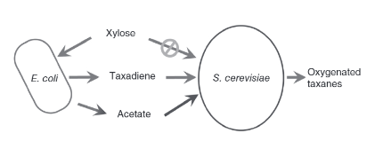

Figure 1: The mutualistic E. coli-S. cerevisiae consortium for production of paclitaxel (oxygenated taxanes) *(Zhou, Qiao, Edgar, & Stephanopoulos, 2015)*.

In this process, *E. coli* produce simple taxadiene molecules which the *S. cerevisiae* use as a scaffold around which to fold the final compound. The *E. coli* and *S. cerevisiae* also act as inhibitors upon each other such that one species does not out-compete the other. The *E. coli* consumes the carbon source xylose, which *S. cerevisiae* cannot digest, and produces acetate as a byproduct during the production of taxadiene. The acetate is toxic to the *E. coli* cells but can serve as a carbon source for the *S. cerevisiae* while it assembles the *E. coli*-produced taxadiene into paclitaxel. In addition, the authors found that the production of the final product was boosted by increasing the initial concentration of *S. cerevisiae* to prevent poisoning of the *E. coli* community with residual acetate, increasing expression of the oxygenation pathway in *S. cerevisiae* to increase production of the final product, and knocking out the oxidative phosphorylation pathway in *E. coli* which pulls Acetyl-CoA from the acetate pathway, thus drawing carbon away from the *S. cerevisiae*.

### Project Proposal

While the authors proved the concept in a lab setting, a mathematical model of the consortium was never produced. As such, I would like to model the behavior of the *S. cerevisiae-E. coli* fermentation to use xylose to produce paclitaxel as was described in the referenced paper. For simplicity, I will start by assuming that the fermentation is only composed of one *E. coli* cell and one *S. cerevisiae* cell and plan to increase the concentration of the cell types over time to reach the concentrations used in the paper.

## Model Description

### Quantitative Outputs

* Concentration of paclitaxel over time
* Concentration of taxadiene over time
* Concentration of acetate over time
* Concentration of xylose over time
* *(Concentration of* E. coli *cells over time)*
* *(Concentration of* S. cerevisiae *cells over time)*

### Input Parameters

* Initial concentration of xylose
* Initial concentration of *E. coli* cells
* Initial concentration of *S. cerevisiae* cells

### Principles and Processes Modeled

* Conservation of mass
* Mass balances with chemical reactions
* Conservation of energy
* Fermentation
* Mass transfer
* Reaction rates
* Enzymatic reactions

# Review of Deliverable II

## Defining the Model

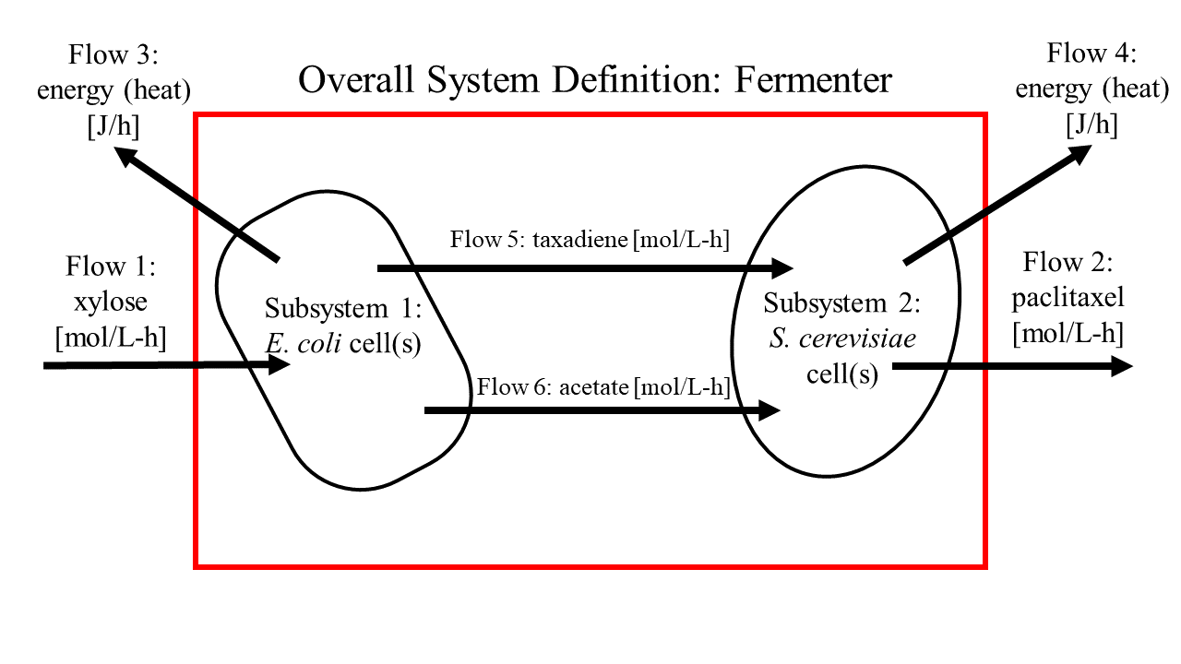

Figure 2: System definition with input and output flows.

## Mathematical Equations

### Flow I: Xylose

Change in xylose = initial xylose + flow in of xylose – *E. coli* consumption of xylose

|  |  |  |
| --- | --- | --- |
|  | $$\frac{∂x}{∂t}=\frac{υ_{1}C_{1}}{V}-r_{x}$$ | [*1*] |

### Flow II: Paclitaxel

Change in paclitaxel = initial paclitaxel + *S. cerevisiae* production of paclitaxel – flow out of paclitaxel

|  |  |  |
| --- | --- | --- |
|  | $$\frac{∂p}{∂t}=\frac{- υ_{2}C_{2}}{V}+r_{nd}$$ | [*2*] |

### Flow III: Energy (Heat) from *E. coli*

Change in energy = heat(s) of reaction of converting xylose to taxadiene and acetate

|  |  |  |
| --- | --- | --- |
|  | $$\frac{∂E_{e}}{∂t}={(H}_{x}r_{x}+H_{x5p}r_{x5p}+H_{gap}r_{gap}+H_{3pg}r_{3gp}+H_{pep}r_{pep}+H_{py}r_{py}+H_{acaa}r_{acaa}+H_{aca}r_{aca}+H_{acca}r_{acca}+H_{hmca}r_{hmca}+H_{mv}r_{mv}+H_{mp}r_{mp}+H_{md}r_{md}+H_{ipp}r_{ipp}+H_{pygp}r_{pygp}+H_{dxp}r_{dxp}+H_{mep}r_{mep}+H_{dme}r_{dme}+H_{dmep}r_{dmep}+H_{mec}r_{mec}+H_{hmbd}r_{hmdb}+H_{dmappgd}r_{dmappgd}+H_{gd}r_{gd})V$$ | [*3*] |

### Flow IV: Energy (Heat) from *S. cerevisiae*

Change in energy = heat(s) of reaction of converting taxadiene and acetate to paclitaxel

|  |  |  |
| --- | --- | --- |
|  | $$\frac{∂E_{s}}{∂t}=\left(H_{d}r_{d}+H_{t5a}r_{t5a}+H_{t5a13a}r_{t5a13a}+H_{db}r_{db}+H_{da}r_{da}+H_{b}r_{b}+H_{bpb}r_{bpb}+H_{nd}r_{nd}+H_{ap}r_{ap}+H_{bp}r_{bp}+H_{a}r_{a}\right)V$$ | [*4*] |

### Flow V: Taxadiene

Change in taxadiene = initial taxadiene + *E. coli* production of taxadiene – *S. cerevisiae* consumption of taxadiene

|  |  |  |
| --- | --- | --- |
|  | $$\frac{∂d}{∂t}= r_{gd}-r_{d}$$ | [*5*] |

### Flow VI: Acetate

Change in acetate = initial acetate + *E. coli* production of acetate – *S. cerevisiae* consumption of acetate

|  |  |  |
| --- | --- | --- |
|  | $$\frac{∂a}{∂t}=r_{acaa}-r_{a}$$ | [6] |

### Overall Mass Balance

Mass in – Mass out = Mass accumulated

Mass of xylose in – Mass of paclitaxel out = Mass accumulated

|  |  |  |
| --- | --- | --- |
|  | $$\frac{∂m}{∂t}=\frac{∂x}{∂t}-\frac{∂p}{∂t}$$ | [7] |
|  | $$\frac{∂m}{∂t}=υ_{1}C_{1}-υ_{2}C_{2}$$ | [*8*] |

### Overall Energy Balance

Energy in – Energy out + Energy Produced – Energy Consumed = Energy accumulated

Energy produced by *E. coli* + Energy produced by *S. cerevisiae* – Energy removed by fermenter = Energy accumulated

|  |  |  |
| --- | --- | --- |
|  | $$\frac{∂E}{∂t}=\frac{∂E_{e}}{∂t}+\frac{∂E_{s}}{∂t}- \frac{∂E_{f}}{∂t}$$ | [9] |
|  | $$\frac{∂E}{∂t}={(H}_{x}r_{x}+H_{x5p}r_{x5p}+H_{gap}r_{gap}+H_{3pg}r_{3gp}+H_{pep}r_{pep}+H_{py}r_{py}+H_{acaa}r_{acaa}+H_{aca}r_{aca}+H_{acca}r_{acca}+H_{hmca}r_{hmca}+H_{mv}r_{mv}+H_{mp}r_{mp}+H_{md}r_{md}+H_{ipp}r_{ipp}+H_{pygp}r_{pygp}+H_{dxp}r_{dxp}+H_{mep}r_{mep}+H_{dme}r_{dme}+H_{dmep}r_{dmep}+H_{mec}r_{mec}+H_{hmbd}r_{hmdb}+H_{dmappgd}r_{dmappgd}+H_{gd}r_{gd}+H_{d}r_{d}+H_{t5a}r_{t5a}+H_{t5a13a}r_{t5a13a}+H_{db}r_{db}+H_{da}r_{da}+H_{b}r_{b}+H_{bpb}r_{bpb}+H_{nd}r_{nd}+H_{ap}r_{ap}+H_{bp}r_{bp}+H_{a}r_{a})V- \frac{∂E_{f}}{∂t}$$ | [*10*] |

## Relevant Parameters, Relationships, and Principles

### Parameters

* *E. coli* cell density (concentration)
* *S. cerevisiae* cell density (concentration)
* Concentration of xylose in flow 1
* Rate of energy removal of fermenter
* Reaction equations, rates, heats, and stoichiometries for reactions highlighted in Figures 3-5
* Growth, division, and death rates of *E. coli* and *S. cerevisiae*

### Relationships

* Enzymatic reaction rate models for reactions highlighted in Figures 3-5
* Convective heat transfer within fermentation broth
* Conductive heat transfer to heat removal method of fermenter
* Mass transfer across cell membranes

### Principles

* Conservation of mass
* Conservation of energy
* Mass transfer
* Enzymatic reactions

## Assumptions

1. The fermentation broth is perfectly homogeneous in composition and temperature
2. The fermentation broth is kept at a constant temperature
3. The fermentation broth contains one *E. coli* cell and one *S. cerevisiae* cell
4. Each reaction has the same order as the number of reactants
5. Transportation across the cell membrane is instantaneous and requires no energy
6. The cell has enough enzymes and cellular resources to perform each reaction
7. There is no wait time between reactions (i.e. no need for reaction products to diffuse within the cell before the next reaction occurs)
8. The output flow is filtered and does not remove any cells, only the desired product and water
9. The normal metabolisms of the *E. coli* and *S. cerevisiae* cells do not produce any additional heat
10. The volume of the fermentation broth is held constant
11. All reactions occur to completion
12. If there is more than one pathway to a desired product, only the most direct pathway is taken (i.e. the pathway with the least number of reactions)
13. Reactions only occur in the forward direction
14. As noted in Figure 5, for every 85g of acetyl-CoA produced by *E. coli*, 33g is used to produce acetate while the rest is used in the normal *E. coli* metabolism

# Deliverable III

## Iteration I

### Assumptions

1. The fermentation broth is perfectly homogeneous in composition and temperature
2. The fermentation broth is kept at a constant temperature
3. The fermentation broth contains one *E. coli* cell and one *S. cerevisiae* cell
4. Each reaction has the same order as the number of reactants
5. Transportation across the cell membrane is instantaneous and requires no energy
6. The cell has enough enzymes and cellular resources to perform each reaction
7. There is no wait time between reactions (i.e. no need for reaction products to diffuse within the cell before the next reaction occurs)
8. The output flow is filtered and does not remove any cells, only the desired product and water
9. The normal metabolisms of the *E. coli* and *S. cerevisiae* cells do not produce any additional heat
10. The volume of the fermentation broth is held constant
11. All reactions occur to completion
12. If there is more than one pathway to a desired product, only the most direct pathway is taken (i.e. the pathway with the least number of reactions)
13. Reactions only occur in the forward direction
14. As noted in Figure 5, for every 85g of acetyl-CoA produced by *E. coli*, 33g is used to produce acetate while the rest is used in the normal *E. coli* metabolism
15. The heats and rates of reaction of the reactions that do not digest or create the inputs or outputs of the system and subsystems (i.e. xylose, paclitaxel, acetate, and taxadiene) are zero.
16. The flow rate of xylose into the system is zero.
17. The initial concentrations of paclitaxel, acetate, and taxadiene are zero
18. The flow rate of paclitaxel from the system is zero
19. The initial concentration of xylose is 5 mol/L
20. The volume of the fermenter is 1 L
21. The cells do not grow and divide

# Appendix A: Table of Nomenclature

|  |  |  |
| --- | --- | --- |
| Symbol | Meaning | Dimensions |
| $$C_{1}$$ | Concentration of xylose | [mol/L] |
| $$C_{2}$$ | Concentration of paclitaxel | [mol/L] |
| $$H_{3pg}$$ | Heat of reaction of converting 3-phosphoglyceric acid to phosphoenolpyruvate | [J/mol] |
| $$H_{a}$$ | Heat of reaction of converting acetate to acetyl-CoA | [J/mol] |
| $$H_{aca}$$ | Heat of reaction of converting acetyl-CoA to acetoacetyl-CoA | [J/mol] |
| $$H_{acaa}$$ | Heat of reaction of converting acetyl-CoA to acetate | [J/mol] |
| $$H_{acca}$$ | Heat of reaction of converting acetyoacetyl-coA to 3-hydroxy-3-methylglutaryl-CoA | [J/mol] |
| $$H_{ap}$$ | Heat of reaction of converting α-phenylalanine to β-phenylalanine | [J/mol] |
| $$H_{b}$$ | Heat of reaction of converting baccatin III and β-phenylalanineCoA to β-phenylalanoyl baccatin III | [J/mol] |
| $$H_{bp}$$ | Heat of reaction of converting β-phenylalanoyl baccatin III to n-debenzoyltaxol | [J/mol] |
| $$H_{bpb}$$ | Heat of reaction of converting β-phenylalanine to β-phenylalanineCoA | [J/mol] |
| $$H_{d}$$ | Heat of reaction of converting taxadiene to taxadiene-5α-ol | [J/mol] |
| $$H_{da}$$ | Heat of reaction of converting 10-deacylbaccatin III to baccatin III | [J/mol] |
| $$H_{db}$$ | Heat of reaction of converting 2-debenzoyltaxane to 10-deacylbaccatin III | [J/mol] |
| $$H_{dmappgd}$$ | Heat of reaction of converting dimethylallyl diphosphate to geranylgeranyl diphosphate | [J/mol] |
| $$H_{dme}$$ | Heat of reaction of converting 4-diphosphocytidyl-2-C-methyl-D-erythritol to 1-diphosphocytidyl-2-C-methyl-D-erythritol-2-phosphate | [J/mol] |
| $$H_{dmep}$$ | Heat of reaction of converting 4-diphosphocytidyl-2-C-methyl-D-erythritol-2-phosphate to 2-C-methyl-D-erythritol-2,4-cyclodiphosphate | [J/mol] |
| $$H_{dxp}$$ | Heat of reaction of converting 1-deoxy-D-xylulose-5-phosphate to 2-C-methyl-D-erythritol-4-phosphate | [J/mol] |
| $$H_{gap}$$ | Heat of reaction of converting glyceraldehyde-3-phosphate to 3-phosphoclyceric acid | [J/mol] |
| $$H_{gd}$$ | Heat of reaction of converting geranylgeranyl diphosphate to taxadiene | [J/mol] |
| $$H_{hmbd}$$ | Heat of reaction of converting 1-hydorxy-2-methyl-2-butenyl-4-diphosphate to dimethylallyl diphosphate | [J/mol] |
| $$H_{hmca}$$ | Heat of reaction of converting 3-hydroxy-3-methylglutaryl-CoA to mevalonate | [J/mol] |
| $$H_{ipp}$$ | Heat of reaction of converting isopentenyl pyrophosphate to dimethylallyl diphosphate | [J/mol] |
| $$H_{md}$$ | Heat of reaction of converting mevalonate-5-diphosphate to isopentenyl pyrophosphate | [J/mol] |
| $$H_{mec}$$ | Heat of reaction of converting 2-C-methyl-D-erythritol-2,4-cyclodiphosphate to 1-hydroxy-2-methyl-2-butenyl-4-diphosphate | [J/mol] |
| $$H_{mep}$$ | Heat of reaction of converting 2-C-methyl-D-erythritol-4-phosphate to 4-diphosphocytidyl-2-C-methyl-D-erythritol | [J/mol] |
| $$H_{mp}$$ | Heat of reaction of converting mevalonate-5-phosphate to mevalonate-5-diphosphate | [J/mol] |
| $$H_{mv}$$ | Heat of reaction of converting mevalonate to mevalonate-5-phosphate | [J/mol] |
| $$H_{nd}$$ | Heat of reaction of converting n-debenzoyltaxol to paclitaxel | [J/mol] |
| $$H_{pep}$$ | Heat of reaction of converting phosphoenolpyruvic acid to pyruvate | [J/mol] |
| $$H_{py}$$ | Heat of reaction of converting pyruvate to acetyl CoA | [J/mol] |
| $$H_{pygp}$$ | Heat of reaction of converting pyruvate and d-clyceraldehyde-3-phosphate to 1-deoxy-D-xylulose-3-phosphate | [J/mol] |
| $$H_{t5a}$$ | Heat of reaction of converting taxadien-5α-ol to taxadiene-5α-13α-diol | [J/mol] |
| $$H_{t5a13a}$$ | Heat of reaction of converting taxadiene-5α-13α-diol to 2-debenzoyltaxane | [J/mol] |
| $$H_{x}$$ | Heat of reaction of converting xylose to xylose-5-phosphate | [J/mol] |
| $$H_{x5p}$$ | Heat of reaction of converting xylose-5-phosphate to glyceraldehyde-3-phosphate | [J/mol] |
| $$r_{3pg}$$ | Rate of reaction of converting 3-phosphoglyceric acid to phosphoenolpyruvate | [mol/L-h] |
| $$r_{a}$$ | Rate of reaction of converting acetate to acetyl-CoA | [mol/L-h] |
| $$r_{aca}$$ | Rate of reaction of converting acetyl-CoA to acetoacetyl-CoA | [mol/L-h] |
| $$r_{acaa}$$ | Rate of reaction of converting acetyl-CoA to acetate | [mol/L-h] |
| $$r_{acca}$$ | Rate of reaction of converting acetyoacetyl-coA to 3-hydroxy-3-methylglutaryl-CoA | [mol/L-h] |
| $$r_{ap}$$ | Rate of reaction of converting α-phenylalanine to β-phenylalanine | [mol/L-h] |
| $$r_{b}$$ | Rate of reaction of converting baccatin III and β-phenylalanineCoA to β-phenylalanoyl baccatin III | [mol/L-h] |
| $$r_{bp}$$ | Rate of reaction of converting β-phenylalanoyl baccatin III to n-debenzoyltaxol | [mol/L-h] |
| $$r_{bpb}$$ | Rate of reaction of converting β-phenylalanine to β-phenylalanineCoA | [mol/L-h] |
| $$r_{d}$$ | Rate of reaction of converting taxadiene to taxadiene-5α-ol | [mol/L-h] |
| $$r_{da}$$ | Rate of reaction of converting 10-deacylbaccatin III to baccatin III | [mol/L-h] |
| $$r_{db}$$ | Rate of reaction of converting 2-debenzoyltaxane to 10-deacylbaccatin III | [mol/L-h] |
| $$r_{dmappgd}$$ | Rate of reaction of converting dimethylallyl diphosphate to geranylgeranyl diphosphate | [mol/L-h] |
| $$r_{dme}$$ | Rate of reaction of converting 4-diphosphocytidyl-2-C-methyl-D-erythritol to 1-diphosphocytidyl-2-C-methyl-D-erythritol-2-phosphate | [mol/L-h] |
| $$r_{dmep}$$ | Rate of reaction of converting 4-diphosphocytidyl-2-C-methyl-D-erythritol-2-phosphate to 2-C-methyl-D-erythritol-2,4-cyclodiphosphate | [mol/L-h] |
| $$r_{dxp}$$ | Rate of reaction of converting 1-deoxy-D-xylulose-5-phosphate to 2-C-methyl-D-erythritol-4-phosphate | [mol/L-h] |
| $$r_{gap}$$ | Rate of reaction of converting glyceraldehyde-3-phosphate to 3-phosphoclyceric acid | [mol/L-h] |
| $$r_{gd}$$ | Rate of reaction of converting geranylgeranyl diphosphate to taxadiene | [mol/L-h] |
| $$r_{hmbd}$$ | Rate of reaction of converting 1-hydorxy-2-methyl-2-butenyl-4-diphosphate to dimethylallyl diphosphate | [mol/L-h] |
| $$r_{hmca}$$ | Rate of reaction of converting 3-hydroxy-3-methylglutaryl-CoA to mevalonate | [mol/L-h] |
| $$r_{ipp}$$ | Rate of reaction of converting isopentenyl pyrophosphate to dimethylallyl diphosphate | [mol/L-h] |
| $$r_{md}$$ | Rate of reaction of converting mevalonate-5-diphosphate to isopentenyl pyrophosphate | [mol/L-h] |
| $$r_{mec}$$ | Rate of reaction of converting 2-C-methyl-D-erythritol-2,4-cyclodiphosphate to 1-hydroxy-2-methyl-2-butenyl-4-diphosphate | [mol/L-h] |
| $$r_{mep}$$ | Rate of reaction of converting 2-C-methyl-D-erythritol-4-phosphate to 4-diphosphocytidyl-2-C-methyl-D-erythritol | [mol/L-h] |
| $$r_{mp}$$ | Rate of reaction of converting mevalonate-5-phosphate to mevalonate-5-diphosphate | [mol/L-h] |
| $$r_{mv}$$ | Rate of reaction of converting mevalonate to mevalonate-5-phosphate | [mol/L-h] |
| $$r_{nd}$$ | Rate of reaction of converting n-debenzoyltaxol to paclitaxel | [mol/L-h] |
| $$r_{pep}$$ | Rate of reaction of converting phosphoenolpyruvic acid to pyruvate | [mol/L-h] |
| $$r_{py}$$ | Rate of reaction of converting pyruvate to acetyl CoA | [mol/L-h] |
| $$r_{pygp}$$ | Rate of reaction of converting pyruvate and d-clyceraldehyde-3-phosphate to 1-deoxy-D-xylulose-3-phosphate | [mol/L-h] |
| $$r_{t5a}$$ | Rate of reaction of converting taxadien-5α-ol to taxadiene-5α-13α-diol | [mol/L-h] |
| $$r_{t5a13a}$$ | Rate of reaction of converting taxadiene-5α-13α-diol to 2-debenzoyltaxane | [mol/L-h] |
| $$r_{x}$$ | Rate of reaction of converting xylose to xylose-5-phosphate | [mol/L-h] |
| $$r_{x5p}$$ | Rate of reaction of converting xylose-5-phosphate to glyceraldehyde-3-phosphate | [mol/L-h] |
| V | Volume of fermenter | [L] |
| $$\frac{∂a}{∂t}$$ | Change in acetate concentration over time | [mol/L-h] |
| $$\frac{∂d}{∂t}$$ | Change in taxadiene concentration over time | [mol/L-h] |
| $$\frac{∂E}{∂t}$$ | Change in energy over time | [J/h] |
| $$\frac{∂E_{e}}{∂t}$$ | Change in energy produced by *E. coli* over time | [J/h] |
| $$\frac{∂E_{f}}{∂t}$$ | Energy removed by fermenter temperature control over time | [J/h] |
| $$\frac{∂E_{s}}{∂t}$$ | Change in energy produced by *S. cerevisiae* over time | [J/h] |
| $$\frac{∂m}{∂t}$$ | Change in mass over time | [mg/h] |
| $$\frac{∂p}{∂t}$$ | Change in paclitaxel concentration over time | [mol/L-h] |
| $$\frac{∂x}{∂t}$$ | Change in xylose concentration over time | [mol/L-h] |
| $$υ_{1}$$ | Volumetric flow of xylose in | [L/h] |
| $$υ_{2}$$ | Volumetric flow of paclitaxel out | [L/h] |

# Appendix B: Supplemental Figures

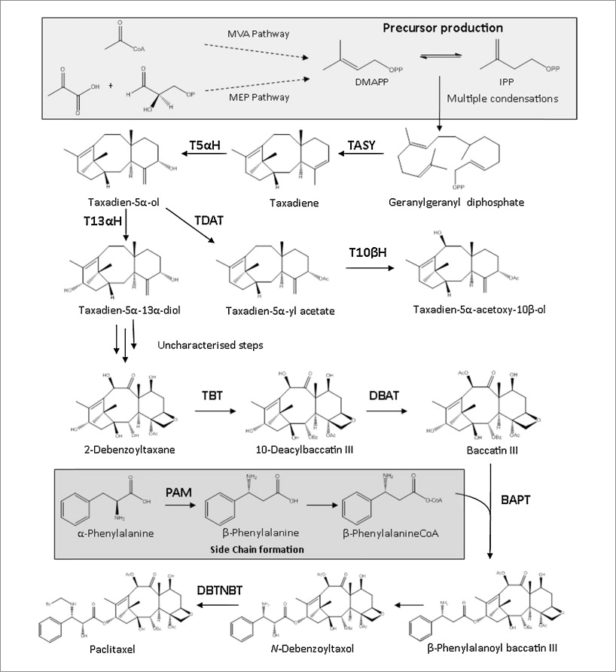

Figure 3: Paclitaxel biosynthesis pathway *(Howat, et al., 2014)*. The first half of the pathway, up to the production of taxadiene, is performed in the E. coli cell while the rest of the pathway is performed in the S. cerevisiae cell.

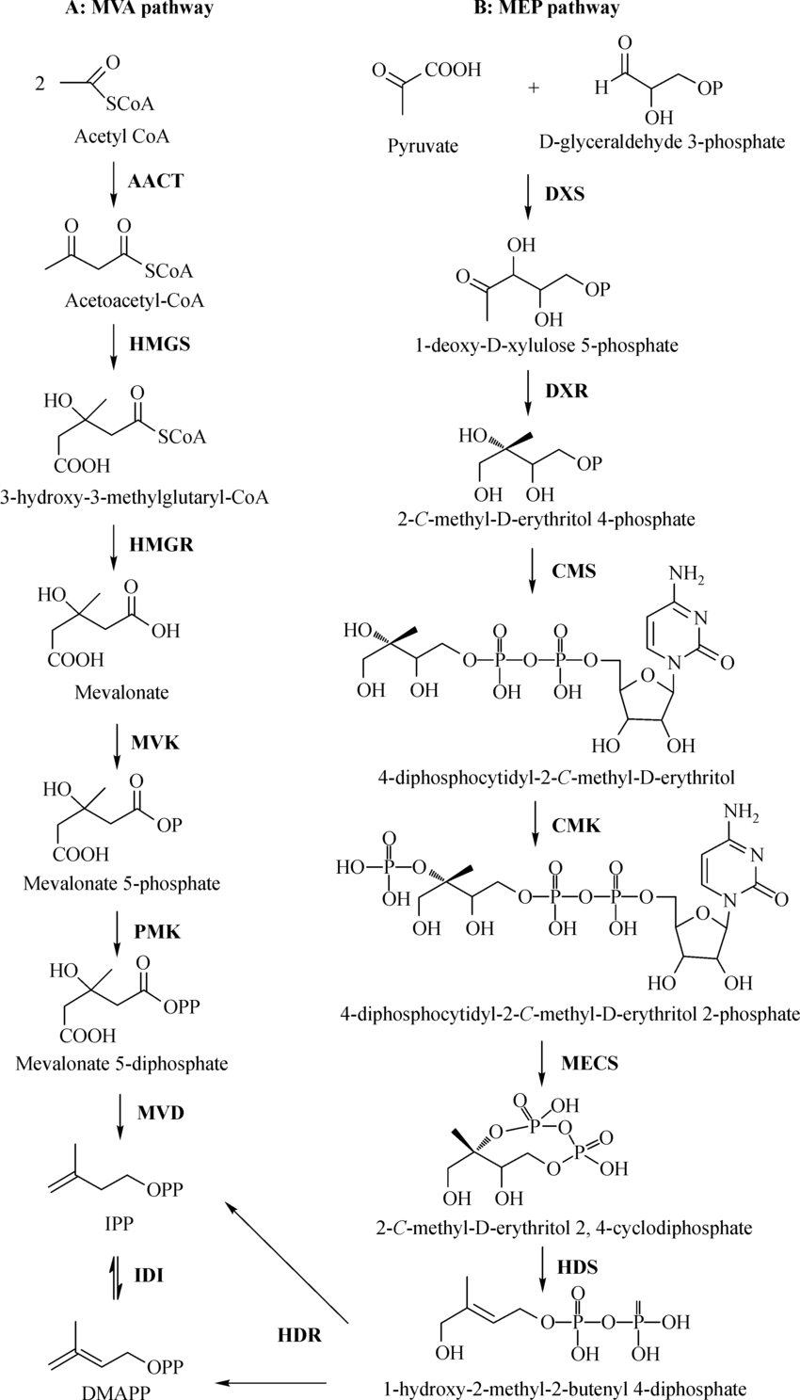

Figure 4: The MEV and MEP pathways referenced in Figure3 *(Zhu, Zeng, Sun, & Chen, 2014)*. These pathways are performed in the E. coli cell.

An external file that holds a picture, illustration, etc.
Object name is nihms940987f6.jpg

Figure 5: E. coli aerobic metabolism of xylose *(Gonzalez, Long, & Antoniewicz, 2017)*. The E. coli cell produces the acetate and then transports the molecule to the fermentation broth, where it is then taken up by S. cerevisiae.

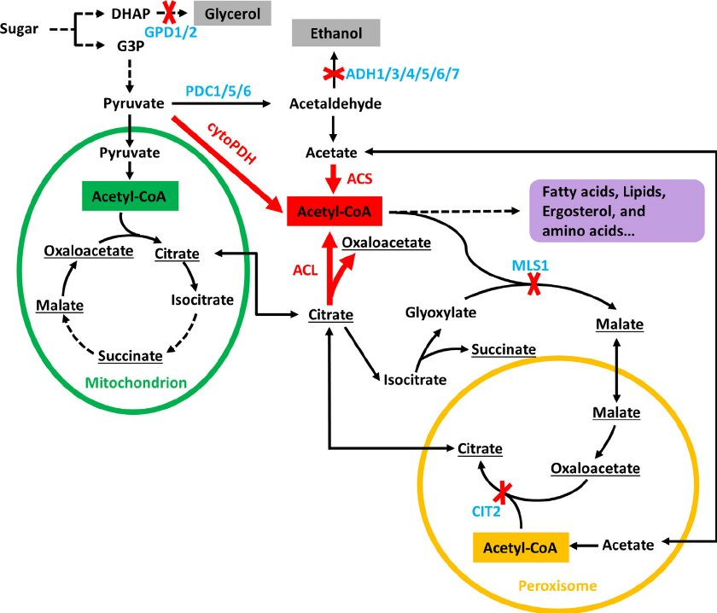

Figure 6: Metabolism of acetate in S. cerevisiae (Lian, Si, Nair, & Zhao, 2014). The acetate is produced in E. coli before being taken up by the S. cerevisiae and being incorporated into the metabolism.

# Appendix C: References

Gonzalez, J. E., Long, C. P., & Antoniewicz, M. R. (2017, January). Comprehensive analysis of glucose and xylose metabolism in Escherichia coli under aerobic and anaerobic conditions by 13C metabolic flux analysis. *Metabolic Engineering, 39*, 9-18.

Howat, S., Park, B., Oh, I., Jin, Y.-W., Lee, E.-K., & Loake, G. J. (2014, May 25). Paclitaxel: biosynthesis, production and future prospects. *New Biotechnology, 31*(3), 242-245.

Lian, J., Si, T., Nair, N., & Zhao, H. (2014, July). Design and construction of acetyl-CoA overproducing Saccharomyces cerevisiae strains. *Metabolic Engineering, 24*, 139-149.

Zhou, K., Qiao, K., Edgar, S., & Stephanopoulos, G. (2015, April). Distributing a metabolic pathway among a microbial consortium enhances production of natural products. *Nature Biotechnology, 33*(4), 377-383.

Zhu, X., Zeng, X., Sun, C., & Chen, S. (2014, September). Biosynthetic pathway of tepenoid indole alkaloids in Catharanthus roseus. *Frontiers of Medicine, 8*(3), 285-293.