|  |
| --- |
| ABE 30100 |
| Microbial Consortium Modeling |
| Deliverable I – Iteration II |

|  |
| --- |
| Atherton, Kathryn F  1-18-2019 |

Table of Contents

Background 1

Concept in Literature 1

Model Proposal 3

Model Description 3

Quantitative Outputs 3

Input Parameters 3

Principles and Processes 3

References 3

# Background

## Concept in Literature

Fermentation is a process used to exploit microorganisms’ ability to produce natural metabolites to the benefit of humans. Organisms such as *Escherichia coli* and *Saccharomyces cerevisiae* have been engineered to ferment products such as insulin and ethanol for human consumption. However, there is a limit to the ability of single-organism fermentations to produce more complex molecules whose building blocks require compartmentalized production to most efficiently create the final product.

In their 2015 Nature Biotechnology paper, Zhou, Qiao, Edgar, and Stephanopoulos fermented *E. coli* and *S. cerevisiae* together to create paclitaxel, a chemotherapy drug (Figure 1).

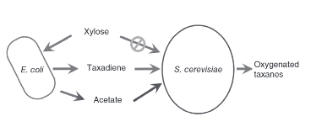

Figure 1: Picture of the fermentation process to be modeled. The E. coli consumes xylose and produces acetate for the S. cerevisiae to uses as a carbon source. E. coli produce taxadiene for the S. cerevisiae to oxygenate and use to produce the final product, paclitaxel (Zhou, Qiao, Edgar, & Stephanopoulos, 2015).

The simpler *E. coli* cells were engineered to produce the building blocks of the final product while the *S. cerevisiae* was programmed to fold these building blocks together to produce paclitaxel (Figure 2, Figure 3). The co-culture was fed xylose, a carbon source that only the *E. coli* cells could metabolize to then produce acetate, a toxin to *E. coli* which *S. cerevisiae* cells could consume for carbon. This, among other genetically engineered tweaks to make the process more streamlined, ensured that neither the *E. coli* nor the *S. cerevisiae* populations overgrew.

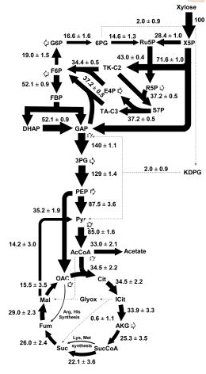

Figure 2: E. coli metabolic pathway for digesting xylose (Gonzalez, Long, & Antoniewicz, 2017).

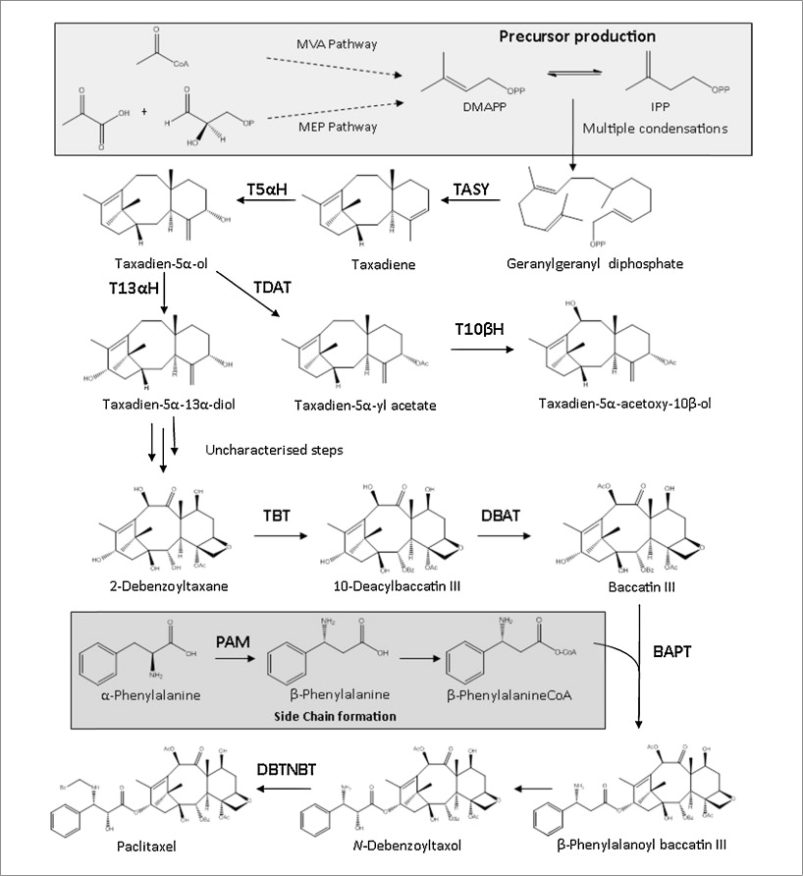

Figure 3: Metabolic pathway to produce paclitaxel (Howat, et al., 2014). In the system to be modeled, the E. coli cells performs the steps until taxadiene is produced. Then, the taxadiene is used by the S. cerevisiae cells to produce the final product.

## Model Proposal

While the authors proved this concept in the lab, a mathematical model of the process was never made, or at least never published. As such, I would like to create a model of the final system that the authors described in their paper, outlined above. My model would output the amount of paclitaxel produced by a certain number of *E. coli* and *S. cerevisiae* cells given an initial amount of xylose in a reactor of specified volume with a defined initial temperature and pH.

# Model Description

## Quantitative Outputs

* Rate of paclitaxel produced [mass/time]

## Input Parameters

* Initial temperature
* Initial pH
* Volume of fermenter
* Initial number of *E. coli* cells
* Initial number of *S. cerevisiae* cells
* Initial amount of xylose [mass]

## Principles and Processes

* Conservation of mass
* Conservation of energy
* Mass balance with reaction
* Enzymatic reactions
* Reaction kinetics
* Heat of reaction
* Batch reactor process
* Mass transfer across a membrane
* Diffusion
* Heat transfer
* Cell growth and death

# References

Gonzalez, J. E., Long, C. P., & Antoniewicz, M. R. (2017, January). Comprehensive analysis of glucose and xylose metabolism in Escherichia coli under aerobic and anaerobic conditions by 13C metabolic flux analysis. *Metabolic Engineering, 39*, 9-18. doi:10.1016/j.ymben.2016.11.0003

Howat, S., Park, B., Oh, I. S., Jin, Y.-W., Lee, E.-K., & Loake, G. J. (2014, May 25). Paclitaxel: biosynthesis, production, and future prospects. *New Biotechnology, 31*(3), 242-245. doi:10.1016/j.nbt.2014.02.010

Zhou, K., Qiao, K., Edgar, S., & Stephanopoulos, G. (2015, January 5). Distributing a metabolic pathway among a microbial consortium enhances production of natural products. *Nature Biotechnology, 33*(4), 377-383. doi:10.1038/nbt.3095