|  |
| --- |
| ABE 30100 |
| Microbial Consortium Modeling |
| Final Project |

|  |
| --- |
| Kathryn Atherton  4-22-2019 |

Contents

Review of Deliverable I 3

Background 3

Concept in Literature 3

Model Proposal 3

Model Description 3

Quantitative Outputs 3

Input Parameters 3

Principles and Processes Modeled 4

Review of Deliverable II 5

Defining the Model 5

Mathematical Equations 5

Overall Mass Balance 5

Mass Balance on Individual Components 6

Overall Energy Balance 7

Relevant Parameters, Relationships, and Principles 8

Parameters 8

Relationships 8

Principles 8

Assumptions 9

Review of Deliverable III 10

Iteration I 10

Assumptions 10

Mathematical Model 10

Model Evaluation 14

Iteration II 15

Assumptions 15

Mathematical Model 15

Model Evaluation 16

Iteration III 17

Assumptions 17

Mathematical Model 17

Model Evaluation 18

Iteration IV 19

Assumptions 19

Mathematical Model 19

Model Evaluation 20

Review of Deliverable IV 21

Iteration V 21

Assumptions 21

Mathematical Model 21

Model Evaluation 23

Iteration VI 24

Assumptions 24

Mathematical Model 24

Model Evaluation 25

Iteration VII 26

Assumptions 26

Mathematical Model 26

Model Evaluation 27

Final Deliverable: Final Iterations and Model Evaluation 28

Iteration VIII 28

Assumptions 28

Mathematical Model 28

Model Evaluation 30

Final Model Evaluation 31

Overview 31

Final Equations 31

Effect of Changing Input Parameters 33

Future Improvements and Recommendations 42

Appendix A: Table of Nomenclature 43

Appendix B: Supplemental Figures 45

Appendix C: Final Model Code 49

Appendix D: References 53

# Review of Deliverable I

## Background

### Concept in Literature

Fermentation is a process used to exploit microorganisms’ ability to produce natural metabolites to the benefit of humans. Organisms such as *Escherichia coli* and *Saccharomyces cerevisiae* have been engineered to ferment products such as insulin and ethanol for human consumption. However, there is a limit to the ability of single-organism fermentations to produce more complex molecules whose building blocks require compartmentalized production to most efficiently create the final product.

In their 2015 Nature Biotechnology paper, Zhou, Qiao, Edgar, and Stephanopoulos fermented *E. coli* and *S. cerevisiae* together to create paclitaxel, a chemotherapy drug (Figure 1).

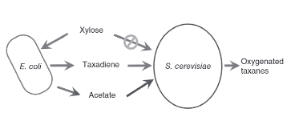

Figure 1: Picture of the fermentation process to be modeled. The E. coli consumes xylose and produces acetate for the S. cerevisiae to uses as a carbon source. E. coli produce taxadiene for the S. cerevisiae to oxygenate and use to produce the final product, paclitaxel (Zhou, Qiao, Edgar, & Stephanopoulos, 2015).

The simpler *E. coli* cells were engineered to produce the building blocks of the final product while the *S. cerevisiae* was programmed to fold these building blocks together to produce paclitaxel (Figure

2, Figure 20). The co-culture was fed xylose, a carbon source that only the *E. coli* cells could metabolize to then produce acetate, a toxin to *E. coli* which *S. cerevisiae* cells could consume for carbon. This, among other genetically engineered tweaks to make the process more streamlined, ensured that neither the *E. coli* nor the *S. cerevisiae* populations overgrew.

### Model Proposal

While the authors proved this concept in the lab, a mathematical model of the process was never made, or at least never published. As such, I would like to create a model of the final system that the authors described in their paper, outlined above. My model would output the amount of paclitaxel produced by a certain number of *E. coli* and *S. cerevisiae* cells given an initial amount of xylose in a reactor of specified volume with a defined initial temperature and pH.

## Model Description

### Quantitative Outputs

* Rate of paclitaxel produced [mass/time]

### Input Parameters

* Initial temperature
* Initial pH
* Volume of fermenter
* Initial number of *E. coli* cells
* Initial number of *S. cerevisiae* cells
* Initial amount of xylose [mass]

### Principles and Processes Modeled

* Conservation of mass
* Conservation of energy
* Mass balance with reaction
* Enzymatic reactions
* Reaction kinetics
* Heat of reaction
* Batch reactor process
* Mass transfer across a membrane
* Diffusion
* Heat transfer
* Cell growth and death

# Review of Deliverable II

## Defining the Model

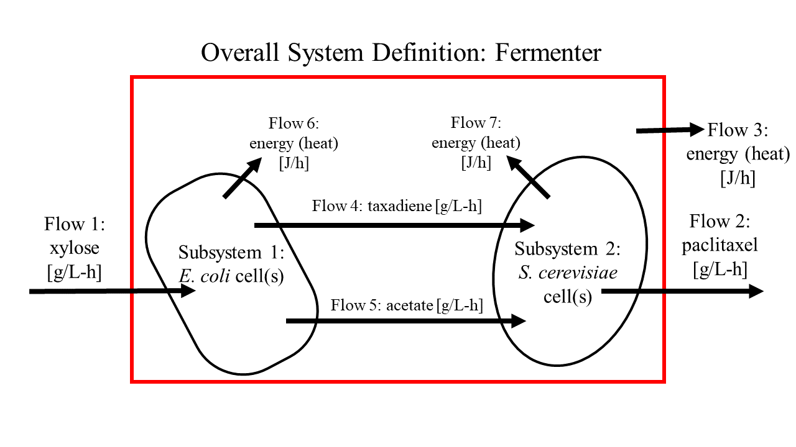

Figure 2: System definition with input and output flows.

## Mathematical Equations

### Overall Mass Balance

Accumulation = In – Out + Generation – Consumption

* Law of Conservation of Mass: mass can neither be created nor destroyed
  + Generation = Consumption = 0

Accumulation = In – Out

* Figure 2: In = Flow 1; Out = Flow 2’

( 1 )

Unit Analysis:

#### Subsystem 1 Overall Mass Balance

Accumulation = In – Out + Generation – Consumption

* Law of Conservation of Mass: mass can neither be created nor destroyed
  + Generation = Consumption = 0

Accumulation = In – Out

* Figure 2: In = Flow 1; Out = Flow 4, Flow 5

( 2 )

Unit Analysis:

#### Subsystem 2 Overall Mass Balance

Accumulation = In – Out + Generation – Consumption

* Law of Conservation of Mass: mass can neither be created nor destroyed
  + Generation = Consumption = 0

Accumulation = In – Out

* Figure 2: In = Flow 4, Flow 5; Out = Flow 2

( 3 )

Unit Analysis:

### Mass Balance on Individual Components

#### Xylose

Accumulation = In – Out + Generation – Consumption

* Figure 2: In = Flow 1; Out = 0
* Assumed: Generation = 0
* Figures 20 – 22: Consumption = metabolism of xylose to produce taxadiene, acetate, and *E. coli* cell growth

( 4 )

Unit Analysis:

* Note: The consumption of xylose to produce cell growth (rx,e) is dependent upon the concentration of xylose, the concentration of acetate (as acetate inhibits *E. coli* cell growth), and the total concentration of cells in the reactor (due to space constraint inhibition). The inhibition considerations will be reflected in future iterations.

#### Paclitaxel

Accumulation = In – Out + Generation – Consumption

* Figure 2: In = 0; Out = Flow 2
* Assumed: Consumption = 0
* Figure 20: Generation = metabolism of taxadiene to produce paclitaxel

( 5 )

Unit Analysis:

#### Taxadiene

Accumulation = In – Out + Generation – Consumption

* Figure 2: In = 0; Out = 0
* Figures 20 – 22: Generation = metabolism of xylose to produce taxadiene; Consumption = metabolism of taxadiene to produce paclitaxel

( 6 )

Unit Analysis:

#### Acetate

Accumulation = In – Out + Generation – Consumption

* Figure 2: In = 0; Out = 0
* Figures 22 – 23: Generation = metabolism of xylose to produce acetate; Consumption = metabolism of acetate to produce *S. cerevisiae* cell growth

( 7 )

Unit Analysis:

#### *E. Coli* Cells

Accumulation = In – Out + Generation – Consumption

* Figure 2: In = 0; Out = 0
* Figure 22: Generation = metabolism of xylose to produce cell growth; Consumption = cell death

( 8 )

Unit Analysis:

* Note that cell death is defined as a function of the concentrations of xylose, acetate, and total cell mass and temperature. This function will be fleshed out in future iterations where cell death is assumed to be nonzero.

#### *S. Cerevisiae* Cells

Accumulation = In – Out + Generation – Consumption

* Figure 2: In = 0; Out = 0
* Figure 23: Generation = metabolism of acetate to produce cell growth; Consumption = cell death

( 9 )

Unit Analysis:

* Note that cell death is defined as a function of the concentration of acetate and total cell mass and temperature. This function will be fleshed out in future iterations where cell death is assumed to be nonzero.

### Overall Energy Balance

Accumulation = In – Out + Generation – Consumption

* Figure 2: In = 0; Out = Flow 3; Generation = Flow 6, Flow 7

( 10 )

Unit Analysis:

#### Subsystem 1 energy Balance

Accumulation = In – Out + Generation – Consumption

* Figure 2: In = 0; Out = Flow 6
* Figures 20 – 22: [Generation – Consumption] = lumped heats of reactions of metabolism of xylose to produce taxadiene, acetate, and *E. coli* cell growth

( 11 )

Unit Analysis:

#### Subsystem 2 Energy Balance

Accumulation = In – Out + Generation – Consumption

* Figure 2: In = 0; Out = Flow 7
* Figures 20, 23: [Generation – Consumption] = lumped heats of reactions of metabolism of taxadiene and acetate to produce paclitaxel and *S. cerevisiae* cell growth

( 12 )

Unit Analysis:

## Relevant Parameters, Relationships, and Principles

### Parameters

* See Appendix A for parameter nomenclature and descriptions

### Relationships

( 13 )

This is used to determine the reaction rates based on the concentration(s) of the reactant(s).

( 14 )

This is used for determining the temperature of the cells, of the broth, and of the water used to cool the broth based on the energy produced by the cellular reactions.

( 15 )

This is used for determining the volume of cells based upon their concentration in the reactor

### Principles

* Conservation of mass
* Conservation of energy
* Reaction kinetics
* Heat transfer

## Assumptions

1. The fermentation broth is perfectly homogeneous in composition and temperature
2. The fermentation broth is kept at a constant temperature
3. The fermentation broth is kept at a constant volume
4. The fermentation broth is kept at a constant pH
5. All *E. coli* cells are identical to each other and all *S. cerevisiae* cells are identical to each other
6. Cells neither grow nor die
7. Each reaction is zeroth order
8. Paclitaxel is able to be produced infinitely with no bounds
9. Transportation across the cell membrane is instantaneous and requires no energy
10. The cells have enough enzymes and cellular resources to perform each reaction
11. There is no wait time between reactions (i.e. no need for reaction products to diffuse within the cell or between cells before the next reaction occurs)
12. The input and output flows are zero
13. The normal metabolisms of the *E. coli* and *S. cerevisiae* cells do not produce any additional heat
14. All reactions occur to completion
15. If there is more than one pathway to a desired product, only the most direct pathway is taken (i.e. the pathway with the least number of reactions)
16. Reactions only occur in the forward direction
17. Reaction rates are the same at all temperatures

# Review of Deliverable III

## Iteration I

### Assumptions

1. The fermentation broth is perfectly homogeneous in composition and temperature
2. The fermentation broth is kept at a constant temperature
3. The fermentation broth is kept at a constant volume
4. The fermentation broth is kept at a constant pH
5. All *E. coli* cells are identical to each other and all *S. cerevisiae* cells are identical to each other
6. Cells neither grow nor die
7. Each reaction is zeroth order
8. Paclitaxel is able to be produced infinitely with no bounds
9. Transportation across the cell membrane is instantaneous and requires no energy
10. The cells have enough enzymes and cellular resources to perform each reaction
11. There is no wait time between reactions (i.e. no need for reaction products to diffuse within the cell or between cells before the next reaction occurs)
12. The input and output flows are zero
13. The normal metabolisms of the *E. coli* and *S. cerevisiae* cells do not produce any additional heat
14. All reactions occur to completion
15. If there is more than one pathway to a desired product, only the most direct pathway is taken (i.e. the pathway with the least number of reactions)
16. Reactions only occur in the forward direction
17. Reaction rates are the same at all temperatures

### Mathematical Model

Below shows the xylose mass balance differential equation described in Deliverable II.

From Assumption 12, there are no input or output flows, so the first term of this equation is zero. The reaction rates to produce taxadiene and acetate, rx,d and rx,a, can be defined by the reaction rate relationship defined in Equation 13. From Assumption 7, the reactions are zeroth order. From Assumption 6, the cells do not grow or die, so the reaction rate to produce cell mass, rx,e, is zero. Thus, the updated Equation 4 is defined below, along with new definitions for the reaction rate terms:

( 16 )

( 17 )

( 18 )

The reaction rate coefficients kx,d and kx,a were found by lumping reaction rates from literature for the reactions in the pathways from xylose to taxadiene and from xylose to acetate. The lumped coefficients were found with the following equation:

( 19 )

In this equation, k1, k2, and k3 are the reaction rate coefficients of the reactions that make up the pathways to the two desired products. The result of this equation, klumped, was multiplied by 60 to convert from minutes to hours. Table 1 details the values of these coefficients and their sources from literature.

Table 1: Xylose Pathway Reaction Coefficients

|  |  |  |
| --- | --- | --- |
| Reaction | Coefficient Value | Source |
| Xylose 🡪 Xylulose 5-Phosphate | 0.065 mol/L/min | (Voronovsky, et al., 2005) |
| Xylulose 5-Phosphate 🡪 Glyceraldehyde 3-Phosphate | 0.57 mol/L/min | (Lee, Cheong, & Kim, 2008) |
| Glyceraldehyde 3-Phosphate 🡪 3-Phosphoglyceric Acid | 0.891 mol/L/min | (Yu, Ladapo, & Whitman, 1994) |
| 3-Phosphoglyceric Acid 🡪 Phosphoenolpyruvic Acid | 0.078 mol/L/min | (Mercade, Cocaign-Bousquet, & Loubiere, 2006) |
| Phosphoenolpyruvic Acid 🡪 Pyruvate | 0.52 mol/L/min | (Malcovati & Valentini, 1982) |
| Pyruvate 🡪 Acetyl CoA | 0.134 mol/L/min | (Inui, Miyatake, Nakano, & Kitaoka, 1990) |
| Acetyl CoA 🡪 Acetate | 0.885 mol/L/min | (Liang, Qv, Jin, & Jiang, 2016) |
| Acetyl CoA 🡪 Acetoacetyl-CoA | 506 mol/L/min | (Feigenbaum & Schulz, 1975) |
| Acetoacetyl-CoA 🡪 3-Hydroxy-3-Methylglutaryl-CoA | 2 mol/L/min | (Durr & Rudney, 1960) |
| 3-Hydroxy-3-Methylglutaryl-CoA 🡪 Mevalonate | 0.0035 mol/L/min | (Middleton, 1972) |
| Mevalonate 🡪 Mevalonate 5-Phosphate | 0.06 mol/L/min | (Bloch, Chaykin, Phillips, & De Waard, 1959) |
| Mevalonate 5-Phosphate 🡪 Mevalonate 5-Diphosphate | 0.06 mol/L/min | (Agranoff, Eggerer, Henning, & Lynen, 1960) |
| Mevalonate 5-Diphosphate 🡪 Isopentenyl Pyrophosphate | 0.00000133 mol/L/min | (Gogerty & Bobik, 2010) |
| Pyruvate + D-Glyceraldehyde 3-Phosphate 🡪 1-Deoxy-D-Xylulose 5-Phosphate | 3 mol/L/min | (Hahn, et al., 2001) |
| 1-Deoxy-D-Xylulose 5-Phosphate 🡪 2-*C*-methyl-D-Erythritol 4-Phosphate | 1.6 mol/L/min | (Takenoya, et al., 2010) |
| 2-*C*-methyl-D-Erythritol 4-Phosphate 🡪 4-Diphosphocytidyl-2-*C*-Methyl-D-Erythritol | 23 mol/L/min | (Chesters, Wilding, Goodall, & Micklefield, 2012) |
| 4-Diphosphocytidyl-2-*C*-Methyl-D-Erythritol 🡪 4-Diphosphocytidyl-2-*C*-Methyl-D-Erythritol 2-Phosphate | 33 mol/L/min | (Chesters, Wilding, Goodall, & Micklefield, 2012) |
| 4-Diphosphocytidyl-2-*C*-Methyl-D-Erythritol 2-Phosphate 🡪 2-*C*-Methyl-D-Erythritol 2, 4-Cyclodiphosphate | 0.75 mol/L/min | (Zepeck, et al., 2005) |
| 2-*C*-Methyl-D-Erythritol 2, 4-Cyclodiphosphate 🡪 1-Hydroxy-2-Methyl-2-Butenyl 4-Diphosphate | 0.99 mol/L/min | (Zepeck, et al., 2005) |
| 1-Hydroxy-2-Methyl-2-Butenyl 4-Diphosphate 🡪 Dimethylallyl Diphosphate | 0.03 mol/L/min | (Wolff, et al., 2003) |
| Isopentenyl Pyrophosphate + Dimethylallyl Diphosphate 🡪 Geranylgeranyl Diphosphate | 0.109 mol/L/min | (Wolff, et al., 2003) |
| Geranylgeranyl Diphosphate 🡪 Taxadiene | 0.003 mol/L/min | (Jennewein, Long, Williams, & Croteau, 2004) |

The paclitaxel mass balance differential equation described in Deliverable II can be found below.

From Assumption 12, there are no input or output flows, so the last term of this equation is zero. The reaction rate to produce paclitaxel, rd,p, can be defined by the reaction rate relationship defined in Equation 13. From Assumption 7, the reaction is zeroth order. Thus, the updated Equation 5 is defined below along with a definition of the reaction rate:

( 20 )

( )

The reaction rate coefficient kd,p was found by lumping reaction rates from literature for the reactions in the pathway from taxadiene to paclitaxel according to Equation 19 and multiplying by 60 to convert from minutes to hours. Table 2 details these reaction rates.

Table 2: Paclitaxel Pathway Reaction Coefficients

|  |  |  |
| --- | --- | --- |
| Reaction | Coefficient Value | Source |
| Taxadiene 🡪 Taxadien-5α-ol | 0.016 | (Jennewein, Long, Williams, & Croteau, 2004) |
| Taxadien-5α-ol 🡪 Taxadien-5α-13α-diol | 5.77 | (Chau, Walker, Long, & Croteau, 2004) |
| 2-Debenzoyltaxane 🡪10-Deacylbaccatin III | 0.00635 | (Nawarathne & Walker, 2010) |
| 10-Deacylbaccatin III 🡪 Baccatin III | 6.1 | (Fang & Ewald, 2004) |
| Baccatin III + β-PhenylalanineCoA 🡪 β-Phenylalanoyl Baccatin III | 2.2 | (Walker, Fujisaki, Long, & Croteau, 2002) |
| β-Phenylalanoyl Baccatin III 🡪 *N*-Debenzoyltaxol | 0.0049 | (Zhu, Zeng, Sun, & Chen, 2014) |
| *N*-Debenzoyltaxol 🡪 Paclitaxel | 0.0049 | (Zhu, Zeng, Sun, & Chen, 2014) |

Below is the differential mass balance equation for taxadiene as described in Deliverable II.

( 6 )

The reaction rates to produce taxadiene and paclitaxel, rx,d and rd,p, can be defined by the reaction rate relationship defined in Equation 13. From Assumption 7, the reactions are zeroth order. The reaction rate terms are defined in Equations 17 and 21. How the lumped reaction rate coefficients are found is described above.

The differential mass balance equation for acetate as described in Deliverable II is referenced below.

Due to Assumption 6, the reaction rate to produce *S. cerevisiae* cell mass is zero. The reaction rate to produce acetate, rx,a, can be defined by the reaction rate relationship defined in Equation 13. From Assumption 7, the reaction is zeroth order. Thus, the updated Equation 7 is defined below:

( 22 )

Again, the method to find the lumped reaction rate coefficient is described above and the reaction rate is defined in Equation 18. Both the mass balance equations (Equations 8 and 9) for *E. coli* and *S. cerevisiae* cell mass simplify to zero due to Assumption 6.

These equations were used to produce the below output.

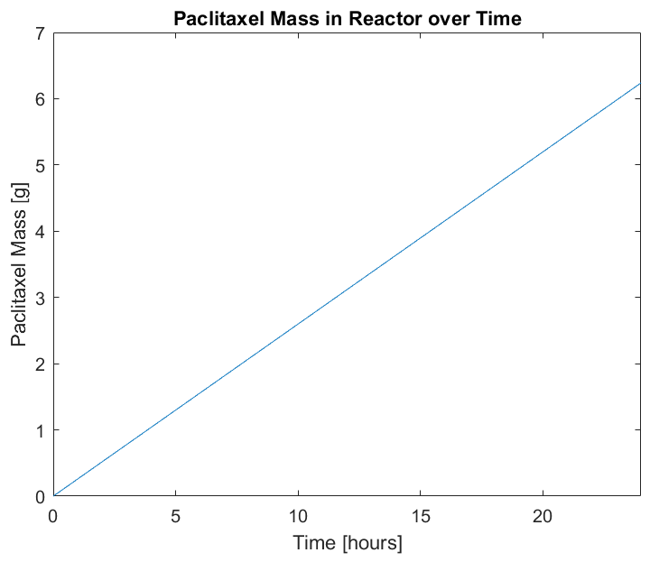

Figure 3: Graphical output of Microbial Consortium Model Iteration I

### Model Evaluation

The model is very inaccurate. It shows a linear relationship between the output of Paclitaxel mass and the reaction time with no consideration of a limit on the mass of Paclitaxel that can be produced from the initial xylose mass (5 g). The next iteration will impose limits on the mass of Paclitaxel that can be produced from the xylose.

## Iteration II

### Assumptions

1. The fermentation broth is perfectly homogeneous in composition and temperature
2. The fermentation broth is kept at a constant temperature
3. The fermentation broth is kept at a constant volume
4. The fermentation broth is kept at a constant pH
5. All *E. coli* cells are identical to each other and all *S. cerevisiae* cells are identical to each other
6. Cells neither grow nor die
7. Each reaction is zeroth order
8. **Xylose mass is the overall limiter of paclitaxel production**
9. Transportation across the cell membrane is instantaneous and requires no energy
10. The cells have enough enzymes and cellular resources to perform each reaction
11. There is no wait time between reactions (i.e. no need for reaction products to diffuse within the cell or between cells before the next reaction occurs)
12. The input and output flows are zero
13. The normal metabolisms of the *E. coli* and *S. cerevisiae* cells do not produce any additional heat
14. All reactions occur to completion
15. If there is more than one pathway to a desired product, only the most direct pathway is taken (i.e. the pathway with the least number of reactions)
16. Reactions only occur in the forward direction
17. Reaction rates are the same at all temperatures

### Mathematical Model

With the update to Assumption 8, the basic mathematical equations of the first iteration will stay the same. However, conditions in the code will change the reaction rates such that when the mass of a reactant is less than that of a final product, the reaction rate will become zero. In the case of xylose, when its mass is less than that of the molecular weight of taxadiene, it will still produce acetate as the molecular weight of acetate is less than that of taxadiene. However, when the mass of xylose is less than the molecular weight of acetate, no reaction will occur. Similar conditions occur in the case of taxadiene. The updated Equations 17, 18, and 21 can be found below:

( 23 )

( 24 ) ( 25 )

The code was also updated with the conditions that if any physical quantity was calculated to be less than zero, the value would be set to zero to prevent values from exiting realistic bounds.

With these new constraints, Figure 4 was produced.

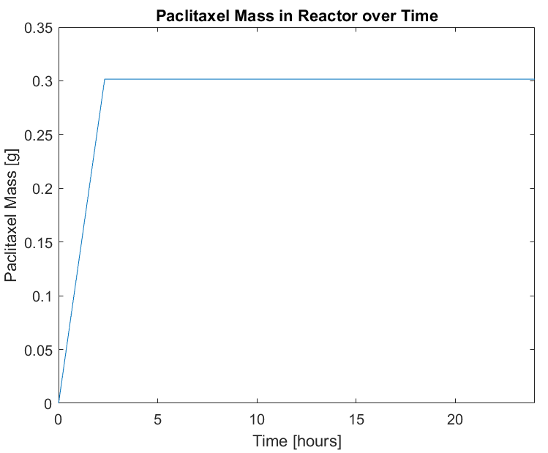

Figure 4: Graphical output of Microbial Consortium Model Iteration II. Notice that the paclitaxel mass remains constant at 0.3 g once this value has been reached.

### Model Evaluation

The model still shows a linear relationship between the output of Paclitaxel mass and the reaction time until all of the reactants have been consumed. However, the rate of reaction (slope of the output line) should not remain constant as the resources decrease. The next iteration will change the assumption that the reactions are all zeroth order.

## Iteration III

### Assumptions

1. The fermentation broth is perfectly homogeneous in composition and temperature
2. The fermentation broth is kept at a constant temperature
3. The fermentation broth is kept at a constant volume
4. The fermentation broth is kept at a constant pH
5. All *E. coli* cells are identical to each other and all *S. cerevisiae* cells are identical to each other
6. Cells neither grow nor die
7. **Each reaction is first order**
8. Xylose mass is the overall limiter of paclitaxel production
9. Transportation across the cell membrane is instantaneous and requires no energy
10. The cells have enough enzymes and cellular resources to perform each reaction
11. There is no wait time between reactions (i.e. no need for reaction products to diffuse within the cell or between cells before the next reaction occurs)
12. The input and output flows are zero
13. The normal metabolisms of the *E. coli* and *S. cerevisiae* cells do not produce any additional heat
14. All reactions occur to completion
15. If there is more than one pathway to a desired product, only the most direct pathway is taken (i.e. the pathway with the least number of reactions)
16. Reactions only occur in the forward direction
17. Reaction rates are the same at all temperatures

### Mathematical Model

With the change in Assumption 7, the only mathematical change in the equations used above is that the reactant concentrations’ powers are now one instead of zero. This will make the reaction rates functions of the reactants. The updated Equations 23 – 25 are below:

( 26 )

( 27 ) ( 28 )

The updated equations produced the output seen in Figure 5.

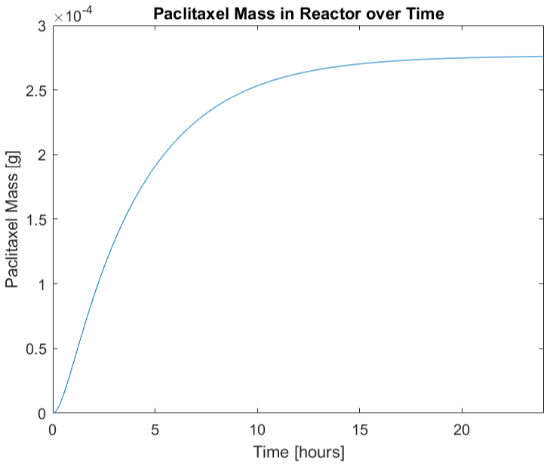

Figure 5: Graphical output of Microbial Consortium Model Iteration III. Notice that there is no longer a linear relationship between the paclitaxel mass and time and that the maximum amount of paclitaxel produced has decreased from 0.3 g to 2.75x10-4 g.

### Model Evaluation

The shape of the curve is more realistic and closer to what I had expected the output of the model to be. However, the model assumes that the rates of reaction in the *E. coli* cells are determined by the entire concentration of xylose even though all the xylose is not used by both reactions. The next iteration will add an assumption to correct this.

## Iteration IV

### Assumptions

1. The fermentation broth is perfectly homogeneous in composition and temperature
2. The fermentation broth is kept at a constant temperature
3. The fermentation broth is kept at a constant volume
4. The fermentation broth is kept at a constant pH
5. All *E. coli* cells are identical to each other and all *S. cerevisiae* cells are identical to each other
6. Cells neither grow nor die
7. Each reaction is first order
8. Xylose mass is the overall limiter of paclitaxel production
9. Transportation across the cell membrane is instantaneous and requires no energy
10. The cells have enough enzymes and cellular resources to perform each reaction
11. There is no wait time between reactions (i.e. no need for reaction products to diffuse within the cell or between cells before the next reaction occurs)
12. The input and output flows are zero
13. The normal metabolisms of the *E. coli* and *S. cerevisiae* cells do not produce any additional heat
14. All reactions occur to completion
15. If there is more than one pathway to a desired product, only the most direct pathway is taken (i.e. the pathway with the least number of reactions)
16. Reactions only occur in the forward direction
17. Reaction rates are the same at all temperatures
18. **If a reactant is used in more than one reaction, the mass of the reactant will be split evenly between the reactions.**

### Mathematical Model

The update to Assumption 18 affects Equations 26 and 27 as these are the only equation that model one reactant being used for multiple different reactions, in this case, two. As such, the updated equations are listed below:

( 29 )

( 30 )

Note that when there is enough xylose to produce acetate, but not taxadiene, all of the xylose present is allowed to participate in the reaction to produce acetate. These updates were made to the code and used to produce the output found in Figure 6.

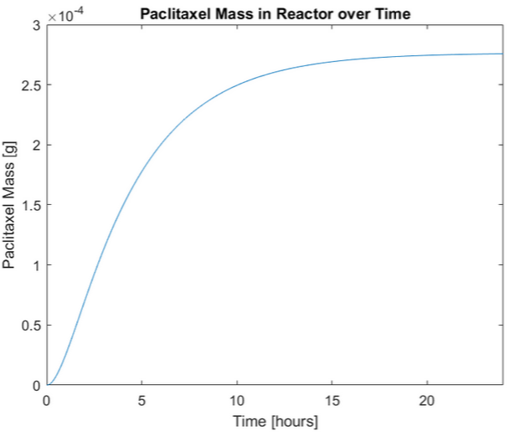

Figure 6: Graphical output of Microbial Consortium Model Iteration IV. The slope of this curve is flatter than that of the last curve.

### Model Evaluation

The slope of the curve of paclitaxel mass over time is flatter than that of the last curve because less xylose mass was assigned to each reaction, thus making the reactions occur more slowly. Assuming the cells do not divide, this model is relatively accurate. The next iteration will include cell growth and the use of resources to produce the cell growth.

# Review of Deliverable IV

## Iteration V

### Assumptions

1. The fermentation broth is perfectly homogeneous in composition and temperature
2. The fermentation broth is kept at a constant temperature
3. The fermentation broth is kept at a constant volume
4. The fermentation broth is kept at a constant pH
5. All *E. coli* cells are identical to each other and all *S. cerevisiae* cells are identical to each other
6. **Cells grow but do not die**
7. Each reaction is first order
8. Xylose mass is the overall limiter of paclitaxel production
9. Transportation across the cell membrane is instantaneous and requires no energy
10. The cells have enough enzymes and cellular resources to perform each reaction
11. There is no wait time between reactions (i.e. no need for reaction products to diffuse within the cell or between cells before the next reaction occurs)
12. The input and output flows are zero
13. The normal metabolisms of the *E. coli* and *S. cerevisiae* cells do not produce any additional heat
14. All reactions occur to completion
15. If there is more than one pathway to a desired product, only the most direct pathway is taken (i.e. the pathway with the least number of reactions)
16. Reactions only occur in the forward direction
17. Reaction rates are the same at all temperatures
18. If a reactant is used in more than one reaction, the mass of the reactant will be split evenly between the reactions.

### Mathematical Model

To model the growth of the cells, Equations 8 and 9 must be updated to include a mathematical growth relationship. The cellular growth model is based upon Michaelis-Menten reaction kinetics and is determined by the variables of concentration of the main carbon source of the cells and the mass of cells. Other parameters in this growth model include the maximum growth rate of the cells, the concentration of substrate which allows for half of the maximum growth rate by the cells, and ratio of how much cell mass can be produced by substrate mass, as seen in Equation 31.

( 31 )

Values for these parameters were found in literature and are detailed in the table below.

Table 3: Cellular Growth Parameters

|  |  |  |
| --- | --- | --- |
| Parameter | Value | Source |
| Ks,e | 0.00716 g/L | (Senn, Lendenmann, Snozzi, Hamer, & Egli, 1994) |
| Ks,s | 0.0000054 mol/L | (Snoep, Mrwebi, Schuurmans, Rohwer, & Teixeira de Mattos, 2009) |
| Ye/x | 0.57 g *E. coli*/ g xylose | (Kayser, Weber, Hecht, & Rinas, 2004) |
| Ys/a | 0.84 g *S. cerevisiae*/ mol acetate | (Daran-Lapujade, et al.) |
| µmax,e | 0.76 h-1 | (Kayser, Weber, Hecht, & Rinas, 2004) |
| μmax,s | 0.5 h-1 | (Snoep, Mrwebi, Schuurmans, Rohwer, & Teixeira de Mattos, 2009) |

Below are the updated versions of Equations 8 and 9 from Deliverable II along with updates to the reaction rate equations from previous iterations:

( 32 )

( 33 )

( 34 )

( 35 )

Equations 16 and 22 must also be updated to reflect that acetate and xylose mass contribute to the production of *S. cerevisiae* and *E. coli* cell mass.

( 36 )

( )

Finally, per Assumption 18, the reaction rates for producing taxadiene and acetate must be updated to reflect that an additional reaction occurs with the xylose mass, so a smaller portion of the xylose mass goes toward the production of these molecules.

( 38 )

( 39 )

With these updates made to the code, the output found in Figure 7 was produced.

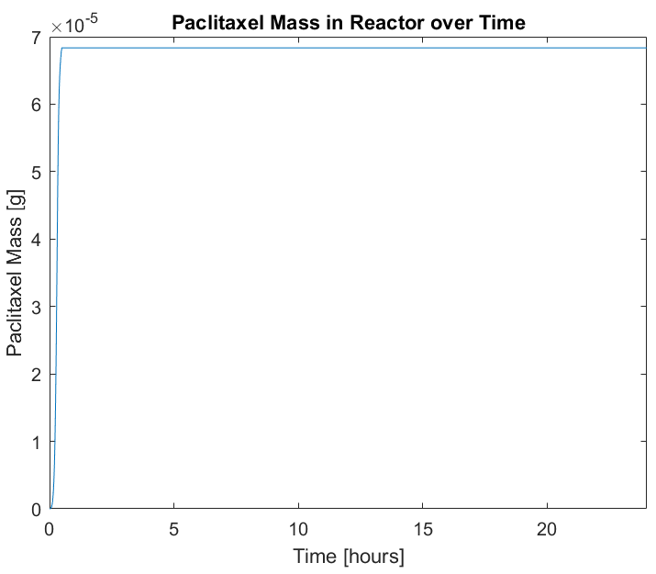

Figure 7: Graphical output of Microbial Consortium Model Iteration V. Notice that the maximum amount of paclitaxel produced is reached much faster than in the previous iteration and that more the maximum amount of paclitaxel produced decreases from 2.75x10-4 g to 6.9x10-5 g.

### Model Evaluation

With the growth of the cells, the reaction occurs much more quickly as there are more “reactors” in the form of cells performing the reaction and the maximum amount of paclitaxel produced decreases as more of the reactant mass goes toward producing cell mass when the cells divide. However, the model does not currently reflect that acetate inhibits the growth of *E. coli* and this will be incorporated into the next iteration.

## Iteration VI

### Assumptions

1. The fermentation broth is perfectly homogeneous in composition and temperature
2. The fermentation broth is kept at a constant temperature
3. The fermentation broth is kept at a constant volume
4. The fermentation broth is kept at a constant pH
5. All *E. coli* cells are identical to each other and all *S. cerevisiae* cells are identical to each other
6. Cells grow but do not die
7. Each reaction is first order
8. Xylose mass is the overall limiter of paclitaxel production
9. Transportation across the cell membrane is instantaneous and requires no energy
10. The cells have enough enzymes and cellular resources to perform each reaction
11. There is no wait time between reactions (i.e. no need for reaction products to diffuse within the cell or between cells before the next reaction occurs)
12. The input and output flows are zero
13. The normal metabolisms of the *E. coli* and *S. cerevisiae* cells do not produce any additional heat
14. All reactions occur to completion
15. If there is more than one pathway to a desired product, only the most direct pathway is taken (i.e. the pathway with the least number of reactions)
16. Reactions only occur in the forward direction
17. Reaction rates are the same at all temperatures
18. If a reactant is used in more than one reaction, the mass of the reactant will be split evenly between the reactions.
19. ***E. coli* growth is inhibited by the presence of acetate.**

### Mathematical Model

The inhibition of *E. coli* growth is modeled by product inhibition Michaelis-Menten kinetics. The concentrations of both xylose and acetate affect the growth rate of *E. coli*.

Table 4: *E. coli* Growth Inhibition Parameters

|  |  |  |
| --- | --- | --- |
| Parameter | Value | Source |
| Ki | 0.008 mol acetate / L | (Roe, O'Byrne, McLaggan, & Booth, 2002) |

This new growth rate equation is reflected in the following updated version of Equation 33.

( 40 )

This updated equation was added to the code and used to produce Figure 8.

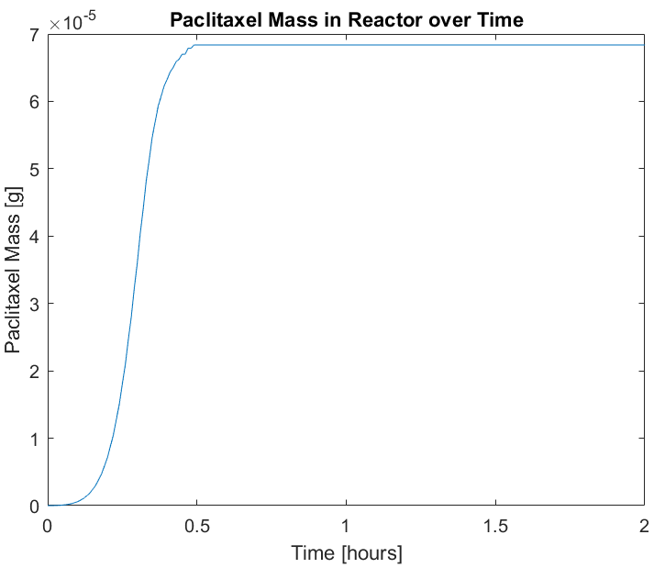

Figure 8: Graphical output of Microbial Consortium Model Iteration VI. Note the change in the time scale from 24 hours to 2 hours to better show the model output prior to the substrate being completely consumed. There seems to be little change in the actual rate of reaction and maximum paclitaxel production.

### Model Evaluation

Though there is little change between the output of this iteration and the previous iteration, this may be because the acetate which inhibits the *E.* coli growth is immediately metabolized by the yeast cells. As such, the growth models of the different cell types have been addressed. The death rates of the cells will be incorporated in the next iteration.

## Iteration VII

### Assumptions

1. The fermentation broth is perfectly homogeneous in composition and temperature
2. The fermentation broth is kept at a constant temperature
3. The fermentation broth is kept at a constant volume
4. The fermentation broth is kept at a constant pH
5. All *E. coli* cells are identical to each other and all *S. cerevisiae* cells are identical to each other
6. **Cells grow and die**
7. Each reaction is first order
8. Xylose mass is the overall limiter of paclitaxel production
9. Transportation across the cell membrane is instantaneous and requires no energy
10. The cells have enough enzymes and cellular resources to perform each reaction
11. There is no wait time between reactions (i.e. no need for reaction products to diffuse within the cell or between cells before the next reaction occurs)
12. The input and output flows are zero
13. The normal metabolisms of the *E. coli* and *S. cerevisiae* cells do not produce any additional heat
14. All reactions occur to completion
15. If there is more than one pathway to a desired product, only the most direct pathway is taken (i.e. the pathway with the least number of reactions)
16. Reactions only occur in the forward direction
17. Reaction rates are the same at all temperatures
18. If a reactant is used in more than one reaction, the mass of the reactant will be split evenly between the reactions.
19. *E. coli* growth is inhibited by the presence of acetate.

### Mathematical Model

For this iteration, it is assumed that cells only die due to “natural causes” (i.e. DNA damage causing the cell to enter apoptosis) rather than due to starvation or environmental temperature changes. As such, the cellular death equation is similar to that of a first order reaction and models that a certain portion of the cellular populations, in this case 50%, die on a regular basis. The updated cellular accumulation equations (Equations 32 and 34) can be found below:

( 41 )

( 42 )

With this update, Figure 9 was produced below.

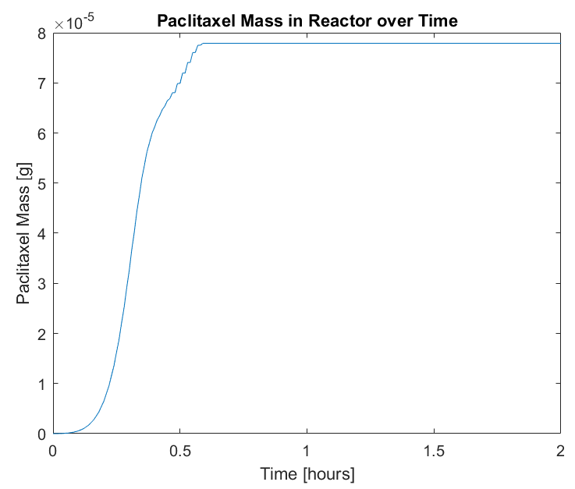

Figure 9: Graphical output of Microbial Consortium Model Iteration VII. Notice that the time to produce the maximum amount of paclitaxel increases slightly from 0.5 h to about 0.6 h and the maximum amount of paclitaxel produced increases from 6.9x10-5 g to 7.75x10-5 g.

### Model Evaluation

The incorporation of a death model shows that the reaction takes more time to consume all of the substrate and produce the maximum amount of paclitaxel, as expected, because there are fewer cells performing the reaction than in the previous iteration. Future iterations will incorporate the concentration of substrate, available reactor volume, and temperature into the growth and death models.

# Final Deliverable: Final Iterations and Model Evaluation

## Iteration VIII

### Assumptions

1. The fermentation broth is perfectly homogeneous in composition and temperature
2. The fermentation broth is kept at a constant temperature
3. The fermentation broth is kept at a constant volume
4. The fermentation broth is kept at a constant pH
5. All *E. coli* cells are identical to each other and all *S. cerevisiae* cells are identical to each other
6. Cells grow and die
7. Each reaction is first order
8. Xylose mass is the overall limiter of paclitaxel production
9. Transportation across the cell membrane is instantaneous and requires no energy
10. The cells have enough enzymes and cellular resources to perform each reaction
11. There is no wait time between reactions (i.e. no need for reaction products to diffuse within the cell or between cells before the next reaction occurs)
12. The input and output flows are zero
13. The normal metabolisms of the *E. coli* and *S. cerevisiae* cells do not produce any additional heat
14. All reactions occur to completion
15. If there is more than one pathway to a desired product, only the most direct pathway is taken (i.e. the pathway with the least number of reactions)
16. Reactions only occur in the forward direction
17. Reaction rates vary with temperature
18. If a reactant is used in more than one reaction, the mass of the reactant will be split evenly between the reactions.
19. *E. coli* growth is inhibited by the presence of acetate.

### Mathematical Model

The update to Assumption 17 means that the reaction rates within each mass balance now depend upon the energy balance equation, which up until this point has not been utilized to its fullest potential. Below are the energy balance equations:

In the case of Equations 11 and 12, because of Assumption 2, the fermentation broth is kept at a constant temperature. As such, the cells will not release their heat to the fermentation broth, so F6 and F7 are zero. Additionally, because of Assumption 12, F3 is also zero. The energy accumulated in the cells will then heat the cells, changing their temperature. An updated version of Equations 10, 11, and 12 can be found below.

( 43 )

( 44 )

( 45 )

The heats of reaction were estimated based upon literature values for similar cells and reactions.

The reaction rate equations must also be updated to reflect the change made to Assumption 17. When the temperature of the cellular systems is below the minimum temperature or above the maximum temperature at which the cells can survive, the reaction rates will become zero. In between these two temperatures, the reaction rates will vary as detailed below (Salvado, et al., 2011):

( 46 )

This equation applies to all of the reaction rate equations such that the reaction rate equations (rx,e, rx,d, rx,a, ra,s and rd,p) are substituted into the equation above for r­opt. This adjustment to the code produced the following outcome:

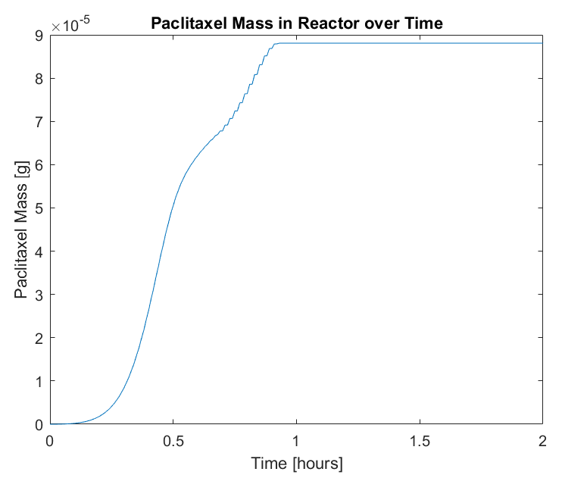Figure 10: Graphical output of Microbial Consortium Model Iteration VIII. Notice that the time to produce the maximum amount of paclitaxel increases slightly again from 0.6 h to about 0.9 h and the maximum amount of paclitaxel produced increases from 7.75x10-5 g to 8.75x10-5g.

### Model Evaluation

With the temperature now affecting the reaction rates, the model takes longer to reach its maximum value. This is because the temperature affects whether the cells are operating at the optimum reaction temperature. In addition, the cells produce more paclitaxel because as the cells are growing more slowly, less xylose mass goes toward the production of cell mass.

## Final Model Evaluation

### Overview

The final model takes into consideration the limitation of paclitaxel creation from the input of xylose mass, the relationship between the rate of reaction and the concentration of the reactant, the use of a reactant for multiple reactions, the growth of both cell types, the inhibition of *E. coli* cell growth due to acetate presence, the death of both cell types, and the fact that temperature affects reaction rates. The first iteration of this model predicted that paclitaxel production would reach nearly 7 g after 24 hours of fermentation with no sign of a slow in production while the final model predicted that a maximum of 8.75x10-5 g of paclitaxel after fermenting for just under an hour. Additionally, the first model plotted a linear relationship between the paclitaxel production and fermentation time while the final iteration predicted a more realistic sigmoidal curve.

### Final Equations

Below are the equations used in the final iteration of the model:

#### Mass Balance Equations:

( 47 )

( 48 )

( 6 )

( 49 )

( 50 )

( 51 )

#### Reaction Rate Equations:

( 52 )

( 53 )

( 54 )

( 55 )

( 56 )

( 57 )

#### Energy Balance Equations:

( 58 )

( 59 )

( 60 )

### Effect of Changing Input Parameters

#### Temperature

The current model assumes that the initial temperature of the fermentation broth is room temperature (25oC). When changing this temperature to the minimum temperature at which reactions occur, the following output is produced:

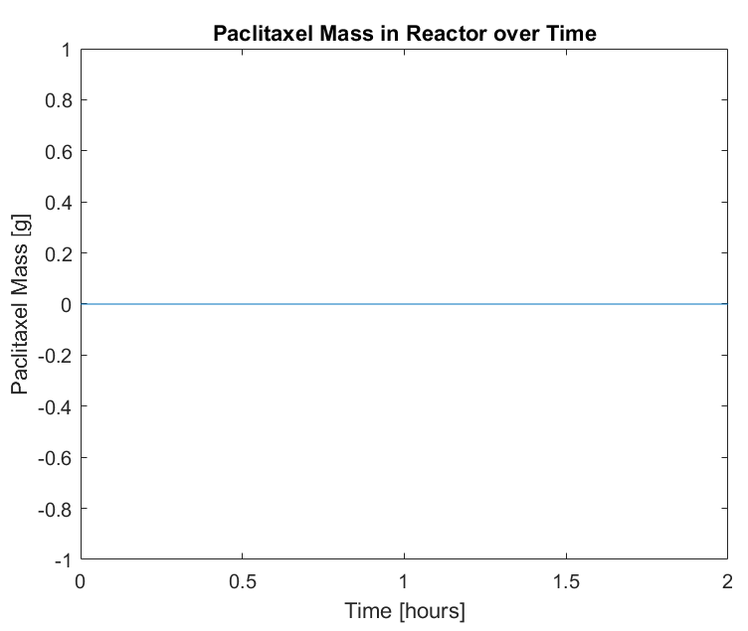

Figure 11: Final Model Output when Initial Temperature is 4oC.

A similar output occurs when the initial temperature is set to the maximum temperature at which reactions occur:



Figure 12: Final Model Output when Initial Temperature is 46oC

These outputs occur because at these temperatures, the cells are at their limits of survival and thus do not produce anything that is unnecessary to their survival. When the temperature is just above the minimum temperature, the below output occurs:

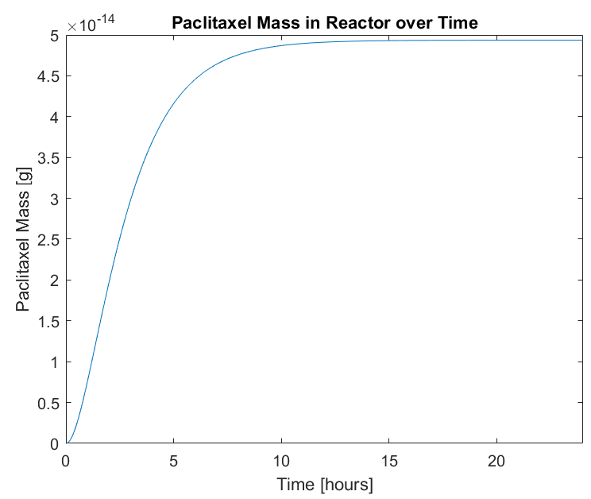

Figure 13: Final Model Output when Initial Temperature is 4.1oC. Notice that the time scale has been changed to 24 hours to better show the output curve.

Additionally, at a temperature just below the maximum temperature for cell viability, the below output is produced:

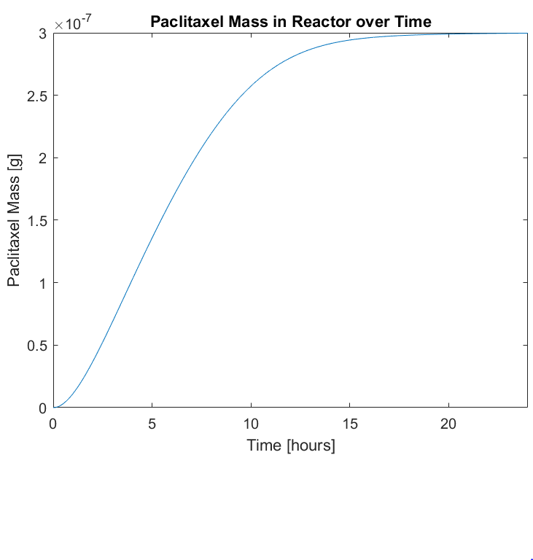

Figure 14: Output of Final Model when Initial Temperature is 45.9oC. Again, notice that the time scale is 24 hours rather than 2 to better show the full output curve.

These outputs show that the cells will produce some of the desired product when the temperature is within the viable cell range. However, the outputs are much lower than that of a starting temperature of 25oC and are produced over 24 hours rather than in under 1 hour. The higher temperature reactions produce more because they are closer to the optimum temperature of 35oC than the lower temperature reactions.

Finally, when setting the initial temperature to the optimum temperature for reactions, the following output is produced:

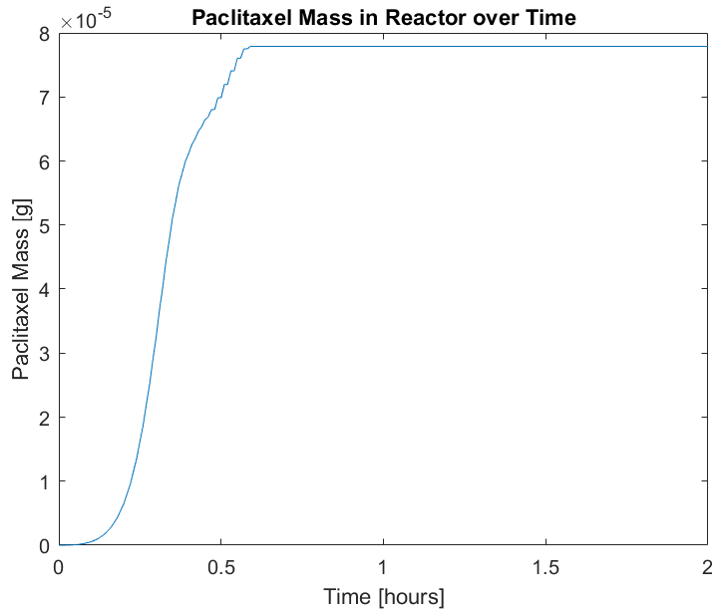

Figure 15: Final Model Output when Initial Temperature is 35oC, the optimum reaction temperature. Notice that the time scale has been changed back to 2 hours to better show the plot shape.

This output shows that the maximum amount of paclitaxel produced is less than when the fermentation starts at room temperature. However, the maximum is reached about 20 minutes faster than when the broth starts at room temperature. This is because the cells are growing more rapidly in the optimum temperature, so more xylose is allocated toward the accumulation of cell mass.

#### InitialCell Mass

Currently, the model assumes a starting *E. coli* cell mass of 2 g. When this is increased to 20 g while holding initial *S. cerevisiae* mass at 2 g, the output below occurs:

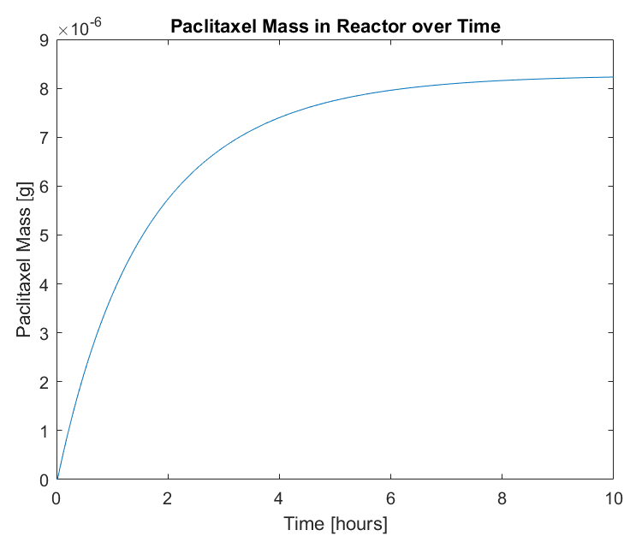

Figure 16: Final Model Output when *E. coli* cell mass starts at 20 g and *S. cerevisiae* mass starts at 2 g. Notice that the time scale has changed to 10 h to better show the shape of the output curve.

When both *E.* coli and *S. cerevisiae* cells begin with 20 g of mass, the following is output by the model:

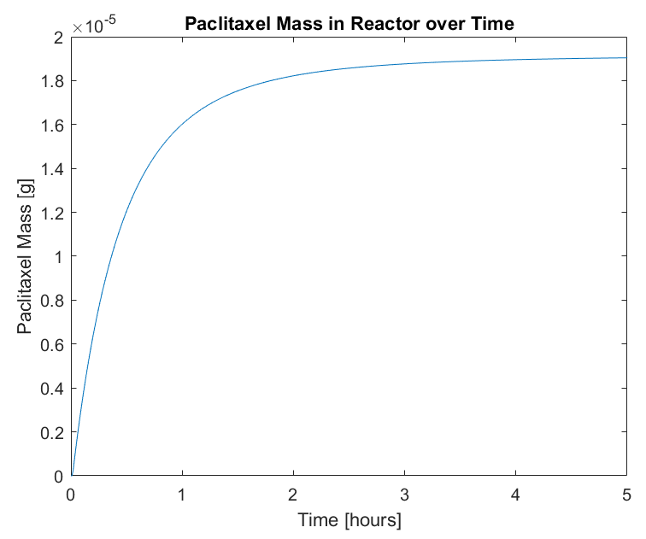

Figure 17: Final Model Output when Both *E. coli* and *S. cerevisiae* cell mass begin at 20 g. Note that the time scale has been changed to 5 hours to show the full output curve shape.

Finally, when *S. cerevisiae* begins with 20 g of cells while *E. coli* starts with 2 g, the following output occurs:

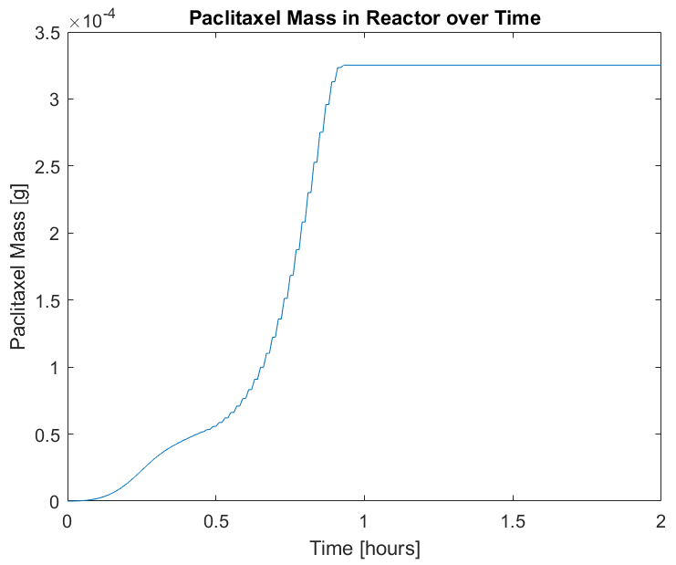Figure 18: Final Model Output when Initial *E. coli* mass is 2 g and Initial *S. cerevisiae* mass is 20 g. Notice that the time scale has been changed back to 2 h to better show the entire output curve.

These outputs show that *S. cerevisiae* cell mass limits the amount of paclitaxel produced and that the most paclitaxel is produced when there is a high ratio of *S. cerevisiae* cells to *E. coli* cells. This makes sense because these cells directly produce paclitaxel. This may also be because the *E. coli* cells produce acetate, which inhibits their growth. Without enough *S. cerevisiae* cells to take up this inhibitor, the excess *E. coli* cells will die out.

#### Xylose Mass

The current model assumes that the fermenter starts with 5 g of xylose. When this is doubled to 10 g of xylose the following output occurs:

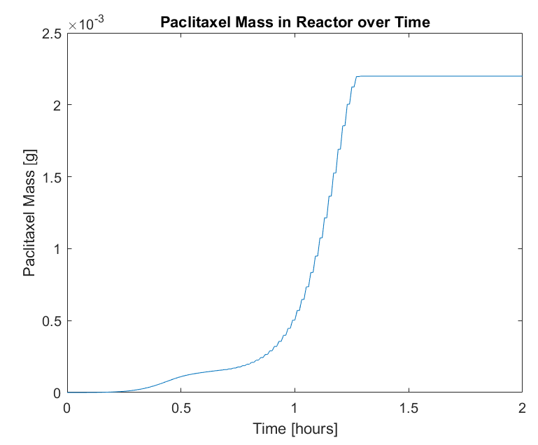

Figure 19: Final Model Output when Initial Xylose Mass is 10 g.

This output shows that when the initial xylose mass is doubled, the final paclitaxel mass increases greatly. This makes sense because there is a larger input of carbon source which can make more substrate as well as more cells to produce more paclitaxel.

### Future Improvements and Recommendations

The model currently does not take diffusion across the cell membrane of either mass or heat into consideration. In future iterations, the energy to diffuse the reactants and products should be included along with the change in concentration gradient, as the current model assumes that the concentration of the entire fermentation broth is the same as the intracellular concentration. Additionally, the model does not consider that the cells will release their excess heat into the fermenter to heat the broth before allowing the cells to heat up. This will have an impact on the reaction rate change due to temperature. The growth rates of the cells should also be a function of the available fermenter volume. Even if there were an infinite amount of carbon present for the cells to digest, the cells would still slow their growth rates once there was no more volume to occupy.

A more detailed model will split the concentration of xylose less equally between cell growth and the production of the desired products, as the cells will not evenly divide a carbon source between its functions and will rather prioritize necessary functions, giving those more of the carbon than functions that are less vital.

Finally, in the future, the in and out flow rates should not be zero. The model predicts the behavior of a batch fermentation. While batch fermentations are well studied and are often used by industry, continuous fermentations are more useful in that the fermentation can occur, allowing the product to flow out of the reactor while the carbon source is continuously fed to the cells. This allows for better continuity between operations that might require continuous flows, making the industrial plant more efficient.

Based upon the current model’s outputs for different starting parameters, it is recommended that when fermenting xylose with *E. coli* and *S. cerevisiae* in consortium to produce paclitaxel, the initial temperature of the fermentation broth should be started at about room temperature, the initial ratio of *E. coli* to *S. cerevisiae* cells should be high, and the amount of xylose in the beginning of the fermentation should be as high as possible to allow for the most efficient and maximum production of paclitaxel.

# Appendix A: Table of Nomenclature

|  |  |  |
| --- | --- | --- |
| Symbol | Parameter Meaning | Units |
| a | Concentration of acetate in the reactor | [g/L] |
| C | Concentration in a flow | [g/L] |
| cp | Specific heat | [J/g-K] |
| d | Concentration of taxadiene in the reactor | [g/L] |
| E | Energy | [J] |
| e | Concentration of *E. coli* cells in the reactor | [g/L] |
| F | Flow rate | [L/h] |
| H | Heat of reaction | [J/mol] |
| k | Reaction rate coefficient | [mol/L-h] or [h-1] (reaction order-dependent) |
| Ki | Inhibition coefficient | [g/L] |
| Ks | Substrate concentration to produce half of the maximum cellular growth rate | [g/L] |
| m | Mass in a system | [g] |
| p | Concentration of paclitaxel in the reactor | [g/L] |
| r | Reaction rate | [mol/L-h] |
| s | Concentration of *S. cerevisiae* cells in the reactor | [g/L] |
| T | Temperature | [K] |
| t | Time | [h] |
| V | Volume of a system | [L] |
| W | Molecular weight | [g/mol] |
| x | Concentration of xylose in the reactor | [g/L] |
| Y | Yield coefficient | [g/g] |
| α | Cellular death constant | [1/h] |
| µ­ | Specific cellular growth rate | [1/h] |
| ρ | Density | [g/L] |

|  |  |
| --- | --- |
| Subscript | Meaning |
| 1 | Property of Flow 1 |
| 2 | Property of Flow 2 |
| 3 | Property of Flow 3 |
| 4 | Property of Flow 4 |
| 5 | Property of Flow 5 |
| 6 | Property of Flow 6 |
| 7 | Property of Flow 7 |
| a | Property of acetate |
| a,s | Property of lumped reactions to convert acetate to *S. cerevisiae* cell growth |
| d | Property of taxadiene |
| d,p | Property of lumped reactions to convert taxadiene to paclitaxel |
| e | Property of *E. coli* cells |
| e/x | Ratio of *E. coli* mass to xylose mass |
| max | Maximum value of a property |
| min | Minimum value of a property |
| opt | Optimum value of a property |
| p | Property of paclitaxel |
| s | Property of *S. cerevisiae* cells |
| s/a | Ratio of *S. cerevisiae* mass to acetate mass |
| s1 | Property of Subsystem 1 |
| s2 | Property of Subsystem 2 |
| x | Property of xylose |
| x,a | Property of lumped reactions to convert xylose to acetate |
| x,d | Property of lumped reactions to convert xylose to taxadiene |
| x,e | Property of lumped reactions to convert xylose to *E. coli* cell growth |

# Appendix B: Supplemental Figures

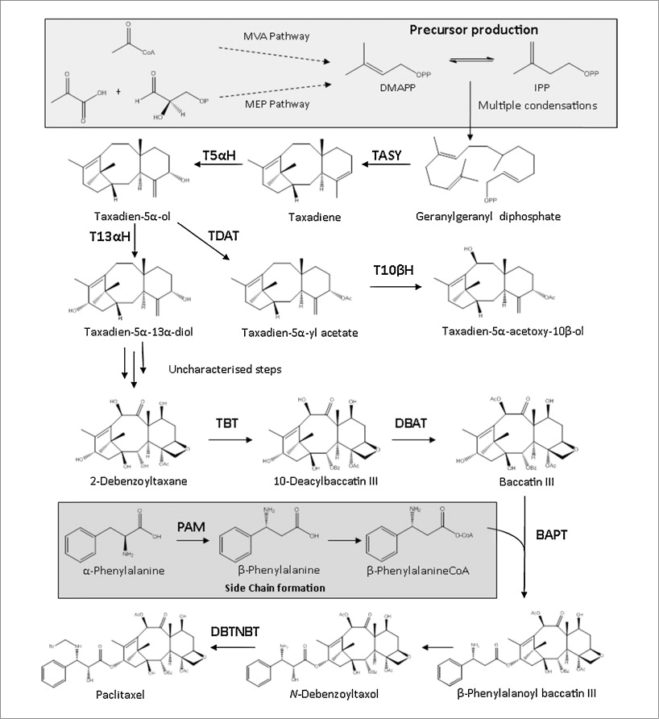

Figure 20: Paclitaxel biosynthesis pathway (Howat S, et al., 2014). The first half of the pathway, up to the production of taxadiene, is performed in the E. coli cell while the rest of the pathway is performed in the S. cerevisiae cell.

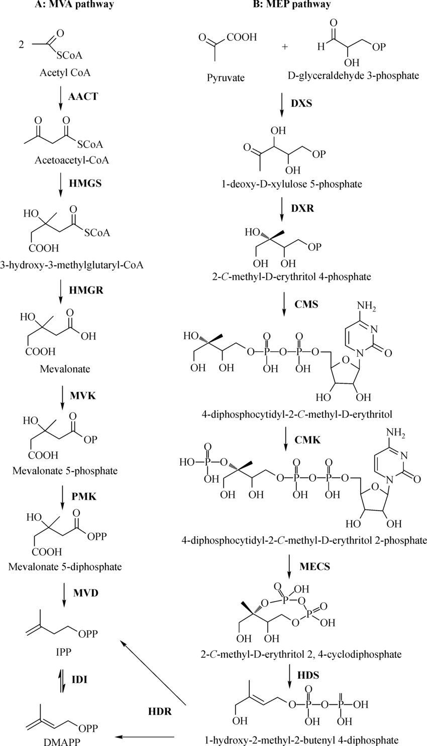

Figure 21: The MEV and MEP pathways referenced in Figure 20 (Zhu, Zeng, Sun, & Chen, 2014). These pathways are performed in the E. coli cell.

An external file that holds a picture, illustration, etc.
Object name is nihms940987f6.jpg

Figure 22: E. coli aerobic metabolism of xylose (Gonzalez, Long, & Antoniewicz, 2017). The E. coli cell produces the acetate and then transports the molecule to the fermentation broth, where it is then taken up by S. cerevisiae.

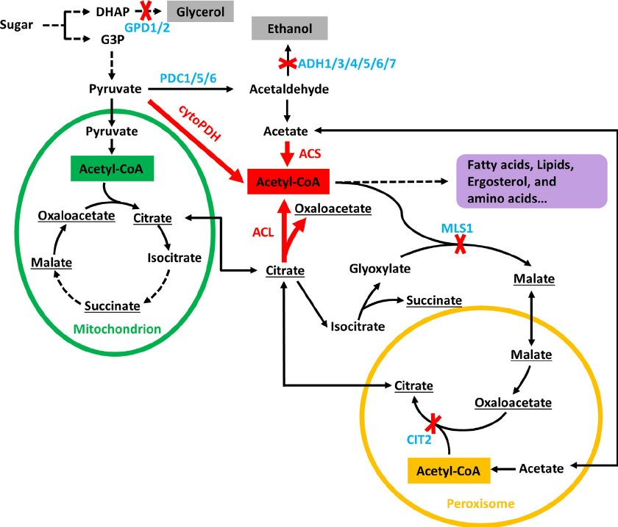

Figure 23: Metabolism of acetate in S. cerevisiae (Lian, Si, Nair, & Zhao, 2014). The acetate is produced in E. coli before being taken up by the S. cerevisiae and being incorporated into the metabolism.

# Appendix C: Final Model Code

clear;

% Constants and Initial Conditions

V = 1; % [L]

Topt = 273 + 35; % [K]

Tmax = 273 + 46;

Tmin = 273 + 4; % [K]

T = 273 + 25; % [K]

Te = T; % [K]

Ts = T; % [K]

cp = 4.186; % [J/g-K]

e = 2; % [g/L]

s = 2; % [g/L]

rho_cell = 200; % [g/L]

rho_water = 1000; % g/L

x = 5; % [g/L]

p = 0; % [g/L]

d = 0; % [g/L]

a = 0; % [g/L]

Wx = 150.13; % [g/mol]

Wd = 272.476; % [g/mol]

Wa = 60.052; % [g/mol]

Wp = 853.906; % [g/mol]

Hxd = 245; % [J/mol]

Hxa = 80; % [J/mol]

Hxe = 1000; % [J/mol]

Hdp = 185; % [J/mol]

Has = 1500; % [J/mol]

kx_x5p = 0.065; % Voronsky

kx5p_gap = 0.57; % Lee

kgap_3pg = 0.891; % Yu

k3pg_pep = 0.078; % Mercade

kpep_pyr = 0.52; % Malcovati

kpyr_accoa = 0.134; % Inui

kaccoa_a = 0.885; % Liang

kaccoa_aacoa = 506; % Feigenbaum

kaacoa_3h3mg = 2; % Durr

k3h3mg_mv = 0.0035; % Middleton

kmv_m5p = 0.06; % Bloch

km5p_m5dp = 0.06; % Agranoff

km5dp_ipp = 0.00000133; % Gogerty

kp_dg3p_1ddx5p = 3; % Hahn

k1ddx5p_2cmde4p = 1.6; % Takenoya

k2cmde4p_4d2cmde = 23; % Richard

k4d2cmde_4d2cmde2p = 33; % Chesters

k4d2cmde2p_2cmde24c = 0.75; % Yu

k2cmde24c_1h2m2b4d = 0.99; % Zepeck

k1h2m2b4d_dmapp = 0.03; % Wolff

kdmapp_ipp_ggdp = 0.109; % Yu

kggdp_d = 0.003; % Jennewein

kd_t5a = 0.016; % Jennewein

kt5a_t5a13ad = 5.77; % Chau

k2dbt_10db = 0.00635; % Nawarathne

k10db_b = 6.1; % Fang

kb_bpacoa_bpab = 2.2; % Walker

kbpab_ndbt = 0.0049; % Zhu

knbt_p = 0.0049; % Zhu

mumax_e = 0.76; % [1/h]

mumax_s = 0.5; % [1/h]

Kse = 0.00716; % [g/L]

Kss = 0.0000054; % [mol/L]

Yex = 0.57; % [g E coli / g xylose]

Ysa = 0.84; % [g S cerevisae / mol acetate]

Ki = 0.008; % [mol acetate / L]

alpha = 0.5;

time = 0:0.01:24; % [h]

p_t = zeros(length(time),1);

delt = 0.01;

for i = 1:length(time)

p_t(i) = p; % [g]

Vs1 = e * V / rho_cell; % [L]

Vs2 = s * V / rho_cell; % [L]

rxd = (x / 3) * 60 * 1 / (1 / kx_x5p + 1 / kx5p_gap + 1 / kgap_3pg + 1 / k3pg_pep + 1 / kpep_pyr + 1 / kpyr_accoa + 1 / kaccoa_aacoa + 1 / kaacoa_3h3mg + 1 / k3h3mg_mv + 1 / kmv_m5p + 1 / km5p_m5dp + 1 / km5dp_ipp + 1 / kp_dg3p_1ddx5p + 1 / k1ddx5p_2cmde4p + 1 / k2cmde4p_4d2cmde + 1 / k4d2cmde_4d2cmde2p + 1 / k4d2cmde2p_2cmde24c + 1 / k2cmde24c_1h2m2b4d + 1 / k1h2m2b4d_dmapp + 1 / kdmapp_ipp_ggdp + kggdp_d); % [mol/L-h]

rxa = (x / 3) * 60 * 1 / (1 / kx_x5p + 1 / kx5p_gap + 1 / kgap_3pg + 1 / k3pg_pep + 1 / kpep_pyr + 1 / kpyr_accoa + 1 / kaccoa_a); % [mol/L-h]

rdp = d * 60 * 1 / (1 / kd_t5a + 1 / kt5a_t5a13ad + 1 / k2dbt_10db + 1 / k10db_b + 1 / kb_bpacoa_bpab + 1 / kbpab_ndbt + 1 / knbt_p); % [mol/L-h]

rxe = mumax_e * (x / 3) / (Kse * (1 + a / (Ki * Wa)) + (x / 3)) * e * V / (Yex); % [g/L-h]

ras = mumax_s * a / (Kss + a) * s * V / (Ysa / Wa); % [g/L-h]

if x < Wd / 6.02e23 % mass of one molecule of taxadiene

rxd = 0;

rxa = x / 2 * 60 * 1 / (1 / kx_x5p + 1 / kx5p_gap + 1 / kgap_3pg + 1 / k3pg_pep + 1 / kpep_pyr + 1 / kpyr_accoa + 1 / kaccoa_a); % [mol/L-h]

rxe = mumax_e * (x / 2) / (Kse * (1 + a / (Ki * Wa)) + (x / 2)) * e * V / (Yex); % [g/L-h]

end

if x < Wa / 6.02e23 % mass of one molecule of acetate

rxa = 0;

rxe = mumax_e * (x) / (Kse * (1 + a / (Ki * Wa)) + (x)) * e * V / (Yex); % [g/L-h]

end

if d < Wp / 6.02e23 % mass of one molecule of paclitaxel

rdp = 0;

end

D = (T - Tmax) * (T - Tmin) ^ 2;

E = (Topt - Tmin) * ((Topt - Tmin) * (T - Topt) - (Topt - Tmax) * (Topt + Tmin - 2 * T));

if Te < Tmin

rxe = 0;

rxd = 0;

rxa = 0;

elseif T > Tmax

rxe = 0;

rxd = 0;

rxa = 0;

else

rxe = rxe * D / E;

rxd = rxd * D / E;

rxa = rxa * D / E;

end

if Ts < Tmin

ras = 0;

rdp = 0;

elseif T > Tmax

ras = 0;

rdp = 0;

else

ras = ras * D / E;

rdp = rdp * D / E;

end

% integrate dxdt = F1 * C1 - (rxe + rxd + rxa) * Wx * Vs1; % [g/h]

x = x - (rxe + rxd + rxa) * Wx * Vs1 * delt; % [g]

if x < 0

x = 0;

end

% integrate dddt = rxd * Wx * Vs1 - rdp * Wd * Vs2; % [g/h]

d = d + rxd * Wx * Vs1 * delt - rdp * Wd * Vs2 * delt; % [g]

if d < 0

d = 0;

end

% integrate dadt = rxa * Wx * Vs1 - ras * Wa * Vs2; % [g/h]

a = a + rxa * Wx * Vs1 * delt - ras * Wa * Vs2 * delt; % [g]

if a < 0

a = 0;

end

% integrate dedt = rxe * Wx * Vs1; % [g/h]

e = e + rxe * delt - e * alpha * delt; % [g]

if e < 0

e = 0;

end

% integrate dsdt = ras * Wa * Vs2; % [g/h]

s = s + ras * delt - s * alpha * delt;

if s < 0

s = 0;

end

C2 = p / V; % [g/L]

% integrate dpdt = rdp * Vs2 - F2 * C2

p = p + rdp * Vs2 * Wd * delt; % [g]

if p < 0

p = 0;

end

% integrate dhs1dt = Vs1 * (Hxd * Wd * rxd + Hxa * Wa * rxa + Hxe * rxe)

hs1 = Vs1 * (Hxd * Wd * rxd + Hxa * Wa * rxa + Hxe * rxe) * delt; % [J]

Te = Te + (hs1 / (e * cp));

% integrate dhs2dt = Vs2 * (Hdp * Wp * rdp + Has * Ws * ras)

hs2 = Vs2 * (Hdp * Wd * rdp + Has * ras) * delt; % [J]

Ts = Ts + (hs1 / (e * cp));

end

plot(time, p_t)

title('Paclitaxel Mass in Reactor over Time')

xlabel('Time [hours]')

xlim([0,2])

ylabel('Paclitaxel Mass [g]')

## 

# Appendix D: References

Agranoff, B. W., Eggerer, H., Henning, U., & Lynen, F. (1960). Biosynthesis of terpenes. VII. Isopentenyl pyrophosphate isomerase. *J. Biol. Chem., 235*, 326-332.

Bloch, K., Chaykin, S., Phillips, A. H., & De Waard, A. (1959). Mevalonic acid pyrophosphate and isopentenylpyrophosphate. *J. Biol. Chem, 234*, 2595-2604.

Cane, D. E., Chow, C., Lillo, A., & Kang, I. (2001). Molecular cloning, expression and characterization of the first three genes in the mevalonate-independent isoprenoid pathway in Streptomyces coelicolor. *Bioorg. Med. Chem., 9*, 1467-1477.

Chau, M., Walker, K., Long, R., & Croteau, R. (2004). Regioselectivity of taxoid-O-acetyltransferases: heterologous expression and characterization of a new taxadien-5alpha-ol-O-acetyltransferase. *Arch. Biochem. Biophys., 430*, 237-246.

Chesters, C., Wilding, M., Goodall, M., & Micklefield, J. (2012). Thermal bifunctionality of bacterial phenylalanine aminomutase and ammonia lyase enzymes. *Angew. chem. Int. Ed. Engl., 51*, 4344-4348.

Daran-Lapujade, P., Jansen, M. L., Daran, J.-M., van Gulik, W., de Winde, J. H., & Pronk, J. T. (n.d.). Role of Transcriptional Regulation in Controlling Fluxes in Central Carbon Metabolism of Saccharomyces cerevisiae, a Chemostat Culture Study.

Durr, I. F., & Rudney, H. (1960). The reduction of beta-hydroxy-beta-methylglutaryl coenzyme A to mevalonic acid. *J. Biol. Chem., 235*, 2572-2578.

Fang, J., & Ewald, D. (2004). Expression cloned cDNA for 10-deacetylbaccatin III-10-O-acetyltransferase in Escherichia coli: a comparative study of three fusion systems. *Protein Expr. Purif., 35*, 17-24.

Feigenbaum, J., & Schulz, H. (1975). Thiolases of Escherichia coli: purification and chain length specificities. *J. Bacteriol., 122*, 407-411.

Gogerty, D. S., & Bobik, T. A. (2010). Formation of isobutene from 3-hydroxy-3-methylbutyrate by diphosphomevalonate decarboxylase. *Appl. Environ. Microbiol., 76*, 85004-85010.

Goldberg, R. N., Ribeiro da Silva, M. A., Ribiero da Silva, M. D., Lobo Ferreira, A. I., Shi, Q., & Woodfield, B. F. (2012, December 4). Thermochemistry of alpha-D-xylose. *Journal of Chemical Thermodynamics, 58*.

Gonzalez, J. E., Long, C. P., & Antoniewicz, M. R. (2017, January). Comprehensive analysis of glucose and xylose metabolism in Escherichia coli under aerobic and anaerobic conditions by 13C metabolic flux analysis. *Metabolic Engineering, 39*, 9-18.

Hahn, F. M., Eubanks, L. M., Testa, C. A., Blagg, B. S., Baker, J. A., & Poulter, C. D. (2001). 1-Deoxy-D-xylulose 5-phosphate synthase, the gene product of open reading frame (ORF) 2816 and ORF 2895 in Rhodobacter capsulatus. *J. Bacteriol., 183*, 1-11.

Howat, S., Park, B., Oh, I., Jin, Y.-W., Lee, E.-K., & Loake, G. J. (2014, May 25). Paclitaxel: biosynthesis, production and future prospects. *New Biotechnology, 31*(3), 242-245.

Inui, H., Miyatake, K., Nakano, Y., & Kitaoka, S. (1990). Pyruvate: NADP+ oxidoreductase from Euglena gracilis: mechanism of O2-inactivation of the enzyme and its stability in the aerobe. *Arch. Biochem. Biophys, 280*, 292-298.

Jennewein, S., Long, R. M., Williams, R. M., & Croteau, R. (2004). Cytochrome p450 taxadiene 5alpha-hydroxylase, a mechanistically unusual monooxygenase catalyzing the first oxygenation step of taxol biosynthesis. *Chem. Biol., 11*, 379-387.

Kayser, A., Weber, J., Hecht, V., & Rinas, U. (2004, December 6). Metabolic flux analysis of Escherichia coli in glucose-limited continuous culture. I. Growth-rate-dependent metabolic efficiency at steady state. *Microbiology, 151*, 693-706.

Lee, J. Y., Cheong, D. E., & Kim, G. J. (2008). A novel assay system for the measurement of transketolase activity using xylulokinase from Saccharomyces cerevisiae. *Biotechnol. Lett., 30*, 899-904.

Lian, J., Si, T., Nair, N., & Zhao, H. (2014, July). Design and construction of acetyl-CoA overproducing Saccharomyces cerevisiae strains. *Metabolic Engineering, 24*, 139-149.

Liang, M. H., Qv, X. Y., Jin, H. H., & Jiang, J. G. (2016). Characterization and expression of AMP-forming acetyl-CoA synthetase from Dunaliella tertiolecta and its response to nitrogen starvation stress. *Sci. Rep., 6*, 23445.

Malcovati, M., & Valentini, G. (1982). AMP- and fructose 1,6-bisphosphate-activated pyruvate kinases from Escherichia coli. *Methods Enzymol., 90*, 170-179.

Mercade, M., Cocaign-Bousquet, M., & Loubiere, P. (2006). Glyceraldehyde-3-phosphate dehydrogenase regulation in Lactococcus lactis ssp. cremoris MG1363 or relA mutant at low pH. *J. Appl. Microbiol., 100*, 1364-1372.

Middleton, B. (1972). The kinetic mechanism of 3-hydroxy-3-methylglutaryl-coenzyme a synthase from baker's yeast. *Biochem. J., 126*, 35-47.

Nawarathne, I. N., & Walker, K. D. (2010). Point mutations (Q19P and N23K) increase the operational solubility of a 2alpha-O-benzoyltransferase that conveys various acyl groups from CoA to a taxane acceptor. *J. Nat. Prod., 73*, 151-159.

Roe, A. J., O'Byrne, C., McLaggan, D., & Booth, I. R. (2002). Inhibition of Escherichia coli growth by acetic acid: a problem with methionine biosynthesis and homocysteine toxicity. *Microbiology*, 2215-2222.

Salvado, Z., Arroyo-Lopez, F. N., Guillamon, J. M., Salazar, G., Querol, A., & Barrio, E. (2011, April). Temperature Adaptation Markedly Determines Evolution within the Genus Saccharomyces. *Applied and Environmental Microbiology, 77*(7), 2292-2302.

Senn, H., Lendenmann, U., Snozzi, M., Hamer, G., & Egli, T. (1994, December 15). The growth of Escherichia coli in glucose-limited chemostat cultures: a re-examination of the kinetics. *Biochim. Biophys. Acta., 1201*(3), 424-436.

Snoep, J. L., Mrwebi, M., Schuurmans, J. M., Rohwer, J. M., & Teixeira de Mattos, M. J. (2009). Control of specific growth rate in Saccharomyces cerevisiae. *Microbiology, 155*, 1699-1707.

Takenoya, M., Ohtaki, A., Noguchi, K., Endo, K., Sasaki, Y., Ohsawa, K., . . . Yohda, M. (2010). Crystal structure of 1-deoxy-d-xylulose 5-phosphate reductoisomerase from the hyperthermophile Thermotoga maritima for insights into the coordination of conformational changes and an inhibitor binding. *J. Struct. Biol., 170*, 532-539.

Voronovsky, A. Y., Ryabova, O. B., Verba, O. V., Ishchuk, O. P., Dmytruk, K. V., & Sibimy, A. A. (2005). Expression of xylA genes encoding xylose isomerases from Escherichia coli and Streptomyces coelicolor in the methylotrophic yeast Hansenula polymorpha. *FEMS Yeast Res., 5*, 1055-1062.

Walker, K., Fujisaki, S., Long, R., & Croteau, R. (2002). Molecular cloning and heterologous expression of the C-13 phenylpropanoid side chain-CoA acyltransferase that functions in Taxol biosynthesis. *Proc. Natl. Acad. Sci. USA, 99*, 12715-12720.

Wolff, M., Seemann, M., Tse Sum Bui, B., Frapart, Y., Tritsch, D., Estrabot, A. G., . . . Rohmer, M. (2003). Isoprenoid biosynthesis via the methylerythritol phosphate pathway: the (E)-4-hydroxy-3-methylbut-2-enyl diphosphate reductase (LytB/IspH) from Escherichia coli is a [4Fe-4S] protein. *FEBS Lett, 541*, 115-120.

Yu, J. P., Ladapo, J., & Whitman, W. B. (1994). Pathway of glycogen metabolism in Methanococcus maripaludis. *J. Bacteriol., 176*, 325-332.

Zepeck, F., Graewert, T., Kaiser, J., Schramek, N., Eisenreich, W., Bacher, A., & Rohdich, F. (2005). Biosynthesis of isoprenoids. Purification and properties of IspG protein from Escherichia coli. *J. Org. Chem., 70*, 9168-9174.

Zhou, K., Qiao, K., Edgar, S., & Stephanopoulos, G. (2015, January 5). Distributing a metabolic pathway among a microbial consortium enhances production of natural products. *Nature Biotechnology, 33*(4), 377-383. doi:10.1038/nbt.3095

Zhu, X., Zeng, X., Sun, C., & Chen, S. (2014, September). Biosynthetic pathway of tepenoid indole alkaloids in Catharanthus roseus. *Frontiers of Medicine, 8*(3), 285-293.