Runge Kutta 4th order example calculations

y’= 1/x – y/x –y y(1) = 0

Analytical solution y = (1-e^{1-x})/x

Standard 4th order Runge-Kutta method

F1 = h*y’(x,y)
F2 = h*y’(x+h/2, y+1/2*F1)
F3 = h*y’(x+h/2,y+1/2 F2)
F4 = h*y’(x+h,y+F3)

y _{i+1} = y_{i} + (F1 + 2*F2 + 2*F3 + F4)/6

Step size = 1

Calculate y(2)
x=1, y=0
F1 = h*y’(x,y) = h*(1/x – y/x –y) = 1*(1/1 -0/1 -0) = 1

F2= h*y’(x+h/2, y+1/2*F1) = h*(1/(x+h/2) – (y+1/2*F1)/(x+h/2) –(y+1/2*F1))
= 1*(1/(1+1/2) – (0+1/2*1)/(1+1/2) –(0+1/2*1)) = -0.1666666667

F3=h*y’(x+h/2,y+1/2 F2) = h*(1/(x+h/2) – (y+1/2*F2)/(x+h/2) –(y+1/2*F2))
= 1*(1/(1+1/2) – (0+1/2*-0.166667)/(1+1/2) –(0+1/2*-0.16667)) = 0.8055556

F4 = h*y’(x+h,y+F3) = h*(1/(x+h) – (y+F3)/(x+h) –(y+F3))
= 1*(1/(1+1) – 0+0.805556/(1+1) – (0+0.80555556)) = -0.7083333

y(2) = y(1) + (F1+2F2+2F3+F4)/6 = 0 +(1 – 2*0.666667 + 2*0.8055556 – 0.7083333)/6 = 0.2615741

Calculate y(3)
x=2, y(2)=0.2615741

F1 = h*y’(x,y) = h*(1/x – y/x –y) = 1*(1/2 -0.2615741/2 -0.2615741)
= 0.10763885

F2= h*y’(x+h/2, y+1/2*F1) = h*(1/(x+h/2) – (y+1/2*F1)/(x+h/2) –(y+1/2*F1))
= 1*(1/(2+1/2) – (0.2615741+1/2*0.10763885)/(2+1/2) –(0.2615741+1/2*0.10763885))
= -0.04155

F3=h*y’(x+h/2,y+1/2 F2) = h*(1/(x+h/2) – (y+1/2*F2)/(x+h/2) –(y+1/2*F2))
= 1*(1/(2+1/2) – (0.2615741+1/2*(-0.04155))/(2+1/2) –(0.2615741+1/2*(-0.04155))
= 0.062882

F4 = h*y’(x+h,y+F3) = h*(1/(x+h) – (y+F3)/(x+h) –(y+F3))
= 1*(1/(2+1) – 0.2615741+0.062882/(1+1) – (0.2615741+0.062882))
= -0.09927

y(3) = y(2) + (F1+2F2+2F3+F4)/6 = 0.2615741 +(0.10763885 + 2*(-0.04155)+ 2*0.062882– 0.09927)/6 = 0.27008

Continuing this for several more steps gives:
x | y | F1 | F2 | F3 | F4
1 | 0 | 1 | -0.16667 | 0.805556 | -0.70833
2 | 0.261574 | 0.107639 | -0.04155 | 0.062882 | -0.09927
3 | 0.270078 | -0.02677 | -0.04432 | -0.03304 | -0.0463
4 | 0.232114 | -0.04014 | -0.03694 | -0.0389 | -0.03186
5 | 0.194834 | -0.0338 | -0.02847 | -0.03162 | -0.02375
6 | 0.165213 | -0.02608 | -0.02174 | -0.02424 | -0.01825
7 | 0.142498 | -0.02 | -0.01683 | -0.01863 | -0.01436
8 | 0.124953 | -0.01557 | -0.0133 | -0.01457 | -0.01153
9 | 0.111143 | -0.01238 | -0.01074 | -0.01165 | -0.00945
10 | 0.100044 | 0.060292 | 0.035588 | -0.04911 | -1.11798

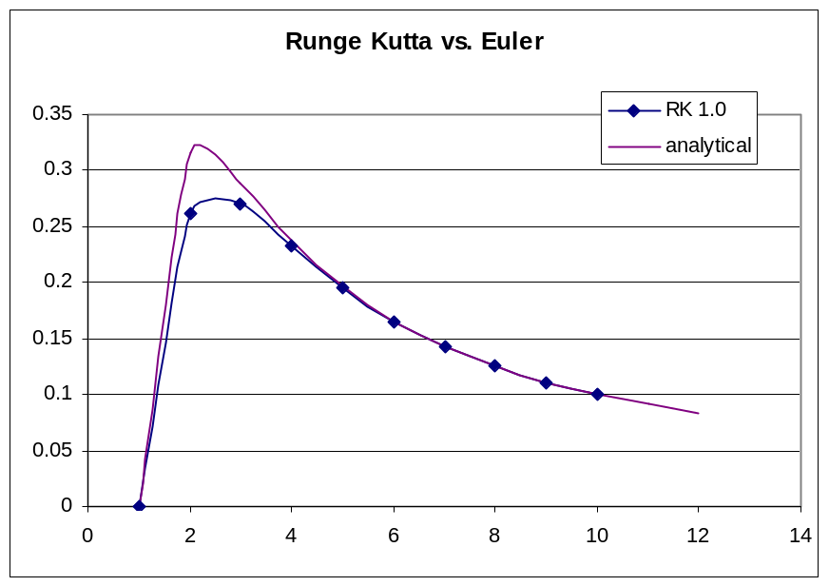

Reducing the step size to 0.5 gives a better fit.

Note that this is due to the issue that the most error occurs when the slope is rapidly changing and the least error when the slope is monotonically changing. So, the model fits quite well in the region from approx. 3 onwards, but has more error in the region from 1 to approx. 2.

Note that reducing the step size to 0.1 does not improve the fit much.

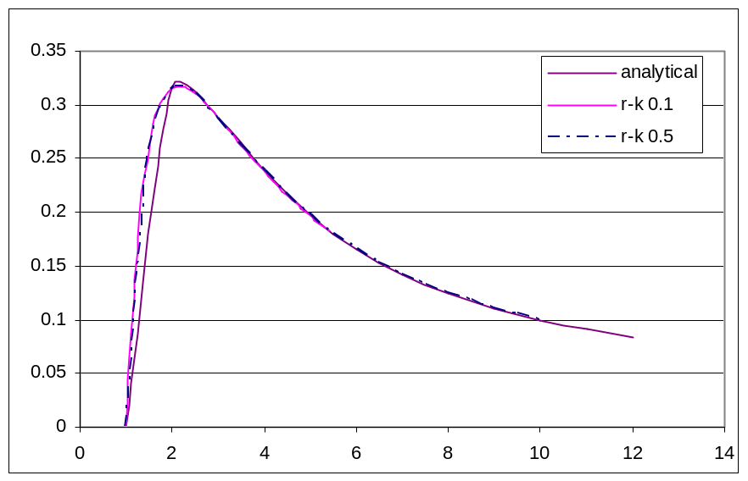

To improve the fit, it is necessary to change the weighting factors. Fehlberg suggests the following weighting factors.

Runge-Kutta-Fehlberg Method

F1 = h*y’(x,y)
F2 = h*y’(x+h/4, y+1/4*F1)
F3 = h*y’(x+3/8*h,y+3/32*F1+9/32*F2)
F4 = h*y’(x+12/13*h,y+1932/2197*F1+7200/2197*F2+7296/2197*F3)
F5=h*y’(x+h,y+439/216*F1-8*F2+3680/513*F3-845/4104*F4)
F6=h*y’(x+h/2,y-8/27*F1*2*F2-3544/2565*F3+1859/4104*F4-11/40*F5)

y _{i+1} = y_{i} + (25/216*F1 + 1408/2565*F2 + 2197/4104*F3 + 1/5*F4)

There are also adaptive methods that change the step size when regions of rapidly changing slope occur and increase the step size in regions of relatively flat, monotonic slope change.

