Problem 2 (50 points)
A chromatographic analysis of a pharmaceutical shows 2 components. Peak 1 is an inert components and peak 2 is the desired drug.

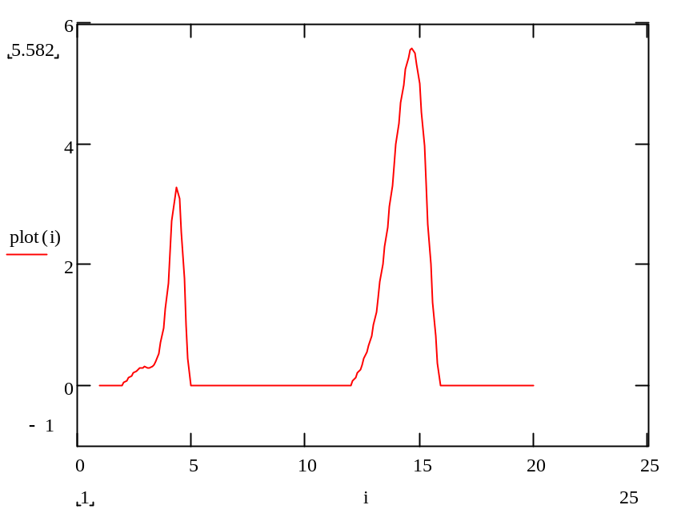
Peak 1
Peak 2

Digital values for this analysis are given below.

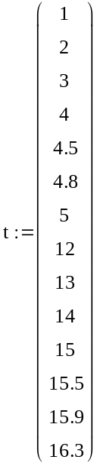
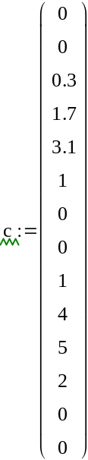

Using this data, create a cubic spline numerical model for the product composition and calculate the % of inert component.
Provide an appropriate plot of your model and clearly show how you calculated/obtained your answer.

