**Tutorial for Exam 3**

**Note:** Other problems may include viscosity problems included in tutorial for exam 2. Also, you should expect multiple choice questions on fundamental aspects of the area covered in the las part of the class.

**Problem 1**. A gel material is characterized by the relaxation test and the results obtained are given in the table below:

|  |  |
| --- | --- |
| Time (min) | Stress (kPa) |
| 0 | 38.0 |
| 0.25 | 31.0 |
| 0.50 | 29.0 |
| 1.0 | 22.5 |
| 2.0 | 17.5 |
| 4.0 | 13.0 |
| 6.0 | 11.0 |
| 8.0 | 10.0 |
| 10.0 | 9.5 |

By assuming that equilibrium is reached in 10 minutes and the data can be described by the three-element Maxwell model (illustrated below), (a) find the equation that can describe this model, (b) is the model a viscoelastic solid or liquid model and (c) determine the rheological parameters of the gel.

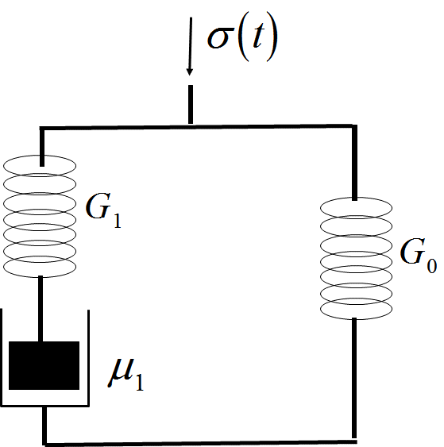

**Problem 2**

The creep analysis on a biomaterial were obtained by applying a constant stress of 50 Pa for 60s on the sample. The data is given in the table below and a Burger model is used to describe the data. Using **creep compliance data,** determine the viscoelastic parameters G1, G2,  and  of the Burger model.

|  |  |
| --- | --- |
| Time (s) | Strain, |
| 0 | 0.0060 |
| 5 | 0.0095 |
| 10 | 0.0140 |
| 15 | 0.0160 |
| 20 | 0.0180 |
| 25 | 0.0188 |
| 30 | 0.0195 |
| 35 | 0.0203 |
| 40 | 0.0210 |
| 45 | 0.0218 |
| 50 | 0.0225 |
| 55 | 0.0233 |
| 60 | 0.0240 |

The Burger Model can be represented by the following mechanical analog

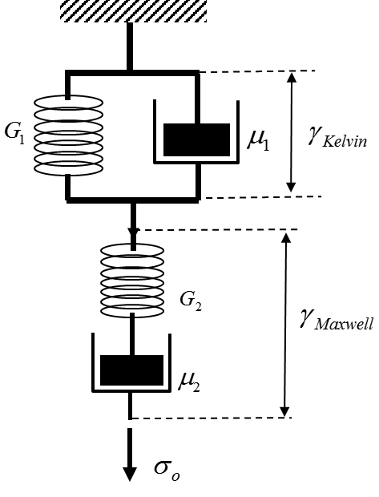

**Problem 3**. During a small strain shear oscillation test in which the frequency is measured in radians/seconds, the shear stress input is given by the following equation:



and the stress output is:



1. Briefly describe stress control and strain control tests? What type of test is the one described above?

2. Based on the results above do you define this fluid as viscoelastic solid or a viscoelastic liquid? Clearly justify your answer.

3. Determine the following rheological parameters for the fluid, , , , G’, G” and G*, the last three parameters calculated at a frequency of 2 rad/sec