









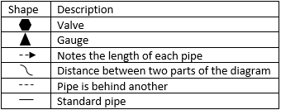



Description of Apparatus:

The lab was completed used a series of piping connected to two centrifugal pumps. Water was allowed to circulate through different paths of piping while the pressure was analyzed for each path. Paths were altered using the valves in the system. Paths differed in length and pipe size which altered the pressure gauge readouts. The configuration can be switched between a single pump, two pumps in parallel, and two pumps in series which will influence the pressure of the water flow.