Agricultural & Biological Engineering

West Lafayette, IN 47907

To: Dr. Abigail Engelberth

From: Kathryn Atherton, Matt Muskat, Alex Smith, Holly Spiritoso

Date: February 12, 2018

Subject: Pump Configuration and Flow Through a Pipe

Processes related to biological materials commonly use pumping-piping systems as a way of transport between machinery and other processing areas. The purpose of a pump is to discharge a pressure that will overcome the pressure of the piping system, in order to allow the fluid to flow at a desired flow rate (Milnes, n.d.). Centrifugal pumps, the type of pumps used in this study, have a rotating impeller that creates a large flow rate and pressure discharge (Geankoplis, 2003). Having the correct pumping-piping system is very important in obtaining high efficiency within these processes, which can be represented with a characteristic curve. Pump configuration is a key factor in making a successful pumping-piping system, due to its effect on the flow rate the pump produces. The configuration of a pump-piping system (single, series, and parallel), in combination with the calculation of pressure drop was studied in this work. Four different piping sizes were used in order to analyze the different pressures of a piping system. Multiple trials of this experiment were completed in order to compare the results with theoretical models to determine the efficiency of a centrifugal pumping-piping system.

The lab was completed using a piping system connected to two centrifugal pumps. Water was allowed to circulate through different paths of piping while the pressure was analyzed for each path. Paths were altered using the valves in the system. First, pump configurations were switched between a single pump, two pumps in series, and two pumps in parallel to manipulate the pressure drop and flow rate and the configuration with the highest flow range was determined and used to look at pressure drop with different pipe diameters. Pipes diameters used were 1”, ¾”, ½” straight, and ½” coiled. Figures 3 and 4 show the design of the flow lab apparatus along with measurements. Figure 3 represents the front view while Figure 4 represents the back side and back overhead view.

The data obtained from varying the pump configurations can be found in Table 1. The single pump configuration pressure drop data was converted to head loss and was plotted against the square of the volumetric flow rate to obtain the pump-specific constants a and b (Figure 5, Appendix A). These values were used to create the theoretical characteristic curves for each pump configuration: single pump (Equation 1), two pumps in series (Equation 2), and two pumps in parallel (Equation 3) (see Appendix D for derivation).

**[1]** Δh = 24.838 - 0.0869Q2  **[2]** Δh = 49.676 - 0.1738Q2 **[3]** Δh = 24.838 - 0.0217Q2

These equations were plotted alongside the raw data in Figure 1 to compare the theoretical and actual characteristic curves.

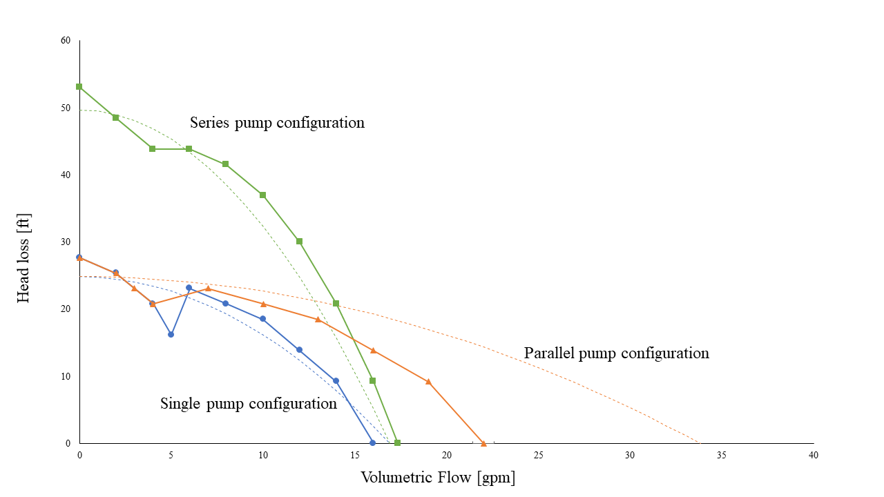

**Figure 1:** Characteristic curves for single (blue), series (green) and parallel (orange) pump configurations. Solid lines show the raw data trends and dotted lines represent the theoretical curves.

While the theoretical curves for the single pump and series pump configurations are relatively accurate when compared with the data, the parallel pump configuration shows that the pumps should be able to produce a much higher maximum flow rate than the data suggests. This may be due to troubles in the system configuration that inhibits the pumps to efficiently receive maximum capacity flow rates. The configuration curves are different due to the management of flow. Two pumps in series cannot increase the maximum flow rate, as only one pump acts on the fluid at a time. However, together, the pumps increase the amount of pressure in the system. Conversely, two pumps in parallel can increase the maximum flow rate because both pumps act on the fluid simultaneously and then combine flows. This configuration cannot increase the pressure in the system as the total flow volume is divided between the two pumps. Pumps in series should be used when the system requires that the fluid be moved a great distance while pumps in parallel should be used when the system requires the fluid be moved at a high flow rate.

As the parallel pump configuration creates the largest range of flow rate, it was chosen as the ideal configuration to test the pressure drop due to friction between various pipe sizes. The data was used to calculate the Reynolds number and the friction factor, and the latter was calculated using both the experimental pressure drop data and constant situational values (e.g. pipe diameter, pipe roughness, Reynolds number). For each pipe diameter, the friction factors and Reynolds numbers were plotted against each other (Figure 2). The differences between Figure 2A and Figure 2B are due to the experimental values used in calculating the friction factor which create more variable error than the constant values used in the Colebrook equation.

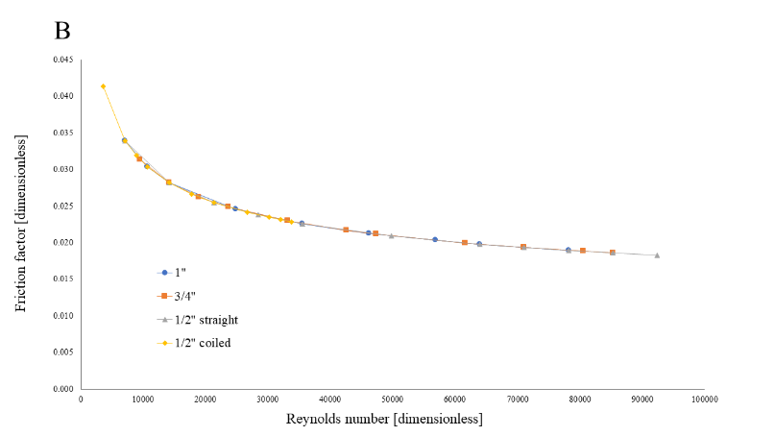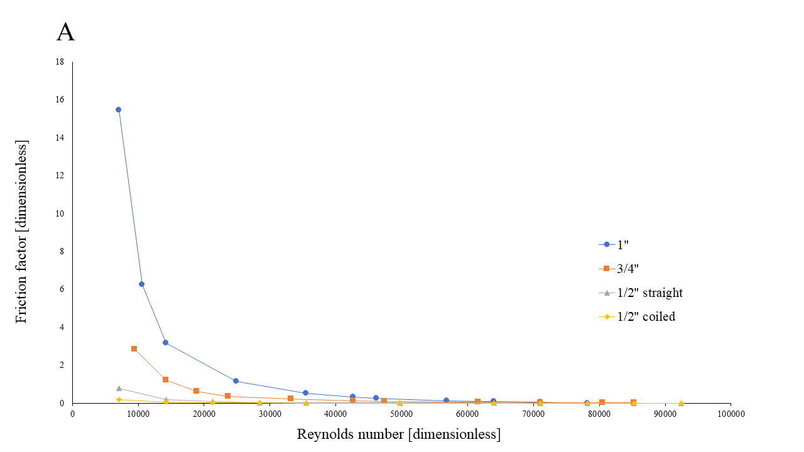

**Figure 2:** Moody diagrams of the friction factor plotted against the Reynolds number. Figure 2A uses the friction factor calculated from experimental data and Figure 2B uses the friction factor calculated from the Colebrook equation. See Appendix A for a semi-log plot of Figure 2A which better displays the friction factor values less than 1.

The data from both parts of the experiment were used to determine the best pump and pipe combination for two given hypothetical situations (Figure 7, Appendix A). As the first requires a high volumetric flow rate of 1300 gallons per hour with a small head loss distance of 5 feet, only the parallel pump configuration would be able to handle this situation. Additionally, when using the Bernoulli equation, a pressure drop between 2.20 and 2.69 psi was calculated for this situation depending on the pipe size. Only the 1” pipe size will allow for a pressure drop this small, according to the experimental data obtained. The second situation requires a low volumetric flow of 260 gallons per hour with a head loss of 13 feet. It was found that a single pump could handle this situation. Using the Bernoulli equation found that a pressure drop between 5.67 and 6.17 psi would occur in this situation. Either the 1” or the 3/4” pipe sizes would allow for this pressure drop, but the 3/4” pipe size is recommended because it has a smaller friction factor and thus produces less friction losses in the system.

This work was intended to find the characteristic curves for single, series, and parallel pump configurations, along with the pressure drop and friction factor of four different pipe sizes. After empirical and theoretical characterizations of pipe configurations, it was found that pumps in series can increase the pressure in the system to pump a fluid over a greater distance, but pumps in series do not increase volumetric flow rate. Pumps in parallel do not increase the pressure, but parallel pumps can move the fluid at an increased flow rate. Single pump configurations have the lowest pressure drop and the lowest maximum volumetric flow rate, but in a system where neither high pressure nor large flow rate is needed, it would be more energy efficient. Pipe diameter effects the frictional losses (the larger the diameter, the greater the frictional loss), but it also decreases flow rate with increasing diameter. In a system where efficiency is favored over flow rate, small pipes would be preferred.

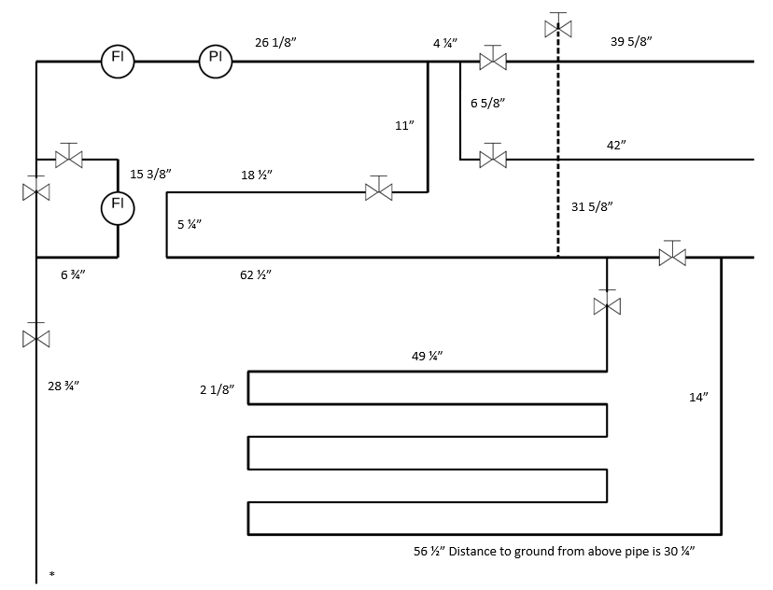**Appendix A: Figures and Tables**

**Figure 3:** Flow apparatus front view with measurements. Dotted lines represent pipes behind other pipes. The asterisk in the bottom left hand corner shows where the pipes in Figure 4 connect to this apparatus.

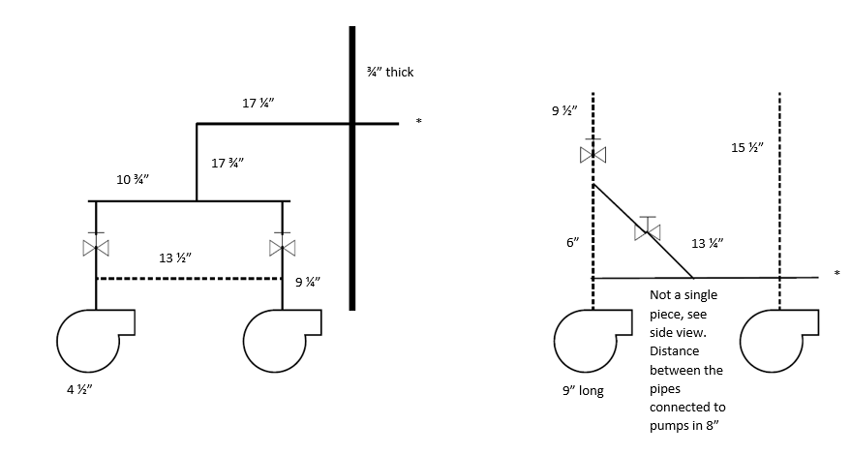

A

B

**Figure 4:** Flow apparatus side view (Figure 4A) and top view (Figure 4B) with measurements. Dotted lines again represent pipes behind other pipes. The asterisks represent where the pipe in Figure 3 connect to this apparatus.

**Table 1:** Volumetric flow and pressure drop data from varying pump configurations. A 1” pipe diameter was used to obtain all values. The asterisked value was used in the sample calculation for converting pressure drop [psi] to head loss [feet].

|  |  |  |  |
| --- | --- | --- | --- |
|  | N measurement | Volumetric Flow [gpm] | Pressure Drop [psi] |
| Single Pump Configuration | 1 | 0 | 12 * |
| 2 | 2 | 11 |
| 3 | 4 | 9 |
| 4 | 5 | 7 |
| 5 | 6 | 10 |
| 6 | 8 | 9 |
| 7 | 10 | 8 |
| 8 | 12 | 6 |
| 9 | 14 | 4 |
| 10 | 16 | 0 |
| Series Pump Configuration | 1 | 0 | 23 |
| 2 | 2 | 21 |
| 3 | 4 | 19 |
| 4 | 6 | 19 |
| 5 | 8 | 18 |
| 6 | 10 | 16 |
| 7 | 12 | 13 |
| 8 | 14 | 9 |
| 9 | 16 | 4 |
| 10 | 17.33 ± 0.57 | 0 |
| Parallel Pump Configuration | 1 | 0 | 12 |
| 2 | 2 | 11 |
| 3 | 3 | 10 |
| 4 | 4 | 9 |
| 5 | 7 | 10 |
| 6 | 10 | 9 |
| 7 | 13 | 8 |
| 8 | 16 | 6 |
| 9 | 19 | 4 |
| 10 | 22 | 0 |

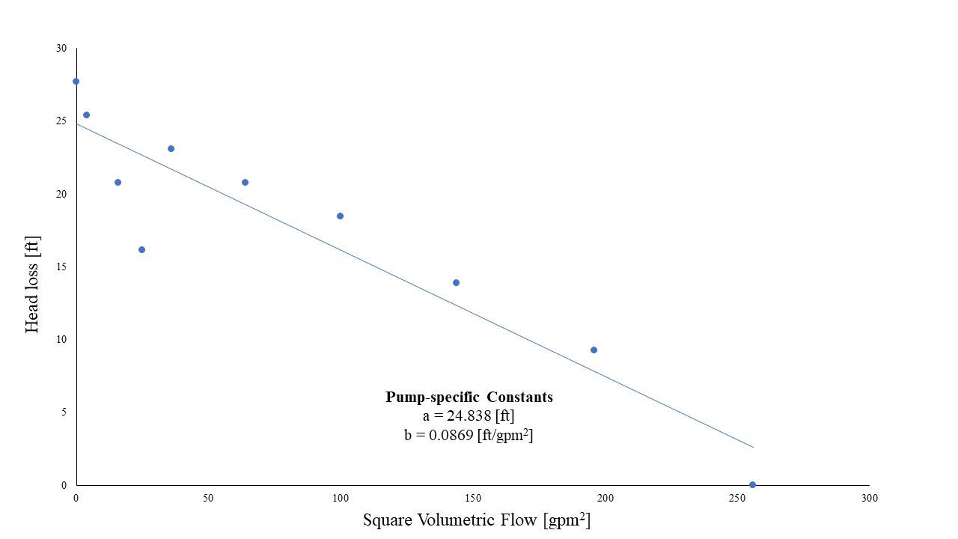

**Figure 5:** Head loss plotted against the square of the volumetric flow to obtain the pump-specific coefficients, a and b. Coefficient a is the y-intercept of the linear trendline and coefficient b is the slope of the line.

**Table 2:** Reynolds number and Darcy friction factor values, calculated with both methods for 1” and ¾” pipe diameters for each volumetric flow rate. The calculation of the asterisked values is shown in the sample calculations in Appendix D.

|  |  |  |  |  |  |
| --- | --- | --- | --- | --- | --- |
|  | **N measurement** | **Volumetric Flow [gpm]** | **Reynolds Number [dimensionless]** | **Darcy Friction Factor from formula [dimensionless]** | **Darcy Friction Factor from Colebrook equation [dimensionless]** |
| 1” Pipes | 1 | 0 | 0 | -- | -- |
| 2 | 2 | 7107 * | 15.433 | 0.034 |
| 3 | 3 | 10660 | 6.235 | 0.030 |
| 4 | 4 | 14214 | 3.157 | 0.028 |
| 5 | 7 | 24874 | 1.145 | 0.025 |
| 6 | 10 | 35534 | 0.505 | 0.023 |
| 7 | 12 | 42641 | 0.331 | 0.022 |
| 8 | 13 | 46195 | 0.266 | 0.021 |
| 9 | 16 | 56855 | 0.132 | 0.020 |
| 10 | 18 | 63962 | 0.087 | 0.020 |
| 11 | 20 | 71069 | 0.042 | 0.019 |
| 12 | 22 | 78176 | 0 | 0 |
| ¾” Pipes | 1 | 0 | 0 | -- | -- |
| 2 | 2 | 9476 | 2.849 | 0.031 |
| 3 | 3 | 14214 | 1.206 | 0.028 |
| 4 | 4 | 18952 | 0.610 | 0.026 |
| 5 | 5 | 23690 | 0.347 | 0.025 |
| 6 | 7 | 33165 | 0.221 | 0.023 |
| 7 | 9 | 42641 | 0.121 | 0.022 |
| 8 | 10 | 47379 | 0.098 | 0.021 |
| 9 | 13 | 61593 | 0.051 | 0.020 |
| 10 | 15 | 71069 | 0.031 | 0.019 |
| 11 | 17 | 80544 | 0.019 | 0.019 |
| 12 | 18 | 85282 | 0.013 | 0.019 |

**Table 3:** Reynolds number and Darcy friction factor values, calculated with both methods for ½” straight and coiled pipes for each volumetric flow rate

|  |  |  |  |  |  |
| --- | --- | --- | --- | --- | --- |
|  | **N measurement** | **Volumetric Flow [gpm]** | **Reynolds Number [dimensionless]** | **Darcy Friction Factor from formula [dimensionless]** | **Darcy Friction Factor from Colebrook Equation [dimensionless]** |
| ½” Straight Pipes | 1 | 0 | 0 | -- | -- |
| 2 | 1 | 7107 | 0.786 | 0.034 |
| 3 | 2 | 14214 | 0.179 | 0.028 |
| 4 | 3 | 21321 | 0.079 | 0.025 |
| 5 | 4 | 28427 | 0.040 | 0.024 |
| 6 | 5 | 35534 | 0.023 | 0.023 |
| 7 | 7 | 49748 | 0.015 | 0.021 |
| 8 | 9 | 63962 | 0.009 | 0.020 |
| 9 | 10 | 71069 | 0.006 | 0.019 |
| 10 | 11 | 78176 | 0.005 | 0.019 |
| 11 | 12 | 85282 | 0.004 | 0.019 |
| 12 | 13 | 92389 | 0.003 | 0.018 |
| ½” Coiled Pipes | 1 | 0 | 0 | -- | -- |
| 2 | 0.5 | 3553 | 0.712 | 0.041 |
| 3 | 1 | 7107 | 0.162 | 0.034 |
| 4 | 1.25 | 8884 | 0.104 | 0.032 |
| 5 | 1.5 | 10660 | 0.065 | 0.030 |
| 6 | 2 | 14214 | 0.032 | 0.028 |
| 7 | 2.5 | 17767 | 0.026 | 0.027 |
| 8 | 3 | 21321 | 0.018 | 0.025 |
| 9 | 3.75 | 26651 | 0.010 | 0.024 |
| 10 | 4.25 | 30204 | 0.008 | 0.023 |
| 11 | 4.5 | 31981 | 0.007 | 0.023 |
| 12 | 4.75 | 33758 | 0.006 | 0.023 |

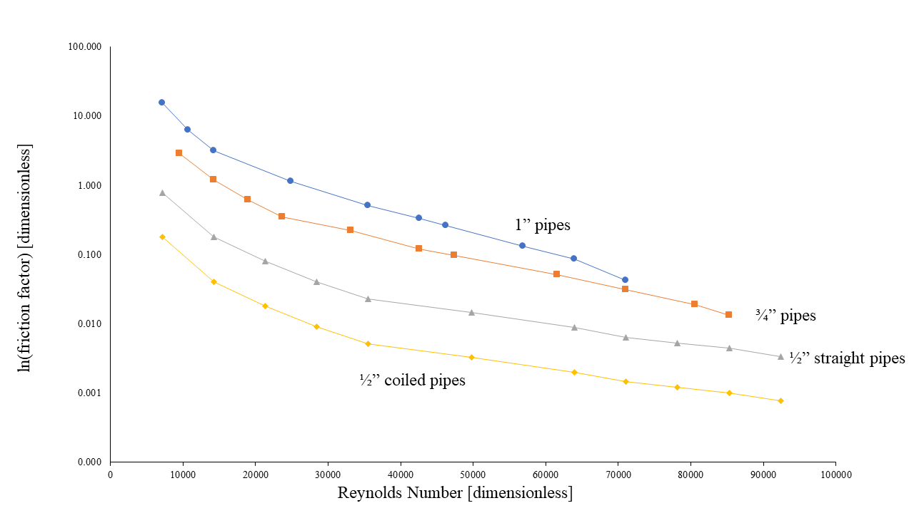

**Figure 6:** A semi-log plot of Figure 2A in order to more easily see the variation in the data points at smaller values as experimental error caused very large friction factors to be calculated.

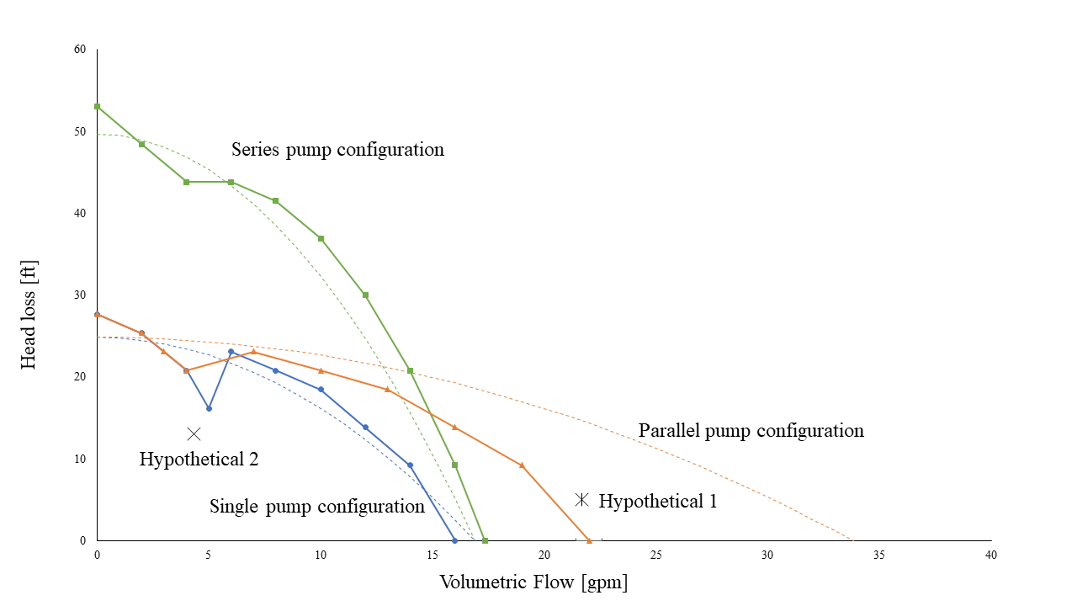

**Figure 7:** The hypothetical situations plotted with the data to visually see which pump configuration is most appropriate for each.

**Appendix B: Nomenclature**

|  |  |  |
| --- | --- | --- |
| Δh | Head Loss | [ft] |
| Q | Flow Rate | [gpm] |
| P | Pressure | [psi, Pa] |
| ρ | Density | [kg/m3] |
| v | Velocity | [m/s] |
| g | Gravitational Constant | [m/s2] |
| z | Height of Fluid | [m] |
| a | Constant specific to pump | [ft] |
| b | Constant specific to pump | [ft/(gpm)2] |
| n | Number of Pumps in Configuration | [count] |
| f | Friction Factor | [dimensionless] |
| Re | Reynolds Number | [dimensionless] |
| μ | Viscosity | [Pa.s] |
| ϵ | Relative Roughness | [dimensionless] |
| D | Diameter | [m] |

**Appendix C: References**

Geankoplis, C. (2010). Transport Processes and Separation Process Principles. Upper Saddle

River, NJ: Prentice Hall, pg 147.

Milnes, Mathew. “The Mathematics of Pumping Water”. *The Royal Academy of Engineering*,

pg 1. <https://www.raeng.org.uk/publications/other/17-pumping-water>. February 2, 2018.

**Appendix D: Sample Calculations**

