Final Report

EFFECT OF TEMPERATURE AND AGITATION SPEED IN MIXING AND HEAT TRANSFER SYSTEMS

Kathryn Atherton

Matt Muskat

Alex Smith

Holly Spiritoso

Bioprocess Engineering Laboratory

Agricultural & Biological Engineering

West Lafayette, IN 47906

February 21, 2018

***Summary***

It is very common in industries to use the technique of agitation to mix a fluid to ensure that a solution is homogeneous in content and temperature. The effect of agitation speed and the heat transfer coefficient on a system mixing a 0.5% xanthan gum solution was analyzed in a Hamilton-kettle agitated vessel. Ten gallons of the xanthan gum solution was poured into the vessel, and the agitation speed was set using a tachometer, and the power consumption was measured with a power meter. Five trials were conducted at different agitation speeds (19.2 rpm, 33.3 rpm, 44.2 rpm, 56 rpm, and 61.2 rpm). At a pressure of 20 psi, a flow of steam was opened into the system, which increased the temperature of the solution being mixed. The times required for the system to reach 40°C, 50°C, 60°C, 70°C, and 80°C was recorded and afterward the steam valve was closed. The xanthan gum solution was then released from the system into buckets and cooled in a water bath for use in future trials. Fresh batches were used for three of the five trials while the other two trials used a mix of old batches that had been partially cooled below 30°C and cold, fresh batches to finish the cooling process of the old bathces.

From the given rheological data set, it was determined that the 0.5% xanthan gum solution is a non-Newtonian, shear-thinning fluid, which was confirmed by the correlation between the apparent viscosity and temperature experimental data. The relationship between power consumption and apparent viscosity was compared with data from literature, which confirmed that the data obtained is reasonable for the anchor paddle impeller type used in the Hamilton-kettle. The relationship between mixing time and agitation speed showed that as agitation speed and temperature increase, the mixing time decreases. A dimensionless analysis was performed to create a relationship between impeller agitation speed and the heat transfer coefficient of the xanthan gum solution. Error in the relationship between agitation speed and the heat transfer coefficient was created by using different batches of possibly varying xanthan gum concentration and volume between trials.

***Introduction***

Processing industries, such as chemical and biological industries, use the technique of agitation to process fluids. Agitation is used to force a fluid in a circular motion to ensure that it is effectively mixed (Geankoplis, 2010). There are multiple equipment variations that can be used for agitation, and that which was selected was a Hamilton-kettle agitated vessel. An important part of an agitation vessel is the jacket, which can aid in heating or cooling the product being mixed with the use of steam or a cooling agent. Heating or cooling a fluid while it is agitated is very common in producing a product, making the jacket a valuable resource. A solution of 0.5% xanthan gum, which is a non-Newtonian fluid, was the fluid that was mixed using agitation in the Hamilton-kettle agitated vessel. The agitation speed of the vessel was varied to determine the correlation between the agitation speed and the heat transfer coefficient of the jacket when mixing. To successfully analyze the relationship between agitation speed and the heat transfer coefficient, the effects of the power consumption, mixing time, and rheology of the fluid were also considered. It is important to study these factors to ensure that the agitation process is running efficiently, to maximize the production and output of the system.

***Theory/Basic Principles***

Shear stress is external force acting on an object or surface parallel to the slope or plane in which it lies. It is usually measured with force applied to the object divided by unit area. In this experiment, force was applied by the rotating agitator. Shear rate is the rate of change of velocity at which one layer of fluid passes over an adjacent layer. In this case, the inner layer of the xanthan gum solution was rotating with the agitator while the outer layer of the solution near the wall of the fixed kettle was relatively stable. Newtonian fluids have shear stress values proportional to shear rate and are unrealistic in biological and food products. The xanthan gum solution was a non-Newtonian fluid with a shear thinning behavior. The relationship between shear rate and shear stress of the xanthan gum solution follows a power law equation below:

**τ** = K(𝜸)n [1]

The value of n will be less than one for a shear thinning fluid, equal to one for a Newtonian fluid and more than one for a shear thickening fluid. Because the viscosity of the xanthan gum solution decreases while the shear rate increases, the average apparent viscosity can be calculated using the equation:

μapp = K(𝜸ave)n-1 [2]

A shear rate coefficient is a proportional relationship between shear rate and rotational speed of an impeller or agitator. This experiment uses Ks = 11 in the equation below:

𝜸ave = 11N [3]

For determining the apparent viscosity of a non-Newtonian fluid, the equation relating average shear rate to impeller speed is applied to shear thinning fluids with a shear rate coefficient.

μapp = K(11N)n-1 [4]

For non-Newtonian fluids, such as the xanthan gum solution, viscosity of the fluid varies with shear rate. The impeller Reynold’s number of this experiment can be found by using the diameter of the agitator impeller, density of the fluid and the average apparent viscosity of the fluid.

N’Re,n = Da2N𝛒/μapp  [5]

Another important factor to be considered is the power number. Because the impeller was run by electricity, had different fluid properties, impeller rotational speed, and geometry, it affected the power number. The relationship between different rotational speeds and power consumptions were measured and analyzed in this experiment. Power number is a dimensionless number relating the resistance force to the inertia force. It can be calculated by dividing power with the product of fluid density, rotational speed and diameter of the impeller.

NP = P / (𝛒N3Da5) [6]

Mixing time is the time for a heterogeneous material to transform into homogenous in the mixing process. It is an important parameter when evaluating the mixing efficiency of the mixing device. In this experiment, the dimensionless mixing factor was determined by the Reynold’s number for non-Newtonian fluids using the chart, the correlation of mixing time for miscible liquids using a turbine in a baffled tank (Geankoplis, 2010). Mixing time can be calculated by the dimensionless mixing factor, rotational speed, diameter of the impeller, diameter of the vessel, standard gravity, and height of the solution contained in the vessel.

Ft = tT *(NDa)2/3g1/6Da1/2/(H1/2 Dt3/2) [7]

In the experiment, the kettle heated the xanthan gum solution by releasing steam into the vessel. Temperature of the steam can be found from the steam table with known pressure values. The convective heat transfer from steam to the xanthan gum solution by temperature differences was equal to the heat generated in the solution. The convective heat transfer can be calculated by the overall heat transfer and area of the vessel. The heat generated of the xanthan gum solution was figured by the mass, heat capacity and temperature change. To simplify the calculation, the vessel area was assumed to be a perfect half sphere. The relationship between ln[(Ts-To)/(Ts-Tf)] and time can be found by equating and integrating Equation 8 and Equation 9. After plotting ln[(Ts-To)/(Ts-Tf)] and time, the overall heat transfer is  
obtained from the slope.

Qin = UA(Tsteam- Tf) [8]

Qgen = mCP ∂T/∂t [9]

m = V𝛒 [10]

Heat transfer in this experiment was separated into the convection of steam, conduction of wall and the convection of the xanthan gum solution as Equation 11 showing below. Since the stainless-steel agitator was thin and had high heat transfer efficiency, the thickness of the agitator wall was assumed to be zero. The area of steam and the xanthan gum solution was assumed to be equal. Therefore, the heat transfer coefficient of the xanthan gum solution could be calculated.

1/ (UA) = R1+R2+R3= 1/(h0A0) + Δx / (KAw) + 1 / (hiAi) [11]

In the equations listed below, c and d are assumed to be ⅓ and 0.21. After plotting the data of heat transfer coefficient and rotational speed, a power law relationship between heat transfer coefficient and rotational speed was found. The value of coefficients a and b could be calculated from the power law equation.

Nu = a * Reb * Prc * Vid [12]

Nu = hD/k [13]

Re = D2N𝛒/μ [14]

Pr = Cpμ/k [15]

Vi = μ/μ0  [16]

***Experimental***

A ten-gallon pre-made 0.5% xanthan gum solution was first poured into a Hamilton-kettle agitated vessel (Figure 1, Appendix A). A tachometer was used to measure the agitation speed and set the agitator as close as possible to the desired value (19.2 rpm, 33.3 rpm, 44.2 rpm, 56 rpm, and 61.2 rpm) and the actual value was recorded. The system steam valve was then opened such that steam flowed into the system at a pressure of 20 psi. The power consumption of the agitated vessel was measured with a power meter and the value recorded. As the steam increased the temperature of the solution, the vessel’s built-in thermometer was monitored. Once the temperature of the xanthan gum solution reached 30°C, a timer was started and the time it took for the system to reach 40°C, 50°C, 60°C, 70°C, and 80°C was recorded. At 80°C, the steam valve was closed and the built-up steam was purged from the system. The xanthan gum solution was continually stirred to cool it down below 80°C so that it could be drained from the kettle into a holding bucket. The kettle was then filled halfway with room-temperature water which was also continually stirred to cool the vessel down below 30°C. Meanwhile, the hot xanthan gum solution was cooled in a water bath and manually stirred with a whisk to also cool it down below 30°C so that it could be used in a future trial. Once the vessel was cooled, the water was released and allowed to flow down the floor drain. For trials 2 and 3, a fresh batch of xanthan gum solution was used and in the following trials, half of a fresh batch was mixed with half of a batch used in an earlier trial in order to more quickly cool the old batches for use.

***Presentation and Discussion of Results***

From the given rheological data set, the shear stress was plotted against the shear rate to find the rheological coefficients at each temperature, 25°C, 30°C, 40°C, 50°C, 60°C, 70°C, and 80°C (see Appendix A, Figures 2 - 8). The flow consistency index is determined by the constant that the shear rate is multiplied by in the power regression equation and the power law index is determined by the exponent of the shear rate. The arcing, concave down shapes of the data trends show that the 0.5% xanthan gum solution is a non-Newtonian, shear-thinning fluid.

With the rheological constants found, the average apparent viscosity at each temperature was calculated using Equation 2 (Geankoplis, 2010). By graphing apparent viscosity vs. temperature at each agitation speed, it is obvious that the apparent viscosity of the xanthan gum solution decreases as temperature and agitation speed increase, which is consistent with the finding that the solution is a shear-thinning fluid (see Appendix A, Figure 9).

Using the apparent viscosity found at 30°C, the impeller Reynolds number was calculated with Equation 5 at each agitation speed (See Appendix A, Table 1) (Geankoplis, 2010). The average power consumption was then used to calculate the power number with Equation 6 (Geankoplis, 2010). The power number was plotted against the Reynolds number (Appendix A, Figure 10). Comparing the experimental curve with those from literature, it appears most like that of a propeller-type agitator (Rushton et. al., 1950). The actual agitator type is an anchor paddle; when comparing the experimental curve with an anchor paddle curve from literature, the curve shapes do appear similar, so it is reasonable to say that the experimental data makes sense (Furukawa et. al, 2012).

Approximate mixing factors were obtained from a graph of mixing factor against Reynolds number from literature at 30°C and 80°C for each agitation speed (Geankoplis, 2010). These values were used to calculate mixing time from Equation 7. By graphing the mixing time against the agitation speed for both temperatures, it can be seen that as agitation speed and temperature increase, the mixing time decreases (Appendix A, Figure 11).

Using Equations 8 and 9, the relationship between temperature, time and the overall heat transfer coefficient was derived and the experimental temperature and time data was plotted for each agitation speed. The slope of Figure 12 (Appendix A) was used to determine the overall heat transfer coefficient in each situation using Equation 17. Assuming the areas of the steam film and xanthan film was equal, the thickness of the agitated vessel is negligible, and the heat transfer coefficient of the steam is 1000 W/m2°C, the heat transfer coefficient of the xanthan solution was calculated for each agitation speed with Equation 12 (Overall Heat Transfer Coefficient, n.d.).

U = dln[(Ts-To)/(Ts-Tf)]/dt * 𝛒VCp/A [17]

A dimensionless analysis was then performed with the Nusselt number, the Reynolds number, the Prandtl number, and the viscosity index. The Nusselt number was plotted against the product of the other three dimensionless numbers to obtain the a and b coefficients for Equation 13; a was determined to be 0.370 and b was determined to be 8.826 (Figure 13, Appendix A). The value of a came from the slope of Figure 13 (Appendix A) and the value of b was calculated by dividing the intercept of Figure 13 by the Prandtl number raised to 0.33 and the viscosity index, which was interpolated at 75°C, raised to 0.21. Values from literature indicate that coefficient a is typically around 0.36 for heating inside a vessel with an anchor-type impeller and coefficient b is typically 0.67 for heating inside the vessel (Pietranski, 2012). One possible reason for this error is the use of fresh batches of solution between different agitation speed trials, leading to different volumes and xanthan gum concentrations and thus different heat transfer responses.

***Conclusions and Recommendations***

With the data collected by varying the agitation speed of the Hamilton-Kettle agitated vessel while heating a 0.5% xanthan gum solution, it was determined that the viscosity of the solution decreases with increases in agitation speed and temperature. This means that the xanthan gum solution is shear thinning. The relationship between power consumed and agitation speed was consistent with the vessel impeller type when compared with relationships found in literature. Finally, a dimensionless function composed of the Nusselt number, Reynolds number, Prandtl number, and viscosity index was developed to predict the heat transfer coefficient from the agitation speed. As the Nusselt number is a function of the heat transfer coefficient and the Reynolds number is a function of the agitation speed, the developed function fulfills this correlation. A potential source of error was the use of various batches which could have had varying volumes and xanthan gum concentrations. This variation from trial to trial may have affected the heat transfer properties of the xanthan gum solution.

***Nomenclature***

Symbol Meaning Units

A area [m2]

Cp specific heat capacity [J/K]

Da impeller diameter [m]

Dt vessel diameter [m]

Ft dimensionless mixing factor dimensionless

g specific gravity [kg/m3]

H height of the solution [m]

h heat transfer coefficient [W/m2K]

K consistency index [Pa.sn]

Ks shear rate coefficient dimensionless

m mass [kg]

n flow behavior index dimensionless

N rotational speed [rps]

Np power number dimensionless

N’Re,n Reynold’s number dimensionless

P power [W]

Pr Prandtl number dimensionless

Qgen heat generated [J]

Qin convective heat transfer [J]

Ri radius [m]

T0 initial temperature [K]

Tf final temperature [K]

Tsteam steam temperature [K]

tT mixing time [s]

U overall heat transfer [W/K·m2]

V volume [m3]

ΔT temperature change dimensionless

Δx thickness of agitator wall [m]

𝜸 shear rate [s-1]

𝜸ave average shear rate [s-1]

μapp average apparent viscosity [kg/m·s]

𝛒 density [mg/mL]

**τ** shear stress [Pa]

***Appendices***

**Appendix A: Figures and Tables**

**A**

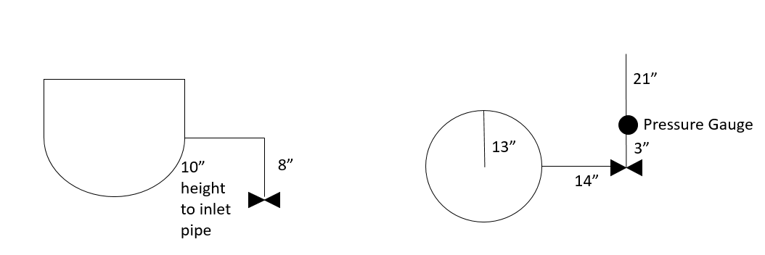

**B**

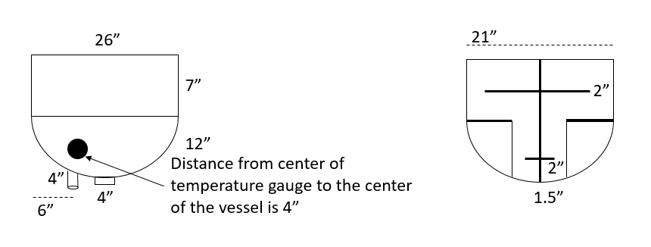

**C**

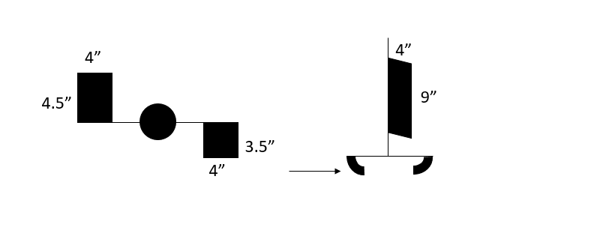

**Figure 1:** Schematic of Hamilton-Kettle agitated vessel. Figure 1A shows the schematic of the entire system, including the steam inlet, Figure 1B shows the inner geometry of the vessel, and Figure 1C shows the shape of the anchor paddle impeller.

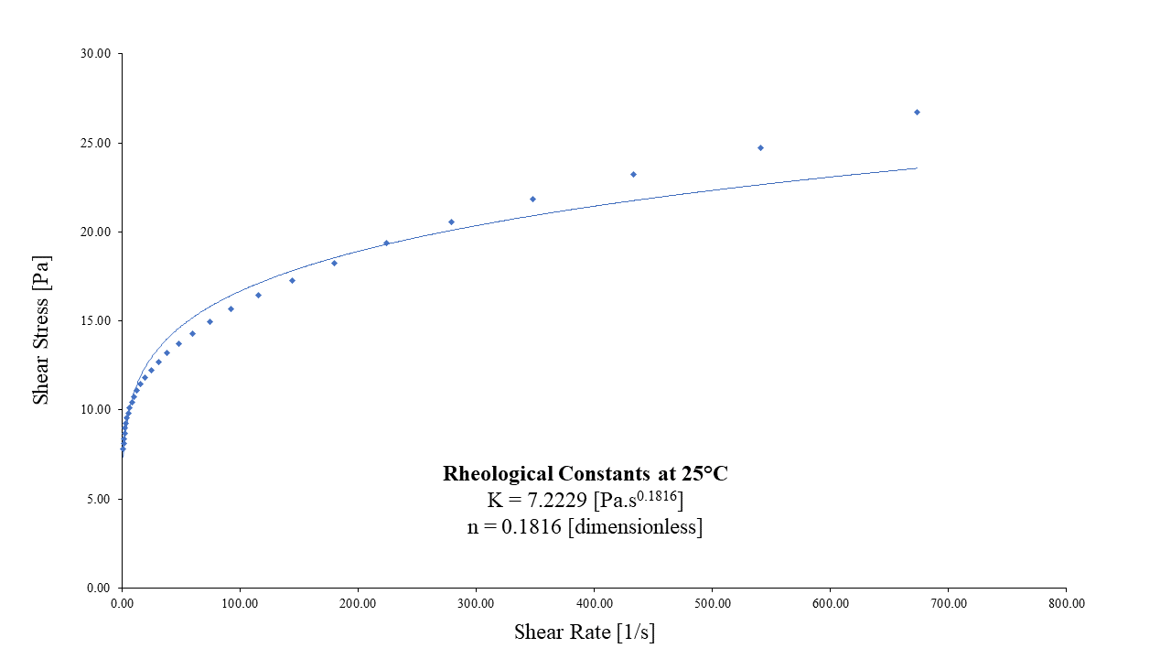

**Figure 2:** Plot of rheological data at 25°C. The shear stress was graphed against the shear rate. From the power regression line, the constants K and n were found.

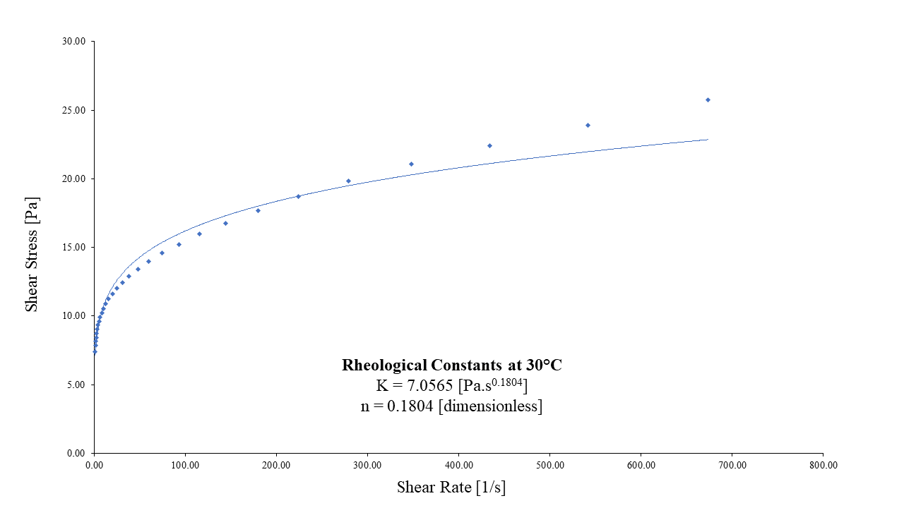

**Figure 3:** Plot of rheological data at 30°C. The shear stress was graphed against the shear rate. From the power regression line, the constants K and n were found.

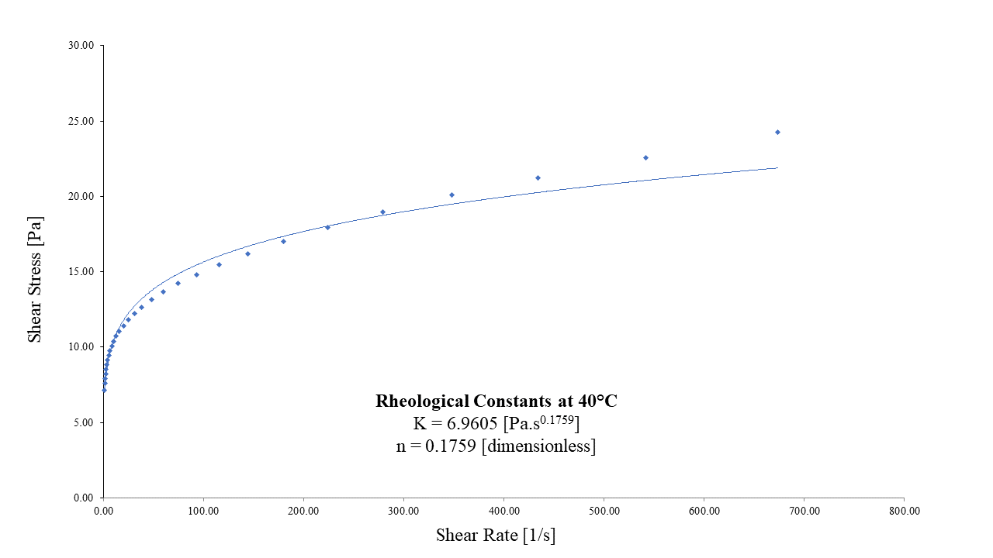

**Figure 4:** Plot of rheological data at 40°C. The shear stress was graphed against the shear rate. From the power regression line, the constants K and n were found.

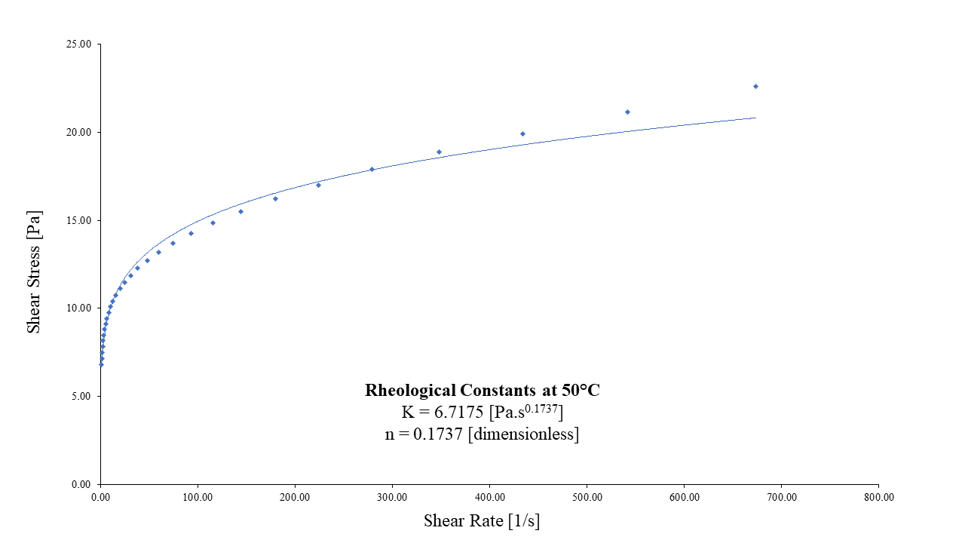**Figure 5:** Plot of rheological data at 50°C. The shear stress was graphed against the shear rate. From the power regression line, the constants K and n were found.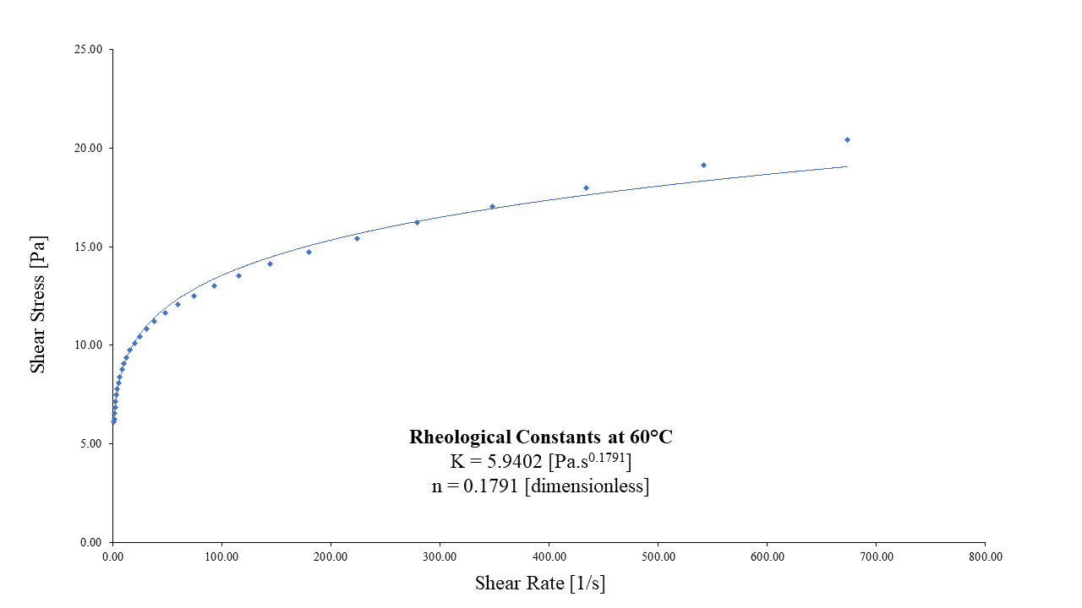**Figure 6:** Plot of rheological data at 60°C. The shear stress was graphed against the shear rate. From the power regression line, the constants K and n were found.

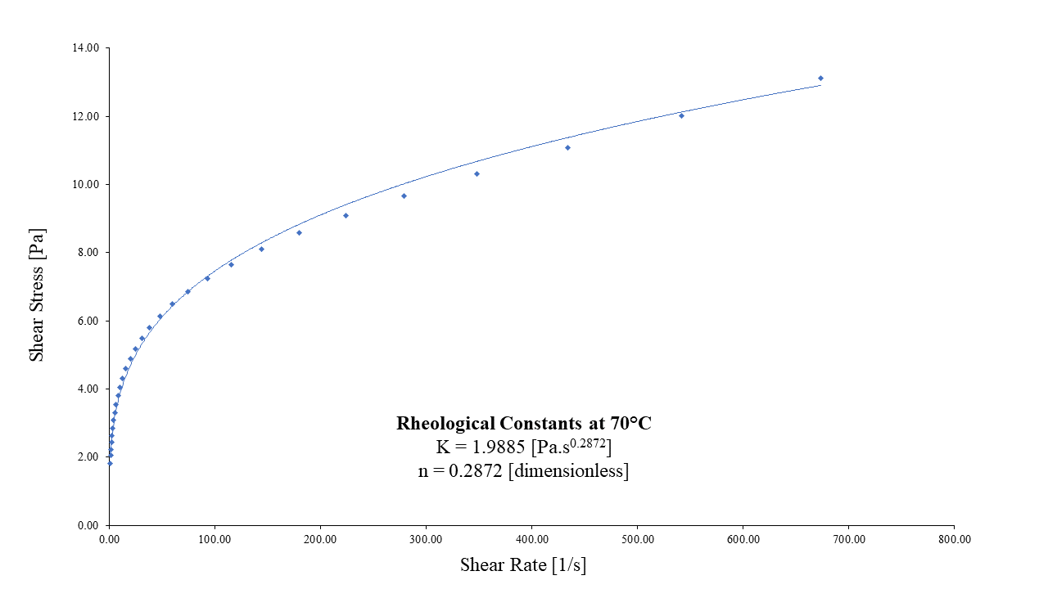

**Figure 7:** Plot of rheological data at 70°C. The shear stress was graphed against the shear rate. From the power regression line, the constants K and n were found.

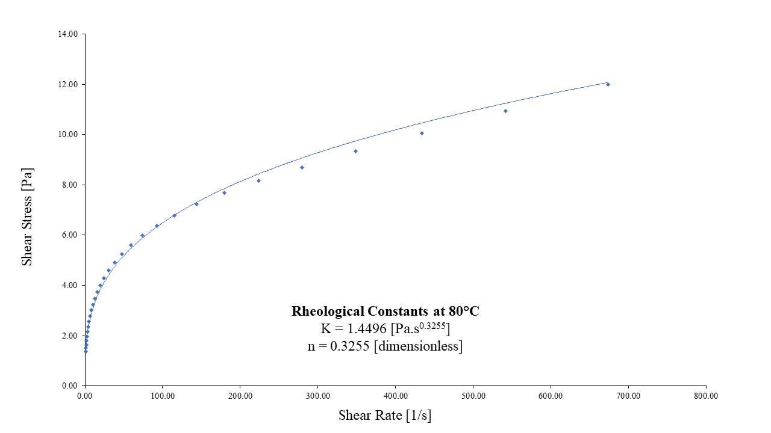 **Figure 8:** Plot of rheological data at 70°C. The shear stress was graphed against the shear rate. From the power regression line, the constants K and n were found.

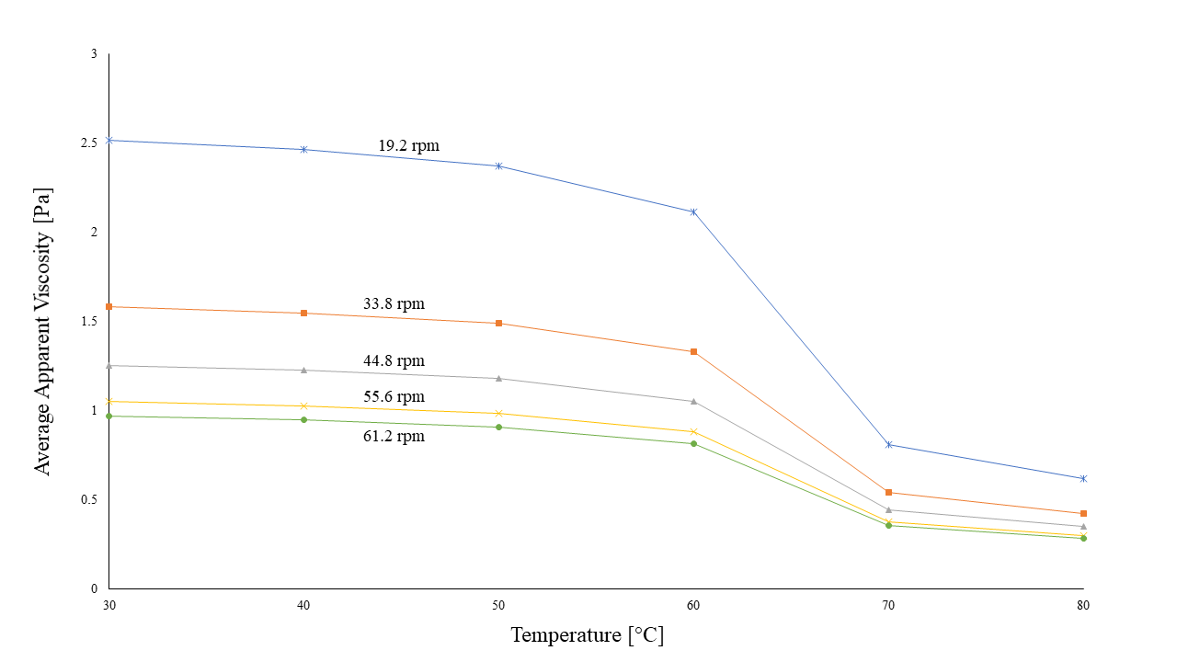

**Figure 9:** Plot of apparent viscosity vs. Temperature for each agitation speed.

**Table 1:** Agitation speeds and Reynolds numbers calculated from apparent viscosity.

|  |  |
| --- | --- |
| Agitation Speed [rpm] | Reynolds Number [dimensionless] |
| 19.2 | 38.00 |
| 33.8 | 106.16 |
| 44.8 | 177.33 |
| 55.6 | 263.05 |
| 61.2 | 312.93 |

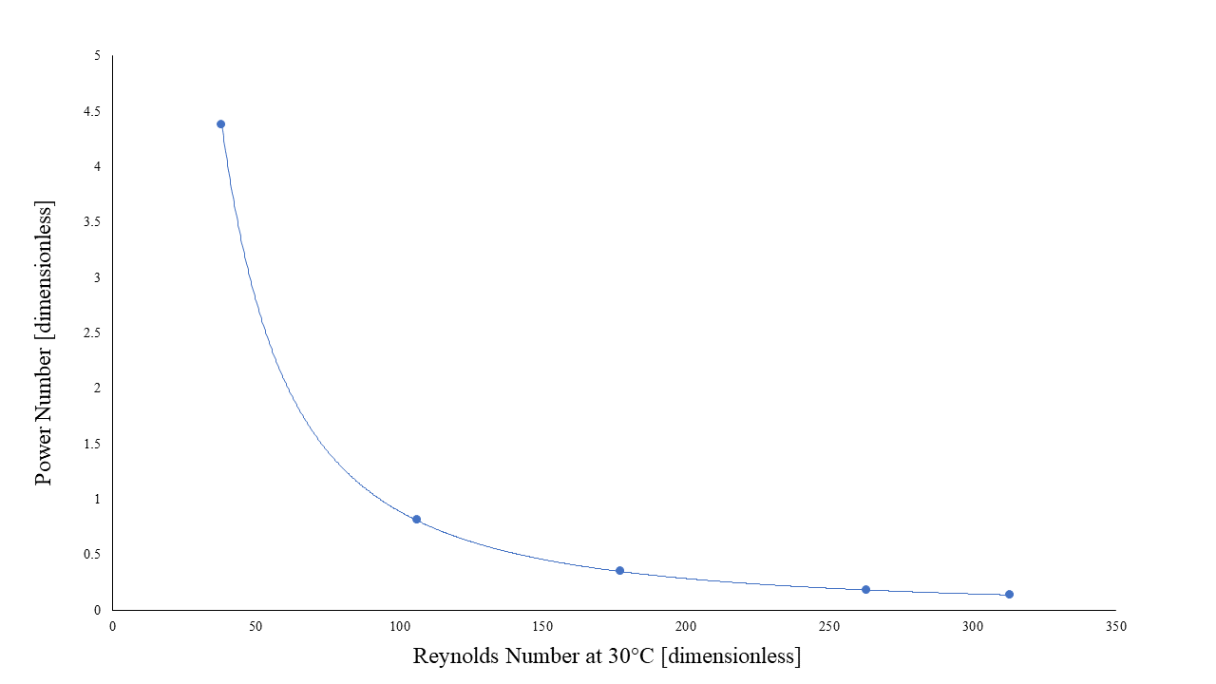 **Figure 10:** Plot of Power number vs. Reynolds number at 30°C.

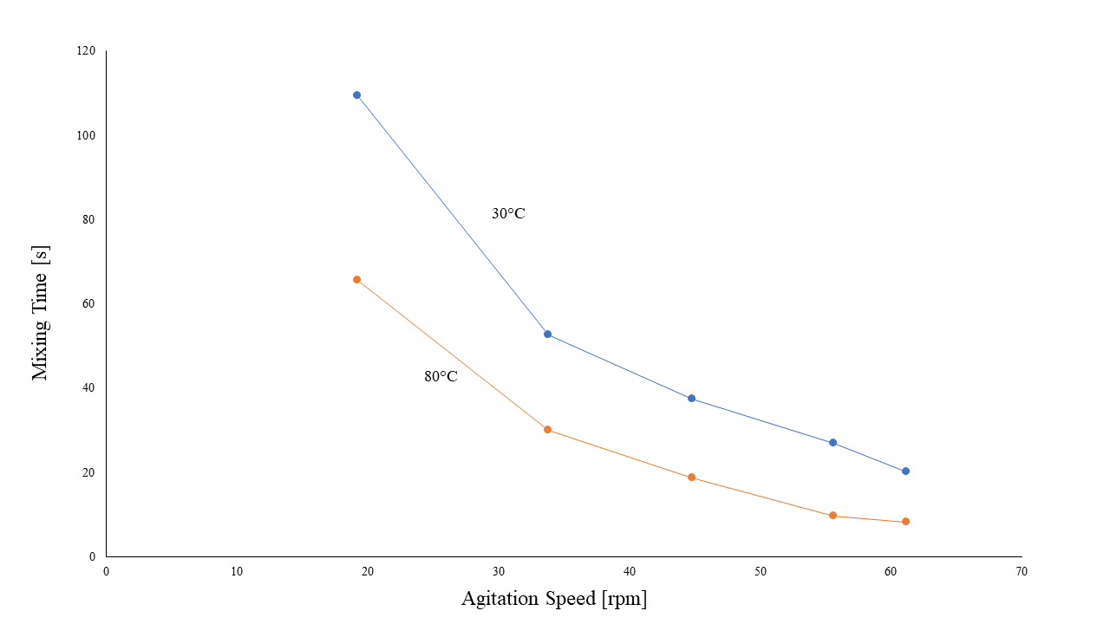

**Figure 11:** Plot of mixing time vs. agitation speed at 30°C and 80°C.

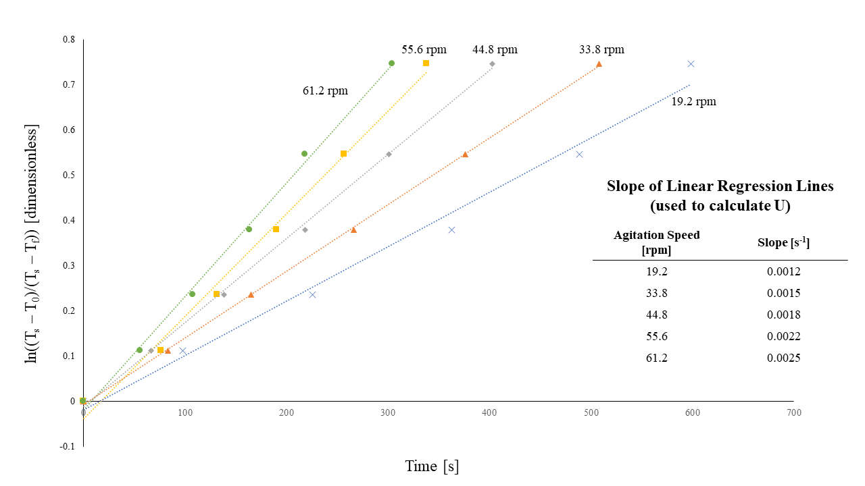

**Figure 12:** Plot of the natural log of the difference in temperature between the steam and the initial temperature over the difference in temperature between the steam and the final temperature against time at each agitation speed.

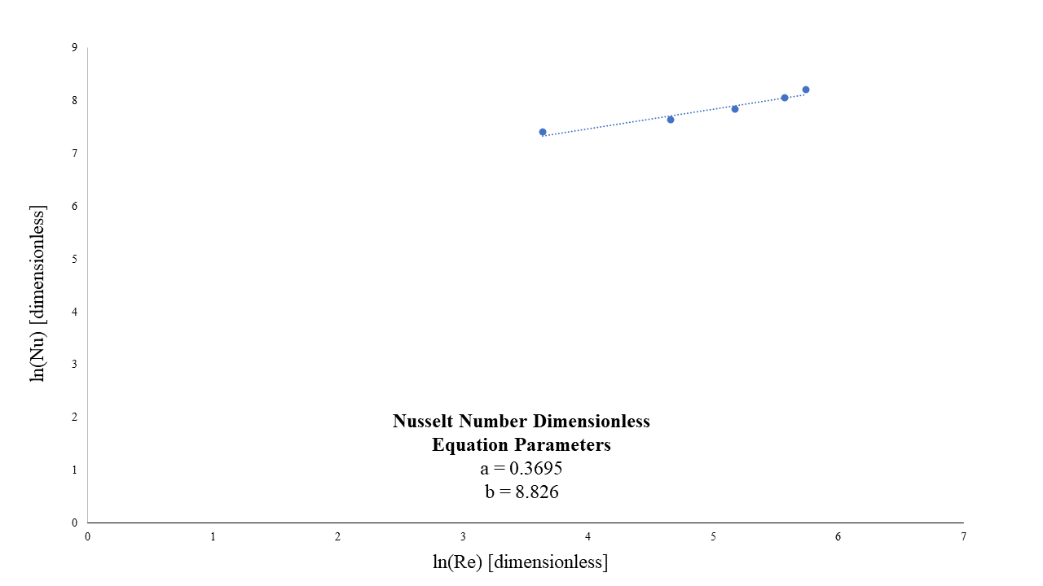

**Figure 13:** Plot of the natural log of the Nusselt number vs. the natural log of the Reynolds number.

**Appendix B: Sample Calculations**

**Appendix C: References**

Bates, R. L., Fondy, P. L., & Corpstein, R. R. (1963). Examination of some geometric parameters of impeller power. *Industrial & Engineering Chemistry Process Design and Development*.

Furukawa, H., Kato, Y., Inoue, Y., Kato, T., Tada, Y., & Hashimoto, S. (2012). Correlation of power consumption for several kinds of mixing impellers. *International Journal of Chemical Engineering*.

Geankoplis, C. (2010). Transport Processes and Separation Process Principles. Upper Saddle

River, NJ: Prentice Hall.

Overall Heat Transfer Coefficient. (n.d.). Retrieved February 21, 2018, from https://www.tlv.com/global/TI/steam-theory/overall-heat-transfer-coefficient.html

Pietranski, J. F., P.E., Ph.D. (2012). Over-all Heat Transfer Coefficients in Agitated Vessels. Retrieved from https://pdhonline.com/courses/k102/k102content.pdf