**Class Activity 1**

1. Horizontal and Vertical Components of Planar Forces

Problem: Determine the x and y components of the forces shown below

[insert picture of the forces and shit]

F1 = 58 kN

sin(30°) = F1y / 58 kN

F1y = 58 kN * sin(30°) = 29 kN

cos(30°) = F1x / 58 kN

F1x = 58 kN * cos(30°) = 50.23 kN

F2 = 50 kN

sin(45°) = -F2x / 50 kN = F2y / 50 kN

-F2x = F2y = 50 kN * sin(45°) = 35.36 kN

F3 = 45 kN

tan(Θ) = 12/5

52 + 122 = x2

25 + 144 = x2

X = 13

-F3x = 45 kN * 5 / 13 = 17.31 kN

-F3y = 45 kN * 12 / 13 = 41.54 kN

F4 = 40 kN

F4x = 40 kN

F4y = 0 kN

1. Components of 3D Forces

Problem: Find the x, y, and z components of the given force. Also, find the angle that the force makes with the y axis. A = 50 kN

FAx = cos(40°) * 50 kN * sin(30°) = 19.15 kN

FAy = sin(40°) * 50 kN * sin(30°) = 16.07 kN

FAz = cos(30°) * 50 kN = 43.30 kN

Fxy = 50 kN * sin(30°) = 25 kN

cos(Θy) = sin(40°) * sin(30°)

Θy = 60°

**Fluid Statics**

**General Formulation of the Linear Momentum Principle**

Fluid statics deals with fluid at rest and the linear momentum principle will be used to develop equations for studying fluid behavior at rest.

Linear momentum principle: This principle states that rate of change of momentum = sum of forces acting on the body

Body (in continuum fluid mechanics) refers to some material volume within the fluid which can be of any arbitrary shape. Consider a differential volume of dV of a fluid with arbitrary shape as shown in the figure below.

“Control volume”

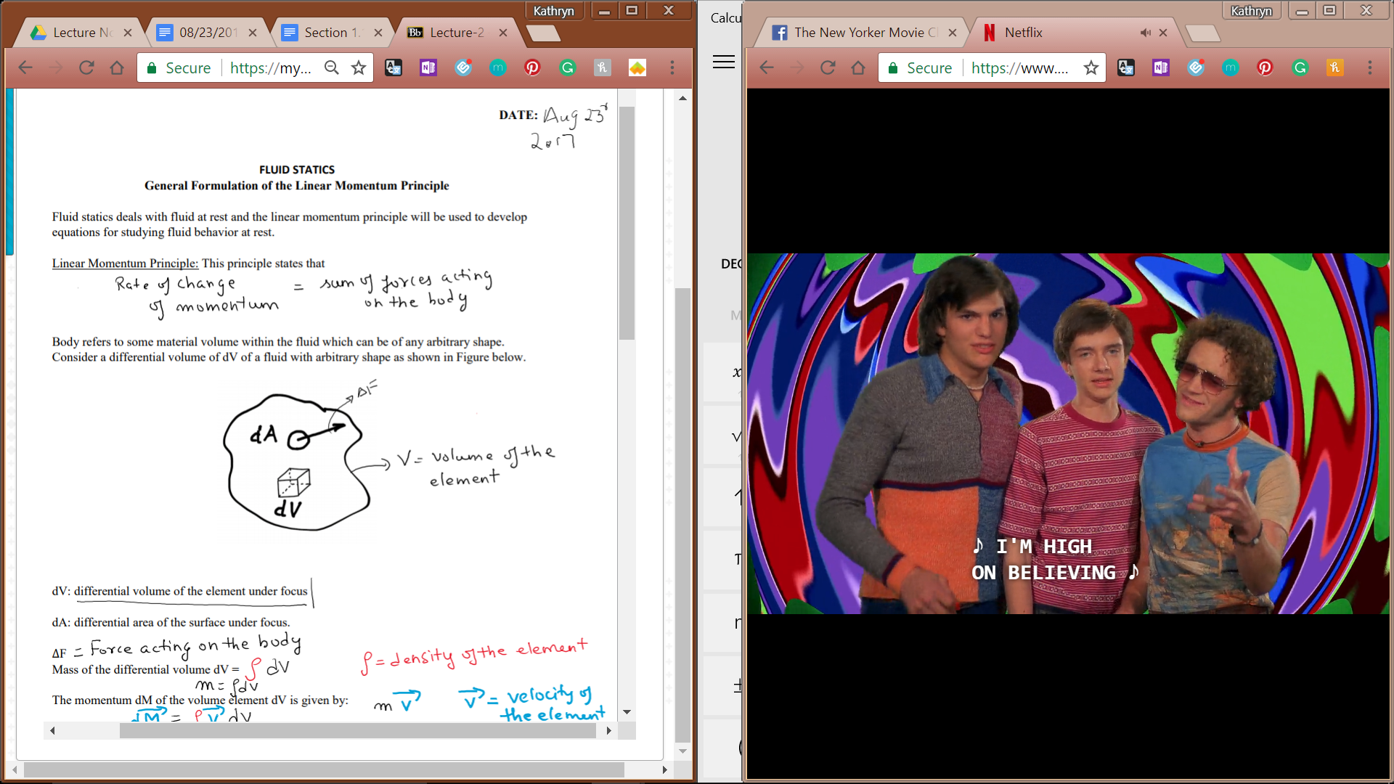

dV: differential volume of the element under focus

dA: differential area of the surface under focus

ΔF: force acting on the body

Mass of the differential volume dV: ⍴dV

⍴ = density of the element

M = ⍴dV

The momentum dM of the volume element dV is given by: d**M** = ⍴**v**dV = m**v**

**v** is the velocity of the element

Therefore, the total momentum **M** of the control volume is given by, **M** = ∫V ⍴**v**dV

Note that momentum is a vector, i.e. it has both magnitude and direction.

Forces on the differential volume

Surface forces: forces acting on body due to surrounding surfaces or contact

Body forces: forces acting on the body due to mass or inherent properties of the body

Gravitational, ~~electrostatic~~, ~~electromagnetic~~

(crossed out forces are not considered in our course -- no charge in fluid)

Surface stress **t** is defined as the surface force acting per unit area. Therefore:

**T** = **F** / A = limΔA -> 0 **ΔF**/ΔA

Body force (B) exerted on the control volume due to its own mass is given by

**B** = ⍴**g**dV

Where g is the acceleration due to gravity, which is a vector. So body force is also a vector.

Now, substituting the momentum and forces for the control volume in the linear momentum principle equation:

D/Dt (**M**) = ∫V ⍴**g**dV + ∫A**t**dA

Change in momentum = body forces + stress forces

This equation is known as the general linear momentum balance equation for any control volume. Can be applied to any shape or any fluid material with proper integrals. We will use this general formulation for developing equations for fluid at rest or fluid statics.

For a static fluid, the momentum principle reduces to

0 = ∫V ⍴**g**dV + ∫A**t**dA