**Fluid Statics**

**Pressure Measuring Devices**

**Barometers: Measuring Absolute Pressure**

A barometer is a device for measuring the absolute pressure of the atmosphere. The one illustrated below consists of a single tube closed at one end and immersed in the barometer fluid (usually mercury). The liquid vaporizes at the closed end and the pressure there is the vapor pressure of the liquid. For mercury, the vapor pressure at room temperature is negligible (around 3 x 10-6 atm) and therefore may be considered zero.

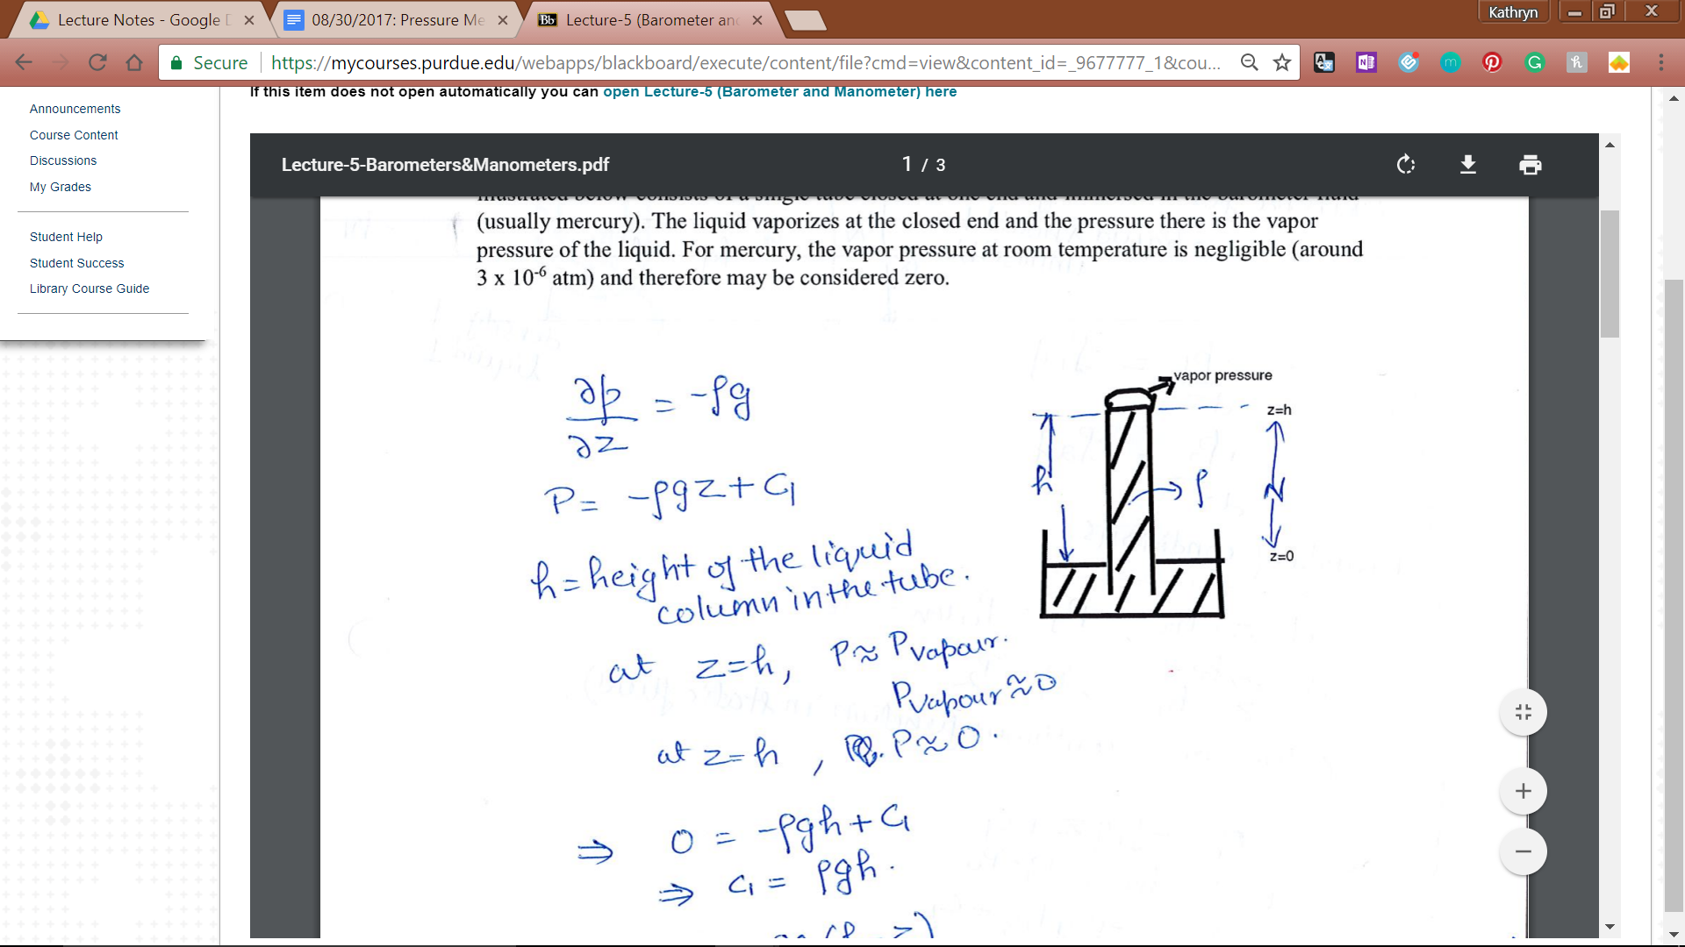

δp = - ⍴g

P = - ⍴gz + c1

H = height of the liquid column in the tube

At z = h, P ≈ Pvap

Hg --> Pvap ≈ 0

0 = -⍴gh + c1

C1 = ⍴gh

P = ⍴g(h-z)

At z = 0, P = Patm (liquid is open to atmosphere)

Patm = ⍴gh

**Manometers: Measurement of Pressure Differences**

Devices which make use of columns of liquid to determine pressure differences. A simple U tube manometer is illustrated here.

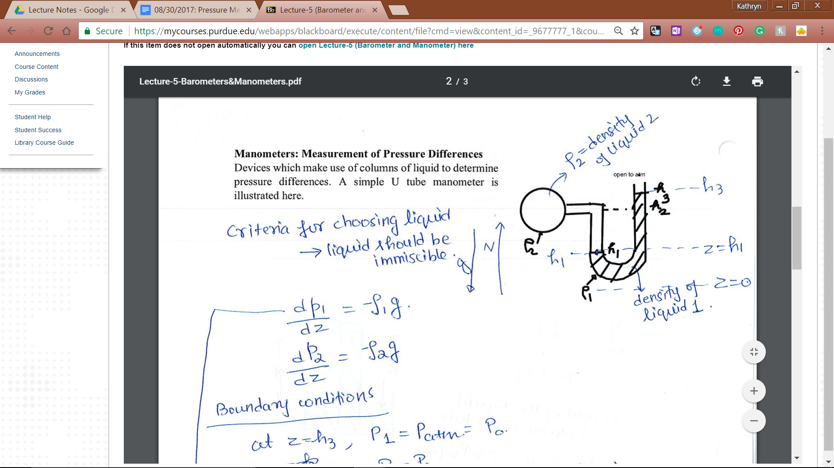

Criteria: when choosing liquids, they should be immiscible.

Write equations for liquid 1 and liquid 2:

dp1/dz = -ρ1g

dp2/dz = -ρ2g

Identify boundary equations:

Interfaces: h3, h1

P at z = h3, P1 = Patm = P0

P at z = h1, P1 = P2

Pressure is a continuous function in a static fluid

P1 = -ρ1gz + c1

P0 = -ρ1gh3 + c1

C1 = P0 + -ρ1gh3

P1 = -ρ1g(h3-z) + P0

P2 = -ρ2gz + c2

P2 = -ρ2gh1 + c2

-ρ2gh1 + c2 = ρ1g(h3-z) + P0

C2 = ρ1g(h3-h1) + ρ2gh1 + P0

C2 = ρ1gh3 + gh1(ρ2-ρ1) + P0

P2 = -ρ2gz + ρ1gh3 + gh1(ρ2-ρ1) + P0