**Class Problem**

**ABE 307**

**Micro-Manometer**

1. The micromanometer illustrated in the figure below is a useful device for accurately measuring small pressure differences. If the densities of the two manometer fluids are nearly the same (ρ1 ≈ ρ2), measurable values of the distance d can be obtained for very small values of the pressure difference, PB - PA. Letting A1 be the cross-sectional area of the reservoirs, and A2 be the cross sectional area of the connecting tube, derive an expression for PB - PA in terms of ρ1, ρ2, g, A1, A2, and d.

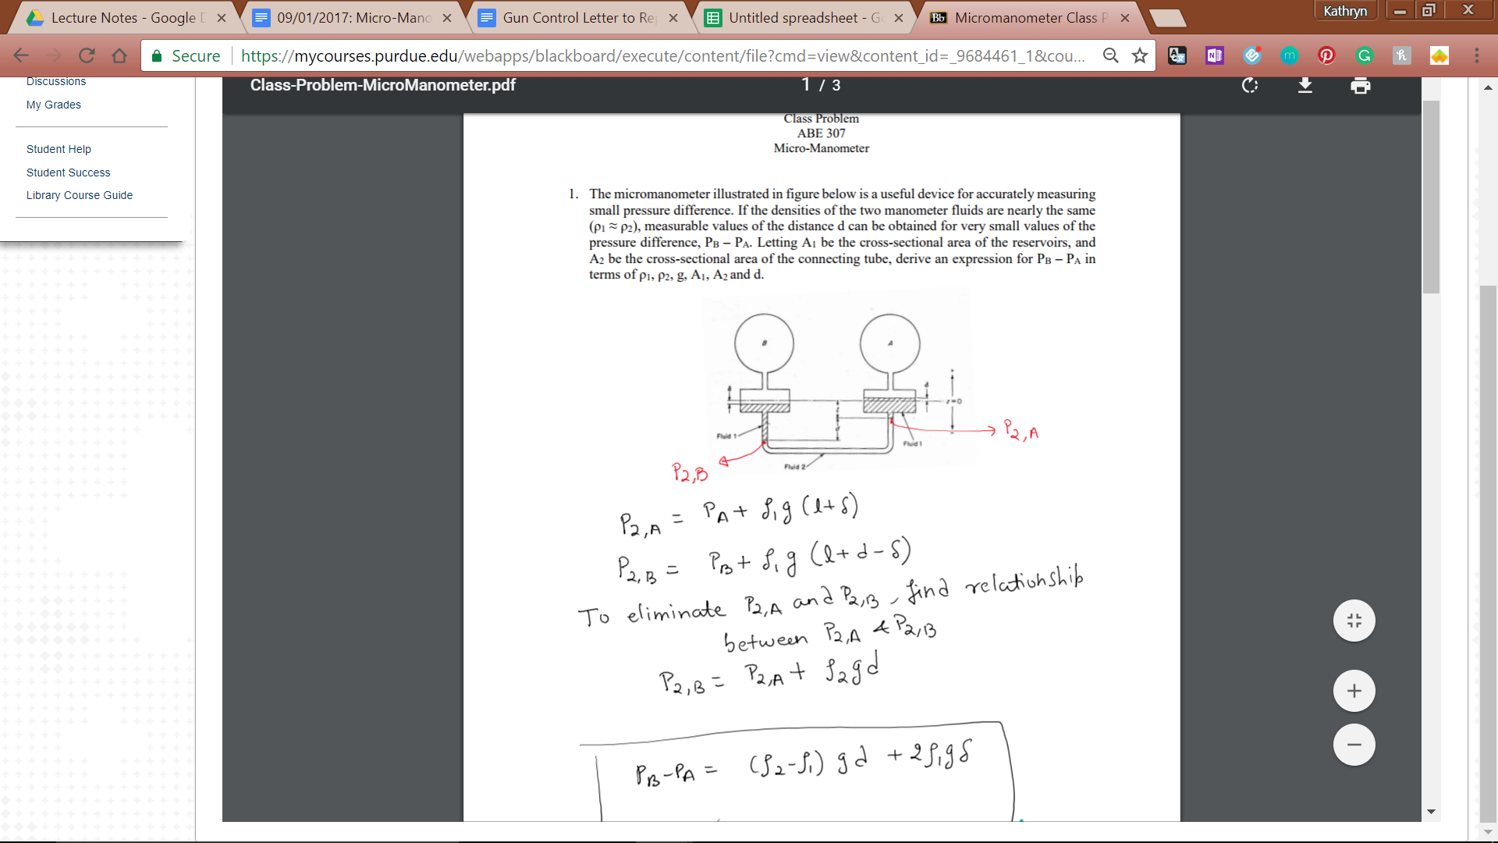

P2,A = PA + ρ1g(ℓ + 𝛿)

P2,B = PB + ρ1g(ℓ +d - 𝛿)

To eliminate P2A and P2B, find relationship between P2A + P2B.

P2B = P2A + ρ2gd

PB - PA = (ρ2 - ρ1)gd + 2ρ1g𝛿 ≈ 2ρ1g𝛿