**Application of Shell Momentum Balance**

**Flow of Fluid through a Circular Tube**

Consider a circular tube and fluid is flowing downwards under the effect of gravity and pressure difference. Density of fluid is ρ and viscosity of fluid is μ. Assume steady state, laminar flow. The length of the tube is L and radius is R. Assume that the length of tube is large compared to radius so we can ignore entrance effect i.e. we can ignore the fact that at tube entrance and exit the flow may not necessarily be parallel to the tube wall and can be unsteady.

We will use cylindrical coordinates for this problem.

* Rectilinear flow
* Assume no rotattion
* V = v(r)
* Cylindrical: P = P(r, θ, z)
  + X = r * cos(θ)
  + Y = r * sin(θ)
* Vz = vz(r)
* Vr = vθ = 0
* P = P(z)

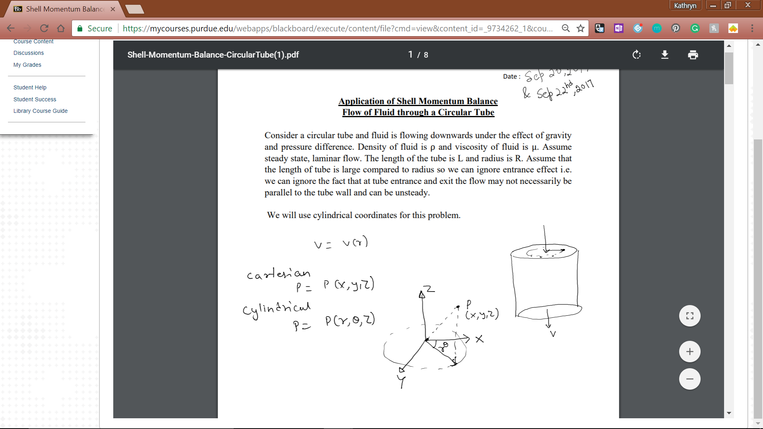

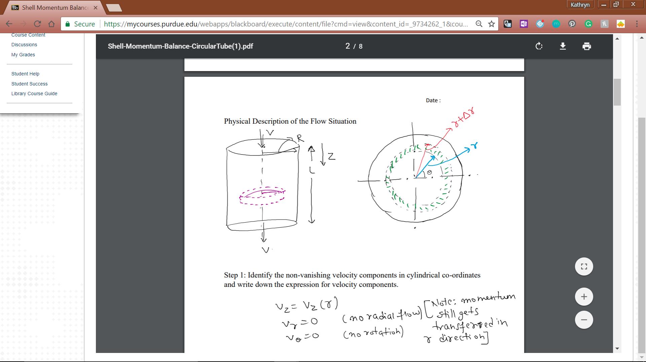

Velocity gradient as r changes, but no velocity in r direction. Assume steady state velocity. Only integrate on dr.

Step 1: Identify the non-vanishing velocity components in cylindrical coordinates and write down the expression for velocity components.

* Vz = vz(r)
* Vr = 0 (no radial flow)
* vθ = 0 (no rotational flow)
* Note: momentum still transferred in r direction.

Step 2: What are the non-vanishing momentum transfer components in cylindrical coordinates?

* Assume convective flux = 0
  + Only those associated with vz
* Φrz, Φzz, Φθz

Step 3: Choose a shell, draw the figure of shell selected

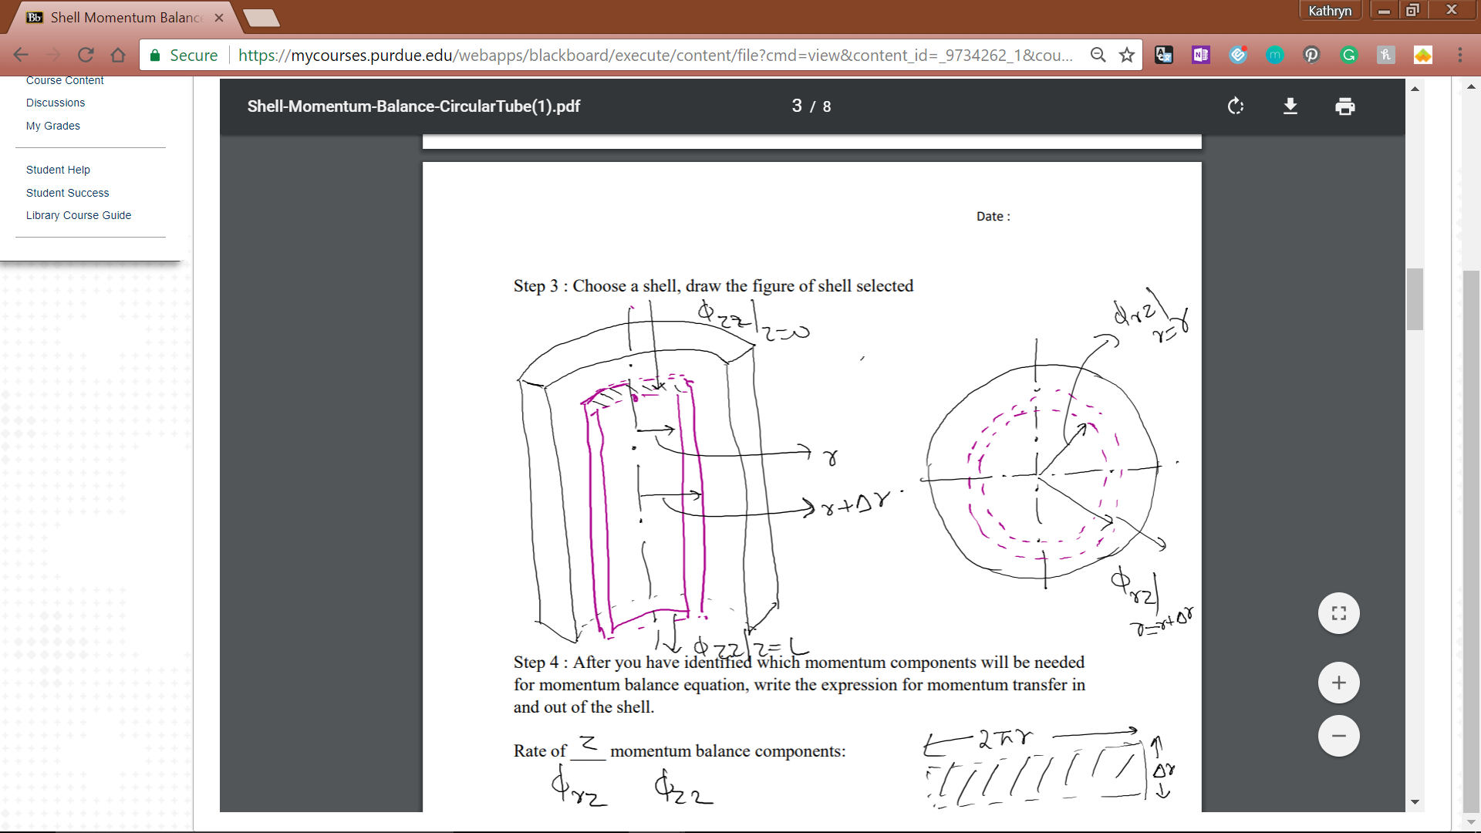

Step 4: After you have identified which momentum components will be needed for momentum balance equation, write the expression for momentum transfer in and out of the shell.

Rate of z momentum balance components:

Gravity + (Φrz|r - Φrz|r+Δr + Φzz|0 - Φzz|L)(2πrL)

Step 5: General Momentum Balance on Shell

(Φzz|0 - Φzz|L)(2πrΔr) + (Φrz|r - Φrz|r+Δr)(2πrL) + (2πrΔrL)ρg = 0

Step 6: Evaluate the components in Momentum Balance Equation to check if any other term goes to zero or can be cancelled out at input and output. For this

Φzz = p + ~~𝜏~~~~zz~~ + ρvzvz

Φrz = 𝜏rz + ~~ρv~~~~r~~~~v~~~~z~~

~~𝜏~~~~zz~~ = 0 = -2μ[dvz/dz]

𝜏rz = -μ[~~dv~~~~r~~~~/dz~~ + dvz/dr]

Assumption: flow is fully developed: vz|z=0 = vz|z=L

Rewrite Momentum Balance Equation after Applying Assumptions

(p + ~~ρv~~~~z~~~~v~~~~z~~)|z=0(2πrΔr) - (p + ~~ρv~~~~z~~~~v~~~~z~~)|z=L(2πrΔr) + 𝜏rz(~~2πrL~~)|r=r - 𝜏rz(~~2πrL~~)|r=r+Δr + ρg(2πrΔrL) = 0

Step 7: Differential Equation for the Shear Stress

(rP|z=0 - rP|z=L)/L + (r𝜏rz|r=r - r𝜏rz|r=r+Δr)/Δr + ρgr = 0

Define modified pressure: P = p - ρgh

P0 = p - ρg(0)

PL = p- ρg(L)

(rP|z=0 - rP|z=L + ρgrL)/L = (r𝜏rz|r=r - r𝜏rz|r=r+Δr)/Δr

r(P|z=0 - (P|z=L + ρgL))/L = d/dr (r𝜏rz)

Integrate and use Boundary Conditions:

R𝜏rz = r2/2 (P0 - PL)/L + C2

𝜏rz = r/2 (P0 - PL)/L + C2/r

Only way to be finite is if c2 = 0

𝜏rz = r/2 (P0 - PL)/L

Step 8: Use Newton’s Law of Viscosity and Obtain Velocity Profile

𝜏rz = -μ dvz/dr

-μ dvz/dr = r/2 (P0 - PL)/L

dvz/dr = r/-2μ (P0 - PL)/L

Vz = -r2/4μ * (P0 - PL)/L + c3

At tube wall, vz = 0 (solid-liquid interface)

No-slip condition (tube is stationary at r = R, vz = 0)

==> c3 = R2/4μ * (P0 - PL)/L

Vz = 1/4μ * (P0 - PL)/L [R2 - r2]

Vz = (P0 - PL)/4μL * R2(1-r2/R2)

Answer the following questions based on your derivations:

1. What is the maximum velocity for fluid flowing in circular pipe?

dvz/dr = 0, d2vz/dr2 < 0 (maximum)

1. What is the average velocity for fluid flowing in circular pipe?

Volumetric flow rate/cross sectional area = ∫0R∫02πvzrdθdr/∫0R∫02πrdθdr

1. What is the mass flow rate of fluid flowing in circular pipe?

⍵ = ρ ∫0R∫02πvzrdθdr

⍵ = ρ(P0-PL)πR4/8μL (Hagen-Poisuelli Equation)

Re = <v>Dρ/μ

Reynold’s Number: < 2100 = laminar flow

1. What is the force applied by the fluid on the walls of pipe?

Area = 2πRL

Fz = 𝜏rz|r=R( 2πRL) => general

Fz = (P0 - PL)πR2 ==> specific

Modified Pressure: P + ρgh (h is from bottom up)

ρgh = P - ρgz (z is from top down)

Different coordinate system