**Equations of Change**

**Associated Readings: Chapter 3 Introduction, Section 3.1, 3.2**

Generalized Equations to Start Fluid Flow Problems. Applicable on any type of fluid flow.

Equation of continuity: general mass balance equation

Equation of motion: general momentum balance equation

1. Equation of continuity: consider a differential element Δx, Δy, Δz; size ΔxΔyΔz

Rate of mass increase = {rate of mass in} - {rate of mass out}

𝛿ρ/𝛿t (ΔxΔyΔz) = (ρvx|x - ρvx|x+Δx)ΔyΔz + (ρvy|y - ρvy|y+Δy)ΔxΔz + (ρvz|z - ρvz|z+Δz)ΔxΔy

Divide by volume: generalized equation of continuity

𝛿ρ/𝛿t = -𝛿/𝛿x ρvx - 𝛿/𝛿y ρvy - 𝛿/𝛿z ρvz

𝛿ρ/𝛿t = -[𝛿/𝛿x ρvx + 𝛿/𝛿y ρvy + 𝛿/𝛿z ρvz]

𝛿ρ/𝛿t = -[▽ * ρ**v**]

▽ = del operator = **i** 𝛿/𝛿x + **j** 𝛿/𝛿y + **k** 𝛿/𝛿z

1. Equation of Motion

Applying the momentum balance in a very general situation

Rate of increase of momentum = {rate of momentum in} - {rate of momentum out} + {body forces}

X-Momentum Transfer Equation

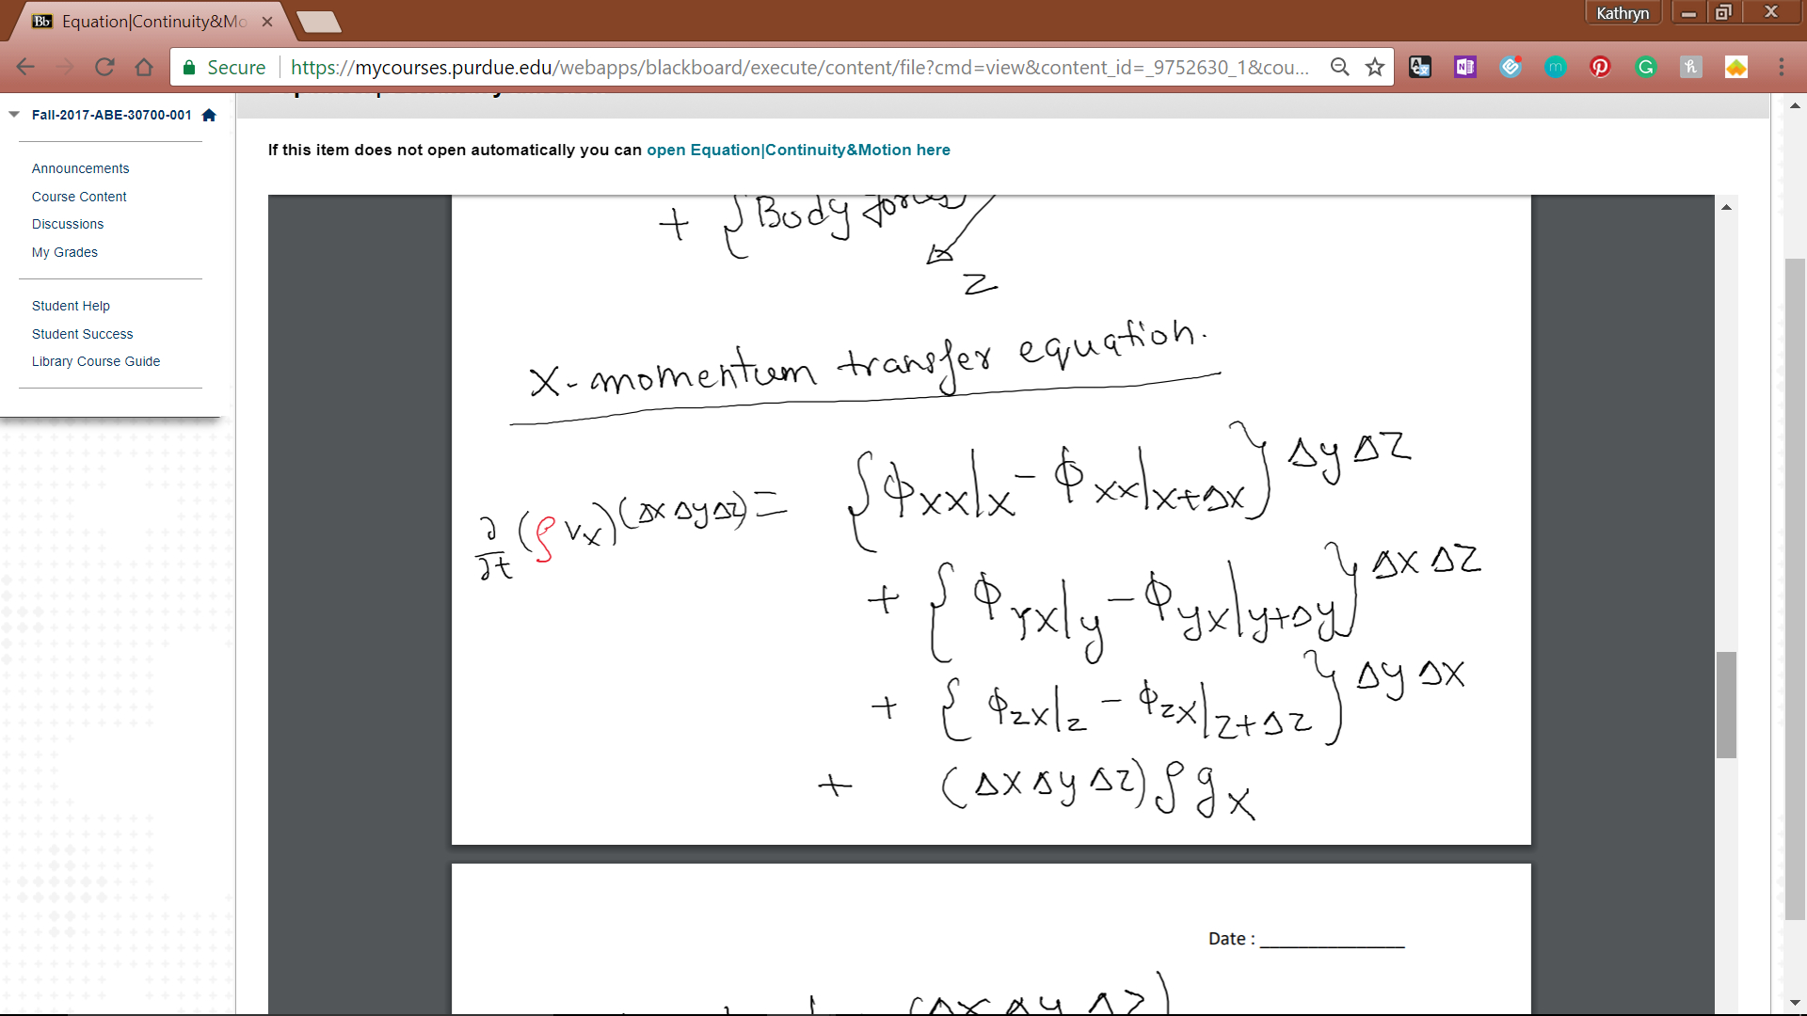

Divide by volume, limit x, y, z to 0

General equation: d/dt(ρ**v**) = -[▽*Φi] + ρ**g**