**List of Equations ABE 30800 – Spring 2018**

**Energy Balance**



**General Energy Transport Equation**



**Heat Conduction** (no convection)

* Cartesian Coordinates



* 1D – Heat Flow (x direction)



* Cylindrical Geometry



* 1D – Heat Flow (r-direction – long cylinder)



* Spherical Geometry



* 1D – Heat Flow (r-direction)



**Heat Convection**



**Radiation**







**Heat Transfer in a composite system** (conduction and convection)

* Convection in both sides and conduction through 3 layers – Cartesian Geometry – 1D

 





* Convection in both sides and conduction through 3 layers – Cylindrical Geometry – 1D









* Convection in both sides and conduction through 3 layers – Spherical Geometry – 1D





* Boundary Conditions

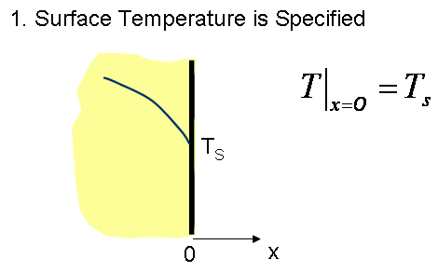

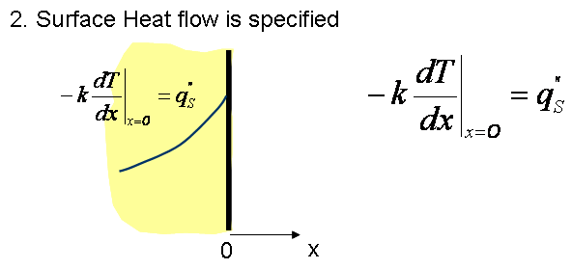

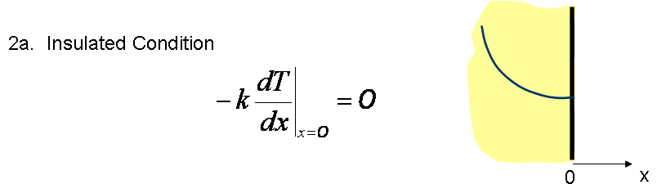



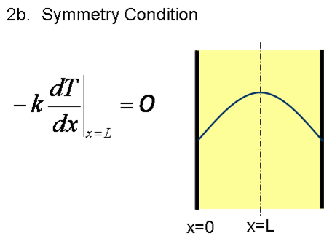

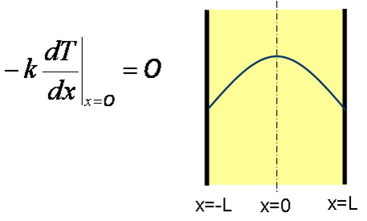or

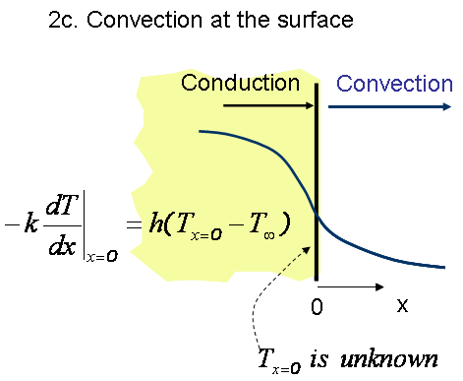

**Steady State Heat Transfer with Heat Generation**

* Cartesian Coordinate – Heat flow in only one direction





* Cylindrical and Spherical Geometry

Equations are specific to the boundary conditions used (see examples given in class)

Steady State Heat Transfer for Extended Surfaces

 



**Conduction Heat Transfer: Unsteady State**

Lumped parameter Analysis





Internal Resistance to Heat Transfer is not negligible

*Using Charts- x is replaced by r and L by R in cylindrical and spherical geometries*



  

L: characteristic length, it depends on the geometry

*Multi-dimensional Problems*





*Analytical Solution (complete) - Slab only*



*Analytical Solution (approximated) - Slab only*





*Transient heat Transfer in a Semi-infinite region*

Constant temperature boundary condition



Convection boundary condition



**Approximated Solution to the Unsteady State Mass Transfer Equation (indicated below) for Three Different Geometries without Using Charts.**

These equations can be used for Unsteady State Heat Transfer. In the case of heat transfer problems, concentrations are replaced by Temperatures.

It has been demonstrated in class that for relative long times, i.e. for Fo > 0.2 the infinite series solution can be approximated by the first term of the series. During lectures we discussed that equation for slab geometries which is given above and rewritten below:



or for temperature



However no equations were given to estimate the temperatures or concentration with position and time for cylindrical and spherical surfaces. The approach to estimate these temperatures or concentrations was to use specific charts for these geometries. The use of charts sometimes may result cumbersome so a more general approach is used to estimate these temperatures and concentrations for Fo > 0.2. For Fo < 0.2 the complete solution (infinite series) should be used.

**The general approach** is summarized in the following equation, e.g. applied to heat transfer:



and to mass transfer



Where *C1* and  are two parameters that depend on the geometry and are tabulated in the table given in the table below as a function of the Biot number:

|  | **Plane wall** | | **Infinite Cylinder** | | **Sphere** | |
| --- | --- | --- | --- | --- | --- | --- |
| **Bi** |  | ***C1*** |  | ***C1*** |  | ***C1*** |
| 0.01 | 0.098 | 1.0017 | 0.1412 | 1.0025 | 0.1730 | 1.0030 |
| 0.02 | 0.1410 | 1.0033 | 0.1995 | 1.0050 | 0.2445 | 1.0060 |
| 0.03 | 0.1732 | 1.0049 | 0.2439 | 1.0075 | 0.2989 | 1.0090 |
| 0.04 | 0.1987 | 1.0066 | 0.2814 | 1.0099 | 0.3450 | 1.0120 |
| 0.05 | 0.2217 | 1.0082 | 0.3142 | 1.0124 | 0.3582 | 1.0149 |
| 0.06 | 0.2425 | 1.0098 | 0.3438 | 1.0148 | 0.4217 | 1.0179 |
| 0.07 | 0.2615 | 1.0114 | 0.3708 | 1.0173 | 0.4550 | 1.0209 |
| 0.08 | 0.2791 | 1.01130 | 0.3960 | 1.0197 | 0.4860 | 1.0239 |
| 0.09 | 0.2956 | 1.0145 | 0.4195 | 1.0222 | 0.5150 | 1.0268 |
| 0.10 | 0.3111 | 1.0160 | 0.4417 | 1.0246 | 0.5423 | 1.0298 |
| 0.15 | 0.3779 | 1.0327 | 0.5376 | 1.0365 | 0.6608 | 1.0445 |
| 0.20 | 0.4328 | 1.0311 | 0.6170 | 1.0483 | 0.7593 | 1.0592 |
| 0.25 | 0.4801 | 1.0382 | 0.6856 | 1.0598 | 0.8448 | 1.0737 |
| 0.30 | 0.5218 | 1.0450 | 0.7465 | 1.0712 | 0.9208 | 1.0880 |
| 0.40 | 0.5932 | 1.0580 | 0.8516 | 1.0932 | 1.0528 | 1.1164 |
| 0.50 | 0.6533 | 1.0701 | 0.9408 | 1.1143 | 1.1656 | 1.1441 |
| 0.60 | 0.7051 | 1.0814 | 1.0185 | 1.1346 | 1.2644 | 1.1713 |
| 0.70 | 0.7506 | 1.0919 | 1.0873 | 1.1539 | 1.3525 | 1.1978 |
| 0.80 | 0.7910 | 1.1016 | 1.1490 | 1.1725 | 1.4320 | 1.2236 |
| 0.90 | 0.8274 | 1.1107 | 1.2048 | 1.1902 | 1.5044 | 1.2488 |
| 1 | 0.8603 | 1.1191 | 1.2558 | 1.2071 | 1.5708 | 1.2732 |
| 2 | 1.0769 | 1.1795 | 1.5995 | 1.3384 | 2.0288 | 1.4793 |
| 3 | 1.1925 | 1.2102 | 1.7887 | 1.4191 | 2.2889 | 1.6227 |
| 4 | 1.2646 | 1.2287 | 1.9081 | 1.4698 | 2.4556 | 1.7201 |
| 5 | 1.3138 | 1.2402 | 1.9898 | 1.5029 | 2.5704 | 1.7870 |
| 6 | 1.3494 | 1.2479 | 2.0490 | 1.5253 | 2.6537 | 1.8338 |
| 7 | 1.3766 | 1.2532 | 2.0937 | 1.5411 | 2.7165 | 1.8674 |
| 8 | 1.3978 | 1.2570 | 2.1286 | 1.5526 | 2.7654 | 1.8921 |
| 9 | 1.4149 | 1.2598 | 2.1566 | 1.5611 | 2.8044 | 1.9106 |
| 10 | 1.4289 | 1.2620 | 2.1795 | 1.5677 | 2.8363 | 1.9249 |
| 20 | 1.4961 | 1.2699 | 2.2881 | 1.5919 | 2.9857 | 1.9781 |
| 30 | 1.5202 | 1.2717 | 2.3261 | 1.5973 | 3.0372 | 1.9898 |
| 40 | 1.5325 | 1.2723 | 2.3455 | 1.5993 | 3.0632 | 1.9942 |
| 50 | 1.5400 | 1.2727 | 2.3572 | 1.6002 | 3.0788 | 1.9962 |
| 100 | 1.5552 | 1.2731 | 2.3809 | 1.6015 | 3.1102 | 1.9990 |
|  | 1.5707 | 1.2733 | 2.4050 | 1.6018 | 3.1415 | 2.000 |

, *L* is the characteristic length and the Biot number could be the heat or the mass Biot number, x is used for a slab and r for cylindrical and spherical geometries.

**HEAT CONVECTION**

* *Momentum/velocity Boundary Layer*

**

* *Thermal Boundary Layer*
* *Condition to achieve fully developed thermal boundary layer*

**

**IMPORTANT DIMENSIONLESS NUMBER DESCRIBING HEAT CONVECTION**

|  |  |
| --- | --- |
| **Dimensionless Number** | **Definition and Physical Significance** |
| Reynolds number |  |
| Nusselt number |  |
| Prandtl number |  |
| Biot number |  |
| Grashof number |  |
| Rayleigh number |  |

**HEAT CONVECTION CORRELATIONS**

In general, they are dependent on the type of flow (Laminar versus Turbulent), the geometry and the type of convection (forced versus natural convection). For Forced Convection one of the typical dimensionless numbers is the Reynolds Number. For Natural convection the Reynolds Number is replaced by the Rayleigh number (see table above). A typical correlation has the form:



* *Some useful Correlations – other correlations could be given in the exam so you do not have to memorize these equations*

1. Flat Plate – **Forced Convection**



1. Flow over a Cylinder **– Forced Convection**



|  |  |  |
| --- | --- | --- |
|  | *B* | *n* |
| 0.4-4 | 0.989 | 0.330 |
| 4-40 | 0.911 | 0.385 |
| 40-4,000 | 0.683 | 0.366 |
| 4,000-40,000 | 0.193 | 0.618 |
| 40,000-400,000 | 0.027 | 0.805 |

1. Flow over a Sphere – **Forced Convection**



For 

1. Flat Plate – **Natural Convection/Vertical Surface**



1. Flow Over Sphere – **Natural Convection**



**6**. Flat Plate – **Natural Convection / Horizontal Surface**

* *Hot side facing up*





* *Hot side facing down*



**Internal Flows**

1. Non-constant heat flux *qw”(x)*



1. Constant heat flux *qw”*



3. Constant surface temperature (either *Ts* or *Tw*



For the case that only internal resistance is significant:





*P*: Perimeter, for a circular pipe**

* ***Convection coefficients calculations***

**Laminar Flow *ReD <* 2,300**

1. Laminar fully developed flow, uniform surface heat flux



1. Laminar fully developed flow, uniform surface temperature



**Turbulent Flow *ReD* > 2,300**

1. Turbulent fully developed flow, uniform surface temperature



*n = 0.4* **(heating)** and *n = 0.3* **(cooling)**

**Freezing**

* ***Slab***



* ***Cylinder***



* ***Sphere***

