**ABE 30800**

**Examples - Unsteady State Heat Transfer**

**Example 1**

A thermocouple probe, which can be approximated as a sphere, is used to measure the temperature of a gas stream. The convection coefficient between the junction surface and the gas is h = 400 W/m2.K, the thermal conductivity of the probe is k = 20W/m.K, the specific heat c = 0.4 kJ/kg.K and the density= 8500 kg/m3. Determine the probe diameter needed for the thermocouple to have a time constant of 1 second. If the thermocouple probe is at 25oC and is placed in a gas stream that is at 200oC, how long will it take for the thermocouple probe to reach a temperature of 199oC?

**Hint**: The time constant of the thermocouple is defined as the time under which the temperature indicated by the thermocouple probe reaches approximately 37% of the temperature change expected.

**Example 2**

In a manufacturing process stainless steel cylinders initially at 327oC are quenched by immersion in an oil bath maintained at 27oC. The external heat transfer coefficient is h = 500 W/m2.K. The dimensions of the cylinders are height H= 60mm and diameter D = 80mm. Consider a time of 3 minutes into the cooling process and determine the temperature at the center of the cylinder, at the center of a circular face and at the middle height of the side.

**Example 3**

Consider a product to be sterilized if its coldest location during heating reaches 115oC. Consider sterilization of potatoes where metal cans would be filled with water and potatoes (4cm diameter) and the can is heated in steam at 121oC. Assume symmetrical heating of potatoes and an overall heat transfer coefficient between the steam and the potatoes of 20 W/m2.K. The thermal diffusivity for potatoes is 1.5 x 10-7 m2/s and the thermal conductivity is 0.4 W/m.K. The potatoes are initially at 30oC. Calculate the heating needed for sterilization.

**Example 4**

In heat-treating, to harden steel ball bearings (*c*=500 J/kg.K,  7800 kg/m3, *k*=50 W/m.K is desirable to increase the surface temperature for a short time without significantly warming the interior of the ball. This type of heating can be accomplished by sudden immersion of the ball in a molten salt bath with  =1300K and *h* = 5,000 W/m2.K. Assume that any location within the ball whose temperature exceeds 1000K will be hardened. Estimate the time required to harden the outer 1mm of a ball of diameter 20mm, if it is temperature is 300K.

**Example 5**

A thermal burn occurs as a result of an elevation in tissue temperature above a threshold value for a finite period of time. The value of both the absolute temperature and the exposure time are crucial in determining the extent of injury. Since heat transfer to inside the skin is limited by thermal conduction, the temperature history in the affected zone is not uniform and regions of graded injury develop with most involvement on the surface. The figure below shows a cross-section of a normal skin and underlying tissue. Burn injuries are described by degrees. A first degree burn is one involving a temporary discomfort with no permanent skin discoloration. A superficial second degree burn involves some but not all of the basal layer. A deep second degree burn involves complete loss of basal layer. In a third degree burn all epidermal elements are destroyed. A fourth degree burn can extend all the way to the bone. Ignoring effects of blood flow, it is possible to analyze the temperature history and thermal injury for up to third-degree burn using the semi-infinite region approximation.

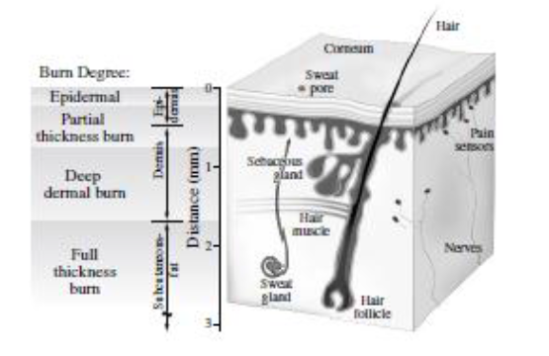

During a skin burn from an oven, approximate the skin and tissue layer to be infinitely thick compared to the damaged layer. The temperature throughout the entire skin and tissue layer is uniform at 33oC before contacting with the oven. The surface layer of the skin increases to the temperature of the oven 200oC, instantaneously upon contact. Find the depth of the damages layer of skin after 2 seconds of exposure to the oven temperature. Consider the skin becomes damaged when it reaches 62oC. The thermal diffusivity of skin is 2.5x10-7 m2/s