**Examples ABE 308**

**Steady State Mass Transfer**

**Problem 1**

It is necessary to design a hollow fiber dialyzer as the one discussed in the lectures in where the flow in only a tube was estimated. Consider that tubes have 0.5mm diameter and the thickness of their wall is 25m. The diffusivity of urea in the tube wall membrane is 1x10-10 m2/s and in the blood is 1.5 x10-9 m2/s. The distribution coefficient, K*, of the membrane for the urea solution is 2. The concentration of urea in blood is 0.0002 g/cm3 and in the dialyzate fluid is zero. The mass transfer coefficient on the dialyzate side is 3 x10-5 m/s. For the blood side, the average velocity in the tube is 2.5m/s. Viscosity and density of blood are 3x10-3 Pa.s and 1020 kg/m3, respectively. Considering steady state transport of urea through the membrane, calculate:

1. Mass transfer coefficient on the blood side
2. The overall mass transfer coefficient for a tube
3. The number of tubes of 24 cm in length are necessary to obtain a total urea removal of 5g/hour

**Problem 2**

Consider a plant growing in a water-logged plot (shown in the figure below). In this water-logged plot, plants can obtain little oxygen from the soil. It is desired to find the oxygen concentration in the submerged root receiving atmospheric oxygen by diffusion. Assume steady state one-dimensional diffusion. The volumetric activity of the plants is constant and assumed to follow a zero order reaction with constant k (assume not CO2 is generated).

1. Write the governing equation of the problem
2. Write the boundary conditions (how many?). An additional boundary condition is needed since the submerged length, *p*, at which the concentration becomes zero is unknown. At this boundary, you can assume that both the oxygen concentration and flux are zero. Another boundary condition is a constant concentration Co at the soil surface.
3. Find the submerged length (where concentration of oxygen becomes zero) as a function of diffusivity, Co and k

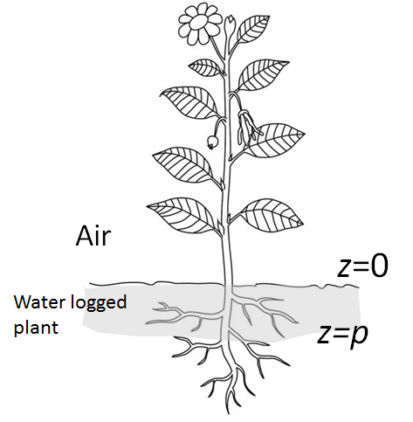

**Problem 3**

A gas diffuses through the walls of a cylindrical tube whose cross-section is shown in the figure below. (1) Derive a relationship for the rate of diffusion of the gas through the tube in terms of the diffusivity and tube dimensions. 2) Setting up a resistance formulation, show the mass transfer resistance of the tube. Assume the inside and outside walls are at gas concentration ci and c0, respectively. (3) Expand the problem to the case in which you have mass convection of the gas in a liquid inside and outside of the tube with mass transfer convection coefficients *hm1* and *hm2*, respectively. The concentrations of gas in the liquid inside and outside the tube are cinside and coutside, respectively. **Hint**: Follow the derivations done for heat transfer.

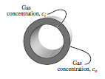

**Problem 4**

Since traditional methods often cannot be used for delivering drugs to the brain, researchers are working on implanting drug-containing polymers directly in the brain tissue. Consider steady one-dimensional diffusion in the *x* direction and a first order kinetics to describe the elimination of drug dopamine near an implant, as shown in Figure below. The boundary conditions of drug concentration are *c0* at the implant surface and zero far from the surface into the brain tissue. The reaction rate, k, for dopamine elimination is 0.6/hour and diffusivity of dopamine in brain tissue is 40×10−11m2/s.

(1) Write the solution for drug concentration as a function of position *x* from the implant surface. Clearly specify your assumptions

(2) Find the distance from the implant surface in cm at which the drug concentration becomes 10% of its value at the implant surface. The volume corresponding to this distance is termed the drug implant surface.

(3) By considering that the average concentration of dopamine over the distance calculated in (2) needs to be 8μg/g of tissue for a certain treatment, what should be the concentration *c0* at the implant surface for this treatment?

