|  |  |  |  |  |
| --- | --- | --- | --- | --- |
| FIRST ORDER | | Film | Ash | Reaction |
| Constant Particle Size | Flat Plate | t/τ = XB  τ = ρBL/bkgCAg | t/τ = XB2  τ = ρBL2/2bkgDeCAg | t/τ = XB  τ = ρBL/bkCAg |
| Cylinder | t/τ = XB  τ = ρBR/bkgCAg | t/τ = XB+(1-XB)ln(1-XB)  τ = ρBR2/4bkgDeCAg | t/τ = 1 - (1-XB)1/2  τ = ρBR/bkCAg |
| Sphere | t/τ = XB  τ = ρBR/bkgCAg | t/τ = 1-3(1-XB)2/3+2(1-XB)  τ = ρBR2/6bkgDeCAg | t/τ = 1 - (1-XB)1/3  τ = ρBR/bkCAg |
| Shrinking Sphere | Small Particle (Stokes regime) | t/τ = 1 - (1 - XB)2/3  τ = ρBR02/bkDCAg | Not applicable | t/τ = 1 - (1-XB)1/3  τ = ρBR0/bkCAg  t= ρ(rc-R)/bkCAg |
| Large Particle (u = constant) | t/τ = 1 - (1 - XB)1/2  τ = (const)R03/2/CAg | Not applicable | t/τ = 1 - (1-XB)1/3  τ = ρBR/bkCAg  t= ρ(rc-R)/bkCAg |

|  |  |  |  |
| --- | --- | --- | --- |
| SECOND ORDER | Film | Ash | Reaction |
| Flat Plate | t/τ = XB  τ = ρBL/bkgCAg | t/τ = XB2  τ = ρBL2/2bkgDeCAg | t/τ = XB  τ = ρBL/bkCAg2 |
| Cylinder | t/τ = XB  τ = ρBR/bkgCAg | t/τ = XB+(1-XB)ln(1-XB)  τ = ρBR2/4bkgDeCAg | t/τ = 1 - (1-XB)1/2  τ = ρBR/bkCAg2 |
| Sphere | t/τ = XB  τ = ρBR/bkgCAg | t/τ = 1-3(1-XB)2/3+2(1-XB)  τ = ρBR2/6bkgDeCAg | t/τ = 1 - (1-XB)1/3  τ = ρBR/bkCAg2 |

Heterogeneous dimensions: mol/time*vol = -1/V * dNA/dt; mol/time*area = -1/S * dNA/dt

-1/S*dNB/dt = -1/4πR2 dNB/dt = -b/4πR2 dNA/dt = bK(CAg-CAs) = bkCAg = r

**PFR packed catalyst**

τP = fV/q = ∫dC/-ξkC

fV/q = 1/-ξk * ln(1-X)

X = 1 - e-ξkfV/q

**MFR packed catalyst**

τM = C0-C/-r = C0-C/kC

X = kτM/1+kτM

X = (ξkfV/q) / (1 + ξkfV/q)

1 - X = ∫(1-X)Edt = ∫e-kTEdt; Cout = ∫C

|  |  |  |  |
| --- | --- | --- | --- |
| NTH ORDER | Film | Ash | Reaction |
| Flat Plate | t/τ = XB  τ = ρBL/bkgCAg | t/τ = XB2  τ = ρBL2/2bkgDeCAg | t/τ = XB  τ = ρBL(Km+Cag)/bVmCAg |
| Cylinder | t/τ = XB  τ = ρBR/bkgCAg | t/τ = XB+(1-XB)ln(1-XB)  τ = ρBR2/4bkgDeCAg | t/τ = 1 - (1-XB)1/2  τ = ρBR(Km+Cag)/bVmCAg |
| Sphere | t/τ = XB  τ = ρBR/bkgCAg | t/τ = 1-3(1-XB)2/3+2(1-XB)  τ = ρBR2/6bkgDeCAg | t/τ = 1 - (1-XB)1/3  τ = ρBR(Km+Cag)/bVmCAg |

If no one resistance is the dominant, calculate each. The longest one is most significant.

τTotal = τfilm + τAsh + τRxn.

tTotal = tFilm + tAsh + tRxn

Enzymatic: b(VmCAg/KmCAg) = -1/s * dNB/dt = -ρBdr/dt; tau is same as nth order

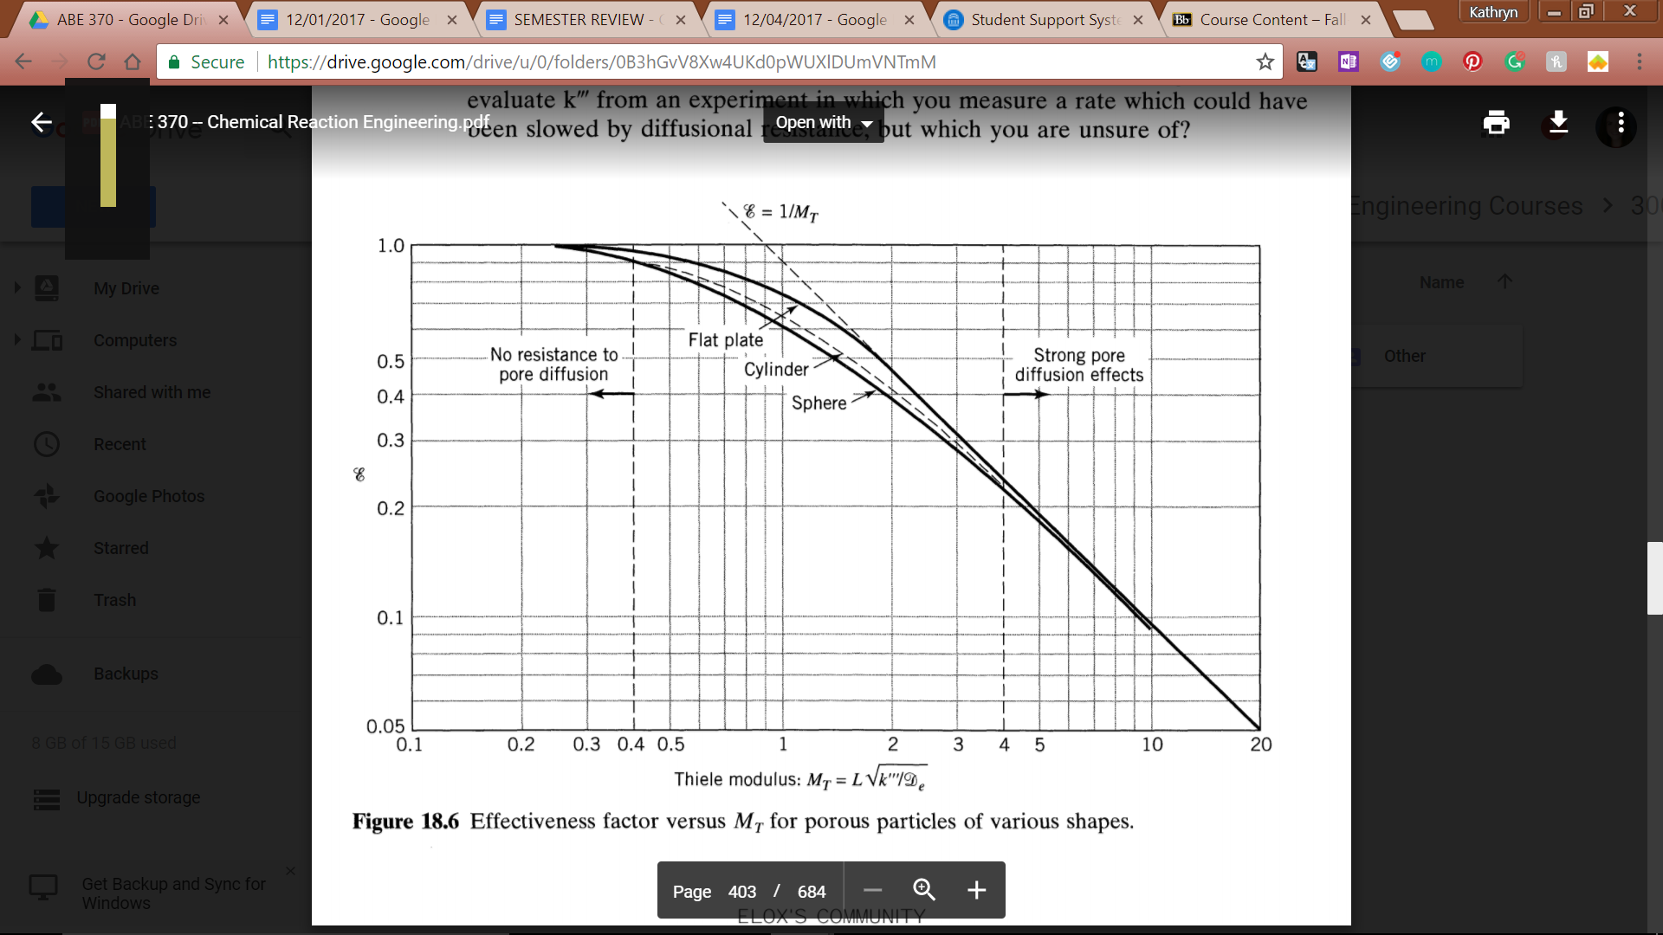

**L for geometries:**

Plate: thickness/2

Cylinder: R/2

Sphere: R/3

MT < 0.4, Effectiveness factor = 1; MT > 4, Effectiveness factor = 1/MT

**ξ for different geometries**

Flat plate: tanh(MT)/MT

Cylinder: use chart/graph to find value

Sphere: 1/MT * 1/tanh(3*MT) * 1/3*MT

MW = ξ * MT2