**Typical Chemical Process:**

Raw materials --> REACTOR (collisions) --> Products

1. What changes are expected to occur?
2. How fast will they occur?

Mass Balance

Stoichiometry

Extent of Reaction (numerical value) vs. Fractional Conversion (always %)

C6H12O6 --> 2 C2H5OH + 2 CO2

5 = (X - 10)/-1

-5 = X-10

X = 5 moles C6H12O6

* 30 moles H2O
* 10 moles C2H5OH
* 10 moles CO2

= 55 moles total

Outlet composition:

30/55 * 100% = 54.5% H2O

10/55 * 100% = 18.2% CO2

10/55 * 100% = 18.2% C2H5OH

5/55 * 100% = 9.1% C6H12O6

**General form of component material balance for species is**

Mole fraction form:

∑ xij * Qj + ∑ ξ * vi = 0

∑ mole fraction * molar flow rate + ∑ ξ * vi = 0

Mass fraction form:

∑ ωij * Fj + ∑ ξ * vi * MWi = 0

∑ mass fraction * mass flow rate + ∑ ξ * vi * molecular weight = 0

**Stepwise:**

1. Draw a picture and label streams and compositions
2. Stoichiometric equations
3. Fill in knowns
4. Solve for unknowns
5. Check by making sure masses in and out are balanced

**Measuring how far a reaction has occurred:**

C = F/V

Fi = (Ni0 - Ni)/Ni0

X = [(Ni0-Ni)/V]/[Ni0/V] = (Ci0 - Ci)/Ci0 = 1 - Ci/Ci0

**Example:**

2A + 3B --> C

2L total reaction mixture

CA0 = 12 mol/L --> CA = 3 mol/L

CB0 = 30 mol/L --> CB = 16.5 mol/L

CC0 = 0 mol/L --> CC = 4.5 mol/L

ΔCA = -9 mol/L

ΔCB = -13.5 mol/L

ΔCC = +4.5 mol/L

XA = 1 - 3/12 = 3/4

XB = 1 - 16.5/30 = 13.5/30

ξA = ξB = 2 * (3 - 12) / -2 = 9

**Molecular Collision Theory**

* Collision
* With enough energy to react
* Orientation

**Transition State Intermediate**

* High energy state
* Unstable
* Decomposes into product

Exothermic Reaction

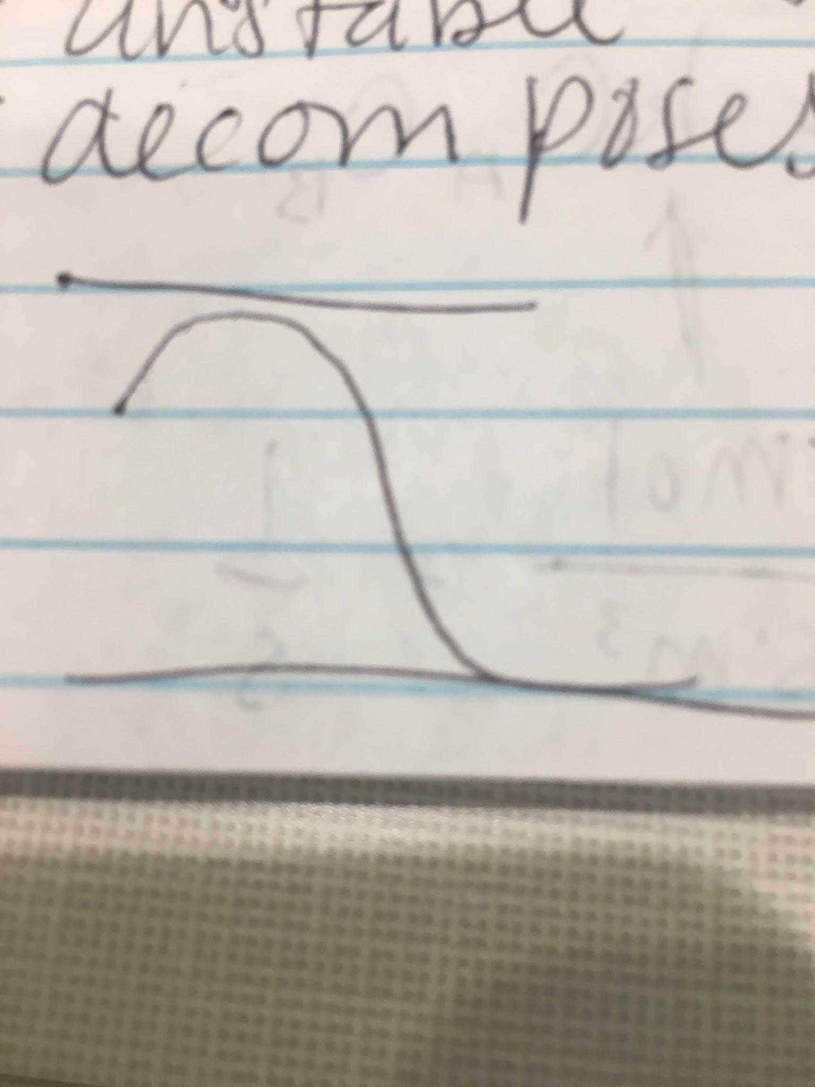

Endothermic Reaction

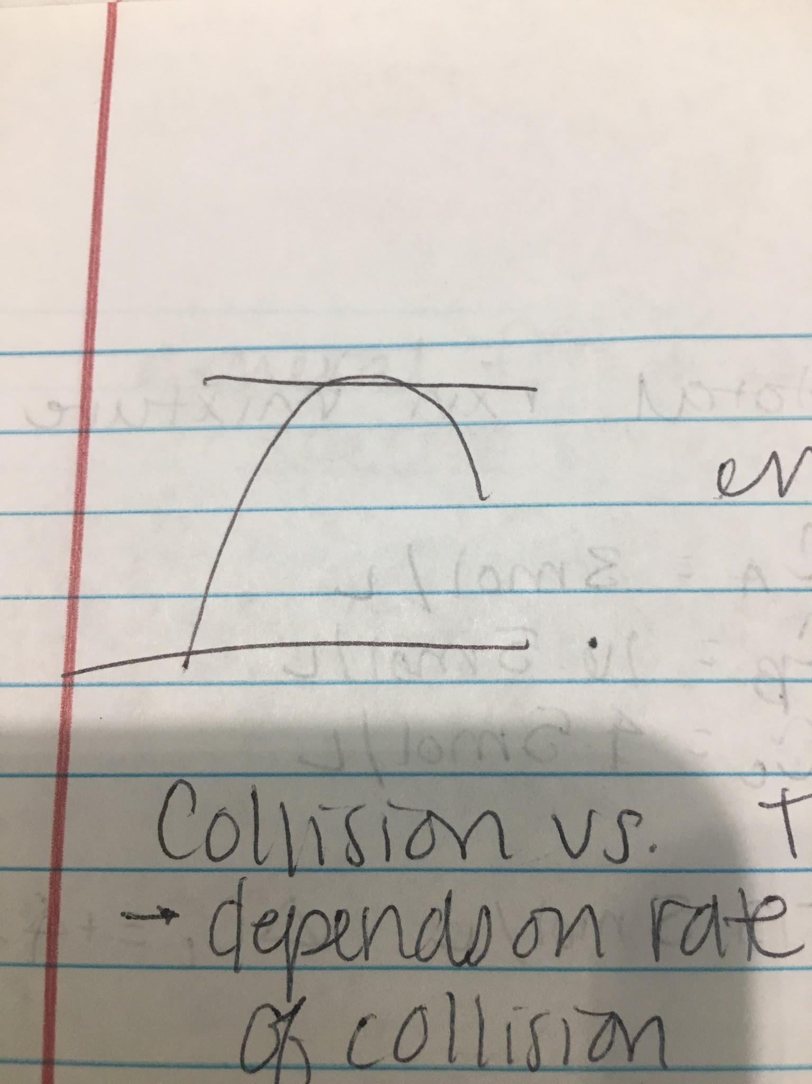

**Collision vs. Transition**

* Dependent on rate of collision
* Transition has no effect on rate
* Transition state dominant
* Rate depends on decomposition into products

Units of Reaction Rate: # moles/ reactant / product consumed/produced per unit time/volume

Ri = 1/V * dNi/dt

**Rate Equation:**

aA + bB --> rR + sS

-rA/a = -rB/b = rR/r = rS/s

A + B --> C

-rA = kCACB

K units: mol/(s*m3) = 1/s