**Arrhenius’ Law**

Reaction rate rA=1/V * dNA/dt

* Activation energy, temperature, gas constant
* Composition-dependent term, rate constant

= f1(temperature) * f2(composition) = k * f2(composition)

k = k0e-E/RT

R = 8.314 J/mol*K

T = absolute temperature

E = activation energy

As T --> ∞, k --> k0

As T --> 0, k --> 0

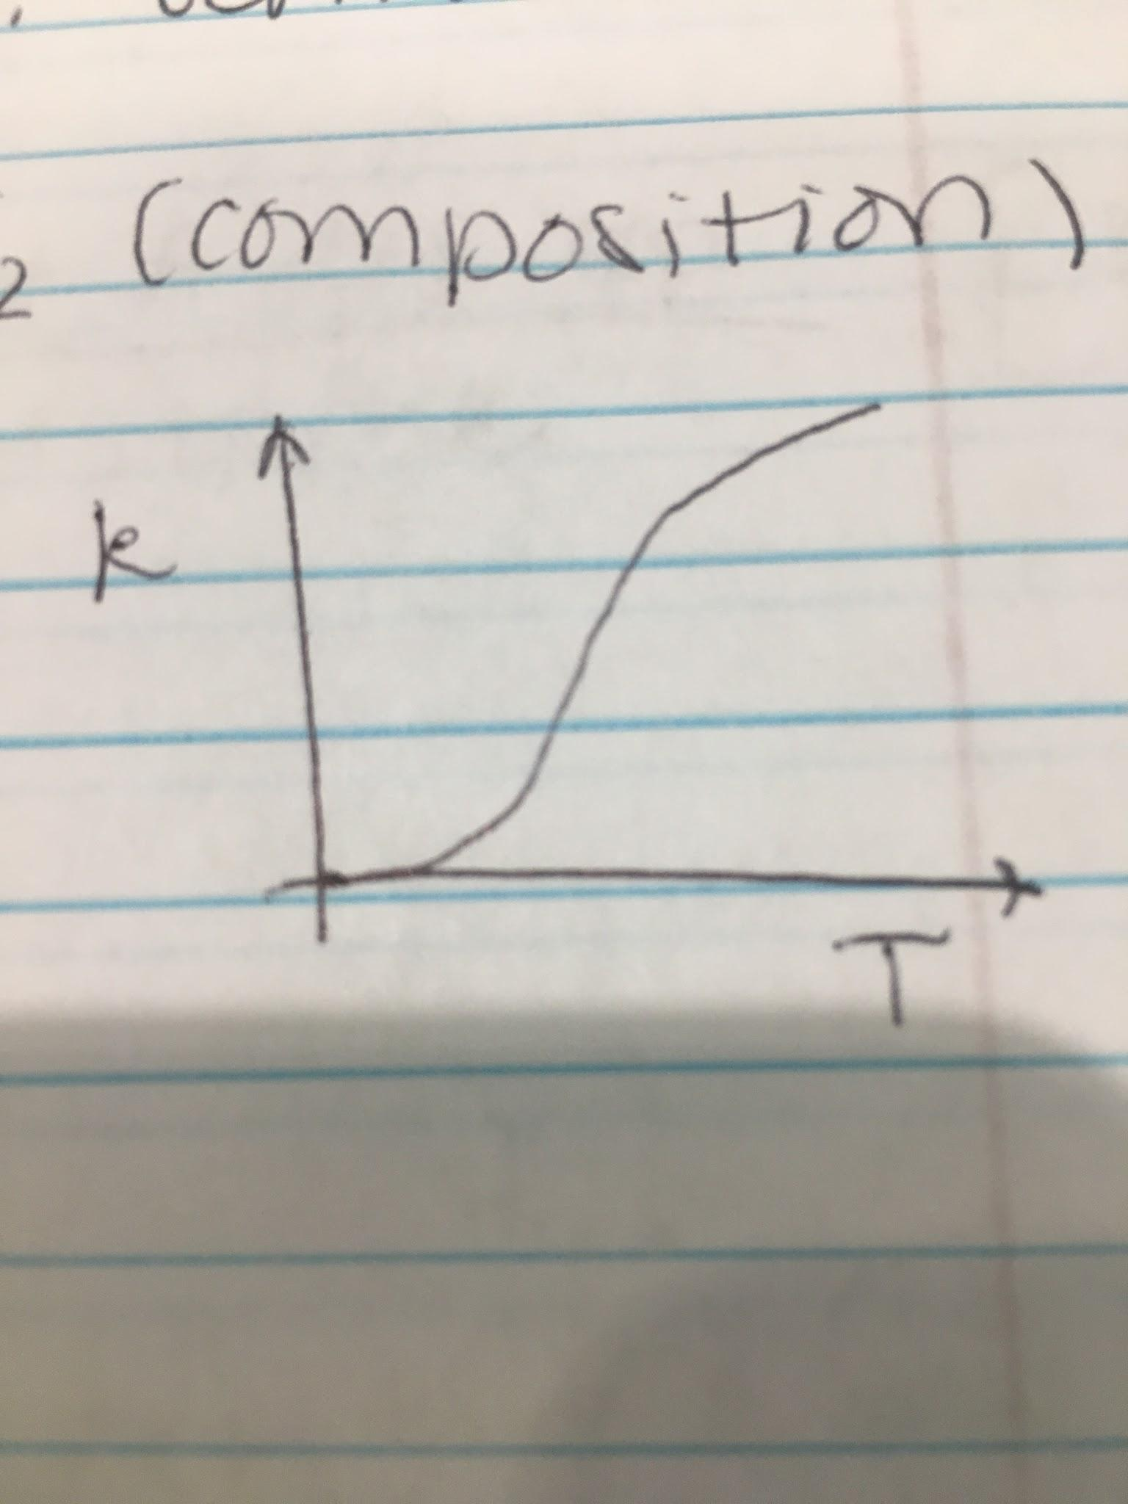

ln(k) = ln(k0) - E/RT

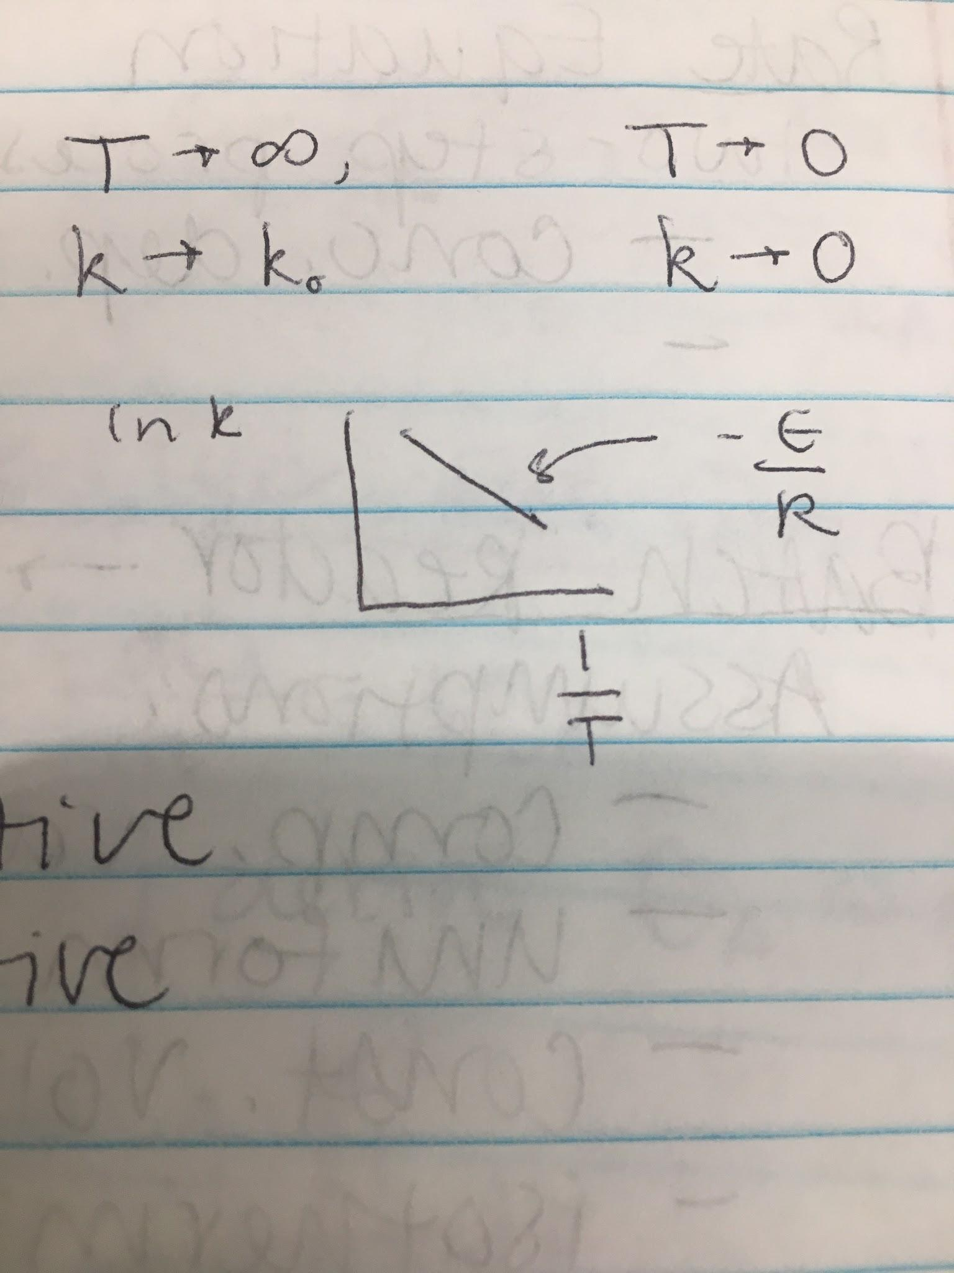

**Temperature Sensitivity**

E ↑, reaction very temperature sensitive

T ↓, reaction more temperature sensitive

**Example 1:**

T1 = 63 + 273 = 336 K (time = 30 mins * 60 seconds / 1 minute = 1800 seconds)

T2 = 74 + 273 = 347 K (time = 15 seconds)

ln(r2/r1) = ln(k2/k1) = E/R * (1/T1 - 1/T2) = ln(t1/t2)

E = 422000 J/mol

aA + bB --> rR + sS

-rA/a = -rB/b = rR/r = rS/s

2A + B <--> C

-rA = k1[A]2[B] - 2k2[C]

-rB = 1/2 * k1[A]2[B] - k2[C]

-rC = k2[C] - 1/2 k1[A]2[B]

**Rate Equation**

Two step process:

1. Concentration dependency found at fixed temperature
2. Temperature dependence of rate is found

**Batch Reaction** --> not continuous

Assumptions:

1. Composition varies with time
2. Uniform composition
3. Constant volume
4. Isothermic

Simple

Need very little supporting equipment

Ideal for small-scale experimental studies on reaction kinetics

Constant volume: dNA/V / dt = dCA/dt