**Common Data Curve: Concentration vs. Time**

-r = -dC/dt = kf(c)

**Integral Method**

* Separate variables
* Integrate to generalized model

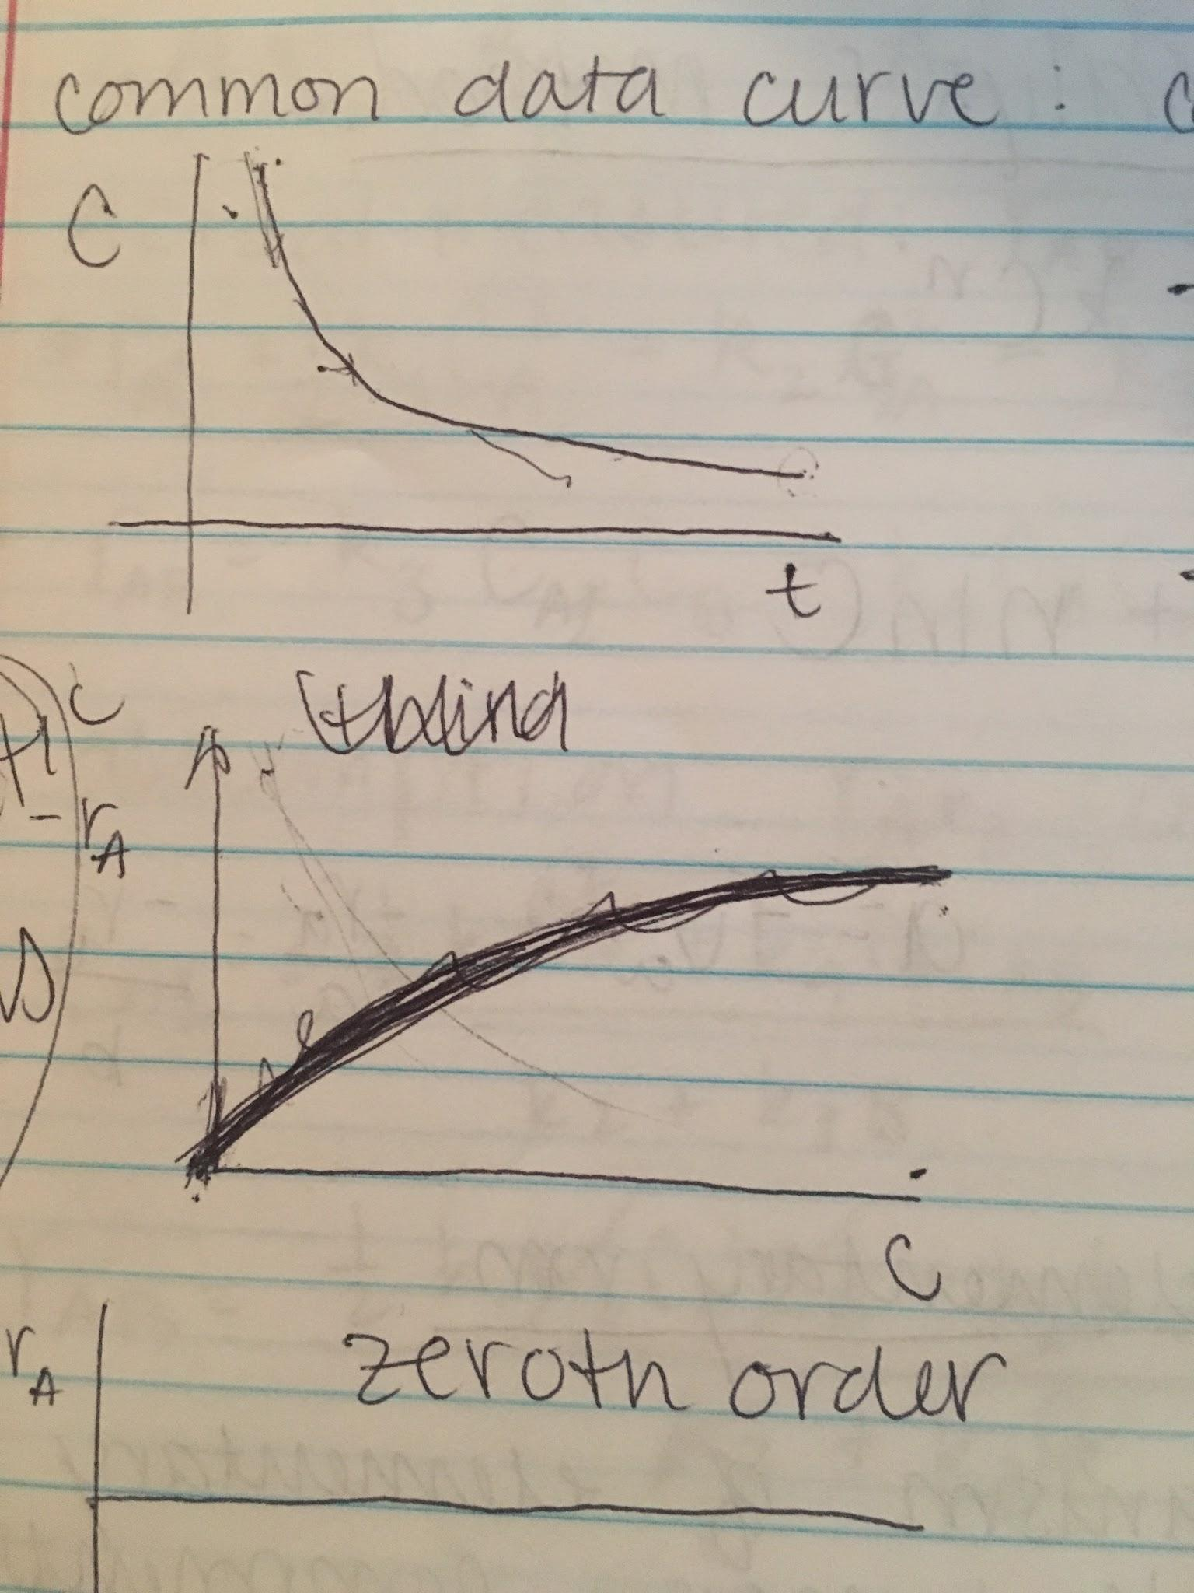

-r = -dC/dt = k

Zeroth Order

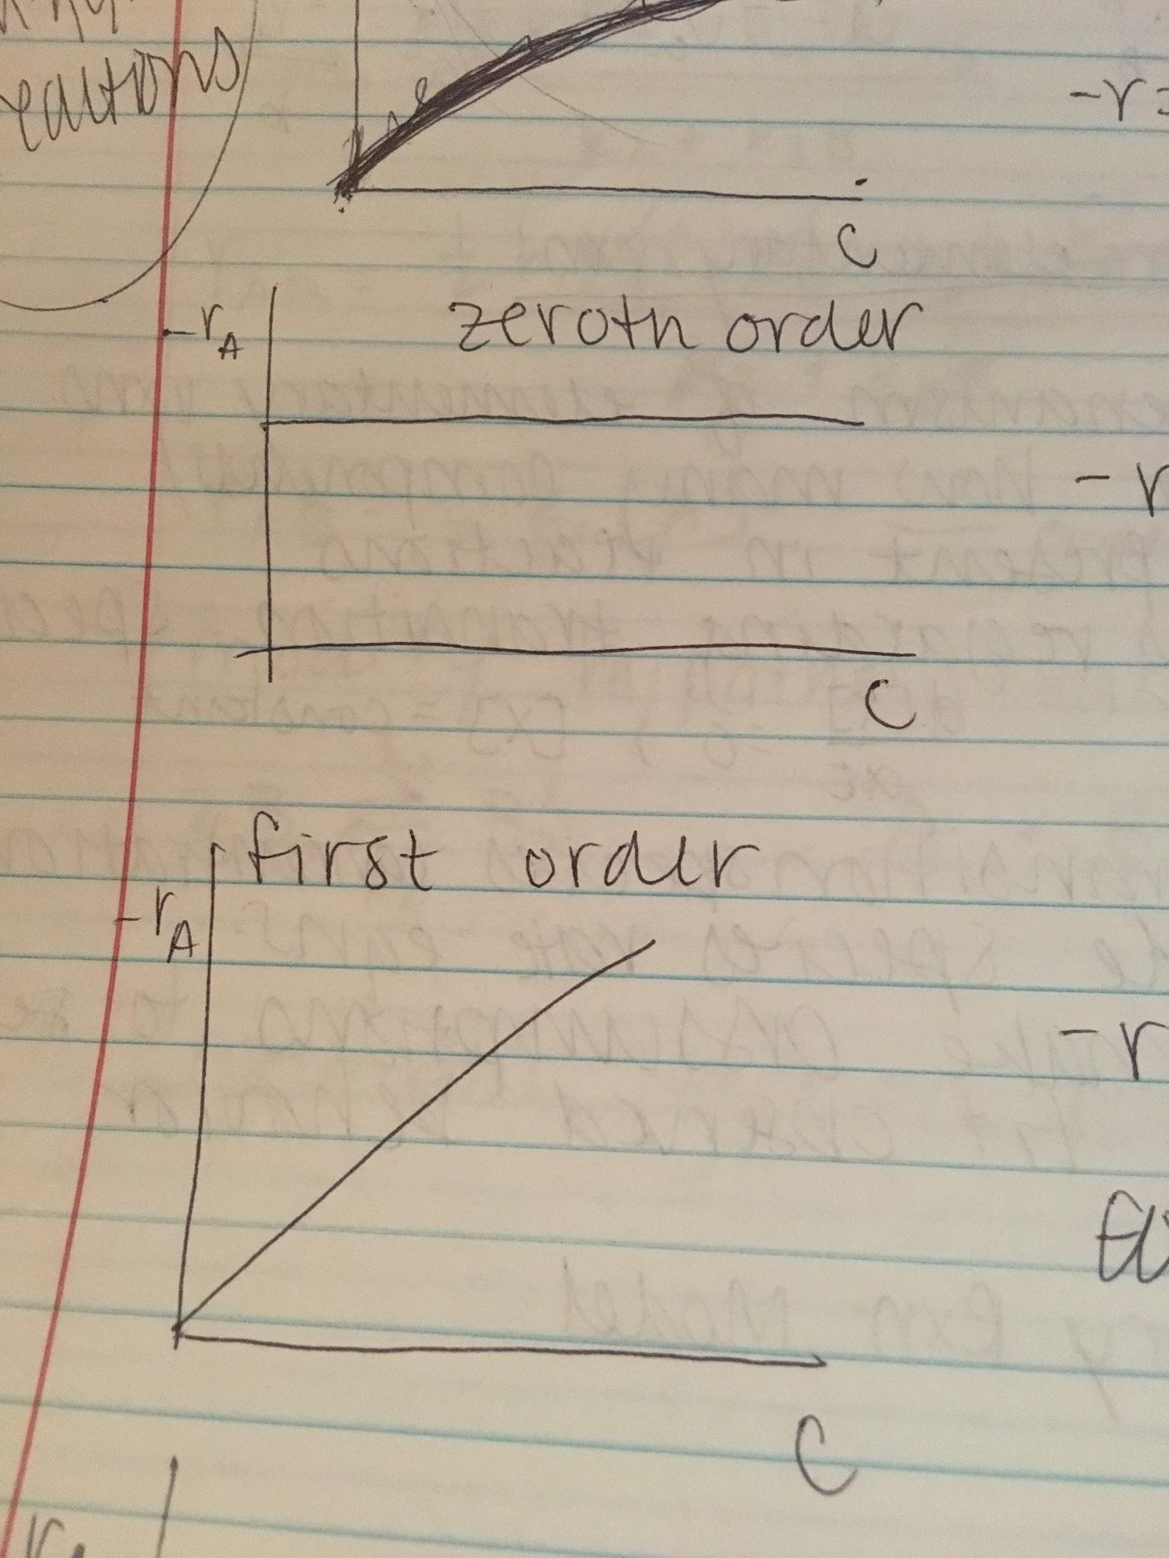

-r = -dC/dt = k

First Order

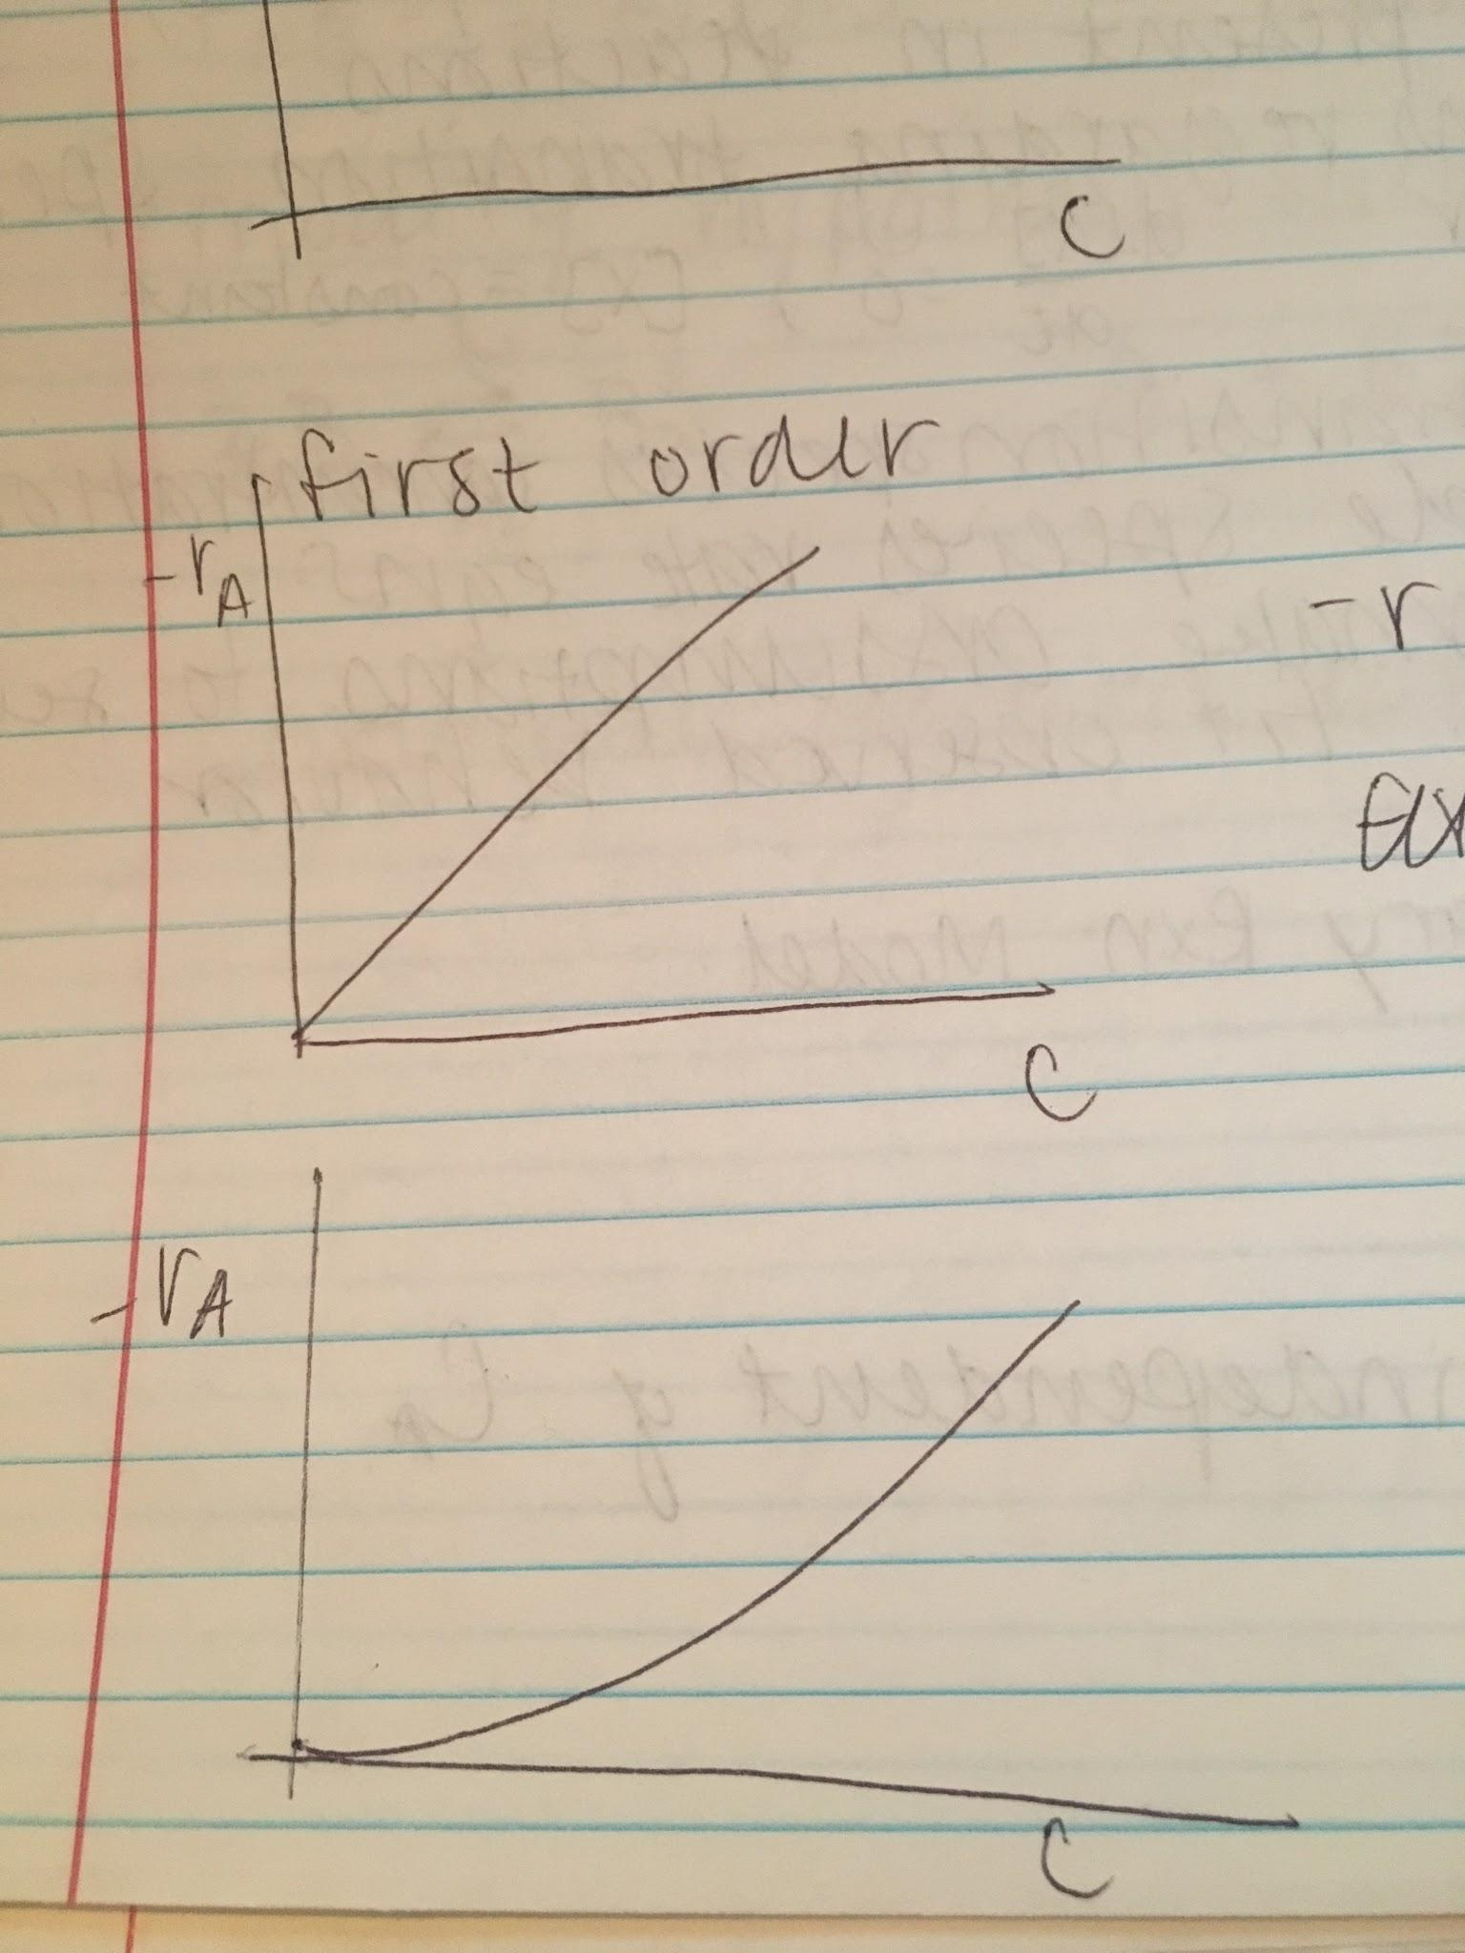

-r = -dC/dt = kC

**Differential Analysis Method**

-dC/dt = k f(c) = kCn

ln(dC/dt) = lnk + n lnC

dCA/dt = kCAaCBb

a = -va

-ra/a = -rb/b

**Complex Non-Elementary Reaction**

1. Propose mechanism of elementary reactions
2. Determine how many components/species are present in the reactions
3. Make assumptions regarding transition species behavior (d[X]/dt = 0, [X] = constant)
4. Solve for transition species concentrations, measurable species rate equations
5. Simplify/Make assumptions to see if rate equations fit observed behavior

**Non-Elementary Reaction Model**

A + B --> AB

rAB = kCB2 -- independent of CA

2A k2<-->k1 A2*

A*2 + B k4<-->k3 A + AB

Actual measured: rAB = kCB2

rA2* = 1/2 k1CA2 - k2CA2 - k3CA2*CB + k4CACAB

rAB = k3CA2*CB - k4CACAB

Assumption: rA2* = 0

CA2* = [1/2 k1CA2 + k4CACAB]/[k2 + k3CB]

To simplify, if k2 is small, A2* --> 2A

rAB = 1/2 k1 [A]2 -- order C is similar

Modify hypothesis such that

2B k2<-->k1 B2*

A + B2* <--> B + AB