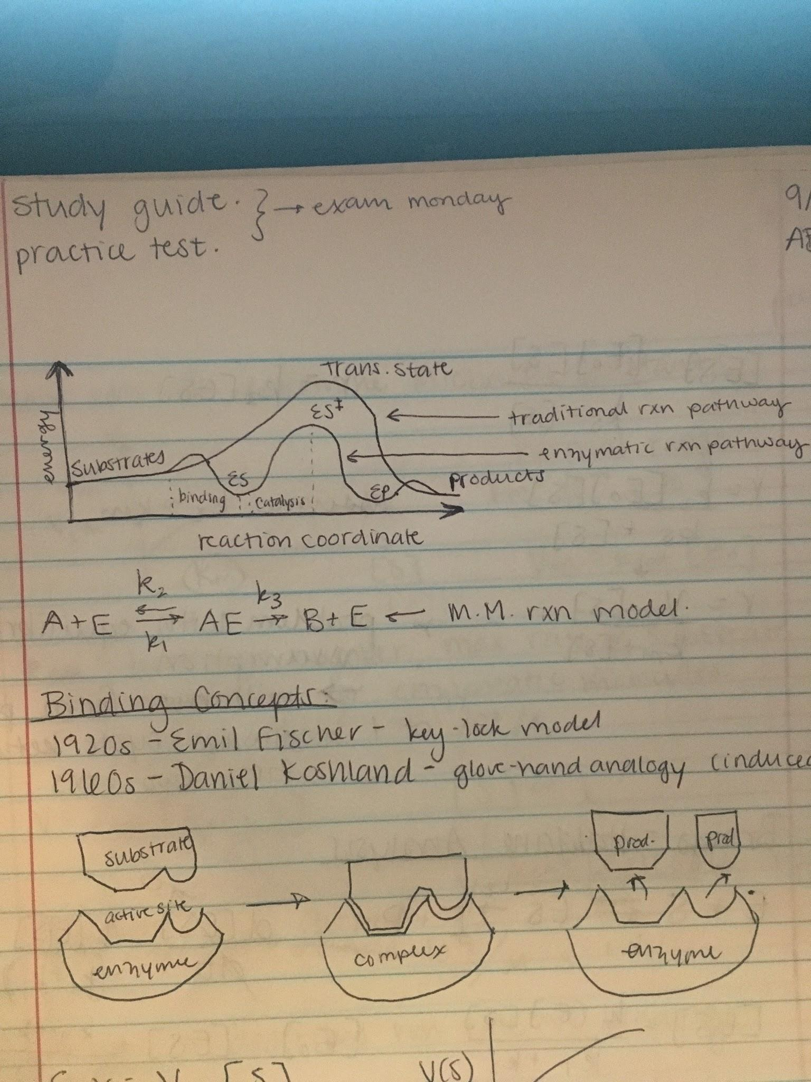

A + E k2<-->k1 AE -->k3 B + E (M & M reaction model)

**Binding Concepts**

1920s: Emil Fischer - key-lock model

1960s: Daniel Koshland - glove-hand analogy (induced fit)



Michaelis-Menten Equation: v = Vm[S]/(Km + [S])

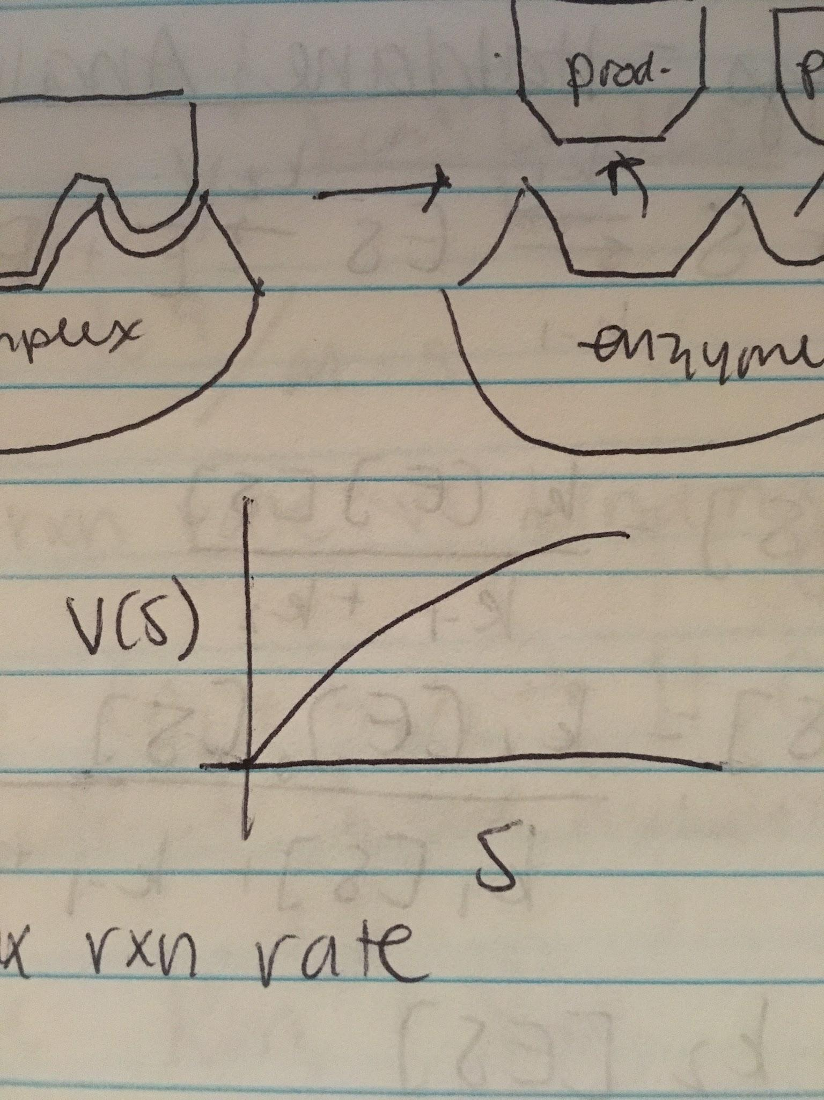

Vm = k3[E0] <-- maximum reaction rate

Km ↑ weak, ↓ strong <-- binding affinity

**M&M Derivation**

E + S k-1<-->k1 ES -->k2 E + P

k1[E][S] = k-1[ES] (equilibrium assumption)

[E][S]/[ES] = k-1/k1 = KS

[E] + [ES] = [E0]

(KS/[S] + 1) [ES] = [E0]

[ES] = [E0][S]/kS + [S]

r = k2[ES] = k2[E0][S]/kS+[S]

Assume kS ~ km

r = Vm[S]/Km + [S]

Problem with equilibrium assumption: will never form product, always cycle between first two reactions

**Briggs-Haldane Analysis**

E + S k-1<-->k1 ES -->k2 E + P

d[ES]/dt = k1[E][S] - (k1 + k2)[ES] = 0

[ES] = k1[E][S]/(k-1 + k2)

[E0] = [ES] + (k-1 + k2)/k1[S] * [ES]

[ES] = k1[E0][S]/(k1[S] + k-1 + k2)

V = k2[ES] = k2[E0][S]/Km + S

Km = k-1 + k2 / k1

Describes binding affinity --> km small = strong binding affinity = k1 large

Vm = k2[E0]

When all enzymes are working on the reaction, Vmax is achieved

**How can we determine the Michaelis Constant?**

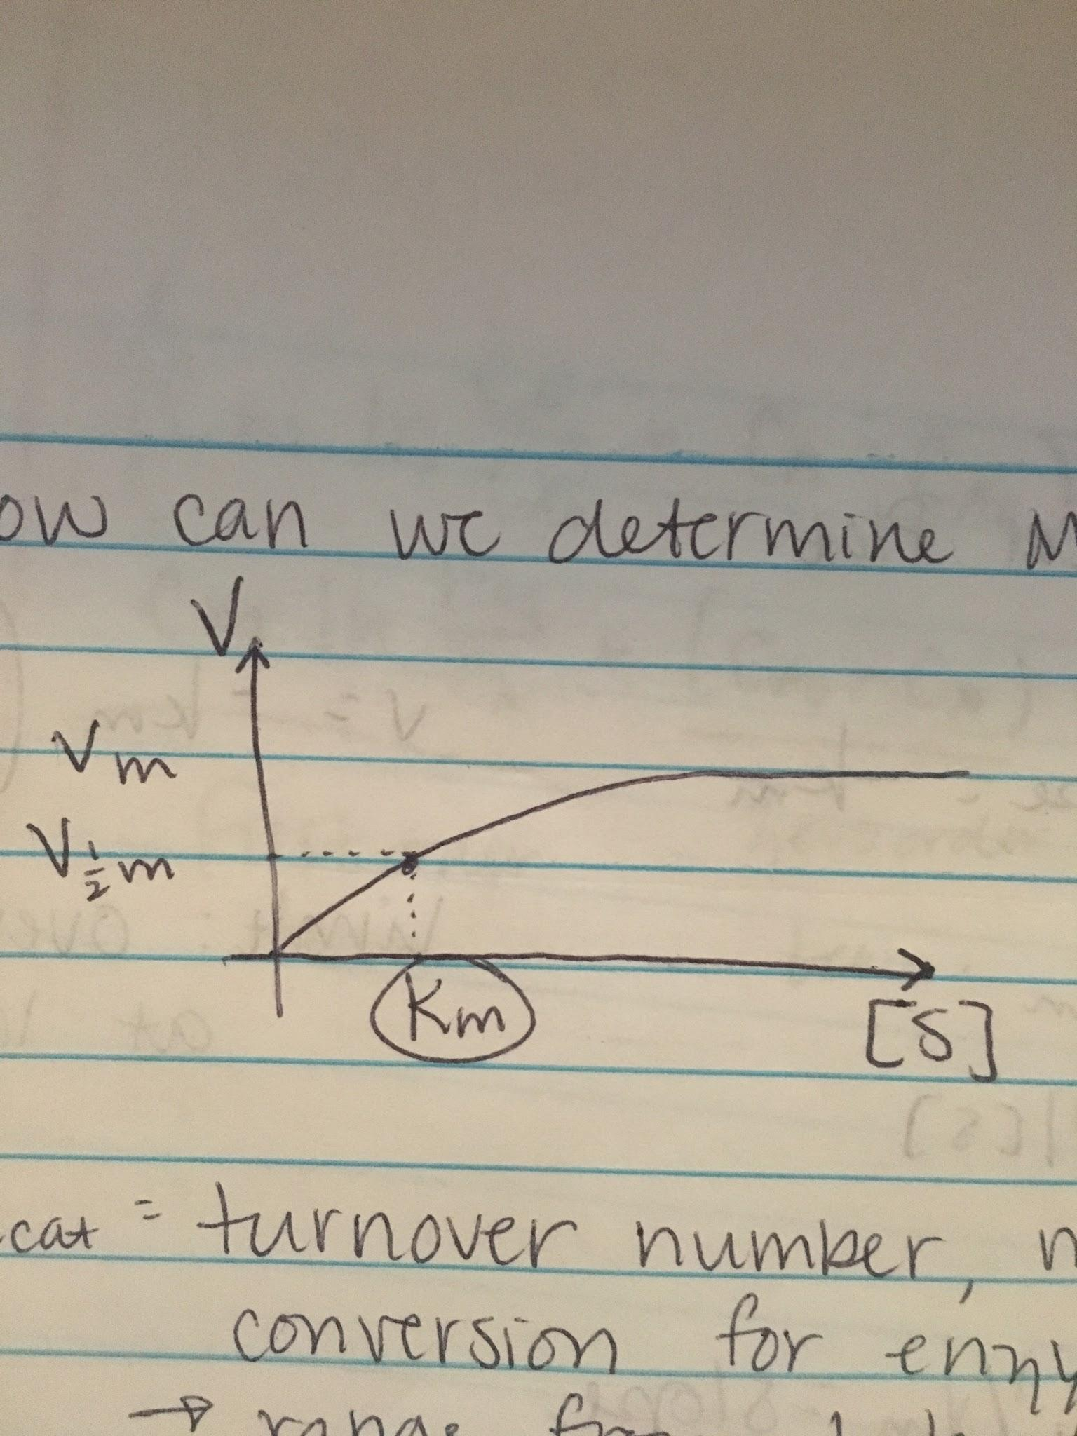

Normal rage: Km = 10-2 - 10-6

Vm = kcat[E0]

kcat: turnover number, max rate of substrate conversion for enzymatic molecules

Range from 1 to 104/s

V = kcat[E0][S]/km + [S]

If [S] << k

V = kcat[E0][S]/km = η[E0][S]

η = catalytic efficiency (describes reaction rate vs binding = kcat/km (average 109/m*s)

**Ways to Determine Km and Vm**

Linearized model: Lineweaver-Burke model

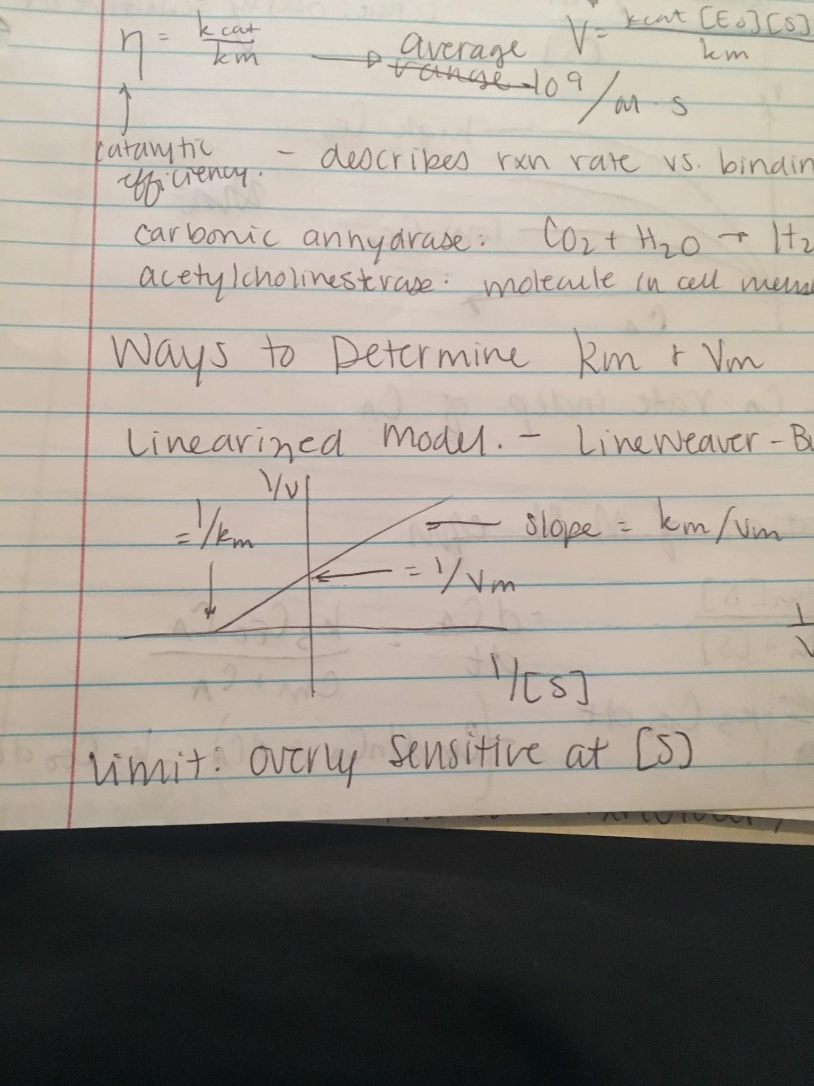

1/V = Km/Vm * 1/[S] + 1/Vm

Limit: overly sensitive at low [S]

Eadie-Hofstee Linear Plot

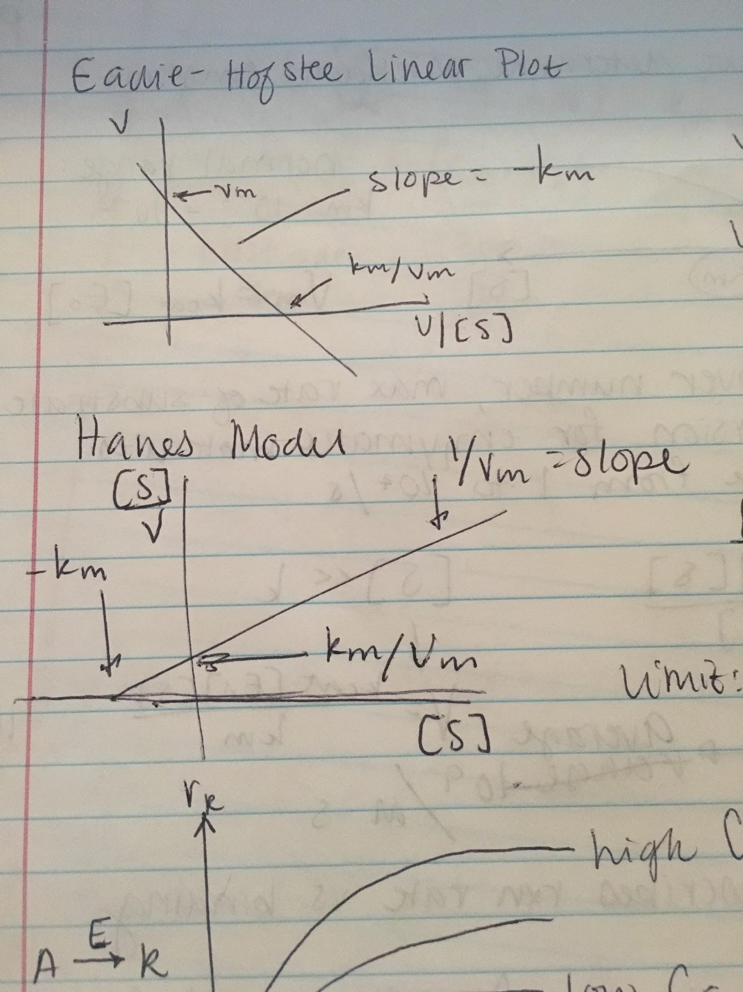

V = -km * V/[S] + Vm

Limit: overly sensitive at low [S]

Hanes Model



[S]/V = [S]/Vm + km/Vm

Limit: overly sensitive at low v

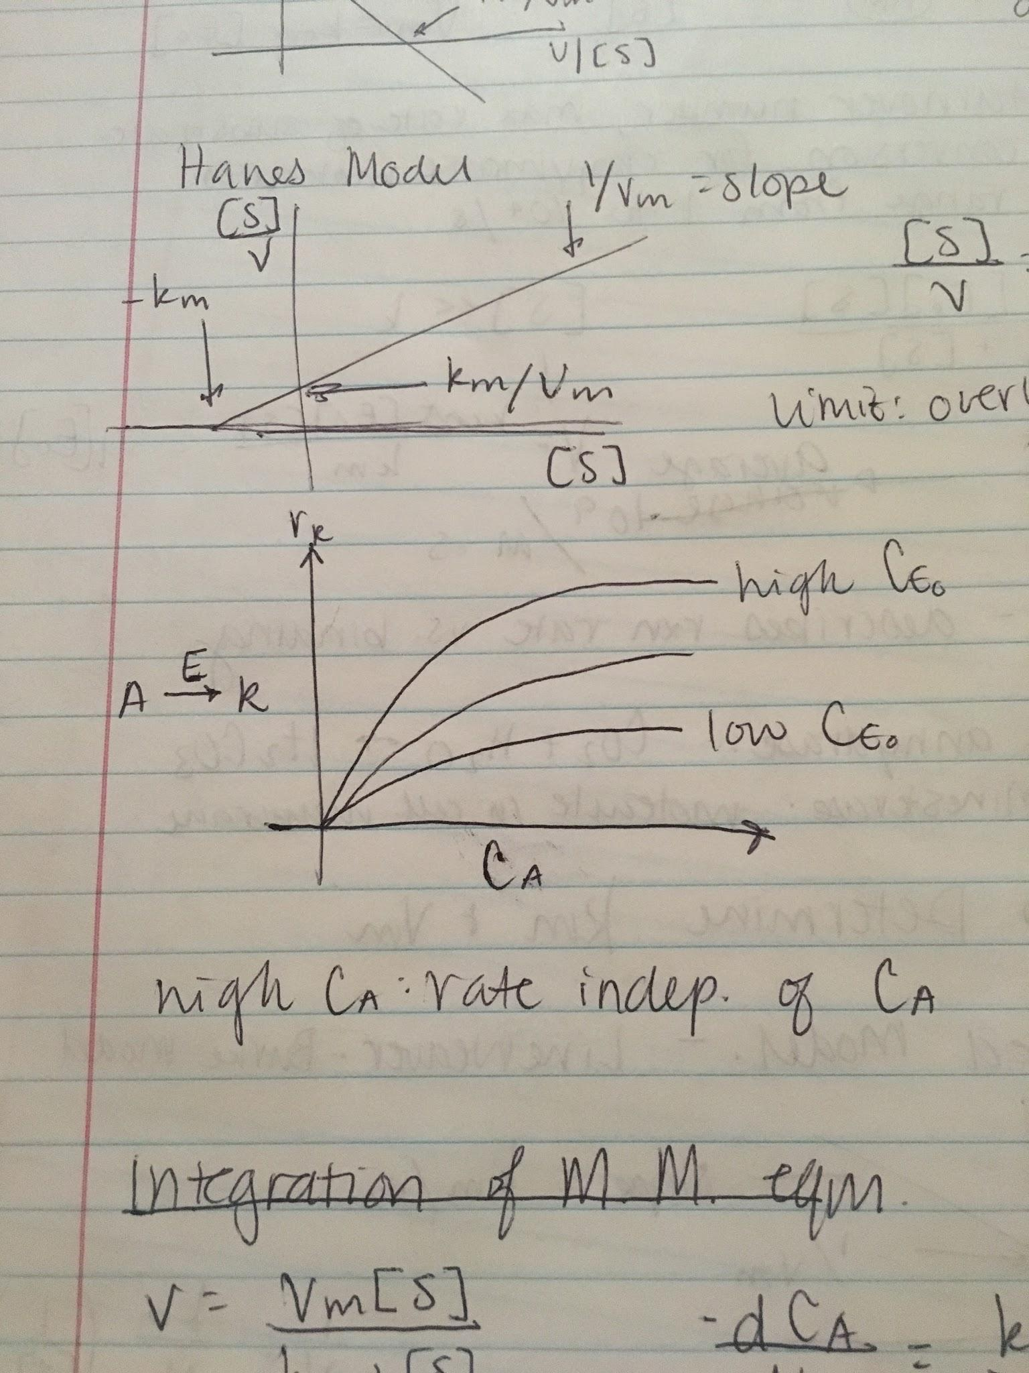

High CA: rate independent of CA

**Integration of M&M Equation**

V = Vm[S]/km+[S]

-dCA/dt = k3CE0CA/CM + CA

∫CA0CA -(Cm + CA)/CA dCA = ∫k3CE0dt

-(Cm dlnCA +dCA) = k3CE0dt

-(Cm ln(CA/CA0) + CA - CA0) = k3CE0 dt

Cm ln(CA0/CA) + (CA0 - CA) = k3CE0t

First order term, second order term