**Uncompetitive Inhibition**

Conformational change required

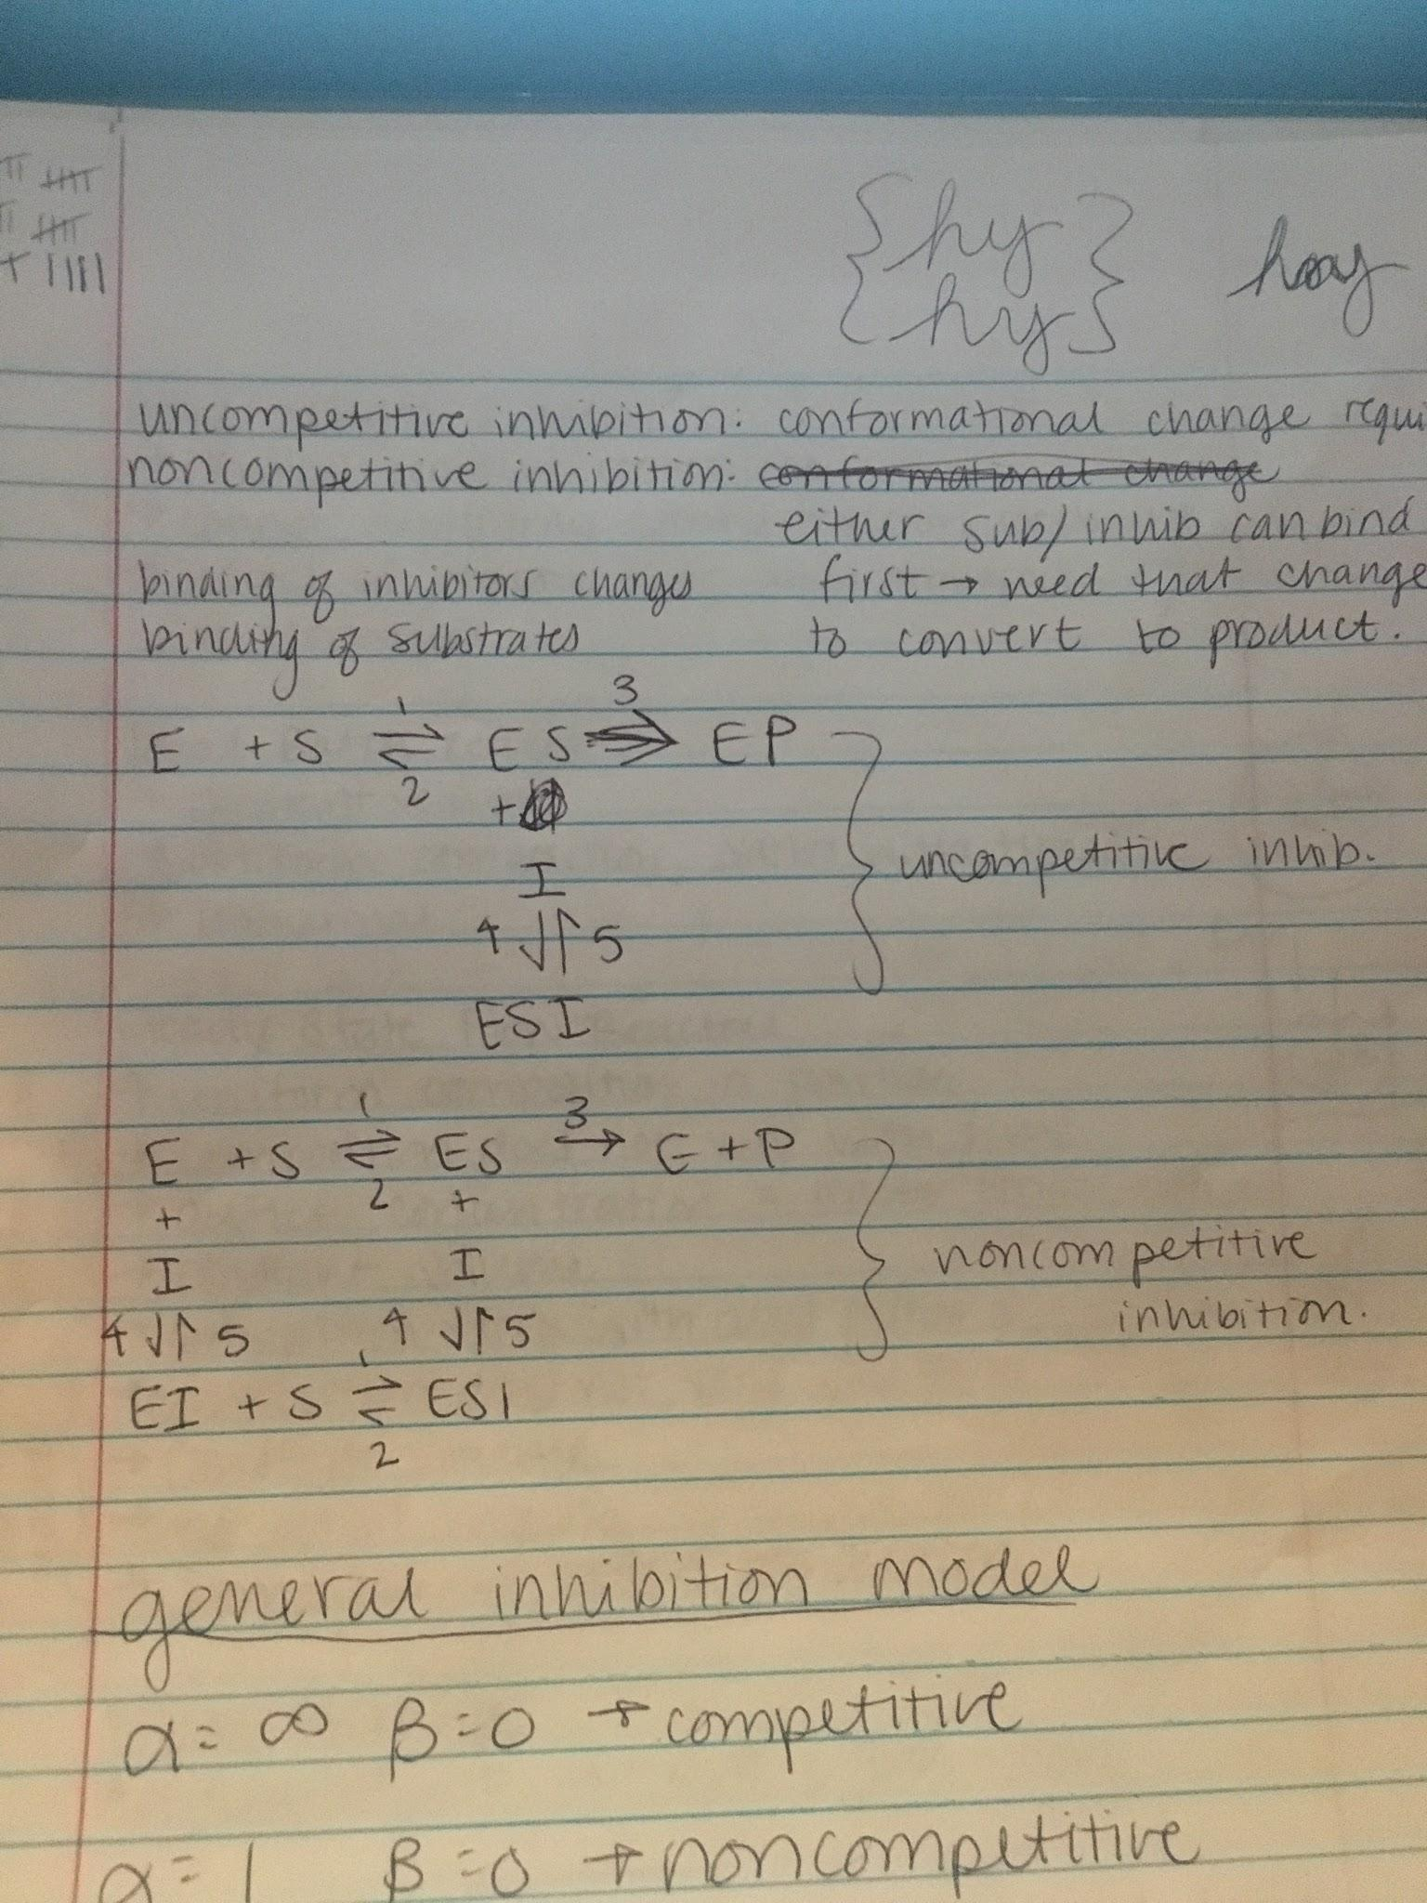

**Noncompetitive Inhibition**

Either substrate or inhibitor can bind first ---> need that change to convert to product

Binding of inhibitors changes binding of substrates



**General Inhibition Model**

α = ∞, β = 0 --> competitive

α = 1, β = 0 --> noncompetitive

**Substrate Inhibition Model (Product Inhibition)**

Enzyme: primary active site binds to substrate, secondary active site does not have as much affinity

Substrate-Induced Inhibition