**PFR Assumptions**

* No axial mixing
* Concentration changes with position
* Radially homogeneous
* Steady state

𝜏 = V/v0 = VCA0/FA0 = CA0∫0XAf-1/rA dXA = **-∫CA0CA -1/rAdCA** (performance equation for PFR)

MFR-reaction rate homogeneous throughout geometry

**MFR**:

FA0 = FA - rAV

FA0 = CA0v0

FA = FA0 (1 - XA)

𝜏 = V/v0 = C0-C/-r (performance equation for MFR)

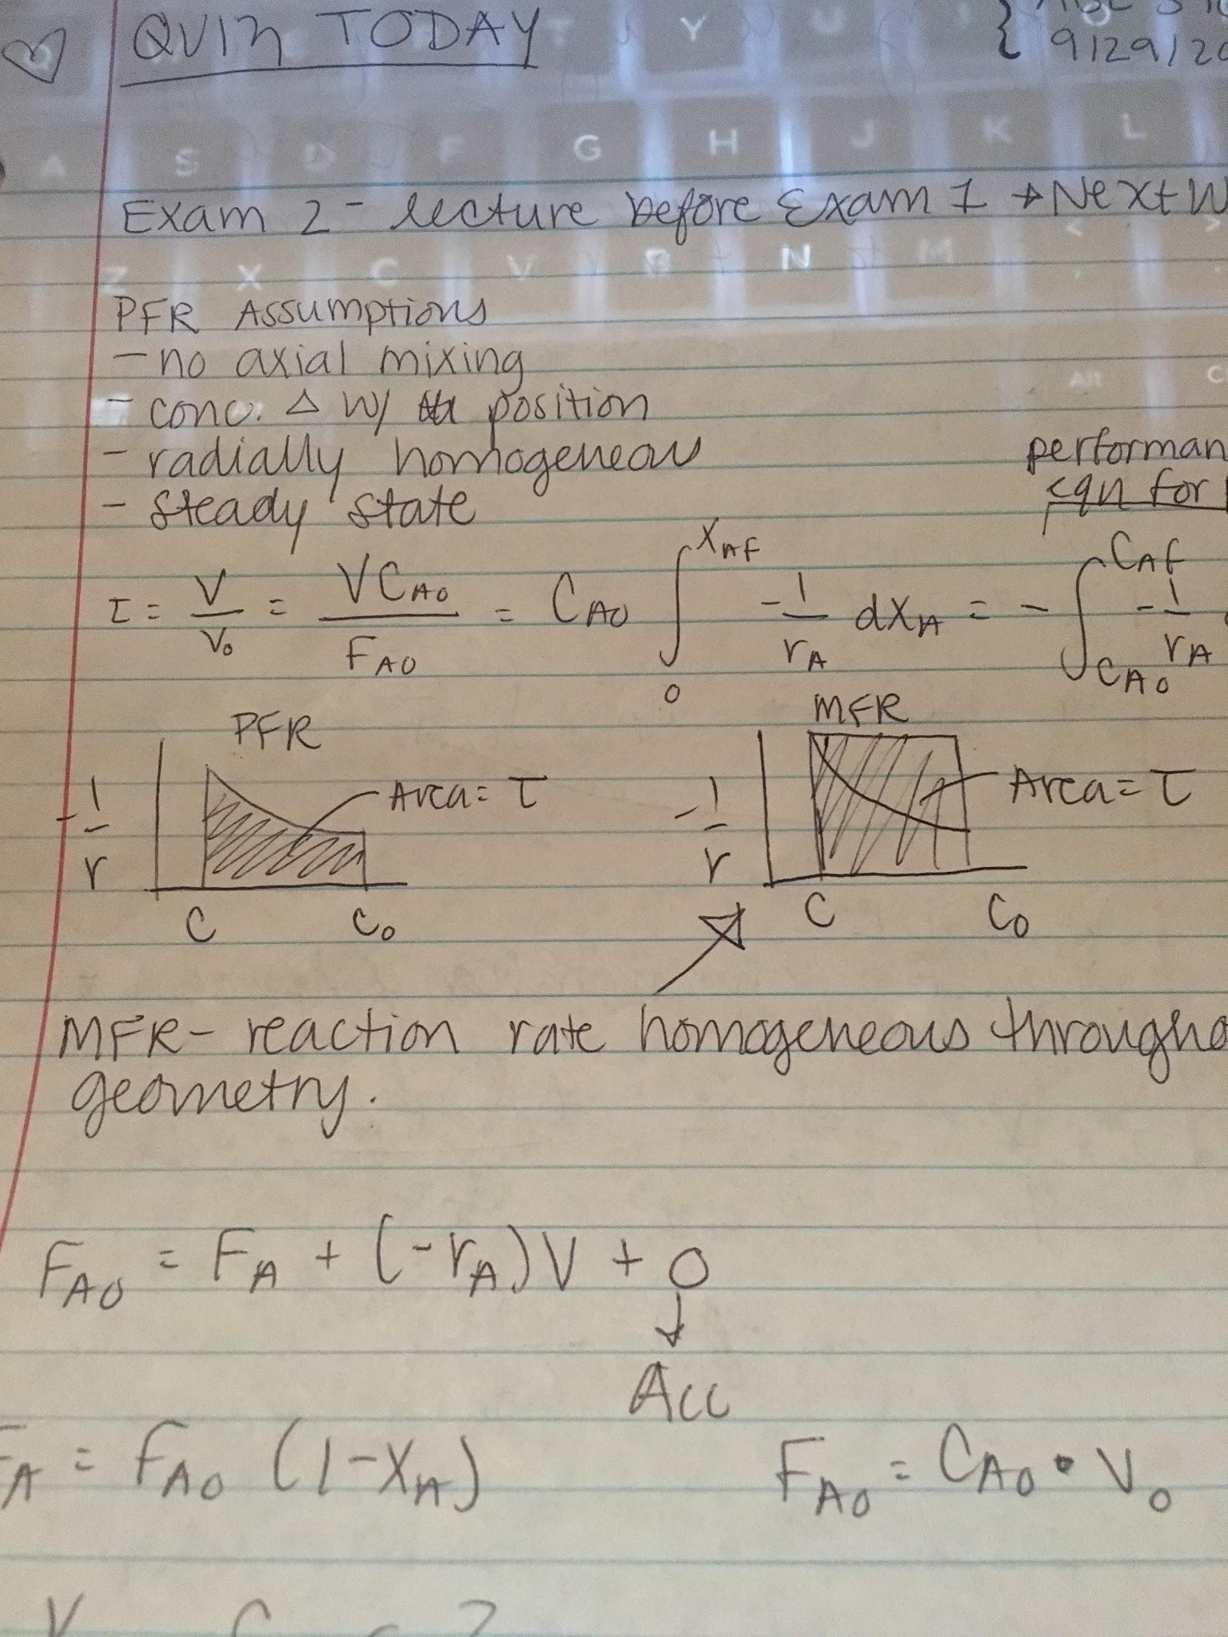

𝜏m/𝜏p: always greater than 1

As reaction order is increased, the ratio increases, 𝜏p gets better

Constant density assumption

* Constant flow rate

System that changes density, volume

* Expansion factor: εA = VXA=1 - VXA = 0/ VXA=0

V = 120 L

Order: 2nd

-r = kC2

𝜏p = ∫C0C dC/r (plug above equation into r)

V = 600 L

OUtlet concentration of species A?

Second order

𝜏 = V/q

k𝜏 = CA0-CA/CA2

XA = 1 - CA/CA0

Nth Order

MFR:

k𝜏 = CA0-CA/CAn = XA/CA0n-1(1-XA)n

PFR:

(n-1)CA0n-1k𝜏 = (CA/CA0)1-n - 1 = (1-XA)1-n - 1

N≠1, assume εA = 0