ABE 460

Lab 1: Introduction to Process Control Systems and Simulink

Kathryn Atherton

August 20, 2018

Monday

Modeling dynamic systems is important to learn how to control and mitigate disturbances and keep the system operating in the most efficient manner. Block diagrams are one way to represent the relationships between processes in a system. Programs such as Simulink on MATLAB use block diagrams to model a system so that one can make decisions about machinery and order of processes before implementing them, which saves time and money.

In this lab, a closed loop block diagram was used to represent a system in which a man controls a steam valve to control the temperature of cold water being heated by the steam. The basic parts of a block diagram and a closed loop system were introduced. Next, differential equations were introduced as a way to mathematically model a water tank being filled and emptied. Finally, Simulink was introduced and used to model the water tank system, creating graphical representations of different scenarios pertaining to the system.

When modeling the water tank system on Simulink, two different flow rates were considered, 500 ft3/s and 1 ft3/s. The model was run with both values and graphs of the models were created for time 0 until the system became stable. The graphs showed that the maximum potential flow rate was not used in the scenario with the flow rate of 500 ft3/s and reached a steady liquid level in under ten seconds whereas the maximum potential flow rate was used in the other scenario and reached the same steady liquid level in about 16 seconds.

As such, although the scenario with the larger flow rate performs the task in less time, it was concluded that the scenario with the smaller flow rate is more ideal to purchase as it uses all of its potential to perform the task. The machinery used in this scenario would likely be less costly and more cost-effective.

1. It is most appropriate for the system to be a fail-close system so as not to continuously heat the water, creating an output of water that is too hot.
   * Control objectives: heat cold water with steam
   * Process (dynamic system): heat exchanger
   * Controller: man
   * Sensor: man’s right hand & brain
   * Actuator: man’s left hand opening/closing steam valve
   * Disturbance: cold water
2. Block diagram: 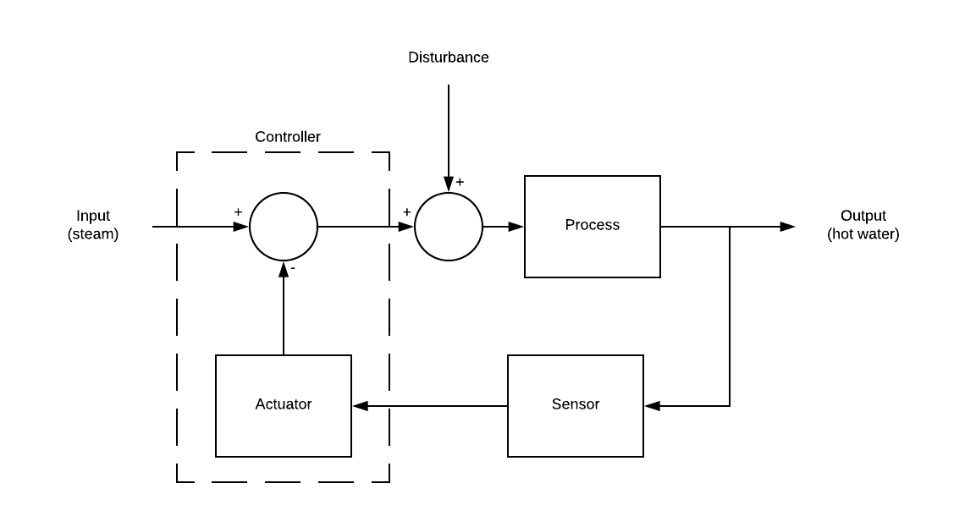

*Figure 1: Block diagram of water heating system*

1. The height of the water in the tank is related to the rate of water being pumped into the tank, the rate of water exiting the tank, the resistance to flow exiting the tank, and the dimensions of the tank.
   * Governing equation for the tank: rate in - rate out = change in volume in tank
   * Change in volume in tank = cross-sectional area * change in height of water
   * Rate in = qin
   * Rate out = qout = h/R (Lumkes, 2014, p 57)
     + R = 10 s/ft2
   * Cross-sectional area = C = 9 ft2
   * Change in height of water = dh/dt
   * Final equation: **dh/dt = (qin - h/R)/C**
     + substituted given values: dh/dt = (qin - h / 10 s/ft2) / 9 ft2
2. MATLAB Simulink Portion
   * Simulink Block Diagram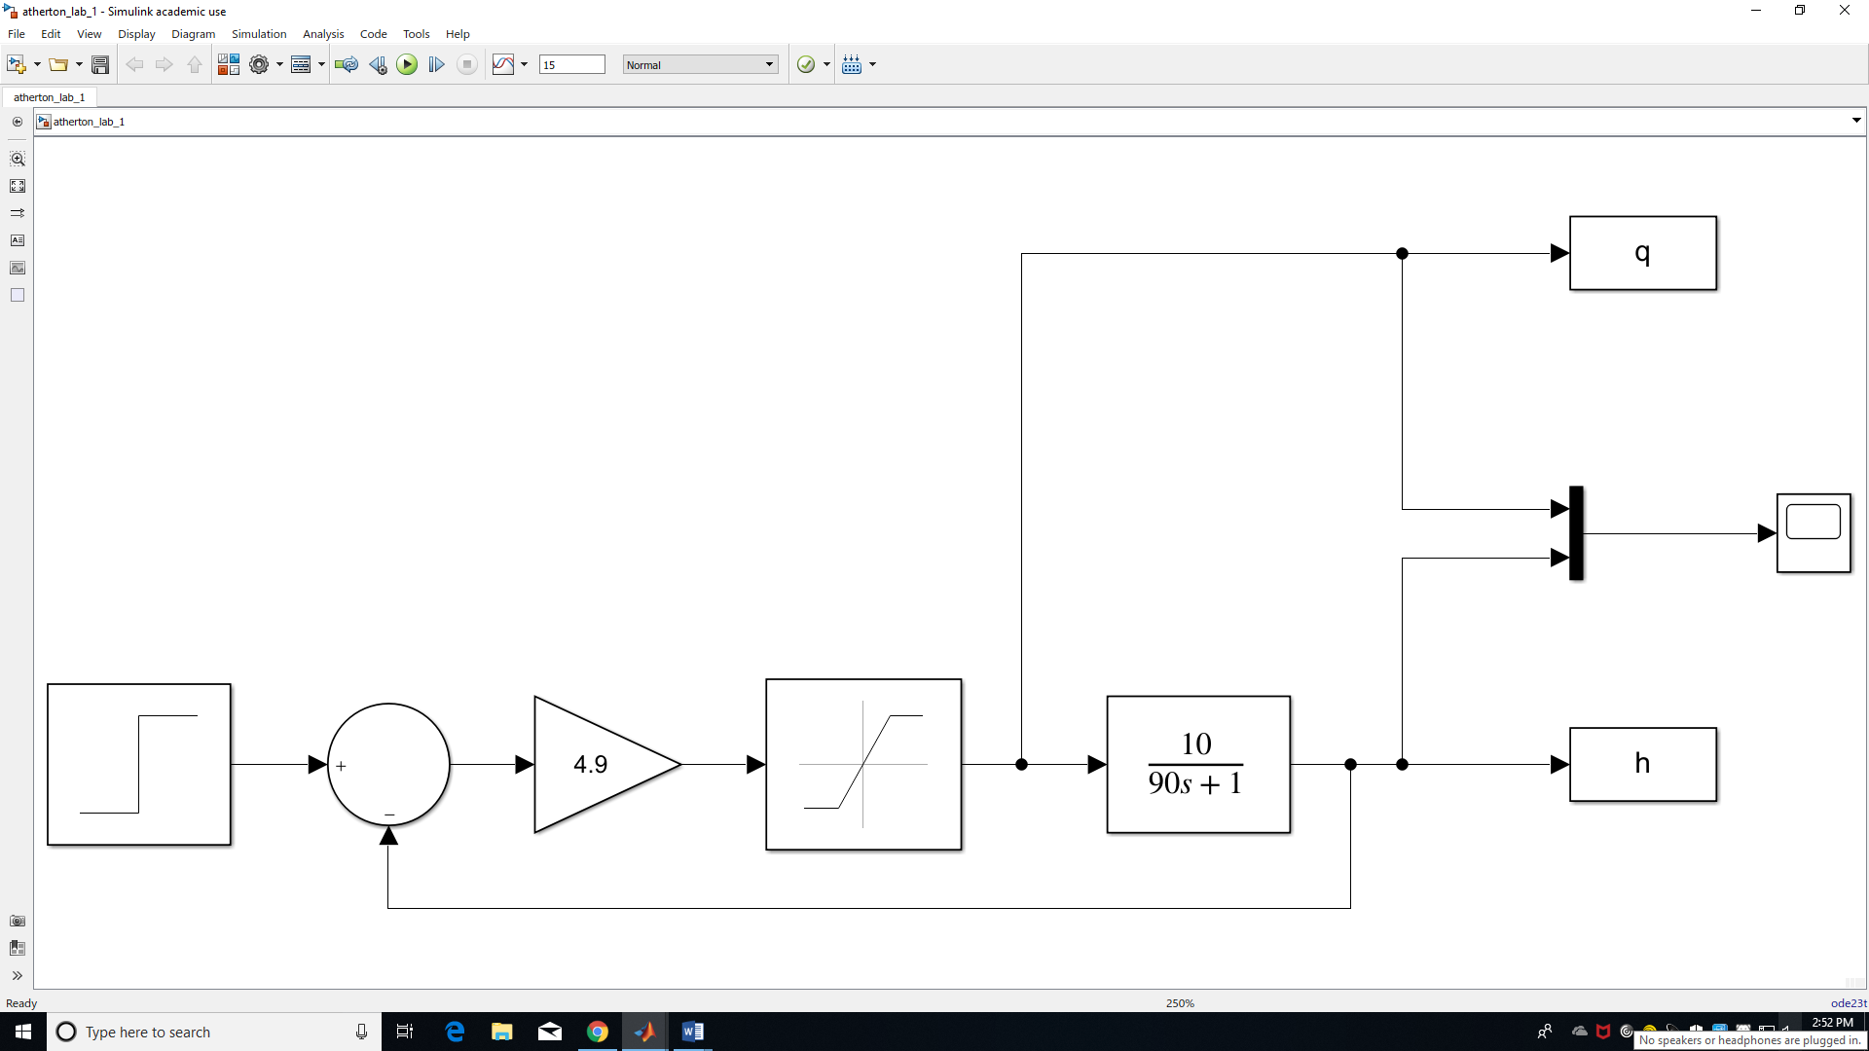

*Figure 2: Simulink block diagram of water filling system*

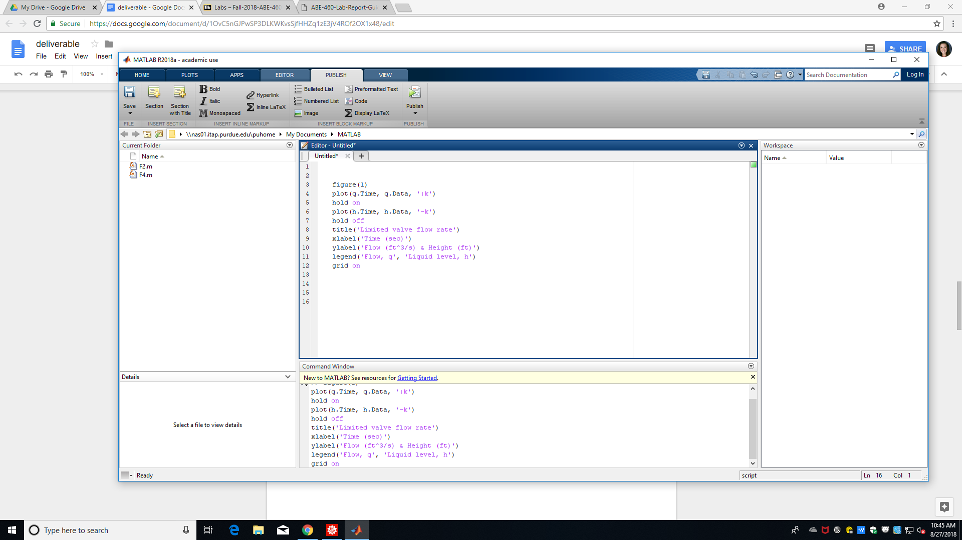

*Figure 3: MATLAB code to plot modeling of water filling system*

* + Graph for when the maximum valve flow rate is 500 ft3/s 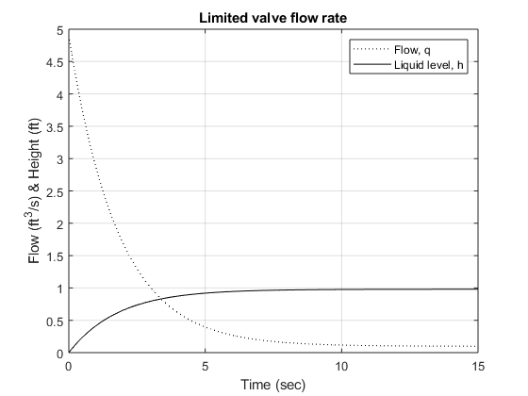

*Figure 4: Flow and height vs time for scenario with maximum flow rate of 500 ft3/s*

* + Graph for when the maximum valve flow rate is 1 ft3/s 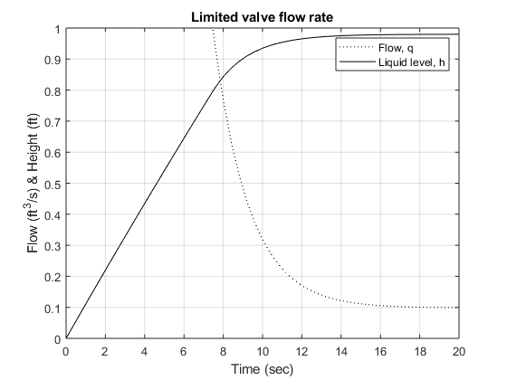

*Figure 5: Flow and height vs time for scenario with maximum flow rate of 1 ft3/s*

* + The simulation using the larger maximum flow rate reaches a steady flow rate in under 10 seconds while the smaller maximum flow rate took about 16 seconds to do the same. Both simulations maintained a liquid level of just under 1 foot. Again the simulation with the larger flow rate reached a steady liquid level in under 10 seconds while that with the smaller flow rate took about 16 seconds. While the system with the flow rate of 500 ft3/s operates much more quickly, it appears to never require its maximum flow rate to perform the task of maintaining a liquid level of 1 foot; as such, purchasing this system would most likely waste money when the other system can perform the same task in just a few more seconds.

References

Lumkes, J. (2014). *Control Strategies for Dynamic Systems: Design and Implementation* (p. 57).