ABE 460

Lab 2: Analog & Digital Sensors and A/D Conversion

Kathryn Atherton

August 27, 2018

Monday

Most systems today have a mixture of analog and digital signals; as such, in order to effectively control a system, these signals must be converted between one another to ensure that each step in a process receives the type of signal it can understand. Analog signals are typically converted to digital signals by sampling the analog signal at a particular frequency, which can greatly affect how accurate the digital signal is in representing its analog counterpart. In this lab, the effects of altering the sampling frequency of a system were analyzed by changing the sampling frequency and phase of a sine wave.

1. Measuring a system slowly captures little information and does not provide much detail about the system. While measuring a system more quickly is more beneficial for controlling the system, it is more costly. Thus, determining a frequency of measurement which captures as much of the system information as possible while maximizing the time between measurements is important for minimizing the cost of effectively controlling a system.

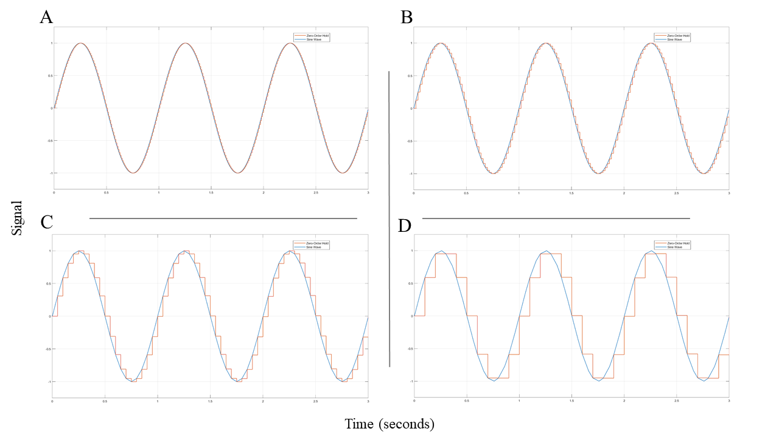

*Figure 1: Analog signal (blue sine wave) and sampled signal (orange zero-hold order line) plotted over time with a phase of 0. The sampling time for each graph is A) 0.01 s, B) 0.02 s, C) 0.05 s, and D) 0.1 s. As sample time increases, the frequency of sampling the analog signal decreases and the sample signal becomes less and less accurate to the original analog signal.*

1. The input signal has a frequency of 1 Hz; as such, the Nyquist Frequency for the input signal is 2 Hz, which requires sampling the signal every 0.5 seconds. In order to detect the entire amplitude of the input signal, it would be beneficial to add a phase of π/2.

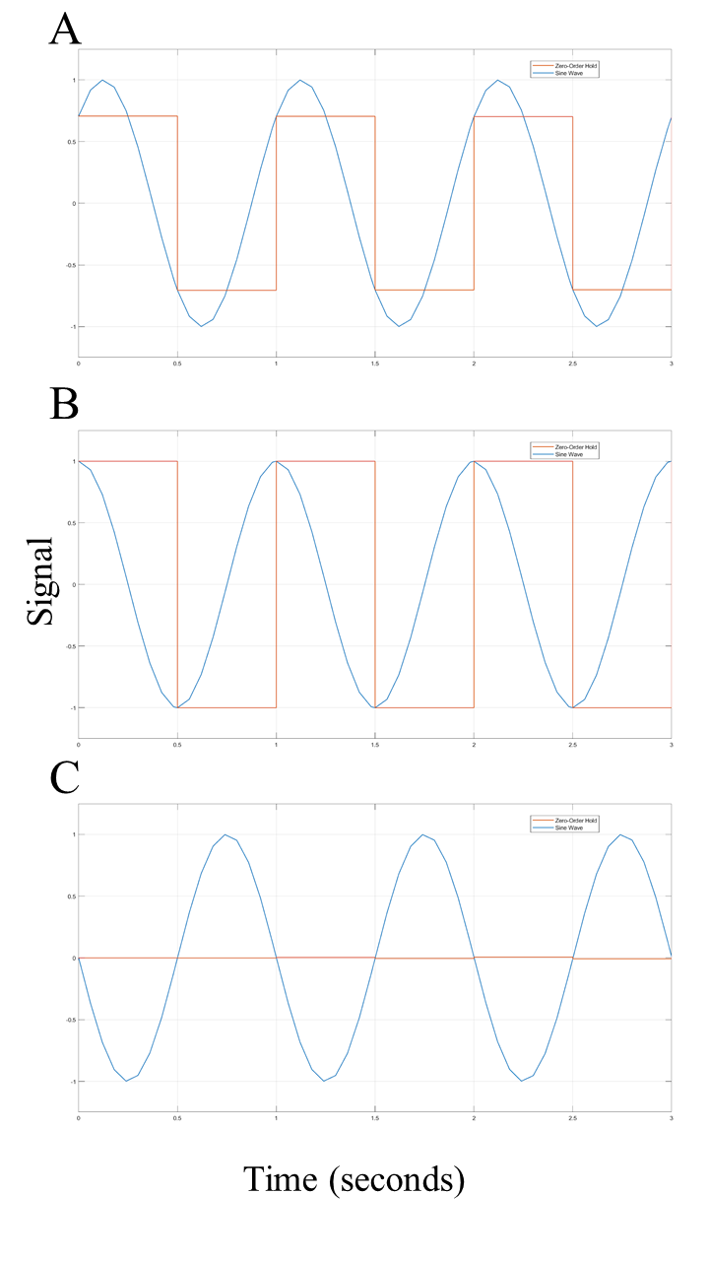

*Figure 2: Analog signal (blue sine wave) and sampled signal (orange zero-hold order line) plotted over time with a sampling time of 0.5 s. The sine wave phase for each graph is A) π/4, B) π/2, and C) π. In order to capture the entire amplitude of the sine wave, a phase of π/2 is required.*

When the sampling time was slower than the Nyquist Frequency, the entirety of the signal was not detected and when the sampling frequency was equal to the input signal frequency, no oscillation was detected over the entire time the model was conducted.

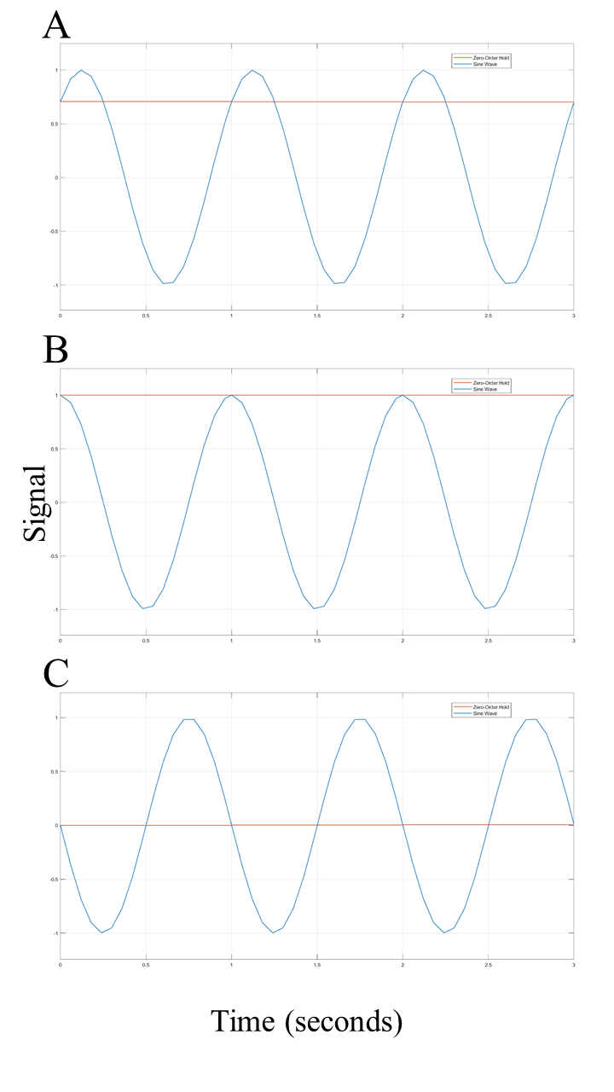

*Figure 3: Analog signal (blue sine wave) and sampled signal (orange zero-hold order line) plotted over time with a sampling time of 1 s. The phase of the sine wave for each graph is A) π/4, B) π/2, and C) π. As the phase of the sine wave changes, the starting position of the sine wave at t=0 moves vertically. The sampled signal shows no oscillation, but stays in the same position as the starting position of the sine wave throughout the entire time.*

A minimum ‘good sampling frequency’ that captures the oscillating shape is 2 times the Nyquist rate, or 4 times the input signal frequency.

*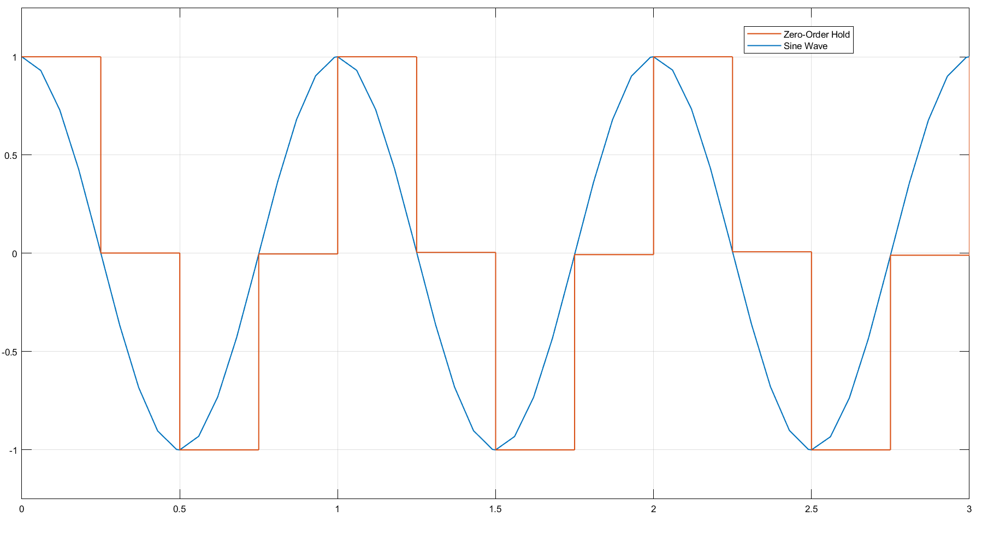*

*Figure 4: Analog signal (blue sine wave) and sampled signal (orange zero-hold order line) plotted over time with a phase of π/2 and a sampling time of 0.25 s.*

1. Re-drawn block diagram:

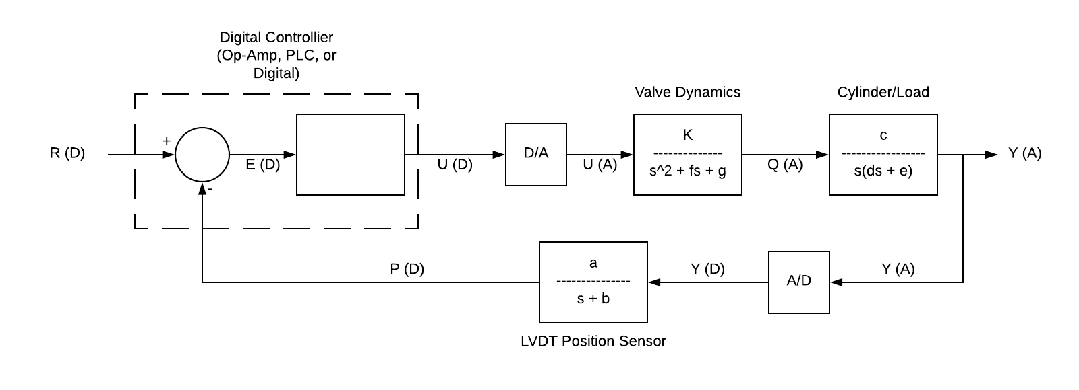

*Figure 5: Block diagram of the given system with added digital/analog and analog/digital converters. An (A) represents an analog signal while a (D) represents a digital signal.*

1. The quantization interval equation is as shown: $Q = \frac{position sensor output range}{2^{bits}- 1}$. Using the given position sensor output range of 20 volts and the given number of bits, 8, Q is equal to 0.0784 V. Given that the cylinder’s travel range is 20 inches and the sensor output range is 20 V, each volt corresponds to 1 inch of cylinder travel. Thus, the ADC has a resolution of 0.0784 inches and a quantization error of half the resolution, or ±0.0392 inches.
2. Supplemental figures:

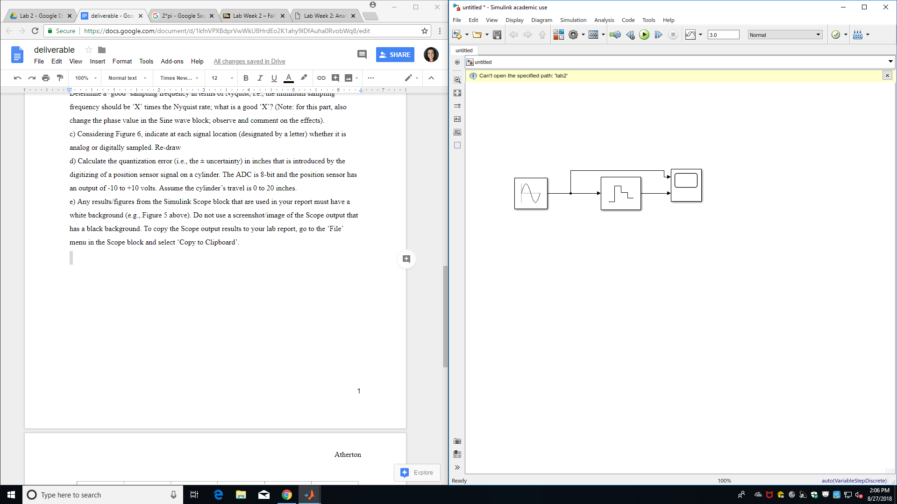

*Figure 6: Simulink block diagram of analog and sampled signal system.*